RCC-NCHS Trouble Reaching You Letter

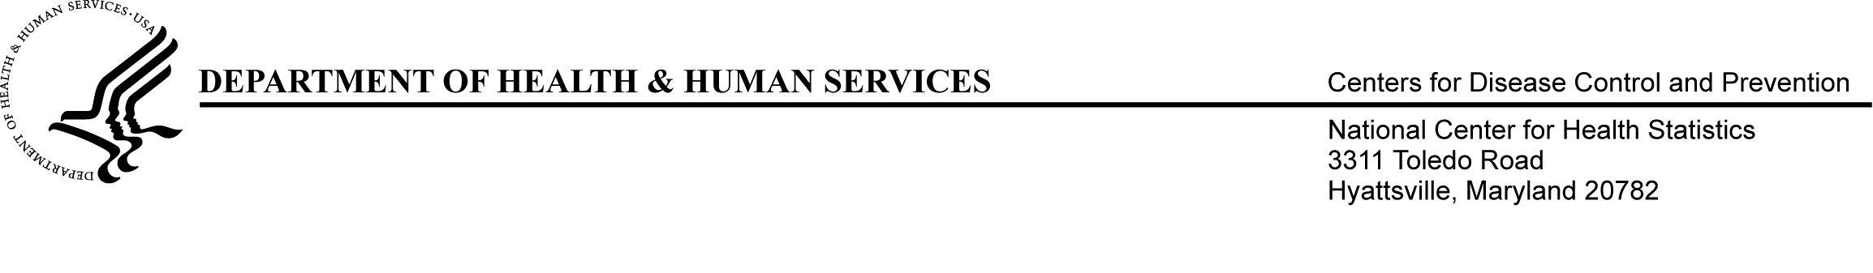

Date

Position
Name of Organization
Address of Organization
Organization City, State, Zip Code

Dear <Position >,

We have been trying to reach you about participating in the 2014 National Study of Long-Term Care Providers (NSLTCP).

This important study collects information about the characteristics of residential care providers, the services they provide, and the characteristics of people who live in these communities. All responses are confidential and protected by federal privacy laws.

We understand that you are very busy. Our attempts to reach you have been unsuccessful. If you have received a questionnaire but have not returned it yet, please consider completing it and sending it back to us. Or, if you would like to complete the questionnaire over the phone or discuss the study with an NSLTCP team member, please call xxx-xxx-xxxx and reference case ID <<case ID>>.

Sincerely,

Lauren Harris-Kojetin
Chief, Long-Term Care Statistics Branch
National Center for Health Statistics

ADSC-NCHS Trouble Reaching You Letter

Date

Position
Name of Organization
Address of Organization
Organization City, State, Zip Code

Dear <Position >,

We have been trying to reach you about participating in the 2014 National Study of Long-Term Care Providers (NSLTCP).

This important study collects information about the characteristics of adult day services centers, the services they provide, and the characteristics of the participants they serve. All responses are confidential and protected by federal privacy laws.

We understand that you are very busy. Our attempts to reach you have been unsuccessful. If you have received a questionnaire but have not returned it yet, please consider completing it and sending it back to us. Or, if you would like to complete the questionnaire over the phone or discuss the study with an NSLTCP team member, please call xxx-xxx-xxxx and reference case ID <<case ID>>.

Sincerely,

Lauren Harris-Kojetin
Chief, Long-Term Care Statistics Branch
National Center for Health Statistics

