RCC-Reminder/Thank You Letter

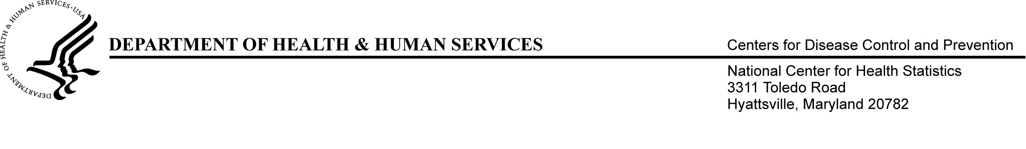
Date
Name of Director
Name of Community
Community Address
Community city, state, zip code

Dear Director,
Recently, we sent you a questionnaire packet for the 2014 National Study of Long-Term Care Providers (NSLTCP). If you already returned your completed questionnaire, thank you for your participation.

If you have not completed and returned your questionnaire yet, we hope you will consider participating. Completing the questionnaire takes 30 minutes on average. Your responses are very important in providing accurate information on long-term care in the United States and in your state.
Please complete the hardcopy questionnaire and return it in the pre-addressed, postage-paid envelope provided earlier by [insert date]. If it is more convenient, you can complete your questionnaire by web over a safe and secure network, by going to this URL address and typing in your unique User ID and password:
URL:
User ID:
Password:

Submit your questionnaire by [insert date] to avoid receiving another questionnaire for this community.

If you are the director for more than one community selected for this study, you will receive and be asked to complete a separate questionnaire for each selected community
If you need technical support, have any questions, or need an additional questionnaire, please call (800) XXX-XXXX.
Thank you once again,

Charles Rothwell, MS, MBA
Director, National Center for Health Statistics
To learn more, please visit http://www.cdc.gov/nchs/nsltcp.htm.
ADSC Reminder/Thank You Letter

Date
Name of Director
Name of Center
Center Address
Center city, state, zip code

Dear Director,
Recently, we sent you a questionnaire packet for the 2014 National Study of Long-Term Care Providers (NSLTCP). If you already returned your completed questionnaire, thank you for your participation.

If you have not completed and returned your questionnaire yet, we hope you will consider participating in NSLTCP. Completing the questionnaire takes 30 minutes on average. Your responses are very important in providing accurate information on long-term care in the United States and in your state.
Please complete the hardcopy questionnaire and return it in the pre-addressed, postage-paid envelope provided in the survey packet by [insert date]. If it is more convenient, you can complete your questionnaire by web over a safe and secure network, by going to the following URL address and typing in your unique User ID and password:
URL:
User ID:
Password:

Submit your questionnaire by [insert date] to avoid receiving another questionnaire for this center.

If you are the director for more than one center, you will need to complete separate questionnaires for each of your centers.
If you need technical support, have any questions, or need an additional questionnaire, please call (800) XXX-XXXX.
Thank you once again,

Charles Rothwell, MS, MBA
Director, National Center for Health Statistics
To learn more, please visit http://www.cdc.gov/nchs/nsltcp.htm.

