Attachment C

CDC Flu UX: Recruitment Message on CDC Flu Website

**Recruitment Message on the CDC Flu Site.**

Selecting “Get Started” will take the potential respondent to the welcome screen of the card sort. For screenshots of the welcome screen of the card sorting tool please refer to **D-SCREENSHOTS-CDCFluCardSort060214**.

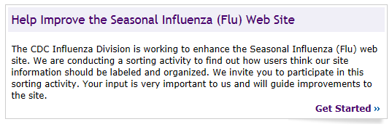

Note: See next page for screen capture of Recruitment message (above) on the CDC Flu Site homepage.

**Recruitment message (above) on the CDC Flu Site homepage**

