CDC SOCIAL MEDIA SATISFACTION SURVEY - SPRING 2014
Form Approved
OMB No: 0920-0956
Exp. Date: March 31, 2016
Online Welcome Message and Consent Form
Thank you for agreeing to help the Centers for Disease Control and Prevention (CDC) evaluate their social media activities. Your feedback is extremely important. We anticipate that it will take approximately 8 minutes to complete these questions.
Your responses to all questions will be kept in a secure manner. All information is used for evaluation purposes only, and CDC does not plan to share the data with anyone outside CDC.
To proceed through the survey, select your answer for each question and click “Continue”.

Public reporting burden of this collection of information is estimated to average 8 minutes per response, including the time for reviewing instructions, searching existing data sources, gathering and maintaining the data needed, and completing and reviewing the collection of information. An agency may not conduct or sponsor, and a person is not required to respond to a collection of information unless it displays a currently valid OMB control number. Send comments regarding this burden estimate or any other aspect of this collection of information, including suggestions for reducing this burden to CDC/ATSDR Reports Clearance Officer; 1600 Clifton Road NE, MS D-74, Atlanta, Georgia 30333; ATTN: PRA (0920-0956)

User Satisfaction Rating
- What is your overall satisfaction with the CDC presence on this social media channel?
SCALE: (1=Very Dissatisfied; 10= Very Satisfied)

- How likely are you to return to this CDC social media channel?
SCALE: (1=Very Unlikely; 10=Very Likely)

- How likely are you to recommend this CDC social media channel to someone else?
SCALE: (1=Very Unlikely; 10=Very Likely)

Social Media Channel Selection
- Please indicate which CDC social media channels you visit/interact with. (Select all that apply) [MULTI]
- Facebook
- YouTube
- Twitter
- LinkedIn
- Google+
- Pinterest
- Instagram
- Flickr
- None of the above

- Which CDC social media channel did you visit to complete this survey? [SINGLE]
- Facebook
IF FACEBOOK SELECTED, GO TO QUESTION 6; RESPONDENT TO ANSWER SECTION A QUESTIONS
- Google+
IF GOOGLE+ SELECTED, GO TO QUESTION 13; RESPONDENT TO ANSWER SECTION B QUESTIONS
- Twitter
IF TWITTER SELECTED, GO TO QUESTION 20; RESPONDENT TO ANSWER SECTION C QUESTIONS
- LinkedIn
IF LINKEDIN SELECTED, GO TO QUESTION 27; RESPONDENT TO ANSWER SECTION D QUESTIONS
- None of the above
SKIP TO END

Facebook-Specific Survey Questions

- What best describes how often you visit Facebook? [SINGLE]
- 3 times or more per day
- Once or twice a day
- A few times per week
- Once a week
- A few times per month
- Monthly or less often
- This was my first time

- What do you think of the frequency of Facebook posts from CDC? [SINGLE]
- I think you should have more posts
- I think the number of posts is fine as is
- I think you should have less posts
- No opinion

- What kind of topics would you like to see posts about on the CDC Facebook page? [OPEN]

- How do you typically access your Facebook account? [SINGLE]
- Desktop/laptop computer
- Mobile phone
- iPad/Tablet

- How do you view the Facebook posts from CDC? (Select all that apply) [MULTI]
- Visit the CDC Facebook page
- See the updated posts within my Facebook news feed
- Not sure

- Approximately how many organizations/businesses/groups are you a fan of on Facebook? [SINGLE]
- Less than 5
- 5-10
- More than 10
- Not sure

- Based on the information you receive from CDC's Facebook posts, how likely are you to make changes to your lifestyle to improve your health? [SINGLE]
- Very likely
- Likely
- Unlikely
- Very Unlikely

SKIP TO QUESTION 32
-------------------------------------------------------------------

Google-Specific Survey Questions
- What best describes how often you visit Google+? [SINGLE]
- Daily
- Weekly
- A few times per month
- Monthly or less often
- This was my first time

- What do you think of the frequency of Google+ posts from CDC? [SINGLE]
- I think you should have more posts
- I think the number of posts is fine as is
- I think you should have less posts
- No opinion
- What kind of topics would you like to see posts about on the CDC Google+ profile? [OPEN]

- How do you typically access your Google+ account? [MULTI]
- Desktop/laptop computer
- Mobile phone
- iPad/Tablet

- How do you view the Google+ posts from CDC? (Select all that apply) [MULTI]
- Visit the CDC Google+ Profile
- See the updated posts within my Google+ feed
- Not sure

- Approximately how many organizations/businesses/groups do you follow on Google+? [SINGLE]
- Less than 5
- 5-10
- More than 10
- Not sure

- Based on the information you receive from CDC's Google+ posts, how likely are you to make changes to your lifestyle to improve your health? [SINGLE]
- Very likely
- Likely
- Unlikely
- Very Unlikely

SKIP TO QUESTION 32
--------------------------------------------------------------------------------------

Twitter-Specific Survey Questions
- What best describes how often you visit Twitter? [SINGLE]
- Daily
- Weekly
- A few times per month
- Monthly or less often
- This was my first time

- What do you think of the frequency of CDC tweets? [SINGLE]
- I think you should tweet more often
- I think the frequency of tweets is fine as is
- I think you should tweet less often
- No opinion

- What kind of topics would you like to see tweets about on CDC's Twitter page? [OPEN]

- How do you typically access Twitter [SINGLE]
- Desktop/laptop computer
- Mobile phone
- iPad/Tablet

- How do you view tweets from CDC? (Select all that apply) [MULTI]
- Visit the CDC Twitter profile
- See the tweets within my news feed
- Not sure

- Approximately how many organizations/businesses/groups do you follow on Twitter? [SINGLE]
- Less than 5
- 5-10
- More than 10
- Not sure

- Based on the information you receive from CDC's Twitter profile, how likely are you to make changes to your lifestyle to improve your health?
- Very likely
- Likely
- Unlikely
- Very Unlikely

SKIP TO QUESTION 32
-------------------------------------------------------------------------------------

LinkedIn-Specific Survey Questions
- What best describes how often you visit LinkedIn? [SINGLE]
- Daily
- Weekly
- A few times per month
- Monthly or less often
- This was my first time

- What do you think of the frequency of posts from CDC on LinkedIn? [SINGLE]
- I think you should have more posts
- I think the number of posts is fine as is
- I think you should have less posts
- No opinion

- What kind of topics would you like to see posts about on the CDC LinkedIn page? [OPEN]

- Approximately how many organizations/businesses/groups do you follow on LinkedIn? [SINGLE]
- Less than 5
- 5-10
- More than 10
- Not sure

- Based on the information you receive from CDC's LinkedIn page, how likely are you to make changes to your lifestyle to improve your health? [SINGLE]
- Very likely
- Likely
- Unlikely
- Very Unlikely

SKIP TO QUESTION 32
-------------------------------------------

ALL RESPONDENTS

User Role
- Which of these best describes you? [SINGLE]
- Individual interested in health issues
- Friend or family member of an individual interested in health issues
- Healthcare provider (physician, nurse, physician's assistant, nurse practitioner, pharmacist, or other healthcare provider) [IF SELECTED, SHOW QUESTION 33]
- Public Health Professional [IF SELECTED, SHOW QUESTION 34]
- Emergency health professional (First responder, EMT, Paramedic)
- Researcher or scientist
- Educator, teacher or trainer
- Student
- Policymaker, legislator, or staff
- Other, please specify: [OPEN]

- Which best describes your role as a Healthcare Provider: [SINGLE]
- Doctor
- Nurse (LPN, RN, NP, PA)
- Pharmacist
- Other, please specify: [OPEN]

- Please describe your role as a Public Health Professional:
- State Public Health Professional
- Local Public Health Professional
- Tribal Public Health Professional
- Federal Public Health Professional
- Not-for-Profit Public Health Professional
- Other, please specify: [OPEN]

Experience with CDC Social Media
- How did you find the CDC social media channel you visited today:
- A link on www.cdc.gov
- Search engine
- Follow CDC on another social media channel
- Word of mouth
- Email subscriptions/RSS Feeds
- A blog post mentioning the CDC social media channel
- Referral or links from other websites
- Media/news story
- CDC mobile app
- Other, please specify: [OPEN]

- Which of the following additional channels/applications would you like CDC to develop/join? (Select all that apply) [MULTI]
- Tumblr
- iPhone Apps
- iPad Apps
- Android Apps
- Other, please specify [IF SELECTED, SHOW QUESTION 37]
- None
- Please describe the other channels/applications would you like CDC to develop/join? [OPEN]

Content Quality
- Please select the level to which you agree or disagree with the following statements (a-e)
SCALE:
1=Strongly Disagree
2=Disagree
3=Neither Agree/Disagree
4=Agree
5=Strongly Agree
Don't Know

  - CDC's social media posts are credible.
  - CDC's social media posts are relevant.
  - CDC's social media posts are actionable.
  - CDC's social media posts are informative.
  - CDC's social media posts are understandable.

- How frequently have you visited the CDC website in the last 6 months? [SINGLE]
- Never
- Once
- 2-5 times
- 6-15 times
- 16 or more times
- Don't Know
- In general, which of the following social media services have you actively participated with in the last 30 days (e.g. posted/shared comments, tweeted, etc.) [MULTI]
- Facebook
- Twitter
- YouTube
- Flickr
- Google+
- LinkedIn
- Pinterest
- Instagram
- Tumblr
- Internet Forums
- Blogs
- Other

User Demographics
- What is your age? [SINGLE]
- 13-19 years old
- 20-24 years old
- 25-34 years old
- 35-44 years old
- 45-49 years old
- 50-54 years old
- 55-65 years old
- 65 and older
- Prefer not to answer

- How would you describe yourself? [MULTI]
- White (not of Hispanic heritage)
- Hispanic or Latino
- Asian
- Black or African American
- American Indian or Alaska Native
- Native Hawaiian or other Pacific Islander
- Prefer not to answer

- What is the highest level of education you have completed? [SINGLE]
- High school or less
- Some college
- College degree
- Advanced degree
- Prefer not to answer

- What is your gender? [SINGLE]
- Female
- Male
- Transgender
- Prefer not to answer

Additional Feedback
- Do you have any additional feedback about how CDC's social media services could better meet your needs? [OPEN]

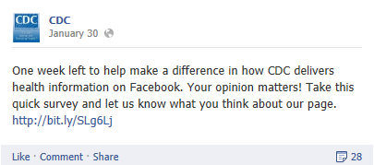
CDC social media users will be prompted to take the survey via links posted on CDC’s social media channels, as seen in the following examples (Facebook and Twitter):

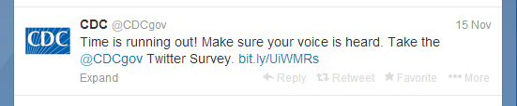

Clicking on the link will take them to the opening screen in Survey Monkey:
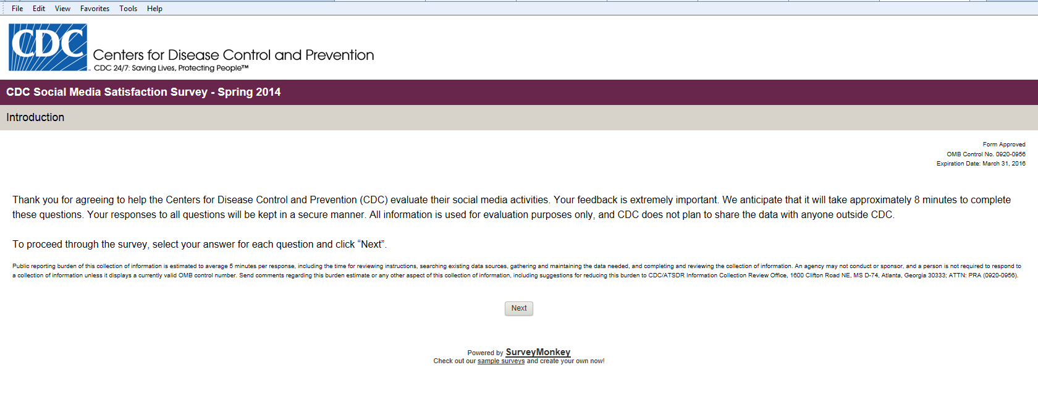

Based on response to #5, users will be taken to either Facebook, Google+, Twitter or LinkedIN screens below to answer questions specific to those channels: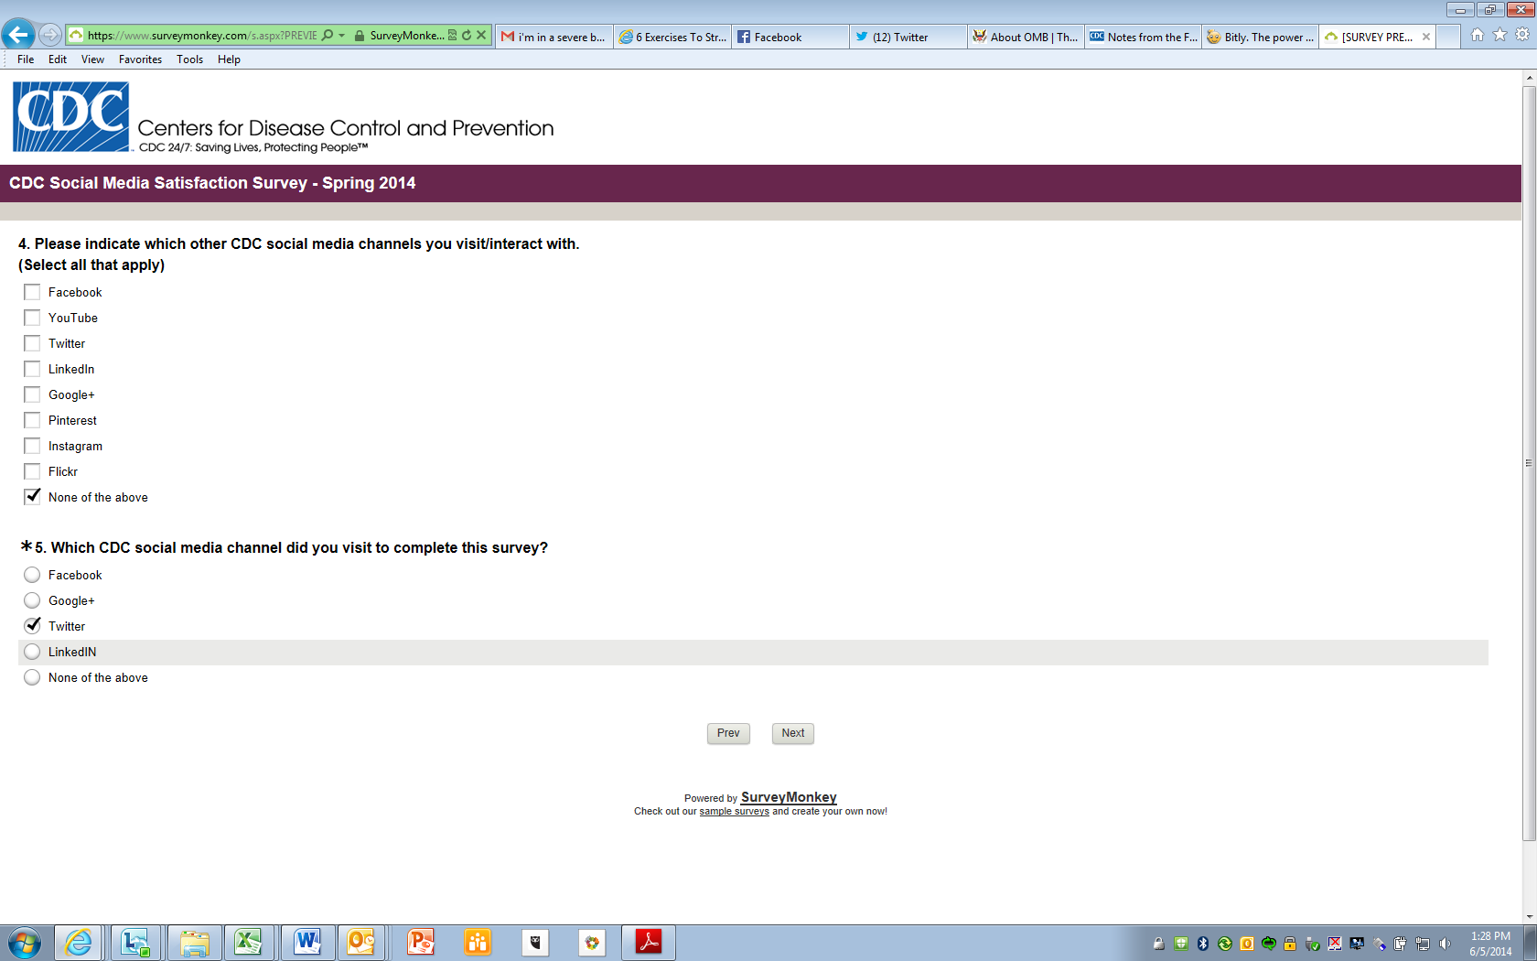
Facebook Questions:
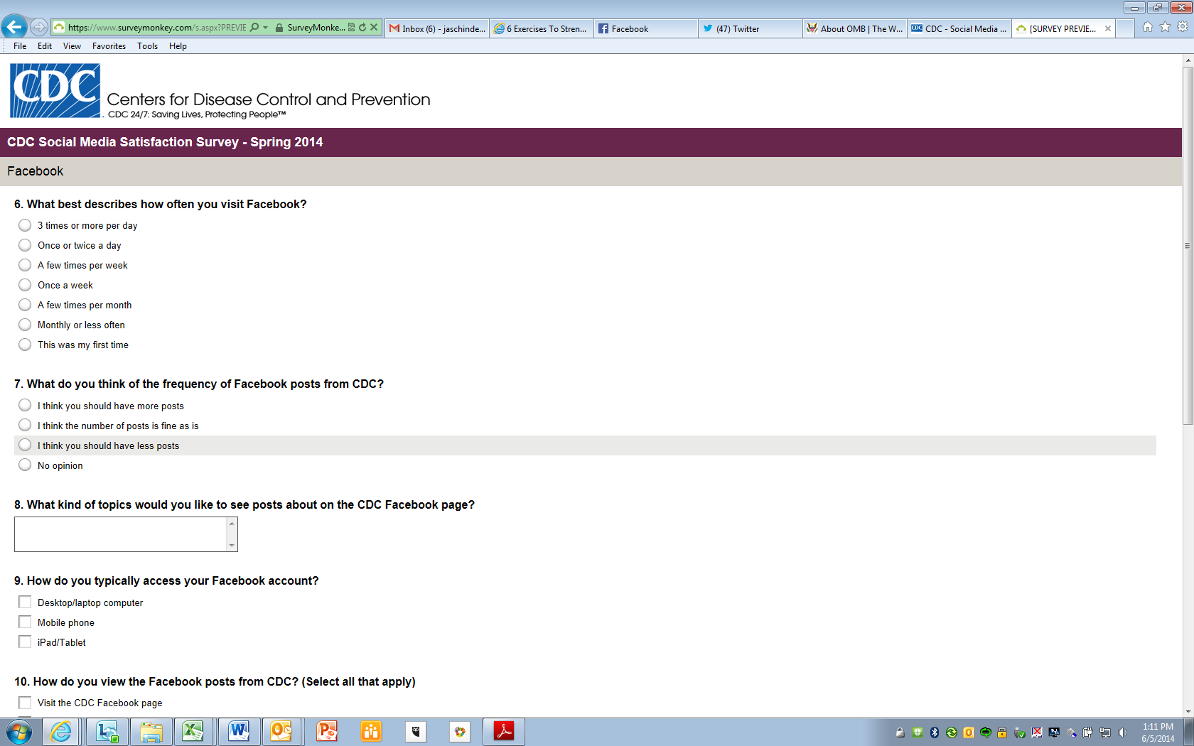
Google+ Questions:
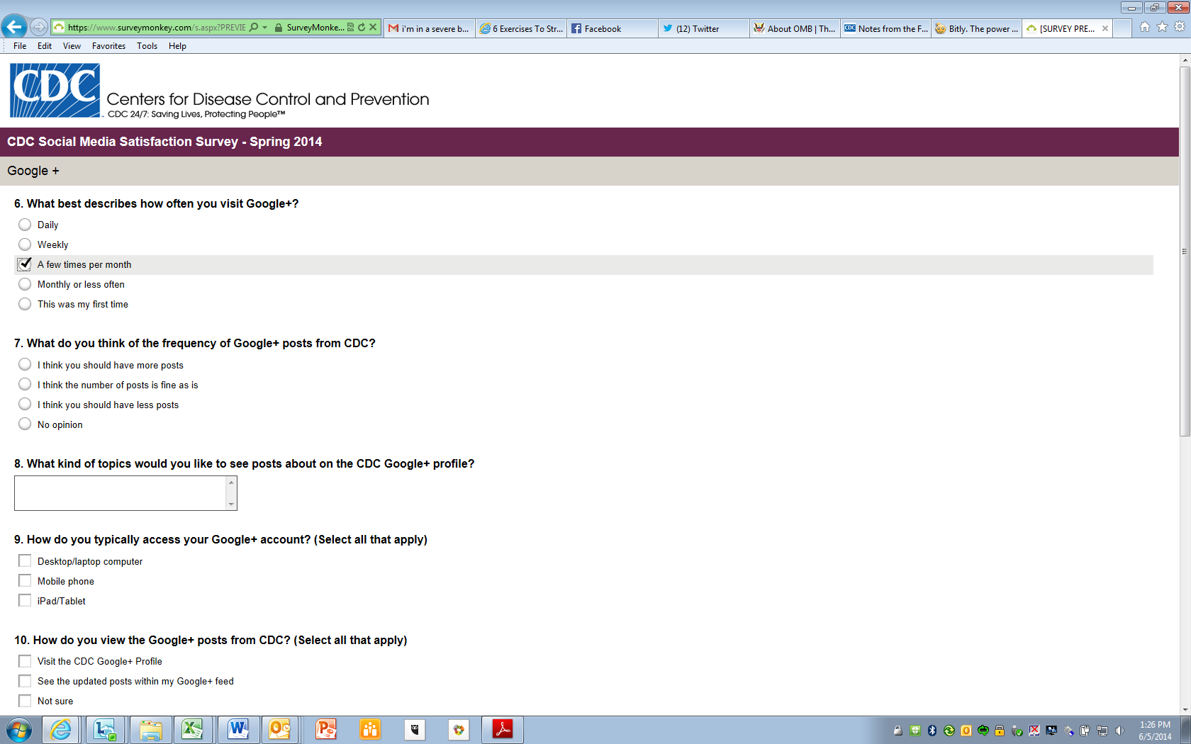
Twitter Questions:
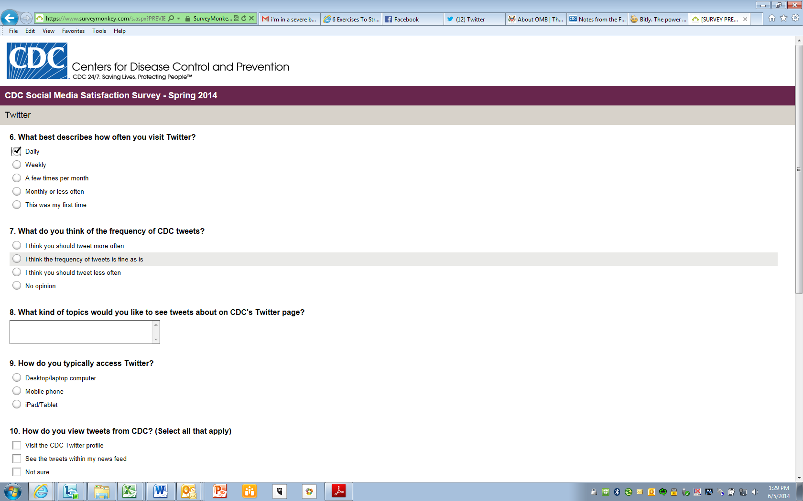
LinkedIN Questions:
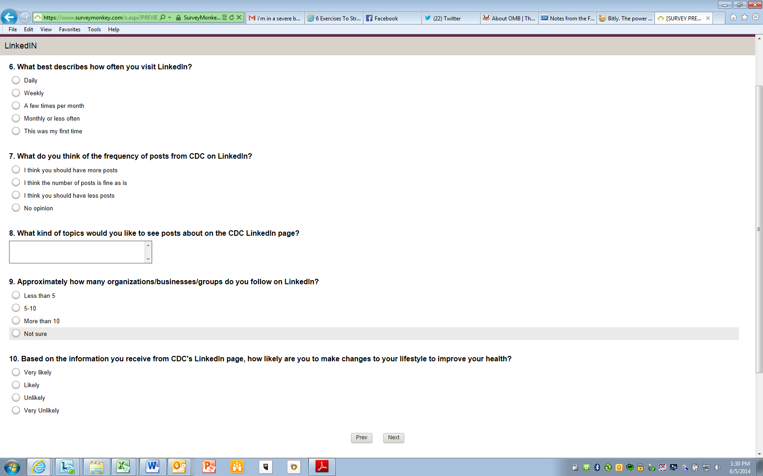
All Users will then respond to final set of questions:
