Appendix A: Pop-up Box
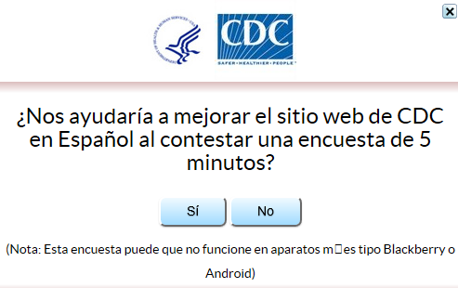

English Translation:
Will you help us improve CDC.gov and take this 5 minute survey?
Yes No
(Note: This survey may not work on android or blackberry devices)

