Attachment C

**CDC Digital Health Tools Survey: Digital Health Tools Survey Screen Shots**

***\*TEXT IN RED, CAPS AND ITALICS ADDED FOR CLARIFICATION, BUT NOT TO BE INCLUDED IN ACTUAL SURVEY.***

*PRE-TEST QUESTIONS BEGIN, QUESTIONS ASKED OF ALL PARTICIPANTS*

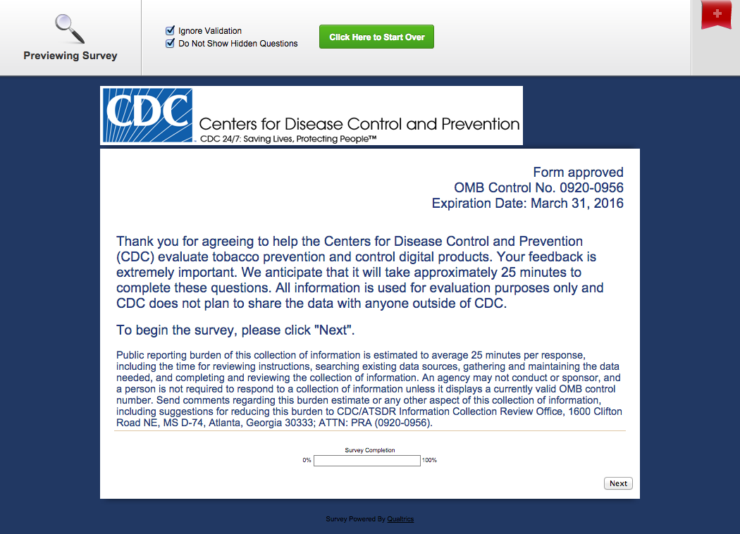

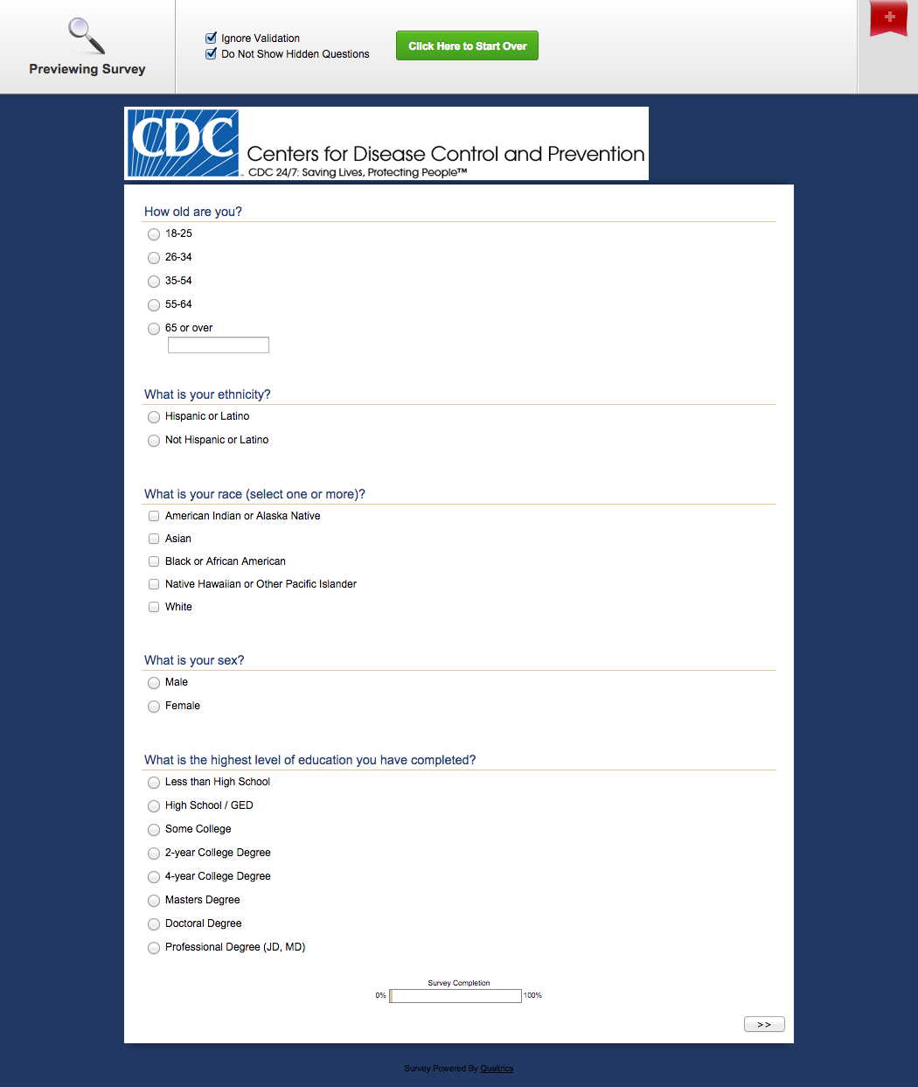

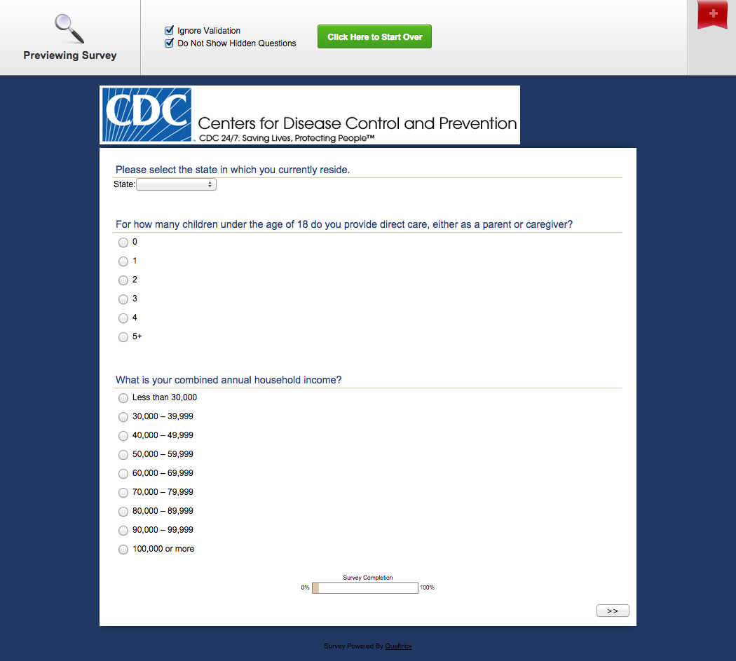

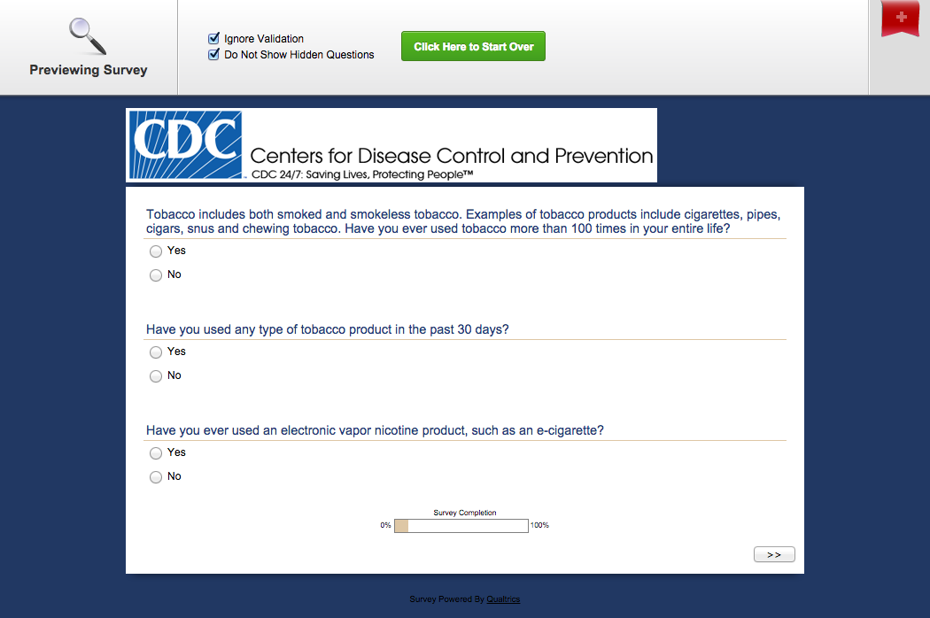

*PRE-TEST QUESTIONS END*

*EXPOSURE TO DIGITAL TOOLS AND ALTERNATES BEGINS*

*ALL PARTICIPANTS EXPOSED TO ONE (1) OF FOUR (4) SITES,*

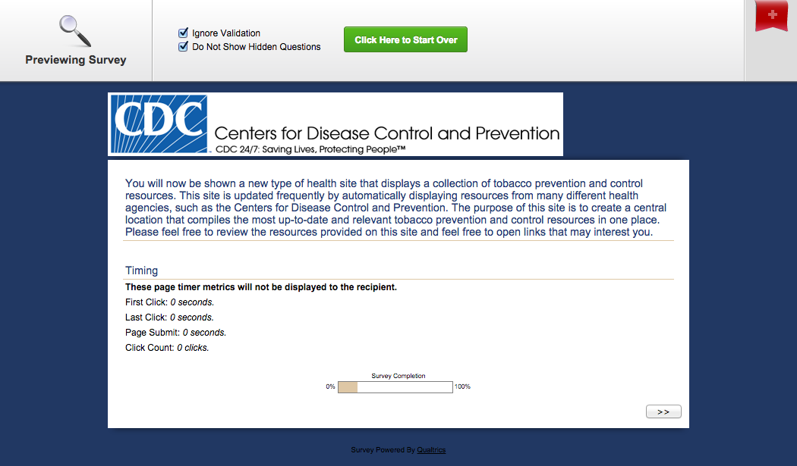

*EXPOSURE TO THE MICROSITE TOOL, GROUP 1*

*EXPOSURE TO THE ALTERNATE TO THE MICROSITE SITE, GROUP 2*

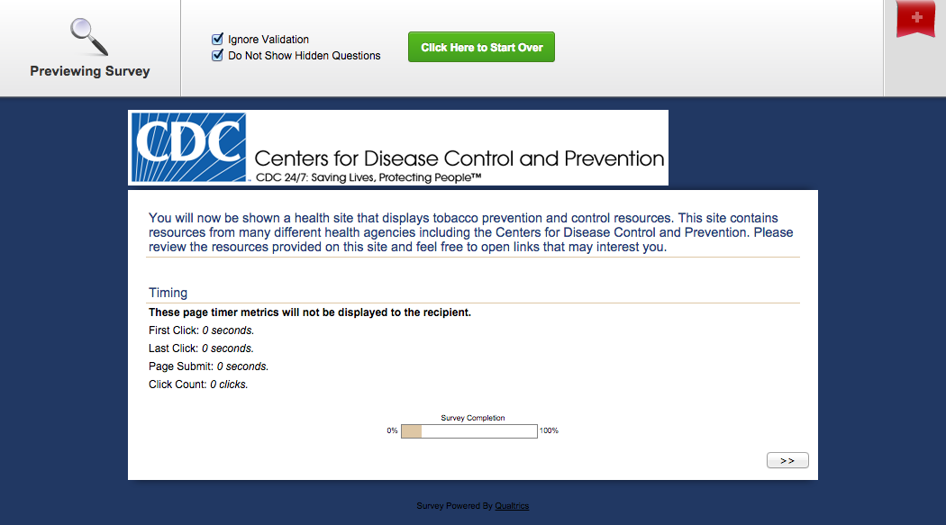

*EXPOSURE TO THE DATA WIDGET TOOL, GROUP 3*

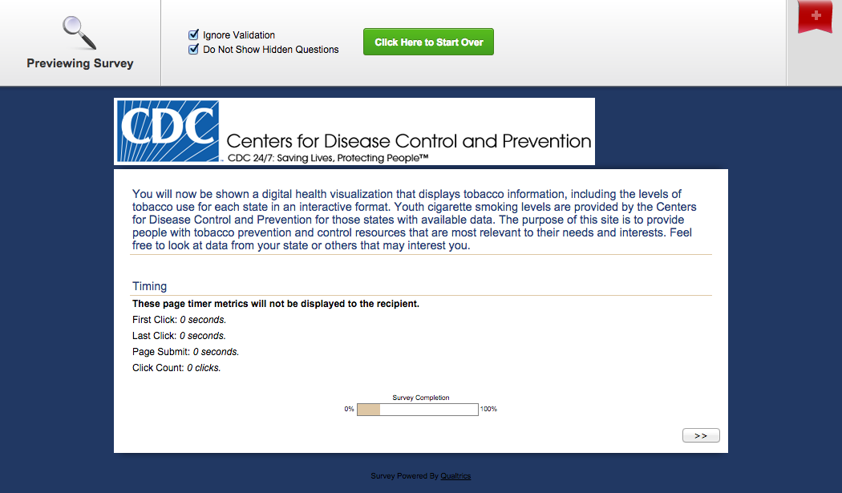

*EXPOSURE TO THE ALTERNATE TO THE DATA WIDGET SITE, GROUP 4*

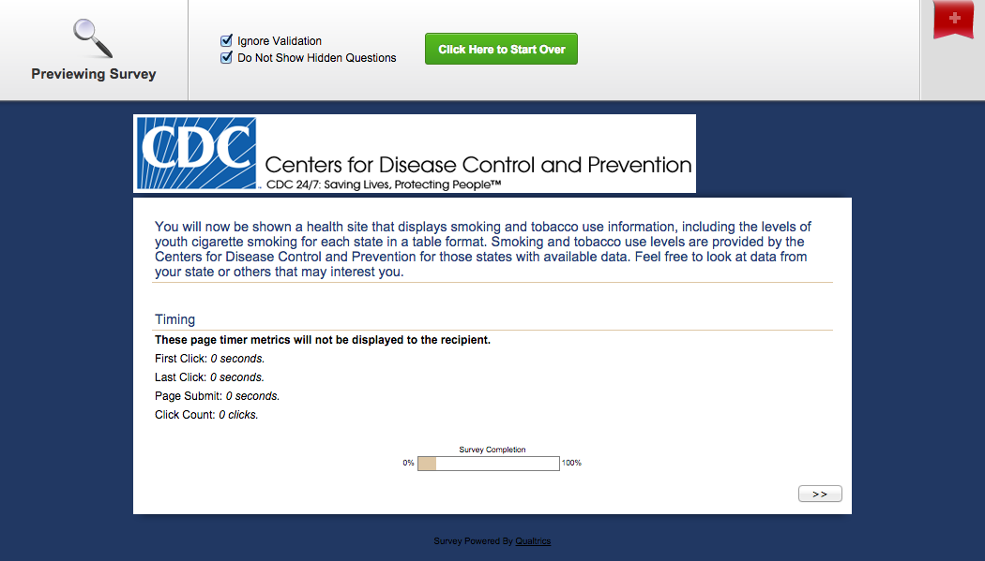

*POST-TEST QUESTIONS BEGIN*

*ONLY PARTICIPANTS IN GROUPS 1 AND 2 ANSWER THESE QUESTIONS*

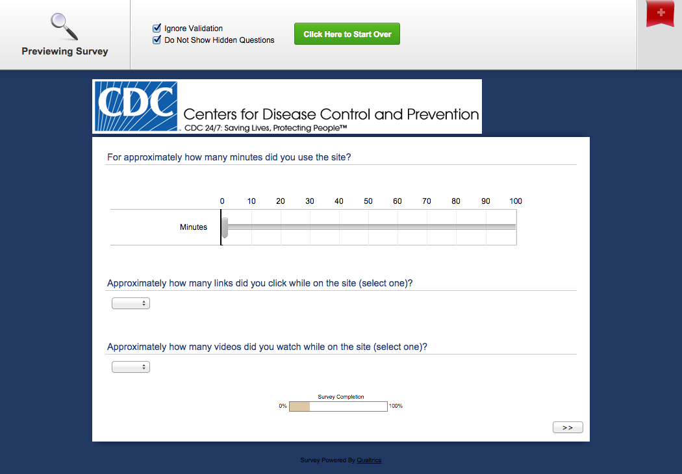

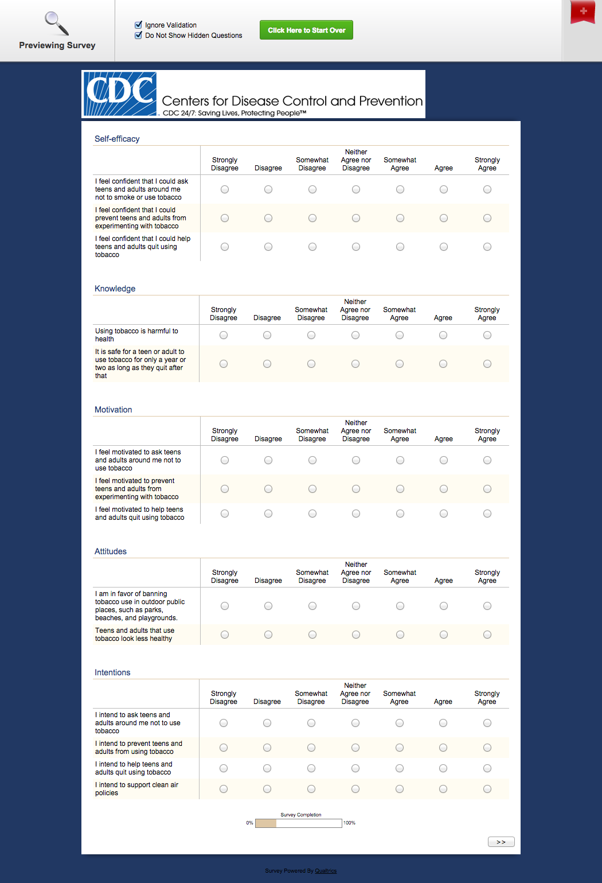

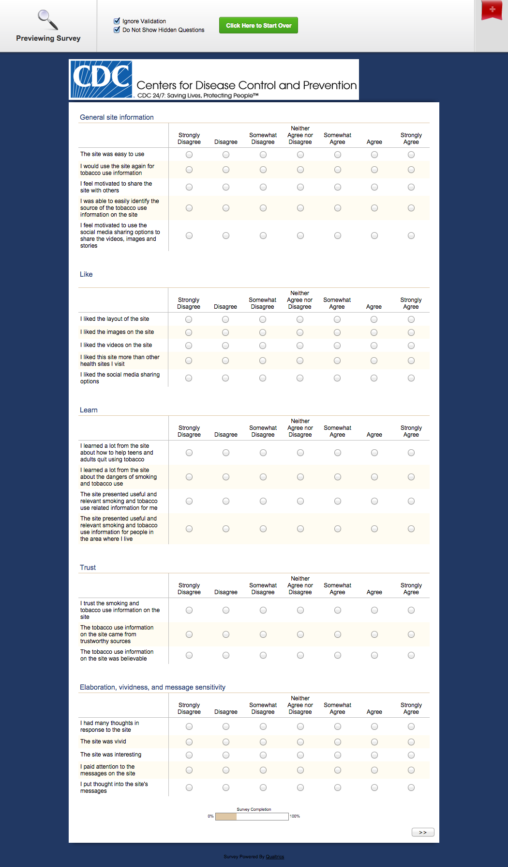

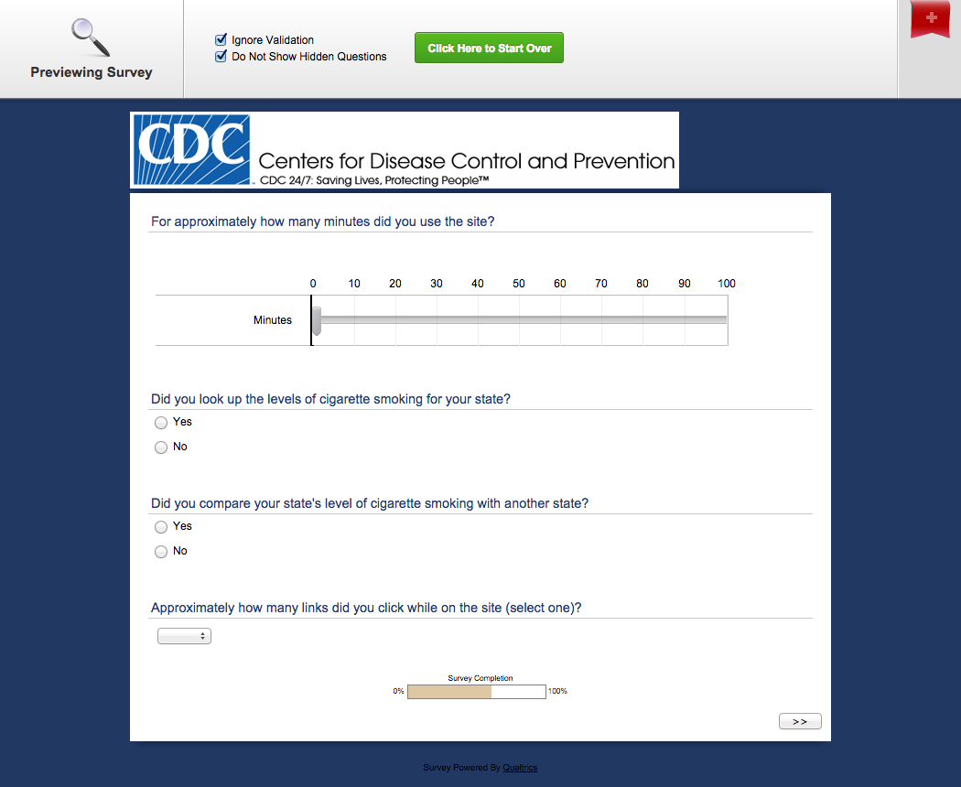

*ONLY PARTICIPANTS IN GROUPS 3 AND 4 ANSWER THESE QUESTIONS*

