Attachment C

CDC Flu UX: Recruitment Message on CDC Flu Website
Recruitment Message on the CDC Flu Site.

Selecting “Get Started” will take the potential respondent to the welcome screen of the card sort. For screenshots of the welcome screen of the card sorting tool please refer to D-SCREENSHOTS-CDCFluCardSort060214.

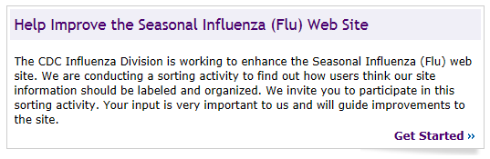

Note: See next page for screen capture of Recruitment message (above) on the CDC Flu Site homepage.

Recruitment message (above) on the CDC Flu Site homepage

