OADC Fact Sheet Testing- Survey Screen Shots
Welcome Screen
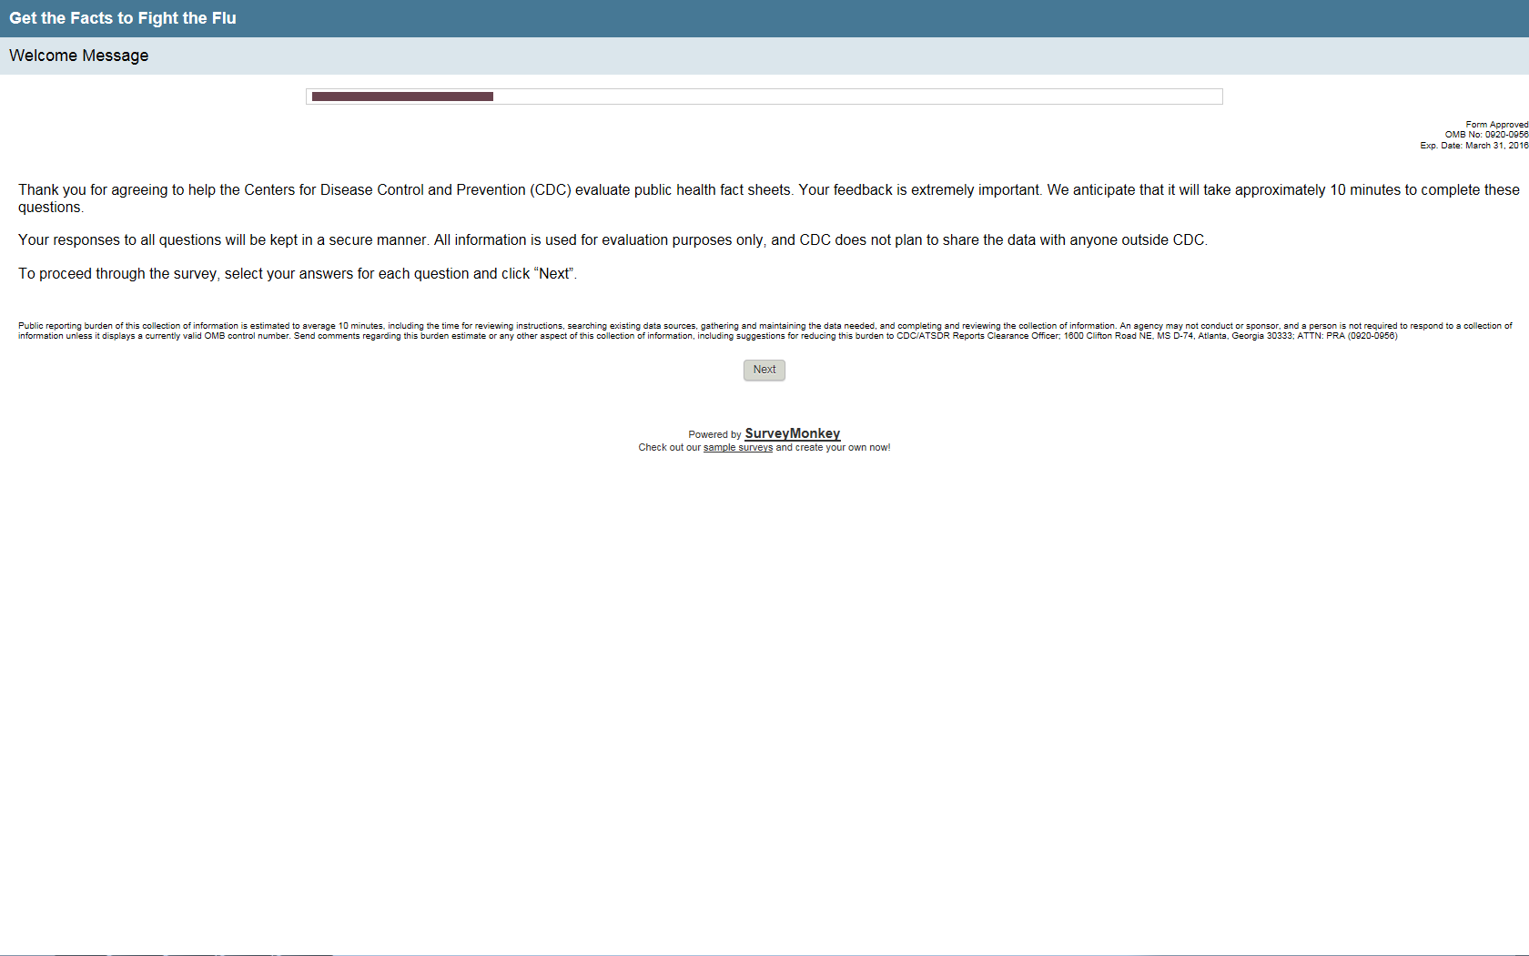

Demographic Questions

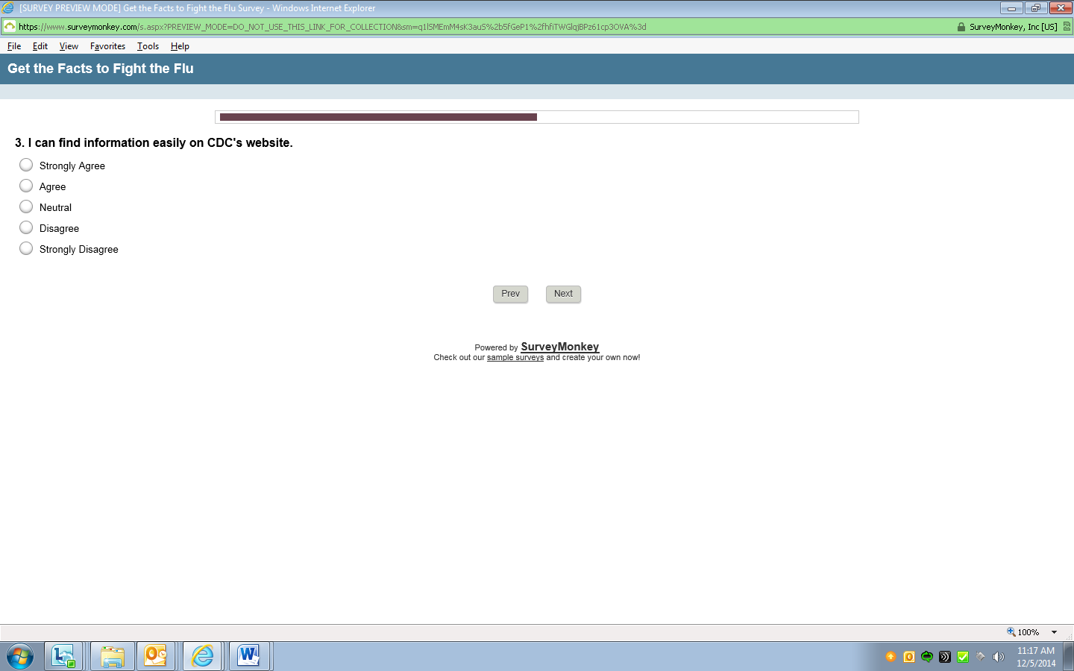
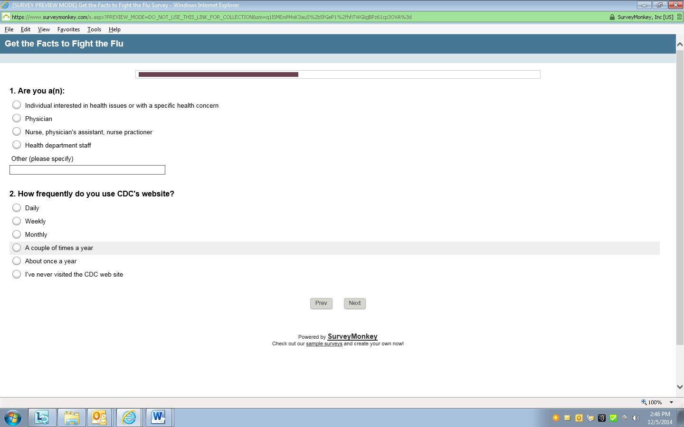
Fact Sheets Questions
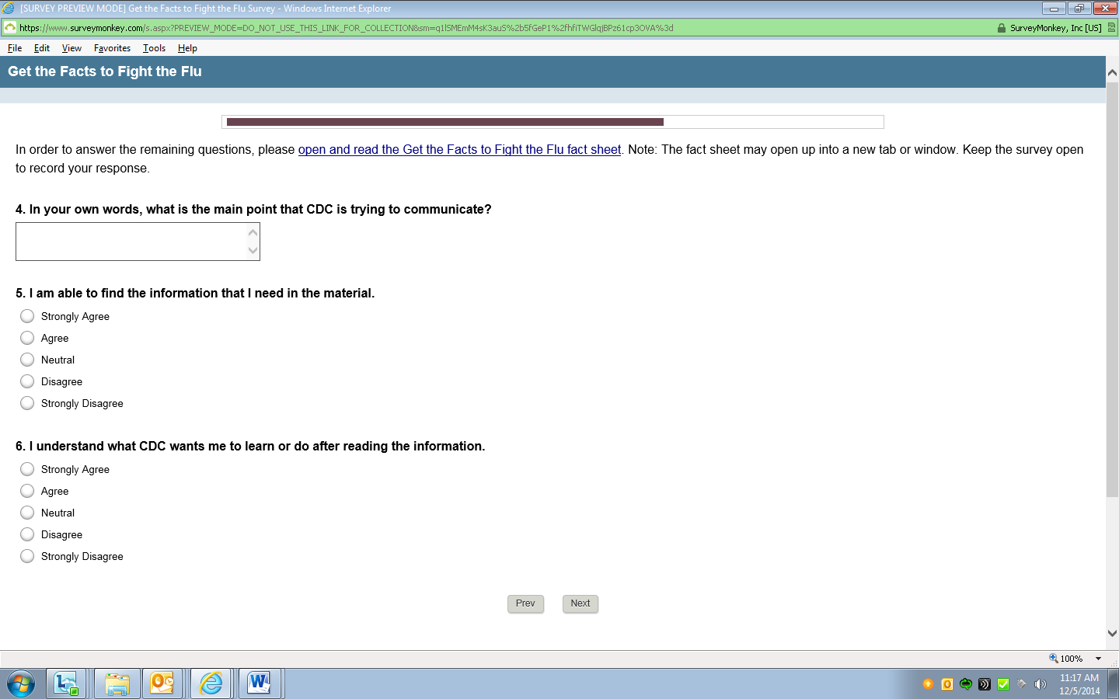
**In order to answer the remaining questions, respondents will be asked to open a link and read a fact sheet. When the link is accessed, the fact sheet (pdf) will display.

