ATTACHMENT – F: Online Instrument - Web

Immunization Information Systems Examination of Services and Value Assessment
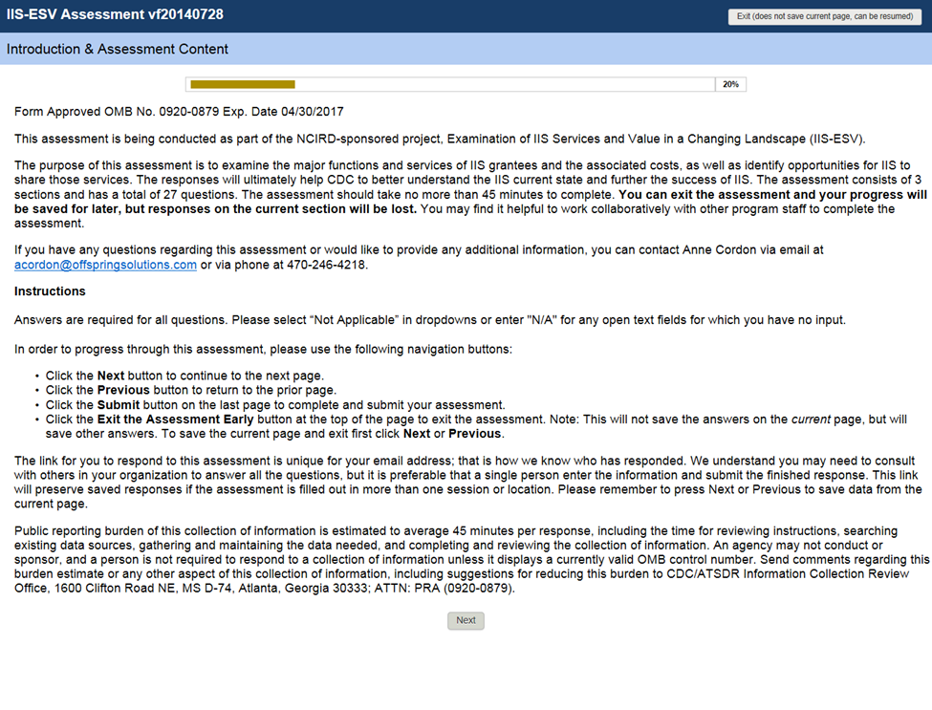

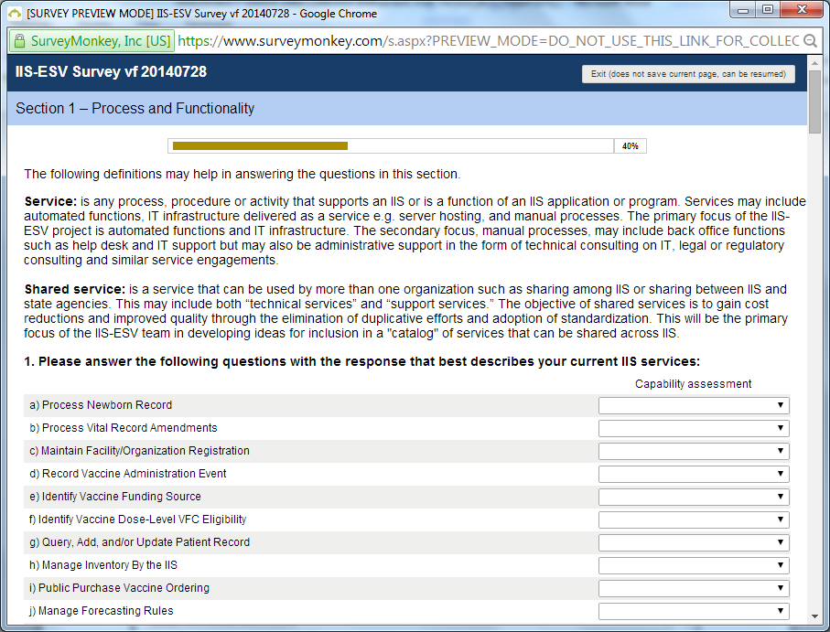
Question 1 Dropdown Menu Choices:
- Optimally performs this function
- Adequately performs this function
- Marginally performs this function
- Does not performs this function
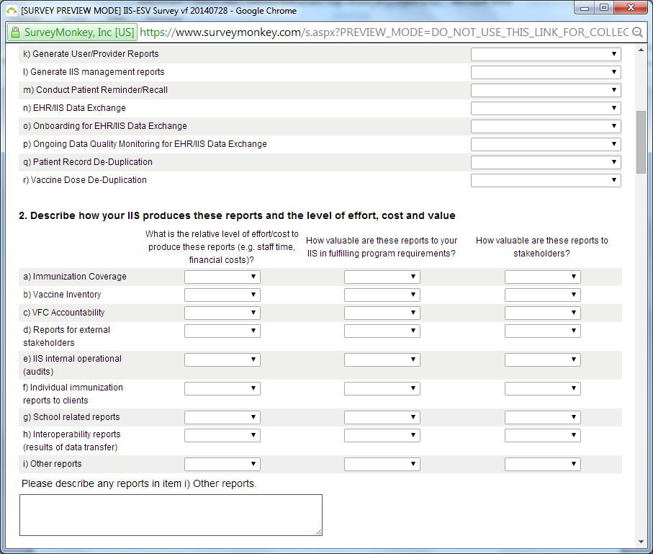
Question 2 Dropdown Menu Choices:
What is the relative level of effort/cost to produce these reports (e.g. staff time, financial costs)?
- Very low
- Low
- Medium
- High
- Very high
- Not applicable
- Don’t know
How valuable are these reports to your IIS in fulfilling program requirements?
- Very low
- Low
- Medium
- High
- Very high
- Not applicable
- Don’t know
How valuable are these reports to stakeholders?
- Very low
- Low
- Medium
- High
- Very high
- Not applicable
- Don’t know
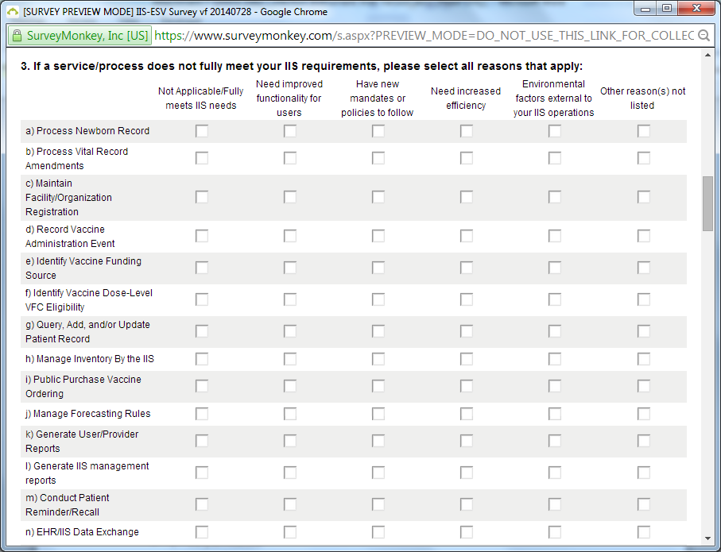
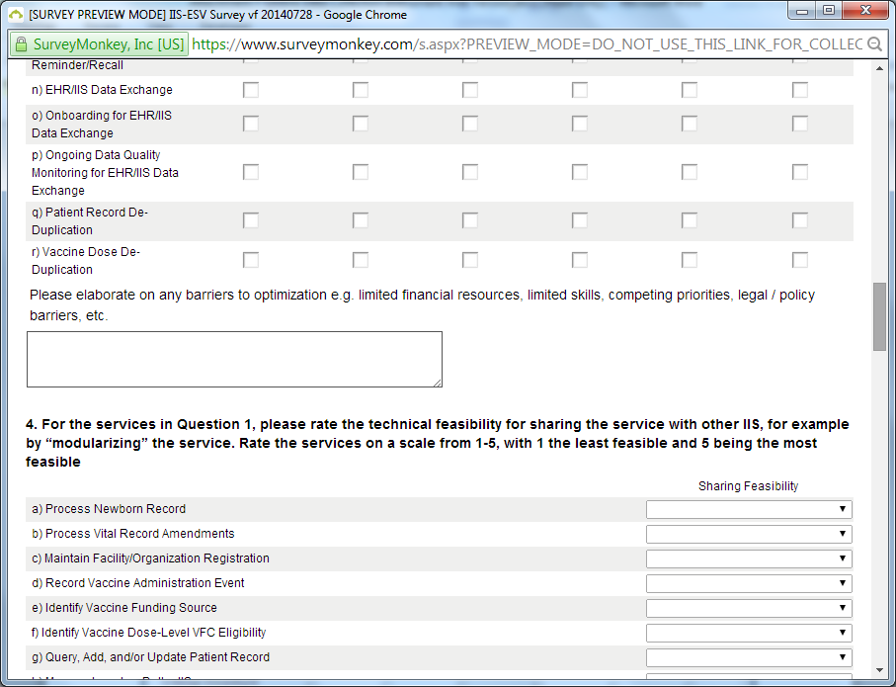
Question 4 Dropdown Menu Choices:
- 1 – Very unfeasible
- 2 – Unfeasible
- 3 – Mix of feasible and unfeasible
- 4 – Feasible
- 5 – Very feasible

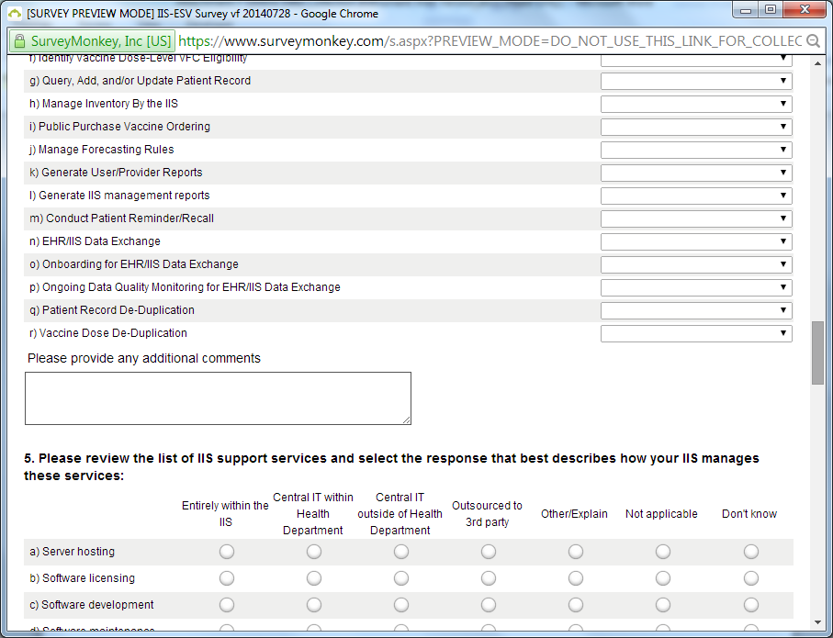
Question 4 Dropdown Menu Choices:
- 1 – Very unfeasible
- 2 – Unfeasible
- 3 – Mix of feasible and unfeasible
- 4 – Feasible
- 5 – Very feasible

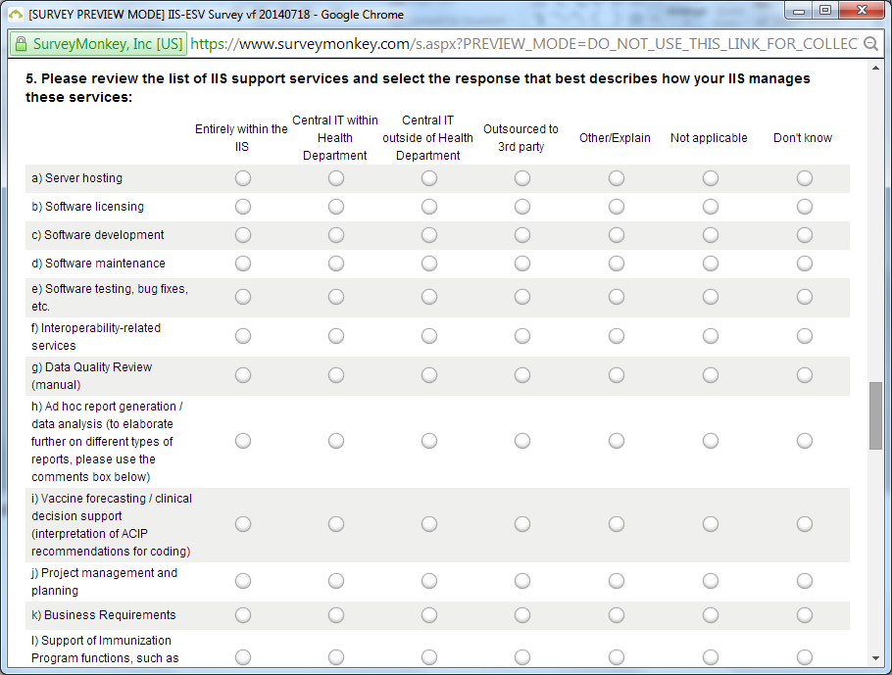
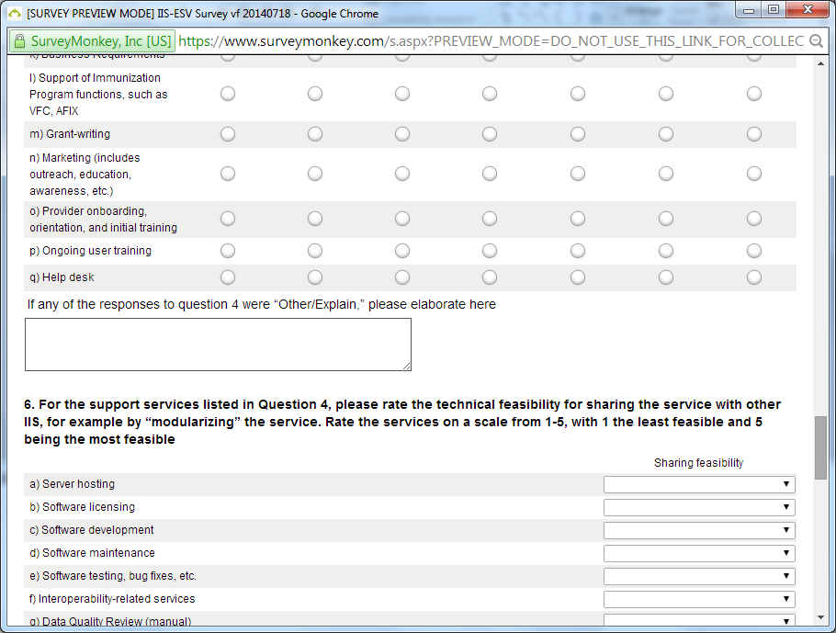
Question 6 Dropdown Menu Choices:
- 1 – Very unfeasible
- 2 – Unfeasible
- 3 – Mix of feasible and unfeasible
- 4 – Feasible
- 5 – Very feasible
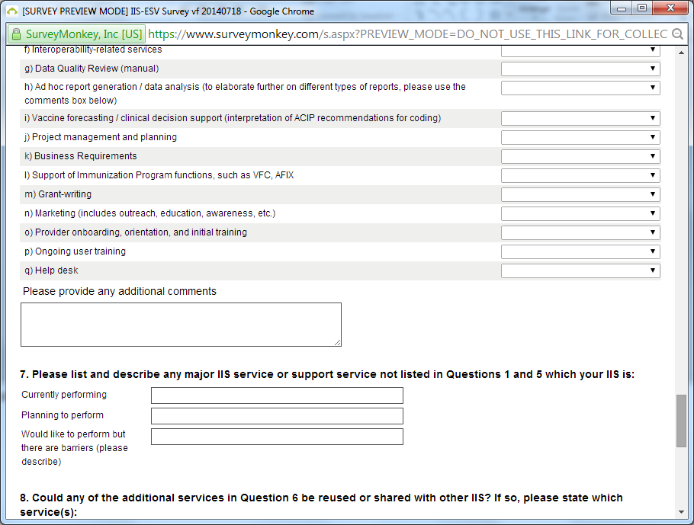
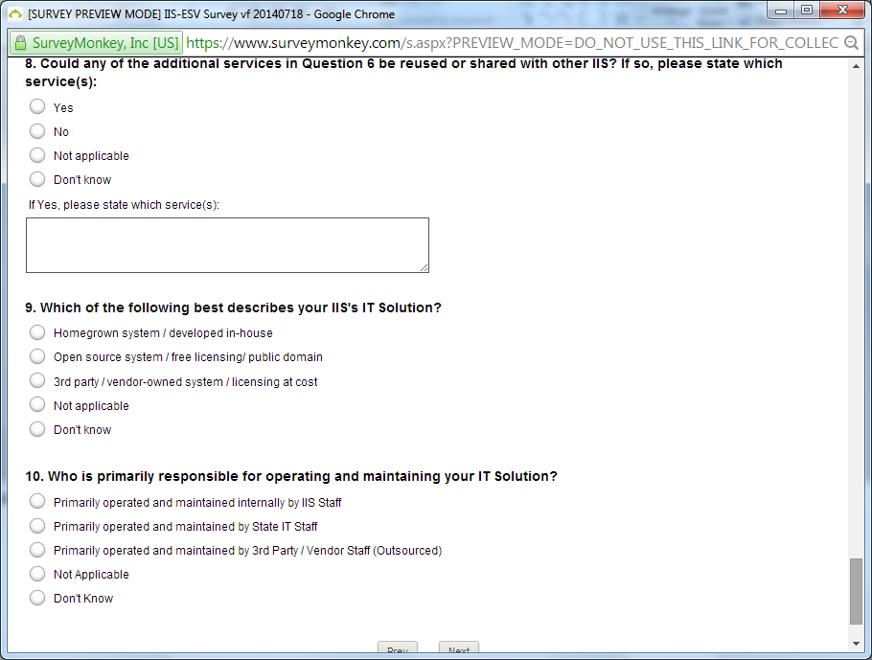
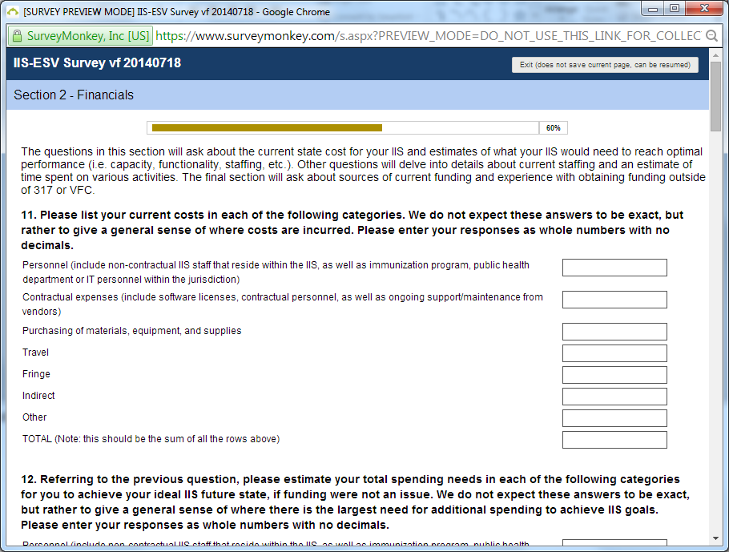
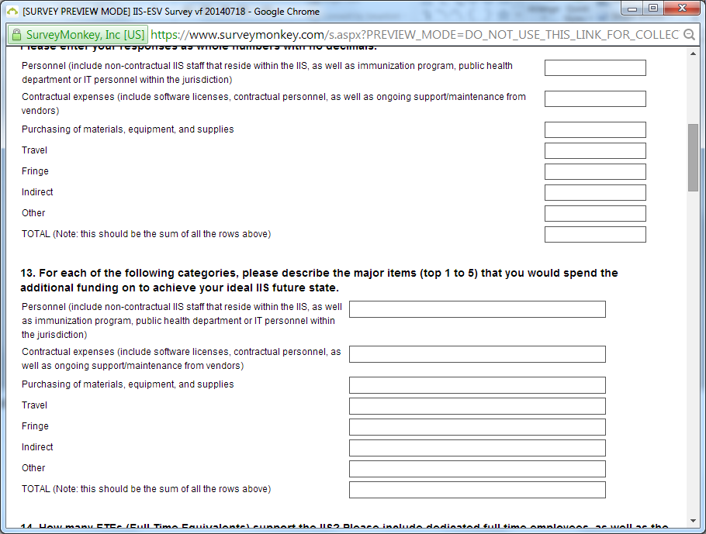
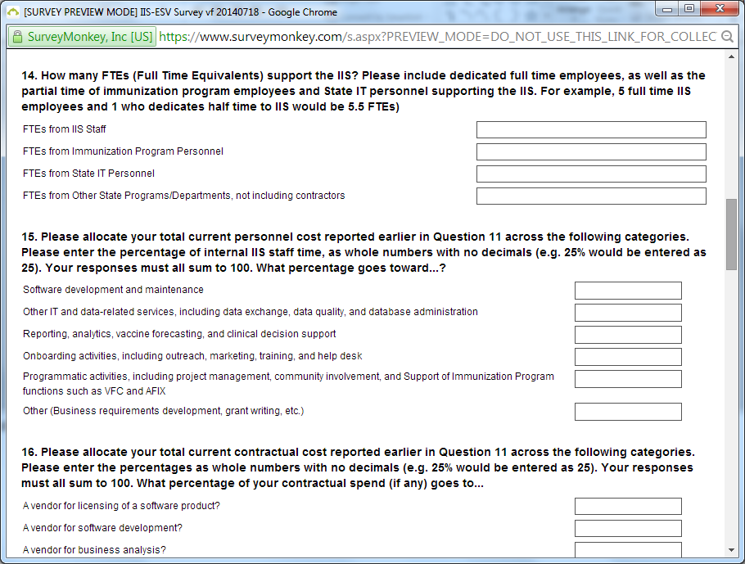
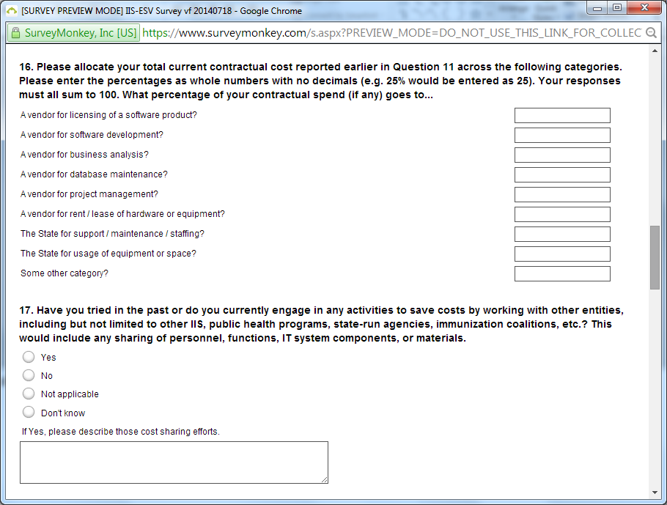
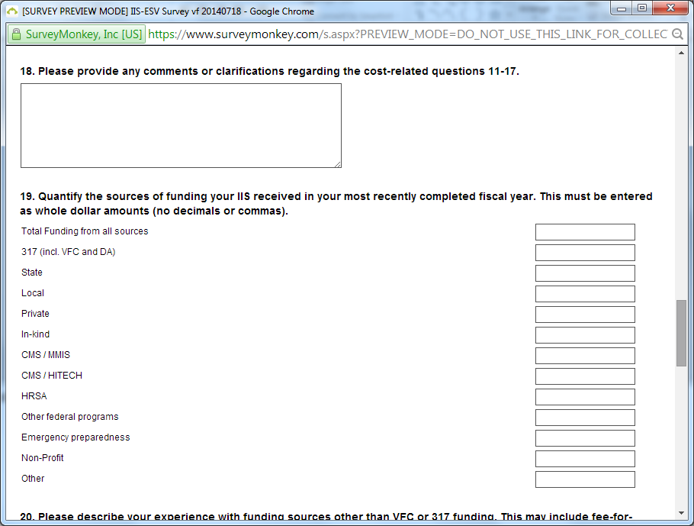
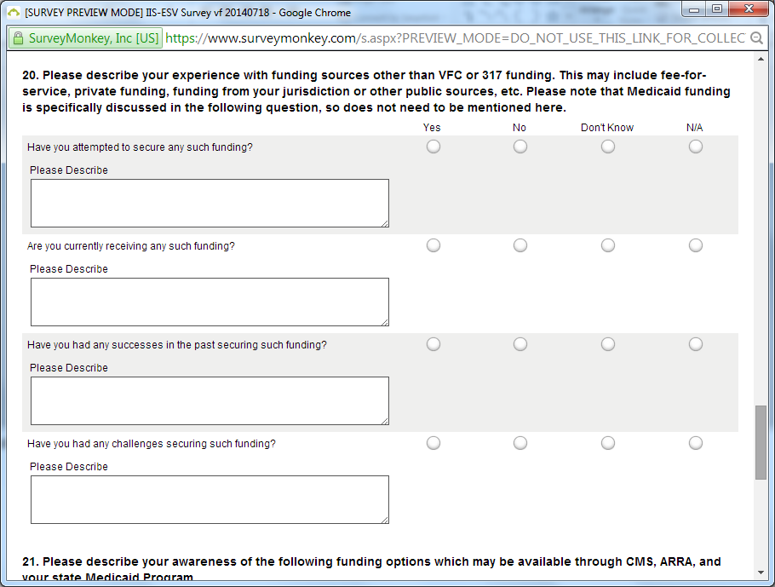
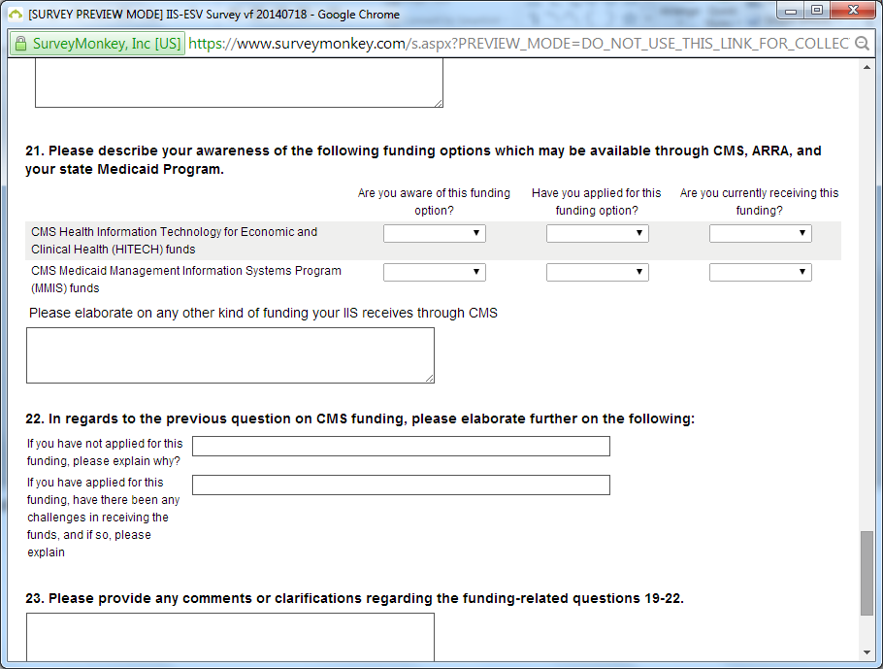
Question 21 Dropdown Menu Choices:
- Yes
- No
- Don’t Know
- Not Applicable
