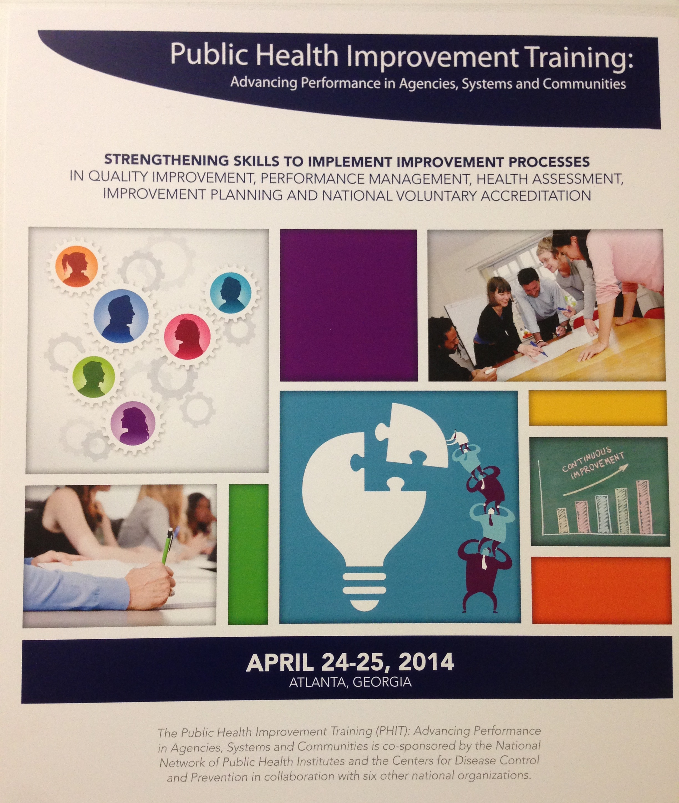
Public Health Improvement Training (PHIT)

Assessment Report

2014

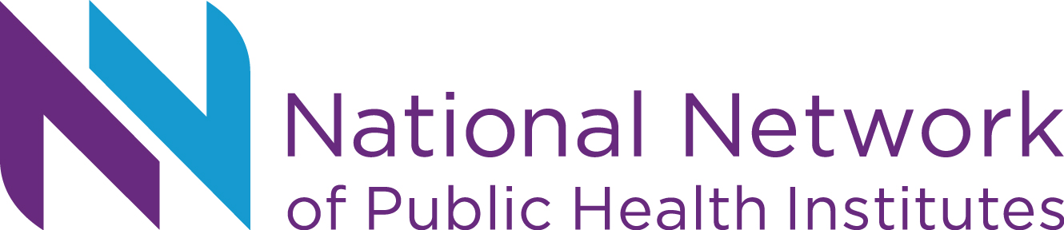

Table of Contents
Context 3
Goals and Objectives of PHIT 4
Actual Attendance at PHIT 2014 5
Training Evaluation 6
Knowledge & Abilities in Four Topic Areas 9
Value and Relevance of PHIT Overall 11
Most Useful Aspects of PHIT 12
Opportunities for Improvement 16
Planning for the Future 24
Individual Session Evaluation Results 25
Actions Planned/ Takeaways from Sessions 29

Appendix A: Planning Committees 55
Appendix B: Evaluation Form 56
Appendix C: Full List of Actions Planned/ Takeaways 69

Context

The mission of the Office for State, Tribal, Local and Territorial Support (OSTLTS) is to advance public health agency and system performance, capacity, agility and resilience.
On April 24-25, 2014, the 12th Annual Public Health Improvement Training (PHIT): Advancing Performance in Agencies, Systems and Communities was co-sponsored by the National Network of Public Health Institutes and the Centers for Disease Control and Prevention (CDC) with input and contributions from six other key national organization partners.
Over the past 12 years, PHIT has evolved from a training focusing around the National Public Health Performance Standards (NPHPS) to in later years, incorporating a variety of topics determined from the field. PHIT 2014 features training on topics including
- Quality improvement and facilitation
- Performance management and performance measures
- National voluntary accreditation
- Health assessment and improvement planning
- Strategic planning
The National Network for Public Health Institutes (NNPHI) was engaged through a co-sponsorship agreement and was responsible for the overall planning, coordination and implementation of PHIT.
Through a separate CDC co-sponsorship agreement, NNPHI has been responsible for the overall planning and implementation of the National Public Health Improvement Initiative (NPHII) Grantee Meeting as well. Both PHIT and NPHII were held in the same location, with PHIT following the one day NPHII Grantee Meeting. NNPHI’s roles in providing overall planning and implementation of both the PHIT and NPHII Grantee Meeting strengthened the ability to increase complementary content, reduce redundancy and streamline registration and logistics between events.

Planning for PHIT
The planning of PHIT 2014 is comprised from a set of representatives from these eight national partner organizations:
- Office for State, Tribal, Local and Territorial Support (OSTLTS)
Centers for Disease Control and Prevention (CDC)
- American Public Health Association (APHA)
- Association for American Indian Physicians (AAIP)
- Association of State and Territorial Health Officials (ASTHO)
- National Association of County and City Health Officials (NACCHO)
- National Network of Public Health Institutes (NNPHI)
- Public Health Accreditation Board (PHAB)
- Public Health Foundation (PHF)

Sources Used to Plan for PHIT 2014
To inform the planning of PHIT 2014, NNPHI shared various data sets with the planning committee to use data to plan for PHIT 2013. Data sources included
- previous years’ PHIT evaluation data, particularly from 2013
- the Follow Up Survey Data Report NNPHI conducted six months post-PHIT in 2013
- the NPHII Pre-Meeting survey was electronically sent to all Performance Improvement Managers and their Principal Investigators to identify how to best support sustained performance improvement practices, identify training needs and increase connections among PIMs, CBA partners and other resource partners

Planning Time
NNPHI scheduled and hosted one hour monthly planning calls with the PHIT planning committee and was in close communication at least weekly with CDC throughout the planning period (December 2013-April 2014).

Goals and Objectives of PHIT
Goal: To increase the public health workforce’s implementation of public health agency, system and community health improvement processes.

Objectives: Following the Public Health Improvement Training, participants will be better able to
- prepare for public health agency accreditation
- structure process to assess and improve agency, systems or communities
- employ performance management systems
- utilize public health improvement tools

Actual Attendance at PHIT 2014
Actual Attendance | # | %
# of total participants | 233 | 100%
# state HD reps | 51 | 22%
# local HD reps | 95 | 41%
# tribal HD reps | 14 | 6%
# territory HD reps | 5 | 2%
# public health institutes | 10 | 4%
# national organizations | 24 | 10%
# university reps | 4 | 2%
# CDC reps | 26 | 11%
# “Other” | 4 | 2%
# of US states represented | 46 | 92%
# of US territories + DC represented | 7 | -
of the 233, # who attended NPHII as well | 108 | 46%

Meeting Evaluation
In an effort to constructively evaluate both the overall meeting and individual sessions of all types, NNPHI and CDC collaboratively designed the evaluation form. Attendees received evaluation forms at the top of their meeting packets. As an incentive for completion, participants were given a pre-loaded flash drive of all meeting materials, including presentations, upon submission of their completed evaluation. Data from the written evaluations was entered and analyzed by NNPHI.
Purpose of the Evaluation Report
The data represented in this report is intended to
- Constructively inform the planning for future Public Health Improvement Trainings
- Constructively evaluate the meeting’s content, level, and structure
- Assess what knowledge and abilities participants gained to take actionable steps
- Provide evaluation results on each individual session to understand which sessions should be considered for future years and to provide feedback to presenters
PHIT 2014 Attendance
Of the 233 PHIT participants, 159 attendees or 68% submitted evaluation forms.
Organizational Affiliation | N | %
Local health department | 79 | 50%
State health department | 40 | 25%
Territorial health department | 6 | 4%
Tribal health department | 6 | 4%
Board of health | 1 | 1%
Public health institute | 2 | 1%
University | 3 | 2%
State association | 1 | 1%
National organization | 6 | 4%
CDC | 7 | 4%
Other  - Regional organization (2x)  - Consultant  - District Health Department (2x)  - Hospital/health system  - PHAB | 7 | 4%
Missing | 1 | 1%
Total | 159 | 100%

Respondents were asked to select their level of expertise within their organization/agency. Below is a chart of the two largest organizations represented (State and Local Health Departments) compared with the overall total:

Respondents were asked to select all roles that apply to them:

Thirty-seven respondents listed roles in the “Other” category, including:
- Accreditation specialist/staff (2x)
- Admin Asst. Help the accreditation coordinator
- Administrator of MCH Division
- Assistant/Deputy Director (2x)
- Combined PIM, PM & HAIC
- Communications Support
- Community Benefit Oversight
- Compliance officer
- Division director, accreditation team
- Epidemiologist (2x)
- Fellow (Public Health Prevention Service)
- Finance manager
- GAL Friday [?]
- Health Educator (2x)
- Health Equity Coordinator
- Health Officer
- Human Resources
- Internal Collaboration DOH
- Middle manager- not single program focused
- Performance management specialist
- PHIT team member Registered Dietician
- Grant writer
- Policy Analyst
- Program director (2x)
- Public health advisor
- Public Health Analyst
- Specialist
- Support LHD's
- Team lead
- Training administrator

Knowledge & Abilities in Four Topic Areas
Respondents were asked questions about knowledge and ability to perform key public health improvement functions before and after attendance at PHIT. Below are charts that demonstrate their increase in knowledge and ability on four public health improvement topic areas.

Topic | Total n= | BEFORE  mean | AFTER  mean
Prepare for public health accreditation | 125 | 4.04 | 4.75
Structure processes to improve agencies, systems or communities | 130 | 3.65 | 4.44
Employ performance management systems | 134 | 3.49 | 4.42
Utilize public health improvement tools | 138 | 3.83 | 4.64

(1=no knowledge; 2=little knowledge; 3=basic; 4=explain; 5=team; 6=teach)

Value and Relevance of PHIT Overall

Participants were asked questions about their overall attendance and experience at PHIT. From the responses below, it’s clear that PHIT is a valuable and relevant training for the public health improvement workforce. Opportunities for improvement could be to expand after-conference activities such as the Dine Around.
Overall | strongly agree | agree | neither agree nor disagree | disagree | strongly disagree | no answer | Total n=
My attendance at PHIT was a valuable use of my time | 67% | 32% | 1% |  |  |  | 146
PHIT content met the needs of my current job | 58% | 40% | 1% |  |  | 1% | 146
I gained valuable resources and/or information from PHIT that I will use in my work | 68% | 32% |  |  |  |  | 146
I shared valuable insight with at least one other peer or participant | 61% | 36% | 3% |  |  | 1% | 145
I liked the structure of the training | 59% | 39% | 3% |  |  |  | 145
Participating in the Dine-Around on Wednesday evening added value to my PHIT experience | 12% | 10% | 2% | 1% |  | 75% | 141

Most Useful Aspects of PHIT
Participants were asked to “Please describe the most useful aspect(s) of PHIT.” Their responses are below.

Networking & Peer Sharing
- Networking (8x)
- Networking and sharing of resources (2x)
- Network / -grouping centralized states for discussions.
- Networking / -energy and sharing of resources with/from others / -hear others challenges / -always great presenters
- Networking / -hearing from peers and experts / -every session is critically useful and essential to our mission / -PHIT does it better than any other agency
- Networking / -tools for QI and PM and resources including people / -tools and resources for accreditation
- Networking / SHIP insights
- Networking and finding other participants dealing with similar issues while doing the CHA/CHIP. Gaining insight into the PHAB accreditation process- eg. site visits, what they look for in documentation
- Networking and getting new ideas from other states
- Networking and getting useful tools from my peers
- Networking and learning more about CDC tools around state preventive status reports.
- I appreciate that all of the presenters are more than willing to share their resources to help everyone else. This is extremely helpful as we do not have to recreate the wheel.
- Networking to share tools, games, processes, stories
- Participating in the focus group on Wednesday was actually insightful and provided additional connections and resources. Plus those of us in the focus group tended to touch base with one another and sit together in sessions and break times throughout PHIT.
“Networking was invaluable and the sharing of tips and resources among us.”
- Networking with LHD in Texas
- Networking with other tribes
- Networking with peers / Learning tools/ Hearing challenges of other agencies and how they overcame the challenges
- Networking with peers, viewing tools are using/ have developed / hearing from accredited health departments
- Networking with those who shared good ideas, what worked and what doesn't work and being able to share my perspectives.
- Networking- hearing the experiences of colleagues doing similar work.
- Networking- seeing what other LHDs like us are doing / ToP methods make the event very engaging and conducive to learning. / Israel's presentation was exciting to hear.
- Networking, tools, resources
- Networking; motivational speakers; "head space" to discuss concepts with like-minded colleagues
- Networking! It was useful to have district/rural workshops. / Listening to other success stories and learning processes and tools to implement in my department.
- Being able to network and share resources with like-minded professionals!
- Discussions with other attendees / -introduction of useful tools
- The networking and "touching base" every year
- The networking. The contact information in the back of the binder is great.
- The opportunity to network and meet other health departments that are experiencing the same issues to Performance management and Quality Improvement and those that were more experienced and could offer suggestions and resources available. The opportunities for groups to share lessons learned during activities.
- I felt the lectures were excellent and useful but felt the ideas and information gained from talking to other attendees priceless. I heard a lot of great ideas.
- Meeting and discussing challenges and successes and sharing ideas with others.
- Meeting new people to share resources and tools / -obtaining useful information and resources I can take back to our health district that we can use towards accreditation / -meeting the staff at NACCHO and other agencies

Peer-to-Peer Connections & Sharing
- Connecting with my peers (3x)
- Connecting with peers who have similar problems and challenges and discussing ways forward
- Face to face discussions with others
- Workshops led by peers
- Talking with colleagues, sharing ideas
- Peer to peer- these colleagues are awesome, intelligent and fun. Great support system
- Peer to peer networking, sharing resources, hearing stories from the field
- I most appreciated hearing about others experiences in assessment and improvement planning / tools that have been distributed
- Peer networking/materials made available.
- Peer networking and peer presentations
- Hearing from others about what they are trying, using and what is and is not working for all things PM, QI, and accreditation
- "Real" information on accreditation process
- Ability to network with peers and share resources / -hearing from PHAB directly about certain aspects of the accreditation process
- Asking questions to site visitors, accred sites and others
- Being around "my people" who understand and have enthusiasm for PM/QI/Accreditation etc. I have a difficult time describing my job to people, and really appreciate the camaraderie, networking, and energy of my peers
- Break out sessions / storyboards in lobby

Session Content
- Performance management sessions (5x)
- Participatory/interactive sessions (3x)
- Launching sessions (2x)
- Plenary and wrap up sessions that help bring all of it (QI, PMs, CHA, CHIP, SP) together
- All of the sessions were a wealth of information that will be utilized.
- PHAB accreditation sessions / hands on opportunities / networking
- The session with the local health department and the hospital together. Great!
- Sessions were focused on practical and applicable ideas.
- The presenters who are subject-matter expects and having the opportunity to interact with them was very valuable
- PHAB Accreditation session (how to become a successful applicant)
- Loved the PM and QI sessions
Ex: I enjoyed the sessions with well-structured hands on activities (some sessions had small group work that wasn't as well facilitated) but several had very productive hands on activities with worksheets etc.
- Sessions where we broke into groups based on our experience
- Topics were varied and diverse backgrounds of the speakers. / Tools to take away
- Friday morning breakout session was most beneficial to me
- Found the skill building activities to be very applicable and informative
- Excellent course/session content
- The sessions on day 1 were great
- The resources, tools, knowledge gained from the sessions; seeing what other departments are doing

Training Structure/Format
“One of the best trainings I’ve ever been to in my career”
- The training was well structured and informational.
- The structure and format of sessions was greatly improved this year.
- Valuable insight- eye of the receiver- can only guess if it was valuable to them. Year 5- Ideas for NNPHI / -Peers / -great presentations / -Gets better every year / -Great NNPHI staff- great team planning
- NNPHI Does an outstanding job with conference planning. It is a welcoming team; information is relevant and where we ware all on the continuum of accreditation, info is appropriate.
- PHIT provides critical training that we as public health practitioners need to be able to implement PM and QI in our HDs
- Variety of sessions
- Enjoy the fuzzy straws and sticky notes on the tables
- Well structured and well run.

Miscellaneous
- Information on quality improvement (2x)
- Gaining resources to help meet the needs of the domains
- Connecting with agencies for technical assistance
- Great training- as usual too many good things for too short of a time. The performance measure training was VERY useful. Also great to hear about Cross Jurisdictional Sharing
- Hearing and learning from the field
- I receive information about strategic planning / who will be useful to review our plan
- Identification of resources / Networking and team exercises
- Learning from others about their process of getting accreditation (challenges, successes, etc.) different resources available.
- Listening to stories of other LHD's and tools that work for them and not working.
- Co-located with NACCHO's ACLC meeting
- Personal interaction with participants / -the Hawai'i poster / -Israel Nieves-Rivera during PHITing it all together / -Friday QI 10:30 session group interaction was helpful
- Practical advice and guidance on site visits and documentation
- Practical examples and tools that can be used (2x)
- Real stories from the field; need more of these because not all models fit everyone, variety is important.
- Storytelling
- The resources collected are extremely valuable. Great suggestions on how to approach co-workers to have that CQI culture change.
- The tips that I can take back with me and all of the practical application
- Tools and examples from other departments
- Where to find the resources to use for what I need to do. / Useful resources that other departments use.

Opportunities for Improvement
Participants were asked to “Please describe the least useful aspect(s) of PHIT.” Their responses are below.

Awareness
- Didn't know about PHIT event (10x)
- I still don't totally understand the distinction between this and the open forum. Seemed to have a lot of overlap on topics.

Session Content (Various Issues)
- Thursdays reflection and closing plenary not helpful (3x)
- Some of the trainings were lacking a bit in clarity, with activities that were well intentioned, but didn't quite work. / More concrete examples (perf. means for example) would be helpful, especially in different contexts
- I would have appreciated sessions more focused on skill building/approach building for the different elements (CHIP/CHA, workforce dev. performance management) and a session walking participants through specific resources, websites, etc.
- The sessions on day 2 for developing useful and practical performance measures (part 1 and 2) were disappointing. I was really hoping to get something from (content wise) that I could take back to my health department and train our staff with. My department is struggling with writing performance measures.
- The larger coming together sessions were less useful than the break outs.
- The session at 4:15 on Thursday was the weakest aspect of the training. It was still useful; however, the session has room to grow. I would like to see more relevance for this session next year. All the information I gained in this session is something I could gain by having dinner with others. It may be helpful to the presenters to have a clock present so they can monitor their time. 2 of the presentations I attended had difficulty with time management and this affected the quality of the end of the presentation.
- I didn't find the plenary sessions helpful - perhaps from tiredness at the end. And lack of content.
- Performance management system: from prioritization to priority. Adding more structure and steps to follow.
- Please restructure the developing useful performance measure session

Venue/ AV
- Aside: the venue is cool but ALSO irritating - no substantial suggestions
- Wish I had some coffee and small snacks in each session / -Atlanta is a good location with restaurants etc. close by / -Would choose another hotel next time.
- Need coffee all day
- Some of the room environments were too drafty and cool- especially ballroom/grand room 2
“There needs to be at least TWO PHIT sessions per year, three if possible.”
- The lighting in the main room was very dim, hard to see speakers and maintain focus / -the binder of the agenda, sessions, etc. was cumbersome to keep up with
- It would be great if we could have microphones in every break-out room.
- Would have liked more intimate rooms for skills building etc. -great room 2 always seemed too big- loved the studio rooms

Not enough time
- The time for sessions was too short (3x)
- I would actually like more time to attend more sessions. It was hard to pick and I didn't get to attend all the sessions I would have liked to.
- Assessing where your agency is. I think less time should be spent on this as most people seem to know where they are at in readiness, etc. This time could be spent talking about how to get to next steps/phases etc.
- There were many sessions I wasn't able to attend. Repeating them more would be helpful.
- I understand the need for networking, although precious time was wasted during day 1 early sessions.
- Travel time for us almost equaled conference time. That is hard to justify no matter how good the conference was. Also - this was at the same time as our Wisconsin conference on the same topics.

Schedule of Sessions
- Having 1 session after lunch didn't seem worth it; participation probably would have gone up if we worked until 1 then breaked.
- Have closing plenary right after AM workshop and end at 1 pm
- Consider offering Wednesday evening plenary instead of wrap-up
- The reflections and plenary on the first day, I didn't find useful / -skip lunch on the last day and end earlier / -have training in the middle of the week, for people with travel restrictions
- Having multiple intriguing sessions at the same time! It was such a challenge to select sessions! Therefore, it made each decision lofty, and was frustrating when a session wasn't extraordinary, or when it didn't meet expectations listed in the detailed agenda. / In the future, the conference could be extended another day, or more sessions could be repeated. Even reducing the number of options would reduce feelings of anxiety or regret.
- Would have preferred to end before lunch instead of come back after

More In Depth/Experience Levels
- Too broad (QI) of focus on some presentations. Would like more detail.
- Training even at level 2 was a bit basic. Increased level of in depth training would be helpful. Geared at sustainability etc.
- Some of the things that were less useful/helpful to me were some of the beginner topics since we are farther ahead. Also it would be nice to see the pool of speakers/expand to more of us who are doing this work and who are willing/able to share new stories.
- Trainings were good but particularly facilitation and training could be at a more advanced level.
- Some of the presentations were labeled as advanced and were fairly basic- it was still informative and reassuring, but I left not learning as much as I thought
- Level of skills and knowledge offered from trainings. Need more advanced levels.

Repetition of Sessions
- After 3 years, content is the same (presentations are repeating). Not sure if I will return. / I've been to some presentations before, need to expand. Then the others I haven't been to are repeated morning and afternoon limiting options.
- The repetition of sessions every year and not providing advanced sessions.

Miscellaneous
- A few of the activities across multiple sessions seemed like veiled attempts to get people to peer network. Would have been more useful to present relevant examples over which conversation could be generated.
- Increase the networking opportunity, maybe more breakouts (sub breakouts) after presentation for deeper connection to content.
- Some session descriptions weren't accurate to what was actually presented / presenters should think about presenting not just what they did, but HOW they did it.
- A working lunch.
- The lack of inclusion of culturally diverse perspectives when it comes to the accreditation process i.e. some areas of the country are More diverse than others - does that get included as a focal point for this process?
- Please invite CDC Content folks so we can network with them.
- Prefer spiral bound vs binder / -include pics and twitter handle for participants / -data session could be greatly improved- was most looking for ward to that and was disappointed slightly
- Can we please stop reading every speakers bio when they are introduced? Some are very long and it is not necessary. We can read this in the speaker information if included in binders like it has been in previous years. If they are speaking obviously they are SME's. We don't need to hear their degrees, number of employers, positions, years, etc. This includes the intro sessions and NNPHI folks.
- For the poster sessions - it would be helpful to have a rep near the posters during the breaks to discuss them, answer questions

Additional Comments
Do you have any additional comments, questions, or anything else you would like to add?

Compliments
- I thoroughly enjoyed the meeting and the experience of being around such committed health professionals. The skill sessions were great- and really the high point for me.
- Thank you! (5x)
You all have had great offerings and I have a lot of tools to go home with as well as renewed energy!!! With the loss of NPHII funding, things were dismal at my agency but I feel confident that I can go back and re-energize our team and fight for QI/PM/ACC readiness.

- Enjoyed the conference and learned good things
- everything is great.
- Excellent job throughout!
- My first time attending and I loved the hotel, the content, and the people of all levels of experience and backgrounds. I really enjoyed the dine-around Wednesday because I was able to meet people that I could chat with during the conference. We became friends, not just colleagues.
- I wasn't able to attend last year but was so fortunate to attend this year. You all have had great offerings and I have a lot of tools to go home with as well as renewed energy!!! With the loss of NPHII funding, things were dismal at my agency but I feel confident that I can go back and re-energize our team and fight for QI/PM/ACC readiness.
- I found the PHIT program to be a very valuable learning experience.
- Thank you - great job Lil and team!
- Thank you for a well organized and scheduled conference. I would suggest skipping "lunch" on the last day - work straight through to assist us with return travel.
- Thank you for putting together a great and informative meeting. I learned a ton, including things like the "7" that I can put into practice right away. I really appreciate all the work that went into making this so valuable. Well done!
- well done. Hard to coordinate such a large group.
- this training/conference is more valuable than most.
- First time here, hands down best conference. walked away with bountiful amount of knowledge, peers, and resources.
- more advanced sessions are definitely needed, maybe based on phases of QI etc.
- Keep up the great work!!
- Good meeting.
- Great conference
- Great conference A lot of good sessions that could be offered twice.
- Great conference! Good organization! Thank you for providing such a high quality venue and conference to enhance public health practice.
- Great job guys!
- I enjoyed the conference and have a lot to take back to our team! Presenters were all great.
- Thank you for the opportunity to present- great conference! Split up the prizes to more people
- Thanks for all the hard work that went into this conference!
- Thanks for putting together another great training!
- Overall PHIT was great!
- Overall this has been a wonderful experience and has helped build the knowledge base for our health dept personnel who attended and gave us an opportunity to make some key connections that we will maintain in our endeavors.
- This was my first PHIT training. I was impressed with the participants and presenters- professional, helpful group of individuals- Can't wait to return next year!! Great networking opportunities.
- wonderful having all materials on USB drive very well planned program- rich source of information and skill building more posters- could ask people personally to submit -Carmelita et. al - wonderful -nice to have so many CDC and technical assistance program here for so much of the time and so accessible. -thanks to Lil- warm, helpful, bright!
- This was a great training and good networking opportunities for accreditation purposes.
- This was my first PHIT conference. I would be interested in attending the rest. Don't give incentives to people who steal clickers- it encourages further theft.
- awesome experience!
- Wonderful, excellent, fantastic training. Thank you! It would be beneficial to provide more repeat sessions, extend the duration of the conference, or provide fewer choices for each time slot. My only negative feedback is that I'm leaving feeling like I missed out on useful information! It was very difficult to select sessions, and after talking to colleagues, I do feel a sense of regret that I didn't get to everything I wanted to. Thank you!!! Seriously, thanks.

Content Ideas
- Being in Atlanta, it would be great to hear Dr Friedman as a keynote speaker.
- health departments that have achieved accreditation could be recognized somehow- 1. stickers on name badges 2. asterisks by their names in the participant list 3. Have them stand up in an opening session
- IT would be nice to hear specific examples of how becoming accredited will improve the health of our people. How does this translate to community level impact? How it is not just another institutional/academic project that makes people feel good? Thank you!
- PHIT sessions next time: 1. I'd like to know how to determine our accreditation activities are making a difference- performance measurement for PM/QI- how are we doing? 2. Presentation from a health director who gets this, to doing it, and can articulate it 3. funding opportunities 4. PH infrastructure to support these activities 5. Fun ways to engage staff in this work 6. How to communicate this work in simple terms 7. Share what hasn't worked - a. depts who have had to do accreditation plans of their PM system and b. Depts who are in their late 2nd or 3rd iteration Also, are you able to summarize where all participants are with their PM/QI process i.e. who has a PIM, who has a CHIP, strategic plan, QI plan, PM System? How are CHPs structured to support this work, etc.
- I don't think you need to offer as many choices for each break-out session. I think limiting it to fewer really high-quality ones would lead to all attendees getting the most out of the training, even though the break-out sessions would be bigger.
- Less general information and more intensive education. Have you thought about "tracks" with a product at the end? also- have the agenda available at registration so we may plan flights accordingly!
- So valuable to hear from peers but a few more advanced sessions would be great, aspecially as we all advance ie leadership training beyond the technical skills Thank you so much for making room for us at PHT- I know it wasn't easy.
- Please have sessions employ more adult learning methods. Overall, this was an excellent training. I hope that more of these will be available. What would be extremely helpful would be to offer scholarships to offset travel costs. I really like having all he materials hole punched so we can put it in the notebooks,
- Maybe sessions on working with staff, linking PM with individual performance evaluation
- This is an amazing training that is very informative and for all levels. I appreciate the diversity of sessions available.
- It seemed like there were a fair amount of small errors throughout the process (Difficulty registering on site, handouts not matching slides/speaker's notes, error on scrambled word game etc) these were all minor things but also things that could have be easily caught by a second set of eyes. Overall though, good training I gained some very valuable information relevant to my work and felt that most of all of the sessions I attended were valuable.
- The networking exercise during the city/county breakout was very good. -need more advanced topics (e.g.) maintenance and sustainability of PM. Most departments have a PM system now, but sustaining it is the next chronological challenge. -presentations aout a specific product/computer software are not generalizeable. They do not resonate with departments who cannot afford those systems.
- This training was fantastic. I look forward to next year. Add a second plan group activity the second night. It doesn't have to be a dine around; it could be a sightseeing activity.
- This was a great and very useful conference. Some notes I took- a few of the sessions I attended the presenters really "steamrolled" through the material. It was great material - just left me feeling overwhelmed trying to keep up and absorb. I also heard few different comments from presenters along the lines of "We all know about" or "you're all familiar with/know how to do" - don't make assumptions. Some of us don't know these things. Also, I realize basic concepts for things like PM, QI, etc apply regardless of what your dept looks like, the dynamics of your dept does matter when it comes to implementation. My entire health dept is 10 FTE, many presenters are from depts with 100+ or up to 1,500 FTE. Any consideration given to gearing some kind of focus toward the small depts would be great. Love having all the national partners and resources available. I attended the "Health status data for health assessment" session and got a lot from it. I would love to see a basic "data 101" all the various sources f data- where to find it, how to use it, what we can and should be collecting in house and tools for tracking or collecting it, etc. A thorough, concise resource guide for all of the various public health entities would be helpful. I didn't even know about OSTLTS and STHD before this visit. Not all of us have been doing this for years and years. Could someone undertake a project to create a guide capturing all the organizations-- NACCHO, NNPHI, PHAB, CDC, OSTLTS, ASTHO, PHI, PHF, etc along with a brief summary description of who they are, what they do, why they exist, what resources they provide, and how they can help us accomplish our public health work. When I attend these conferences, people always seem very willing to share their tools/work and help others- but I'm sure that's a very small percent of what is actually out there. I know there are various sites out there for sharing, but it seems useless unless we know where and how to find them.
- Took so much from this training. I will make it back even if I have to cover the costs myself.
- ubiquitous issues of not being able to attend all sessions that are of interest CEUS- very good!
- Unfortunate number of one time only selections that were scheduled at the same time
- Would like to hear more about branding strategies that other health departments are using and how they came into development.
- Your clever scavenger hunt worked. I probably wouldn't have gone to as many tables if I wasn't incentivized. NNPHI as an organization should be described a little more. Showcase what they've done and expalin more what COPPHI is. LEAN was used often- maybe next year have a session about what it means, how organizations utilize it.

Venue. I loved it! I hated it!
- Liked the location!
- I didn't love the vibe of the hotel. Too night club-ish, would have preferred a professional, southern feel.
- Loved the W- thanks for the touch of luxury
- Not impressed with the "W" hotel check in and out was difficult.
- it was fun to stay and meet in a hip hotel!
- The lighting in the meeting rooms was much better here. Last year it was bright, blinding, and distracting. -liked location better two years ago near Perimeter, offered more to do in the evenings. -Will need more stories from the field and different presentations next year in order for it to be worth my time.
- -It would be great to have health departments who already are accredited present at the sessions. I would have liked to see a demo of a dashboard, for example, or real performance measures that are being used.
- -knowledgeable speakers and presentations -was not crazy about hotel -really enjoyed dine around and networking -great conference overall - thank you! -liked scavenger hunt!
- No coffee maker in room no hair dryer in room even though I requested one.
- Please provide coffee and tea in meeting rooms!
- Please have coffee and tea available!
- Safe running / walking routes identified or a hotel that can provide that.
- Facilities seemed to be dim which didn't provide high energy level. Would encourage better lighting and physical activity breaks during sessions.
- The location of this meeting was ideal - close to restaurants, transportation, very walkable. The hotel was very nice. I liked that this conference aligned with another meeting I wanted to attend (ACIC) and that NACCHO had funds to help offset the cost of my attendance at this conference. Overall, a very positive experience.
- Previous venues have been better- no room refresh between sessions was awkward!

Planning for the Future
What is MOST IMPORTANT to you in meeting LOCATION/SPACE? (Select up to 3) Total n=134 | n | %
Walkable areas close to hotel | 108 | 81%
Restaurants close-by | 94 | 70%
Fun city | 43 | 32%
Short distance from airport | 33 | 25%
Co-located with a relevant meeting | 13 | 10%
Large conference rooms | 11 | 8%
Drivable distance | 6 | 5%
Other | 23 | 17%

“Other” responses include:
- Affordability of travel (5x)
- Nice hotel amenities (2x)
- Easy travel options to and from airport to hotel (2x)
- Closer to the West coast (2x)
- Short distance from where I live (2x)
- Weather at time of meeting (2x)
- Cost of food in the hotel
- Functional space
- Clean space; friendly hotel staff
- Food sized breakout rooms- enough of them, good acoustics in larger rooms
  - Hot tub! This is a lovely hotel and that part is amazing
- If it's a good conference- it doesn't matter!
- Wi-Fi accessible/free to participants
- Within walking distance to shopping mall

Individual Session Evaluation Results

When looking across the skill-building workshops, experiences from the field, and plenary sessions, those ranking highest in the ideal category (“Appropriate”) are highlighted in turquoise.
LEVEL of CONTENT in this session was… | too basic | somewhat too basic |  | appropriate |  | some-what too advanced |  | too advanced |  | n/a | Total n=
Skill-Building Workshops 1
Building and Sustaining a Culture of QI Improvement in Health Departments |  | 40% |  | 54% |  | 6% |  |  |  |  | 48
Intro to Performance Management and QI | 4% | 11% |  | 85% |  |  |  |  |  |  | 27
Health Status Data for Health Assessment and PSR |  | 15% |  | 62% |  | 8% |  | 8% |  | 8% | 13
Facilitation of Performance Improvement Activities | 8% | 21% |  | 71% |  |  |  |  |  |  | 52
NPHPS Simulation |  |  |  | 71% |  | 29% |  |  |  |  | 7
Experiences from the Field
Engaging Staff and Accreditation Documentation |  | 2% |  | 93% |  | 5% |  |  |  |  | 44
Performance Management: Align and Measure |  | 4% |  | 88% |  | 8% |  |  |  |  | 25
Strategic Planning |  |  |  | 86% |  | 14% |  |  |  |  | 14
Innovative CHNA and CHIP Partnerships |  |  |  | 100% |  |  |  |  |  |  | 10
Tips and Tricks from Planning… | 5% | 21% |  | 68% |  | 5% |  |  |  |  | 19
How to Operationalize… Workforce Development Plan |  | 8% |  | 68% |  | 24% |  |  |  |  | 25
Skill-Building Workshops 2
Developing Performance Measures Part I |  | 5% |  | 73% |  | 18% |  | 2% |  | 2% | 44
Telling Your Story |  |  |  | 71% |  | 29% |  |  |  |  | 7
Performance Management System: From Prioritization… | 3% | 9% |  | 88% |  |  |  |  |  |  | 33
Using the Prevention Status Reports |  |  |  | 100% |  |  |  |  |  |  | 5
PHAB Site Visits |  |  |  | 100% |  |  |  |  |  |  | 40
Skill-Building Workshops 3
Developing Performance Measure Part II |  | 14% |  | 50% |  | 22% |  | 11% |  | 3% | 36
Building and Sustaining a Culture of QI in Health Departments | 11% | 4% |  | 79% |  | 7% |  |  |  |  | 28
Helping You Prepare: Tips for Being a Successful PHAB Applicant | 4% | 4% |  | 92% |  |  |  |  |  |  | 26
Telling Your Story |  |  |  | 100% |  |  |  |  |  |  | 30
Plenary Sessions
Welcome |  |  | 7% |  | 88% |  |  |  |  | 5% |  | 153
PHITing It All Together |  |  | 5% |  | 87% |  | 6% |  | 1% | 1% |  | 153
Reflections | 4% |  | 10% |  | 68% |  |  |  |  | 18% |  | 131
Closing PHIT | 1% |  | 7% |  | 80% |  | 1% |  |  | 11% |  | 90

Participants were also asked how the content of the sessions was relevant to their current job responsibilities.
Content of this sessions was RELEVANT to my current job RESPONSIBILITIES | strongly agree | agree |  | neither agree nor disagree |  | disagree |  | strongly disagree |  | n/a | Total n=
Skill-Building Workshops 1
Building and Sustaining a Culture of QI Improvement in Health Departments | 35% | 57% |  | 7% |  | 2% |  |  |  |  | 46
Intro to Performance Management and QI | 48% | 48% |  |  |  | 4% |  |  |  |  | 27
Health Status Data for Health Assessment and PSR | 79% | 7% |  | 14% |  |  |  |  |  |  | 14
Facilitation of Performance Improvement Activities | 34% | 51% |  | 11% |  | 2% |  | 2% |  |  | 53
NPHPS Simulation | 71% | 29% |  |  |  |  |  |  |  |  | 7
Experiences from the Field
Engaging Staff and Accreditation Documentation | 72% | 26% |  |  |  |  |  |  |  | 2% | 43
Performance Management: Align and Measure | 64% | 36% |  |  |  |  |  |  |  |  | 25
Strategic Planning | 64% | 36% |  |  |  |  |  |  |  |  | 14
Innovative CHNA and CHIP Partnerships | 60% | 30% |  | 10% |  |  |  |  |  |  | 10
Tips and Tricks from Planning… | 37% | 63% |  |  |  |  |  |  |  |  | 19
How to Operationalize… Workforce Development Plan | 54% | 42% |  | 4% |  |  |  |  |  |  | 26
Skill-Building Workshops 2
Developing Performance Measures Part I | 46% | 39% |  | 14% |  | 2% |  |  |  |  | 44
Telling Your Story | 43% | 57% |  |  |  |  |  |  |  |  | 7
Performance Management System: From Prioritization… | 64% | 30% |  | 3% |  | 3% |  |  |  |  | 33
Using the Prevention Status Reports | 80% | 20% |  |  |  |  |  |  |  |  | 5
PHAB Site Visits | 62% | 36% |  | 3% |  |  |  |  |  |  | 39
Skill-Building Workshops 3
Developing Performance Measure Part II | 14% | 60% |  | 22% |  | 3% |  |  |  | 3% | 37
Building and Sustaining a Culture of QI in Health Departments | 48% | 48% |  | 3% |  |  |  |  |  |  | 29
Helping You Prepare: Tips for Being a Successful PHAB Applicant | 58% | 42% |  |  |  |  |  |  |  |  | 26
Telling Your Story | 80% | 17% |  |  |  |  |  | 3% |  |  | 30
Plenary Sessions
Welcome | 36% |  | 49% |  | 10% |  |  |  | 1% | 4% |  | 152
PHITing It All Together | 58% |  | 39% |  | 1% |  |  |  | 1% | 1% |  | 151
Reflections | 14% |  | 49% |  | 21% |  | 5% |  |  | 11% |  | 133
Closing PHIT | 43% |  | 37% |  | 8% |  |  |  |  | 12% |  | 89

Finally, participants were asked about the information the presenters provided.

Presenter(s) Provided VALUABLE  Information | strongly agree | agree |  | neither agree nor disagree |  | disagree |  | strongly disagree |  | n/a | Total n=
Skill-Building Workshops 1
Building and Sustaining a Culture of QI Improvement in Health Departments | 25% | 58% |  | 13% |  | 2% |  | 2% |  |  | 48
Intro to Performance Management and QI | 37% | 59% |  |  |  | 4% |  |  |  |  | 27
Health Status Data for Health Assessment and PSR | 57% | 36% |  | 7% |  |  |  |  |  |  | 14
Facilitation of Performance Improvement Activities | 33% | 50% |  | 11% |  | 4% |  | 2% |  |  | 54
NPHPS Simulation | 57% | 43% |  |  |  |  |  |  |  |  | 7
Experiences from the Field
Engaging Staff and Accreditation Documentation | 73% | 21% |  | 7% |  |  |  |  |  |  | 44
Performance Management: Align and Measure | 56% | 44% |  |  |  |  |  |  |  |  | 25
Strategic Planning | 64% | 36% |  |  |  |  |  |  |  |  | 14
Innovative CHNA and CHIP Partnerships | 70% | 30% |  |  |  |  |  |  |  |  | 10
Tips and Tricks from Planning… | 21% | 63% |  | 11% |  | 5% |  |  |  |  | 19
How to Operationalize… Workforce Development Plan | 50% | 39% |  | 12% |  |  |  |  |  |  | 26
Skill-Building Workshops 2
Developing Performance Measures Part I | 43% | 50% |  | 5% |  | 2% |  |  |  |  | 44
Telling Your Story | 43% | 43% |  | 14% |  |  |  |  |  |  | 7
Performance Management System: From Prioritization… | 58% | 33% |  | 9% |  |  |  |  |  |  | 33
Using the Prevention Status Reports | 80% | 20% |  |  |  |  |  |  |  |  | 5
PHAB Site Visits | 65% | 35% |  |  |  |  |  |  |  |  | 40
Skill-Building Workshops 3
Developing Performance Measure Part II | 14% | 54% |  | 22% |  | 5% |  | 3% |  | 3% | 37
Building and Sustaining a Culture of QI in Health Departments | 35% | 62% |  | 3% |  |  |  |  |  |  | 29
Helping You Prepare: Tips for Being a Successful PHAB Applicant | 58% | 42% |  |  |  |  |  |  |  |  | 26
Telling Your Story | 77% | 20% |  |  |  |  |  | 3% |  |  | 30
Plenary Sessions
Welcome | 36% |  | 52% |  | 8% |  |  |  | 1% | 4% |  | 156
PHITing It All Together | 61% |  | 36% |  | 1% |  |  |  | 1% | 1% |  | 154
Reflections | 13% |  | 51% |  | 21% |  | 3% |  |  | 13% |  | 135
Closing PHIT | 43% |  | 40% |  | 4% |  | 1% |  |  | 11% |  | 90

Participants were asked questions related to the Launching Sessions.
Launching Sessions | strongly agree | agree |  | neither agree nor disagree |  | disagree |  | strongly disagree |  | n/a | Total n=
Participating in this session will be beneficial to my work
Counties/Districts/Cities | 44% | 43% |  | 13% |  |  |  |  |  |  | 77
Rural Jurisdictions | 33% | 53% |  | 7% |  | 7% |  |  |  |  | 15
Centralized States | 24% | 53% |  | 24% |  |  |  |  |  |  | 17
Decentralized States | 47% | 42% |  | 5% |  | 5% |  |  |  |  | 19
Tribes | 20% | 40% |  | 40% |  |  |  |  |  |  | 10
Territories | 67% | 25% |  |  |  |  |  |  |  | 8% | 12
I gained potential solutions from my peers or facilitators for challenges I face
Counties/Districts/Cities | 46% | 37% |  | 17% |  |  |  |  |  |  | 78
Rural Jurisdictions | 40% | 27% |  | 27% |  | 7% |  |  |  |  | 15
Centralized States | 18% | 53% |  | 18% |  | 12% |  |  |  |  | 17
Decentralized States | 53% | 32% |  | 11% |  | 5% |  |  |  |  | 19
Tribes | 10% | 50% |  | 30% |  |  |  |  |  | 10% | 10
Territories | 58% | 17% |  | 8% |  |  |  |  |  | 17% | 12
I shared tips or lessons learned from my peers
Counties/Districts/Cities | 46% |  | 46% |  | 6% |  |  |  |  | 1% |  | 78
Rural Jurisdictions | 40% |  | 60% |  |  |  |  |  |  |  |  | 15
Centralized States | 29% |  | 65% |  | 6% |  |  |  |  |  |  | 17
Decentralized States | 47% |  | 53% |  |  |  |  |  |  |  |  | 19
Tribes | 20% |  | 60% |  | 20% |  |  |  |  |  |  | 10
Territories | 50% |  | 17% |  | 17% |  |  |  |  | 17% |  | 12
Launching | too little | somewhat too little |  | appropriate |  | some-what much |  | too much |  | n/a | Total n=
The level of interaction in this session with the presenter(s) and other participants was…
Counties/Districts/Cities | 1% | 8% |  | 88% |  | 1% |  | 1% |  |  | 77
Rural Jurisdictions |  |  |  | 100% |  |  |  |  |  |  | 15
Centralized States |  |  |  | 100% |  |  |  |  |  |  | 16
Decentralized States |  | 5% |  | 90% |  |  |  | 5% |  |  | 19
Tribes |  | 30% |  | 60% |  |  |  |  |  | 10% | 10
Territories |  |  |  | 92% |  |  |  |  |  | 8% | 12
The level of interaction in this session with other participants was…
Counties/Districts/Cities |  | 5% |  | 88% |  | 4% |  | 3% |  |  | 77
Rural Jurisdictions |  | 7% |  | 93% |  |  |  |  |  |  | 14
Centralized States |  | 6% |  | 94% |  |  |  |  |  |  | 17
Decentralized States |  | 17% |  | 83% |  |  |  |  |  |  | 18
Tribes |  |  |  | 70% |  | 20% |  |  |  | 10% | 10
Territories |  |  |  | 92% |  |  |  |  |  | 8% | 12

Actions Planned/ Takeaways from PHIT Sessions

The following information provides a summary of responses for each plenary, skill-building, experience from the field and launching sessions held at PHIT 2014. For each session, participants were asked two questions: 1) “please describe if and how you will implement what you have learned in this session,” and 2) “any additional comments about the session.”

Below are word bubbles that represent the most frequent takeaway deduced from each session’s qualitative responses, as well as key quotes for each “theme.” See Appendix C for a full list of session responses to each question.

PHIT 2014 Welcome

OSTLTS and PSR
- I will be checking out the OSTLTS portal site for additional resources.
- Take PSR to leadership
- I was previously unaware of OSTLTS, will be checking out gateway website.
- The prevention status reports will be reviewed and shared!
- Will sign-up for Web portal

NPHS and Accreditation
- Review NPHPS and PHAB standards and incorporate them into our evidence based approaches database as "standards of practice"
- I will utilize the resources on CDC and NACCHO's website to navigate through accreditation of a local health department
- ASI funding is crucial to my job. It is one of the reasons we were so prepared for accreditation. Please please please continue this funding for others.

General
- Great to see the geographic spread of representation on a map
- Now, I know/understand CDC's commitment to QI.
- Ladies who opened were fabulous especially as the first impression and in the morning. / Dr. Thomas shared interesting info and it was refreshing to see someone in his position engaged and knowledgeable as well as able to convey information and enthusiasm.
- I will refer back to all handouts and examples and contact the presenters I communicated with.
- Points given on how to best communicate appropriately based on the level of audience- esp. leadership
- Try to win one of the lovely gifts!
- Broadened my awareness of resources

Other Comments
- Good speakers/overview/start to the day (11x)
- Somewhat unclear of the grant (discussed mainly during this session), more detailed overview would be helpful
- No mention about how all of this will specifically improve the health of the public. Emphasis was on navigating the process, and assumed we all believe accreditation / QI etc. will provide benefits to the man on the street.
- Loved the energy from the hosts and speaker
- It's a very general intro. Not sure what we would be expected to learn from the content...
- I appreciated not reading speaker bios! We know they are capable, and very qualified to provide us with quality info.
- A lot of information presented with no opportunity to take notes on specific items. Big, lost opportunity. Sets the stage for the event.

PHITing It All Together

4SQ and 7’ing
- 4SQ will be implemented / Unleash plan and let others go with it / The tips on what we are doing are good, what will we get rid of and what should we add
- I took lots and lots of notes, but to highlight just a couple of points - definitely 4SQ and facilitating/engaging staff in QI/PM efforts and activities. Also, great reminders about this taking time- its a process, not a project. / "if we identify values that are important to us, then we need to describe and define the behaviors and policies that will demonstrate and support these values" (From Laurie)
- Take back value of using 4SQ in discussions and in meetings / work to explore more in the area of Health Equity
- Will attempt to implement the 4SQ process. liked the idea of having manager discuss what to remove and what to add and improve.
- It has been a difficult transition for the QI and PHAB coordinators to get the idea behind QI to transfer to staff. The idea of let it go will help both the coordinators and the staff. The staff will have to start to understand QI and its importance and the coordinators will back off and not hand hold so much. The 4SQ will also be a valuable tool for advancing the staff.

Results-based Accountability
- Loved how Chelsie made RBA come alive- and how to let folks (field staff, etc.) make the QI connection.
- Chelsea provided some great resources-- / 1. book - "trying hard is not good enough" / 2. MDH elevator pitch for QI / 3. RBA developing PMs tool
- John Kingdom- policy window / RBA Resource- "Trying hard is not good enough" / Israel's quote: "We ask that others change: local gov't, communities, but how often do we change ourselves?"
- Will be reading the book "Trying hard is not good enough" on RBA
- I have a lot of new tools/resources/ideas to check out- RBA
- I will share results-based accountability resources with senior leaders and the performance management team. Both presenters did a great job explaining tools that would/could be applicable in my health department
- Info on RBA was extremely helpful; good to hear how everything fits together
- Excellent presenters and presentations. Using RBA as a tool for PM. Asking the right questions. Work on QI and PM without saying those terms.

Utilize “Yes and”
- "yes, and" quote was valuable / / meeting people where they're at and asking appropriate questions that get at QI, but they don't know it
- "yes and" / meeting individuals at their level / Look for QI opportunities- not necessarily direct QI

Additional Comments
- Israel was great - I could have listened to him all day!!
- Awesome presentations!!! Succinct, empowering, uplifting.
- Both of these presenters were good and provided useful information and presented it in an engaging manner
- Both panelists were excellent. I REALLY enjoyed Israel Nieves-Rivera's presentation.
- Ditch the bios for all sessions and put them in a separate document for us to reference if we need. I assume that if they didn't know their stuff, they would not be presenting. This will give the presenters more time to present and the audience more time or questions. Excellent presenters, great messages and tools.
- Excellent facilitation by Laurie Call (3x)
- Fantastic speakers, well moderated but moderator asked many questions and could have waited for audience participation before filling in gaps.
- Great facilitation by Laurie Call.
- I enjoyed this session -Chelsie's energy and confidence is engaging
- I wish the facilitator allowed more time for audience questions.
- I would have appreciated if the audience had more time to ask questions of the panelists- to have more of a dialogue.
- Minnesota has been an invaluable resource
- Only one, brief mention was made of a concrete example of a specific public health problem that was improved. I need stories about actual successes.

Launching Sessions – All

Counties/Districts/Cities
- I am encouraged to make more connections and learn from other agencies.
- Colorado's "dashboard"
- Great to have the opportunity to network with other health departments. The sharing and conversations are always helpful.
- I don't feel alone in this!
- I gained knowledge of great resources that other HD have used. I will certainly look into the resources for engaging more staff in QI and then PHAb
- I learned about a useful online performance management tool, which I will be looking into for use within our agency.
- Learned much more about the journey for national accreditation
- Learning from peers is important, I can use what others are experiencing to support the work I'm doing and also to help explain to my leadership that we are on a good path.
- Looking into sharepoint
- Loved the roundtable discussion and sharing with those who have more/less experience.
- Loved the session! Best opportunity all training to network with my peers.
- Talked and following who had experience in accreditation process
- There was less here to take back since this is more of a "common issues" session, and an instant networking session. I learned that I have to send my HD colleagues here. This is so much better than APHA or any other source.

Rural Jurisdictions
- Do performance management before QI plan Learned about process map tool
- Some networking occurred and sharing took place but no real learning - just more of an affirmation that we're all struggling with the same issues.
- Will use rural networks to share materials. A lot of others had little experience like me. I liked the interactive questions aligning up in the order of experience.

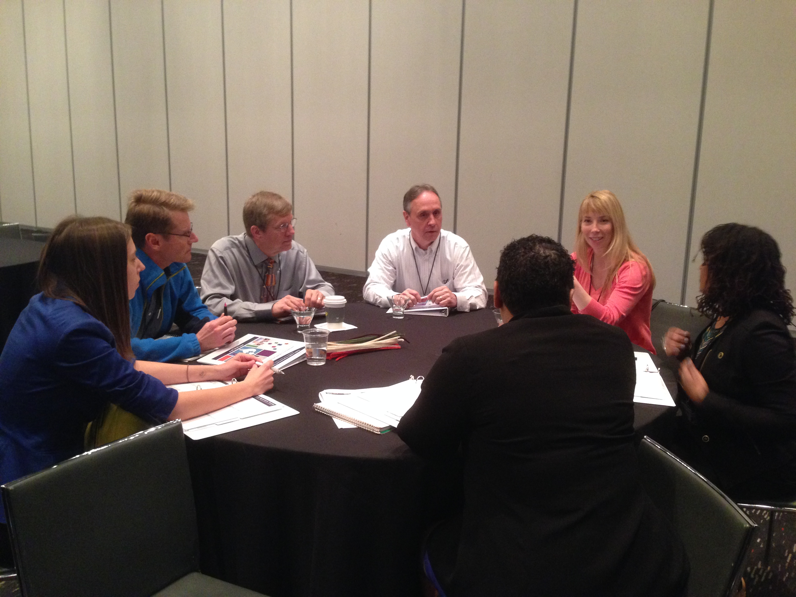
Centralized States
- Great discussion of alignment across state, local/district work. Importance of resources and communication was spot on.
- Great discussions on alignment and prioritization
- Make more contacts with some PIMs/ACs from other centralized states and share notes and learn from their journey
- Probably will not invest in a proprietary software for PM
- Unique challenges to centralized systems, particularly with creating a meaningful CHA and CHIP

Decentralized States
- I'm going to collaborate/follow up with a couple of other states for 1. how to link QI plan, strategic plan, workforce development plan, SHIP together and; 2. How to work with the environment staff on accreditation and why they should be involved
- Made connections that will help me in my work - learned many of the challenges I face are not unique to my department
- Make contact with Colorado, AZ, Ohio, Kansas
- Not sure. Time allotted was just enough to provide basic info in our groups, not sure how helpful it was but I wouldn't want more time allotted.
- Very helpful to learn of state challenges and how politics effect the work
- Will continue to use Washington State's PM and QI concepts in place

Tribes
- Others share the same problems/issues/stumbling blocks -learned some CHA tips
- I was really there to audit so my comments / perspective different from target audience
- It is great to have time to connect to "vent" with fellow Tribal organizations. This time might be even better if we can complete a workshop that will leave us with a tangible result to leave with and use back home.
- It was interesting but my table was very off topic so it was a little disappointing we couldn't get through the assigned topics.
- This was a great "therapy" session and networking session. However we did not necessarily take home any practical solutions or homework.

Territories
- Excellent and specific astho-NACCHO always great
- Further and continue this with NACCHO ASTHOS
- To take time out to celebrate successes

Skill Building Workshops 1
Building and Sustaining a Culture of QI in Health Departments

NACCHO QI Assessment
- NACCHO mini assessment was helpful
- I found the "phase" discussion groups the most valuable. It was helpful to discuss and identify 3 barriers with why and how.
- I will share the mini assessment with our QI council as a precursor to the full roadmap to a QI culture assessment
- Somewhat advanced but appropriate**Will bring back a few ideas. More clear idea of my role in my department.
- The first half was interesting, but didn't go anywhere. Second presentation was for a tool that could be very useful
- Will implement the QI assessment (3x)

Idaho’s QI Map
- Enjoyed the articles shared and detailed on QI assessment. Loved the IDAHO QI map
- I will use Idaho's QI culture mapping process to show QI reach
- Dan's tool to display involvement in QI using the org chart.

Additional Comments
- Did not really address overcoming barriers
- One presenter was- Knowledgeable, but would be helpful if more dynamic, engaging, interested, and not just reading from slides. Encouraging more conversation with audiences would be helpful.
- I didn't hear how I can convince skeptics or create a lasting culture that doesn't rely totally on committed leadership and a plan that few people will read.
- The initial assessment seemed unnecessary as most people seemed to know where they were at. For myself, I was more interested in identifying what to do to get to where I know I want to go.
- This was not helpful. We just identified where we currently are- not how to move ahead.
- Video used to create a visual tool was interesting

Intro to Performance Management and QI

Key Comments
- Help folks understand turning point frame work on QI- especially how it fits together
- The woman from W. VA was fabulous. Wish she had the whole session
- This program provided me with basic introduction and tools to use to implement a PM/QI process. The tools will be used in the development of our PM plan.
- Will make the PDSA model our standard

Health Status Data for Health Assessment and PSR

Key Comments
- CHSI and Epi Info 7- plan to access and use both in future CHA's/CHNA's
- excellent workshop. Information on available resources at CDC invaluable
- Great to learn about CHSI and available resources
- Interesting information and demo of revised CHSI site
- Tons of amazing information, but too much too fast. I really struggled to keep up with how fast she went and the sheer amount of information she was covering. Can't wait for launch of re-designed CHSI!! Needed so much more time for this session-- because this was very useful.
- Presenter seemed to jump around frequently -ran out of time, so didn't get through slides -would have liked to have time to get into these sites for data, but ran out of time
- All talking- no exercise only reviewed half the slides

Facilitation of Performance Improvement Activities

Agenda Development
- -liked agreement gradient and First to Fire tool -handouts great! -good resources and tools for facilitation of meetings
- Facilitation tools to prepare for meetings were great Developing effective agendas
- Practical tools, handout, agenda development worksheet – 5 levels of involvement

Cross Jurisdictional Agreements
- The CJS model and center is a great
- Yes! This was very good. It clarified many definitional and process-based issues with cross-jurisdictional agreements. A very, very good and useful session, both CSPHS and City of Worcester contributions

Additional Comments
- I did not learn much. The interactive parts were too unstructured. There was not enough actual education provided.
- I didn't learn anything in this session. I t would have been relevant, but it was too basic and abstract, wanted more practical tips and guidance. Not helpful to learn about super basic facilitation and meeting planning.
- Some of the material/slides were helpful but the scenarios needed to provide a "mock" case to be able to hold a discussion around --e.g. data. Also, session spent too much time on the basics and would've liked the session to be more devoted to difficult senarios in group.
- There were a few good handouts but the group projects were a bit difficult. Our group got hung up on deciphering the scenario and lost track of the focus on facilitation.
- Needed microphones when participants asked questions -group activity too quick, not enough time, got confusing
- Activity was difficult to do in a short time. Discussion and helpful hints and stories was great

NPHPS Simulation

Key Comments
- Cannot wait for it to come out
- I thought this was a wonderful way to get familiar with the new tool!

Experiences from the Field

Engaging Staff and Accreditation Documentation

Engaging Staff and Leadership
- Both presenters provided great resources and ideas for engaging staff in accreditation. Both techniques were unique and very effective.
- -Wonder presentation that was interactive and informative -ideas to engage staff and leadership will be useful
- Excellent/simple ideas to get people excited and keep people informed about accreditation
- Make learning and participating in accreditation fun
- Think more creatively about how to engage staff in the accreditation process

Good Doc, Bad Doc
- awesome session -loved the good doc/bad doc game- very engaging -will be using rafflecopter as an incentive tool with staff (NOTE: ?)
- -loved this! learned a lot about documentation -great handouts and presentation. -presenters very good, funny, made me laugh after a long day
- Good doc/ bad doc awesome Cheat sheet good
- Great ideas for how to make process fun! and get people excited. Can't wait for Lola's game to be available. Also love the cheat sheet for documentation. Love the idea of using posters too.

Additional Comments
- Awesome! Both Houston and Vermont
- Hope we can get permission to use these presentations and staff engagement programs and games
- Wins Oscar for most enjoyable session-- we need these slides and cheat sheet! Great documentation.

Performance Management: Align and Measure

Scorecard
- Interesting the modification and use of the balanced scorecard by Lake County
- I am going to share the balance scorecard with my performance management team
- Seth's presentation was fantastic! I appreciated the "how to" roadmap for aligning the CHIP, QI plan, strategic plan, and workforce development plan. This was a very relevant topic. I learned so much. WA DOH's PM system is very impressive. It was nice to ee their sophisticated system using Socrata.

Better Alignment
- Look for ways to show alignment from employees to CHIP issues
- Love the diagrams used by Seth at the county level- really helped to make sense of the alignment.

Additional Comments
- I loved what Lake County Person showed regarding alignment of CHIP --> strategic plan --> program plans --> performance appraisals. Also very helpful to know their process in terms of getting/vetting programmatic performance measures.
- I will see how WA's dashboard is set up (we are drafting ours)

Strategic Planning

Key Comments
- I plan to bring this information back to my senior management team to assist them with updating our current strategic plan
- Covered lots of information at a pretty quick pace, makes it a little tough to follow along and absorb the information really well. I really liked and will use the strategic planning process components in the slides as a checklist and framework for moving forward with finishing our plan. Also have a MUCH better understanding of how values in and importance of data for driving strategic planning.
- NACCHO tool
- To further push along with our implementation of strategic planning

Innovative CHNA and CHIP Partnerships

Key Comments
- Backbone support as a core element -strategies for reinforcing community based or CHIP group decisions that PH staff want to change
- Best session in three years. Having a hospital rep was eye opening. Understanding their perspective and needs was really beneficial- but also interesting in the real disconnect between public health and primary care.
Tips and Tricks from Planning…

Key Comments
- Both presenters provided a lot of useful ideas. Much of what was shared can be applied as my CHD works toward completion of our next CHNA/CHIP process and as we attempt to implement our current CHIP.
- Circles of engagement example and communication example were excellent
- How CHIP and strategic plan fit together- A HA moment
- I learned ideas about how to align various initiatives across the agency and how the various components (CHA, CHIP, strategic plan) fit together. This session definitely spurred thinking even though I didn't learn a ton.
- It was useful to see some frameworks - especially for performance-based management/results based framework and the wheel diagram.

How to Operationalize… Workforce Development Plan

- Examples from Wv to begin the process and who to engage
- PHF is really a great provider of TA. Great to hear about real life example.
- PHF website - resources
- Again, the consultant wasn't that useful, but the west VA PM was great. Actual experience is more useful than theory.
- What WV HD did- S plan includes ESS SUC 8 wording "ensure a competent PH workforce"; self assessment WFD as an org learning Jack's slides on pillars- performance management system leading to aligned org.
- Will explore the use of these matrixes

Reflections Session

Key Comments
- "if your hands are busy, your mind can focus"
- Best idea of day- "change must be supported from 'top down' as well as 'bottom up'
- Could have ended without the reflection session
- Good to give people time to do evaluations the first day so they can stay caught up and do it while it's still "fresh"
- good wrap up of the day good facilitators! They used techniques to train adult learners and made it fun!
- Liked having adult learning tools at tables! Sharing with other attendees was very helpful. I wish I could have attended other sessions but time was short.
- Lil and amanda are so personable and have done a great job.
- Love both presenters energy! You made it fun!
- Loved the wrap-up and reinforcing ideas
- I loved the "top 10" ending. Although funny it helps to show how not doing QI PM
- Sharing our experiences and greatest takeways from today was very helpful. I learned some key resources from sessions I would have liked to have attended, but could not due to other relevant sessions.
Skill Building Workshop II

Developing Performance Measures Part I

Utilizing Logic Models
- Good food for thought on how to convey the purpose of logic models as a simple program roadmap and how it helps with control, influence, resources, and power, and ultimately, ties back to performance measurement.
- I didn't realize it would be logic model. We've done those, might have attended a different session.
- I will use the logic model to help programs identify what their short medium and long-term outcomes are.
- The example, breaking down the logic model, will be helpful as I make logic models in my department. A good teaching tool as well
- This will help me sell logic models to "reluctant" staff!

Project Management Roadmaps
- The importance of developing project roadmaps during the development of projects/programs in order to help guide direction.
- The PM roadmap will be very helpful
- Will build more roadmaps

Additional Comments
- It was very quick. It will make sense with part 2.
- I thought the session would focus more on performance management measures
- CHIPS. Not very relevant. Frustrated that I missed the opportunity to attend other sessions. I went into this session thinking it would be more about writing performance measures at the local health department level. The speaker did not give clear instructions for activities. My table was confused by what he was asking us to do.
- Misunderstood what it was about. Would have been helpful if they had used examples of the sorts of things we're working on, like our strategic plan
Telling Your Story

Key Comments:
- I will check out some of the resources (e.g. plain language gw.)
- I will use the poster/storyboard templates
- Start developing talking point bullets and elevator speeches Improved storyboards Ways to communicate our successes

Performance Management System: From Prioritization…

Key Comments
- Excellent presentation and exercises for developing a PM system
- Good map of outcome not being equal to target to do QI intervention. Loved the tool. I want that excel spreadsheet!
- I like the emphasis on finding data sources that can tell the story, they change. Data points that do not move will cause dysfunction by the team as they can lose momentum. Wonderful dashboard! Please email out to participants.
- I need that spreadsheet!! I will be using some of the slides from this presentation to help explain PM to my staff at my HD
- Include/require face-to-face conversations about the PM system and measures: satellite or webinars are not as effective.
- Let folks know don't need experience or complicated software to have a PMS
- Loved to see their PM dashboard. Hope they will share
- When we write up abstracts or reports about our performance management system we'll acknowledge up front that the language we use is termed differently by different people (e.g. aim, goal, measure, target vs. standard measure objective activity)

Using the Prevention Status Reports

Key Comments
- I think the PSR can be very useful to align to the Health Improvement Plan
- PSR tools, cdc website pages (topic reports)
- Using the PSR in planning and communication

PHAB Site Visits

Key Comments
- Bring back tips on how to prepare for site visit and prepare documentation - what to ease staff about process
- Had some valuable tips for documentation to provide and how to make it clear how we are meeting accreditation objectives.
- Preparing for site visit several tips I hadn't thought of to prepare ahead of site visit.
- Some of the "hosting" ideas that are not directly related to accreditation (like local info packets in hotel rooms of site visits)
- That i may never/ever actually finish (and should hire more dedicated contractors)
- This session was so so valuable. It was great to hear from not only a person who went through one site visit, but from an actual site visitor. It was great because PHAB hasn't been helpful in this area.
- It was helpful to hear from a PHAB employee/accreditation specialist

Skill Building Workshops III

Developing Performance Measure Part II

Key Comments
- Some of the key questions in the presentation may be helpful to frame the creation of performance measures
- The information was too overwhelming. I think possibly picking a portion of the entire content would have been better. I attended part 1 last year; if part 2 would have picked up from part 1 and expanded on 1 then maybe 2 next steps it wouldn't have been overwhelming
- Way too confusing. We know differences between Output/Outcome. Needed more info on measures. Give example of program that followed 5 measures and how you might prioritize and reduce to 3 measures. Downstream/ upstream really confused (and it's distracting). He is too high for where I am. Needs to give concrete examples much sooner in the session. I had such high hopes for this session. He should have used Chapel's DPH model. OR he should have related to CHIP work. Taken someone's plan and shown how PM can move forward.
- I do like handouts!! I'm a compulsive note-taker so I can take more focused notes this way. He should have focused more time on common measurement challenges. Give examples of how to measure: prevention, policies, capacity building, workforce organizatinal culture/change, he spent 8 minutes on this.
- Had really hoped for practical guidance on how to measure lofty strategic objectives. Also to discuss whether we develop measure, then strategies to move those measure, or develop strategies, then define measures. More academic than practical.

Building and Sustaining a Culture of QI in Health Departments

Key Comments
- Always engaging when Jack teaches! Love that!
- Color code org chart!
- The activity where we thought about strategies and solutions to the barriers that are preventing us from moving forward.
- The self assessment tool for QI
- This session provided good feedback to take back to our accreditation team. Especially via the interactive discussion groups (ie issues we are facing and how to solve them)
- Tools from NACCHO- excited about the QI self assessment tool

Helping You Prepare: Tips for Being a Successful PHAB Applicant

Key Comments
- Are ya kidding- I will use EVERYTHING covered in this session with my A-team of leadership
- Ensuring that documentation is clearly labeled to PHAB standards
- Evaluation tool of strategic plan for conforming to standards
- This was my favorite session between both days. I felt I had some of my questions finally answered to my satisfaction. I liked that the presenters actually stopped to answer everyone's questions.

Telling Your Story

Key Comments
- Using plain language -communicating with the target audience in a way that they can understand
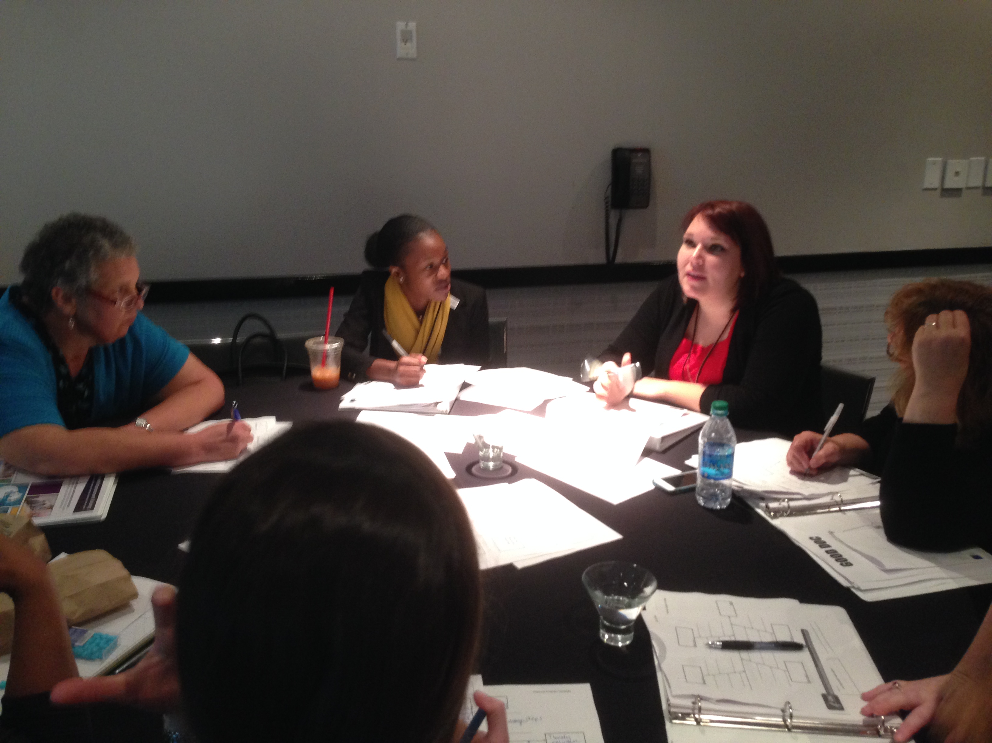
- Great tools and steps! Great and engaging presenters. Val and Kim rocked it!
- Creating a storyboard was a new exercise for me.
- Excellent examples of how to communicate your story. Liked SW's back to basics! liked fishbone example and doing story
- Fantastic session- will be bringing back template and powerpoint slide to team to help us develop our "elevator speeches"
- I like the concept of boiling down the message to the 5 W's. This is a great universal method that everyone has learned in language classes. Nike example was wonderful! I appreciate the tip on focusing on talking points instead of the general group. Grat job on teaching via hands on activity.
- I will provide bullet points to key leaders about the project. I will rewrite certain aspects of the project using plain language.
- Review plain Language book and incorporate content into work templates are great
- Use these templates to tell my project stories to stakeholders, funders, etc.
- Use to develop talking and bullet points. Focus writing efforts to be more clear, concise

PHIT 2014 Closing

PHAB 1.5 Updates
- Les' Presentation on PHAB efforts was good- nice to hear what's coming down the pipe.
- Fun and inspiring closing. U 1.5 information was helpful food for thought!
- How to review documents for appropriateness and meeting the standards
- Identifying winnable battles and highlighting successes- - evaluating what others have tried and what may work for our health department.
- Interesting to hear the 1.5 revisions and the key drivers of the changes.
- It was very helpful to get direct answers of the differences between PHAB I.0 and 1.5.
- It's great to hear the updates from PHAB. The more updates pushed out will solidify it in everyone's mind.
- PHAB does its own QI!
- PHAB is mapping states with HDs in process or already accredited- useful for keeping tabs on accreditation
- PHAB resources on version 1.5 standards will be useful in maintenance phases of accreditation.
- We will use version 1.5 for our next accreditation application. Highlighting the changes in standards, changes in review process, and improvements happening in the review cycle will be very helpful in our preparation work.
- Good to hear that PHAB is practicing what they preach- conducting QI projects on internal processes

Top Ten List
- Loved the top 10 list!
- Loved the top 10 ways to avoid becoming a high performing health department!
- Good closing, creative and high energy
- Nice to know PHAB does PMQI and has a sense of humor.
- Fun. I liked the top 10 ways to avoid becoming a high performing HD. Not really information I can use...

Additional Comments
- Great info on success stories. In the future, it would be helpful to have more details on those successes, or even a narrative from a health department that had a major success by implementing QI. too much info on accreditation as it isn't necessarily relevant to everyone's stage (interest) in the accreditation process.
- Peyton Manning? 12th man? What about Russell Wilson and the Seahawks???
- Prizes / scavenger hunt were fun!
- Loved the humor!
- Love the NNPHI MC's
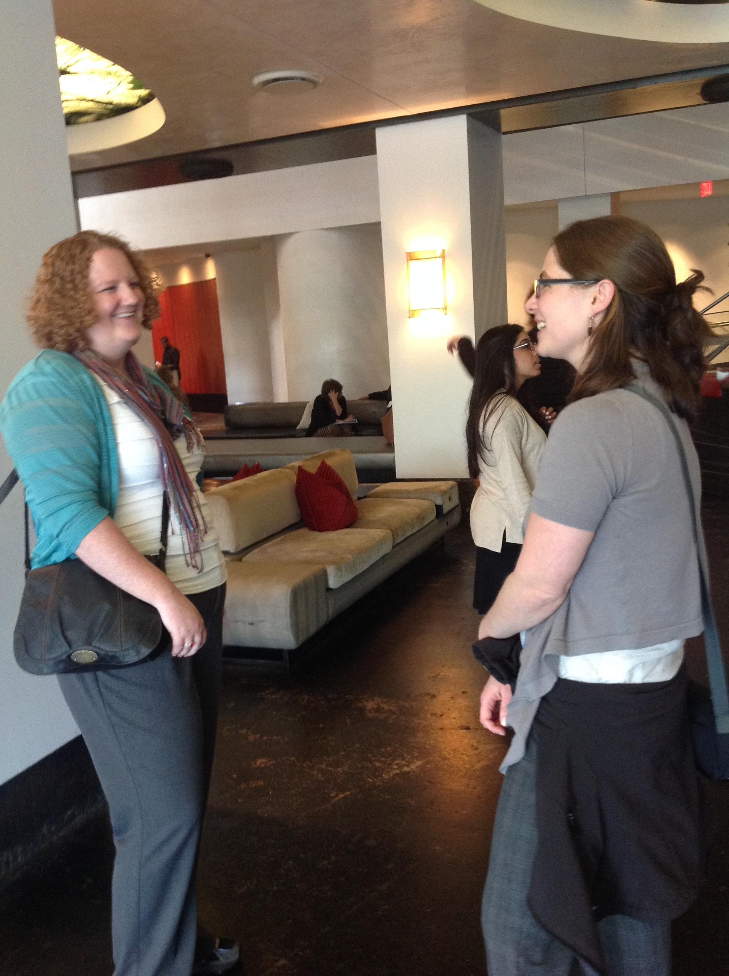
- "brand" our health dept

Appendix A

Appendix A: Planning Committees
PHIT  Planning Committee | NPHII Grantee Meeting  Planning Committee
Liljana Johnson NNPHI Coordinating Contact (primary)
Josh Jennings NNPHI/ Wildflower Consulting Coordinating Contact (primary)
Jennifer McKeever NNPHI Coordinating Contact (secondary)
Carmelita Marrow EMC Venues Conference Planning, Logistics
Debbie Odden EMC Venues Conference Planning, Logistics
Carma Davis CDC (McKing Consultant) Conference Planning, Logistics
Amanda Raudsep CDC Training Liaison | Sandra Cashman CDC PO Grantee Meeting Lead
Teresa Daub CDC Training Liaison | Dianne Ochoa CDC PO GM Lead
Reena Chudgar NACCHO | Chelsie Huntley MN PIM
Jessica Solomon Fisher NACCHO | Donna Estabrook AZ PIM
Denise Pavletic ASTHO | Dan Ward ID PIM
David Stone PHAB | Lisa Aquino / Beverly Wooley AK PIM
Mekia Barclift APHA | Vincent Pinkney TN PIM
Kimberly Moore APHA | Laura Sawney-Spencer/ Lisa Pivec Cherokee Nation Public Health, Oklahoma PIMs
John Stafford/ Dolores Welch AAIP | Colleen Svoboda NE PIM
Alesia Williams CDC | Anita McLees CDC
Jeffrey Brock CDC
Val Carlson CDC
Josh Martinez CDC
Micaela Kirshy PHF
Mark Hansey CDC
Harald Pietz CDC
Letitia deGraft-Johnson AR PIM
Drew Hanchett NY PIM
Heather Reffett DC PIM
Laura Holmes NH PIM

PHIT
Advanced Track Advisory Panel
Partners / organizations

Steering Committee

Appendix B: Evaluation Form
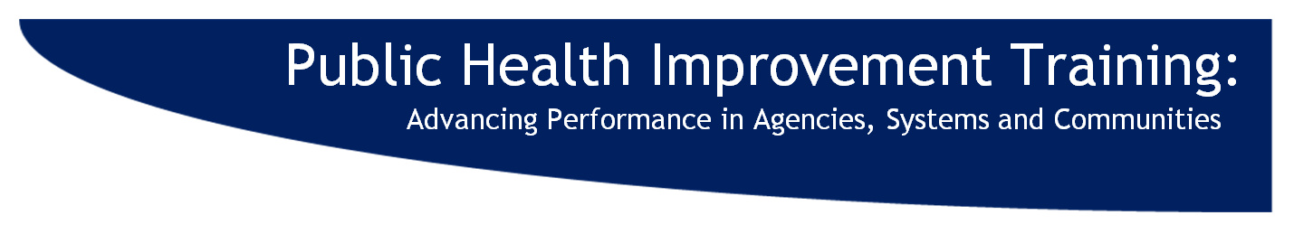
PHIT Evaluation

1. By submitting this completed evaluation form at the registration table, you will receive a flashdrive of PHIT materials. Submitted evaluations shape future Public Health Improvement Trainings. Help us improve PHIT by completing each session evaluation and overall evaluations within this document.

1. What type of organization do you represent?
- Local health department
- State health department
- Territorial health department
- Tribal health department
- Board of health
- Public health institute
- University
- State association
- National organization
- CDC
- Other (Please specify) _______________________

2. What is your role in the organization? (Select all that apply)
- Performance Improvement Manager (PIM)
- Accreditation coordinator
- Mobilizing for Action through Planning and Partnerships (MAPP) coordinator
- Health planner
- Public health nurse
- Program manager
- Program coordinator
- Resource provider to PHIT participants
- Other (Please specify) _______________________

Thursday, April 24  8:30am | Welcome to the Public Health Improvement Training:  Advancing Performance in Agencies, Systems and Communities  Craig Thomas, OSTLTS, CDC

- Place an “X” in the column which accurately reflects your level of agreement with the following statements:
 | Strongly Agree | Agree | Neither Agree nor Disagree | Disagree | Strongly Disagree | Not Applicable
The presenter(s) for this session provided valuable information.
The content of this session was relevant to my current job responsibilities.

 | Too Basic | Somewhat Too Basic | Appropriate | Somewhat Too Advanced | Too Advanced | Not  Applicable
The level of content in this session provided at PHIT was…

- Please describe if and how you will implement what you have learned in this session:

- Any additional comments about the session?

Thursday, April 24  9:00am | PHITing It All Together  Chelsie Huntley, Minnesota, and Israel Nieves-Rivera, San Francisco

- Place an “X” in the column which accurately reflects your level of agreement with the following statements:
 | Strongly Agree | Agree | Neither Agree nor Disagree | Disagree | Strongly Disagree | Not Applicable
The presenter(s) for this session provided valuable information.
The content of this session was relevant to my current job responsibilities.

 | Too Basic | Somewhat Too Basic | Appropriate | Somewhat Too Advanced | Too Advanced | Not  Applicable
The level of content in this session provided at PHIT was…

- Please describe if and how you will implement what you have learned in this session:

- Any additional comments about the session?

Thursday, April 24  10:30am | Launching Sessions

- I attended the following session (SELECT ONE):
- Counties/ Districts/ Cities
- Rural Jurisdictions
- Centralized States
- Decentralized States
- Tribes
- Territories

- Place an “X” in the column which accurately reflects your level of agreement with the following Place an “X” in the column which accurately reflects your level of agreement with the following statements:

 | Strongly Agree | Agree | Neither Agree nor Disagree | Disagree | Strongly Disagree | Not Applicable
Participating in this session was beneficial to my work.
I gained insights into challenges from my peers and/or facilitators.
I shared tips or lessons learned with my peers.

 | Too little | Somewhat too little | Appropriate | Somewhat too much | Too much | Not Applicable
The level of interaction in this session with the presenter(s) and other participants was…

- Please describe if and how you will implement what you have learned in this session:

- Any additional comments about the session?

Thursday, April 24  1:00pm |  | Skill-Building Workshops 1
- I attended the following session (SELECT ONE):
- Building and Sustaining A Culture of Quality Improvement in Health Departments
- Introduction to Performance Management and QI
- Health Status Data for Health Assessment and PSR
- Facilitation of Performance Improvement Activities
- Sharing Resources Across Jurisdictions: A Roadmap to Success
- NPHPS Simulation

- Place an “X” in the column which accurately reflects your level of agreement with the following statements:
 | Strongly Agree | Agree | Neither Agree nor Disagree | Disagree | Strongly Disagree | Not Applicable
The presenter(s) for this session provided valuable information.
The content of this session was relevant to my current job responsibilities.

 | Too Basic | Somewhat Too Basic | Appropriate | Somewhat Too Advanced | Too Advanced | Not  Applicable
The level of content in this session provided at PHIT was…

- Please describe if and how you will implement what you have learned in this session:

- Any additional comments about the session?

Tuesday, April 24  3:00pm |  | Experiences from the Field
- I attended the following session (SELECT ONE):
- Gaining Documentation and Engaging Staff
- Performance Management Systems
- Strategic Planning
- CHA CHIP- HD and hospital collaboration,
- Taking Action on S/CHIP
- How to Operationalize and Align Your Organization’s Workforce Development Plan to Achieve Desired Results

- Place an “X” in the column which accurately reflects your level of agreement with the following statements:
 | Strongly Agree | Agree | Neither Agree nor Disagree | Disagree | Strongly Disagree | Not Applicable
The presenter(s) for this session provided valuable information.
The content of this session was relevant to my current job responsibilities.

 | Too Basic | Somewhat Too Basic | Appropriate | Somewhat Too Advanced | Too Advanced | Not  Applicable
The level of content in this session provided at PHIT was…

- Please describe if and how you will implement what you have learned in this session:

- Any additional comments about the session?

Thursday, April 24  4:15pm | Reflections and Closing Plenary

- Place an “X” in the column which accurately reflects your level of agreement with the following statements:
 | Strongly Agree | Agree | Neither Agree nor Disagree | Disagree | Strongly Disagree | Not Applicable
The presenter(s) for this session provided valuable information.
The content of this session was relevant to my current job responsibilities.

 | Too Basic | Somewhat Too Basic | Appropriate | Somewhat Too Advanced | Too Advanced | Not  Applicable
The level of content in this session provided at PHIT was…

- Please describe if and how you will implement what you have learned in this session:

- Any additional comments about the session?

Friday, April 24  8:30am | Skills Building Workshops 2

- I attended the following session (SELECT ONE):
- Developing Performance Measures Part I
- Telling Your Story
- Performance Management System
- Using the Prevention Status Reports to advance evidence-based public health
- Accreditation Site Visits

- Place an “X” in the column which accurately reflects your level of agreement with the following statements:
 | Strongly Agree | Agree | Neither Agree nor Disagree | Disagree | Strongly Disagree | Not Applicable
The presenter(s) for this session provided valuable information.
The content of this session was relevant to my current job responsibilities.

 | Too Basic | Somewhat Too Basic | Appropriate | Somewhat Too Advanced | Too Advanced | Not  Applicable
The level of content in this session provided at PHIT was…

- Please describe if and how you will implement what you have learned in this session:

- Any additional comments about the session?

Friday, April 25  10:30am | Skills Building Workshops 3

- I attended the following session (SELECT ONE):
- Developing Performance Measures Part II
- Building and Sustaining A Culture of Quality Improvement in Health Departments
- Tips for being a successful PHAB Applicant
- Telling Your Story

- Place an “X” in the column which accurately reflects your level of agreement with the following statements:
 | Strongly Agree | Agree | Neither Agree nor Disagree | Disagree | Strongly Disagree | Not Applicable
The presenter(s) for this session provided valuable information.
The content of this session was relevant to my current job responsibilities.

 | Too Basic | Somewhat Too Basic | Appropriate | Somewhat Too Advanced | Too Advanced | Not  Applicable
The level of content in this session provided at PHIT was…

- Please describe if and how you will implement what you have learned in this session:

- Any additional comments about the session?

Friday, April 25  1:15pm | Closing Plenary

- Place an “X” in the column which accurately reflects your level of agreement with the following statements:
 | Strongly Agree | Agree | Neither Agree nor Disagree | Disagree | Strongly Disagree | Not Applicable
The presenter(s) for this session provided valuable information.
The content of this session was relevant to my current job responsibilities.

 | Too Basic | Somewhat Too Basic | Appropriate | Somewhat Too Advanced | Too Advanced | Not  Applicable
The level of content in this session provided at PHIT was…

- Please describe if and how you will implement what you have learned in this session:

- Any additional comments about the session?

Overall PHIT 2014 Evaluation

- Please complete this section after the last PHIT session you attend. Now that you have participated in PHIT, where do you feel your abilities were prior to attending PHIT 2014 vs. after attending? Place an “X” in the box that accurately reflects your level of agreement with the statements in each column:

I have increased my ability to…
PHIT Objectives | BEFORE PHIT | AFTER PHIT
Increased ability to  Prepare for public health accreditation | □ I had no knowledge  □ I had little knowledge  □ I had a basic understanding  □ I can explain it to others  □ I can do this with a team  □ Did not attend relevant sessions | □ I have no knowledge  □ I have little knowledge  □ I have a basic understanding  □ I can explain it to others  □ I can do this with a team  □ Did not attend relevant sessions
Increased ability to  Structure processes to improve agencies, systems or communities | □ I had no knowledge  □ I had little knowledge  □ I had a basic understanding  □ I can explain it to others  □ I can do this with a team  □ Did not attend relevant sessions | □ I have no knowledge  □ I have little knowledge  □ I have a basic understanding  □ I can explain it to others  □ I can do this with a team  □ Did not attend relevant sessions
Increased ability to  Employ performance management systems | □ I had no knowledge  □ I had little knowledge  □ I had a basic understanding  □ I can explain it to others  □ I can do this with a team  - Did not attend relevant sessions | □ I have no knowledge  □ I have little knowledge  □ I have a basic understanding  □ I can explain it to others  □ I can do this with a team  □ Did not attend relevant sessions
Increased ability to  Utilize public health improvement tools | □ I had no knowledge  □ I had little knowledge  □ I had a basic understanding  □ I can explain it to others  □ I can do this with a team  - Did not attend relevant sessions | □ I have no knowledge  □ I have little knowledge  □ I have a basic understanding  □ I can explain it to others  □ I can do this with a team  □ Did not attend relevant sessions

- Place an “X” in the column that accurately reflects your level of agreement with the following statements:
Value and Relevancy | Strongly Agree | Agree | Neither Agree nor Disagree | Disagree | Strongly Disagree | Not Applicable
My attendance at PHIT was a valuable use of my time.
I found PHIT content met the needs of my current job.
I gained valuable resources and/or information from PHIT that I will use in my work.
I had valuable insight that I shared with at least one other peer or participant.
I liked the structure of the training.
Participating in the Dine-Around on Wednesday evening added value to my PHIT experience
Participating in the CDC excursion on Thursday evening added value to my PHIT experience

- Please describe the most useful aspect(s) of PHIT:

- Please describe the least useful aspect(s) of PHIT and how it might be improved:

- 13. Would you be interested in attending a regional Public Health Improvement Training?
- Yes
- No

What is most important to you in meeting location/ meeting space? (Please select up to three):

- Short distance from airport
- Restaurants close-by
- Walkable areas close to hotel
- Co-located with a relevant meeting
- Large conference rooms
- Fun city
- Drivable distance
- Other ________

- 14. Do you have any additional comments, questions, or anything else you would like to add?

Thank you for your feedback!

Please turn in your evaluation form at registration
to receive a flashdrive of PHIT materials.

Appendix C:

Full List of Actions Planned/ Takeaways
by PHIT Session

Click here to access the Full List of Actions Planned/ Takeaways (34 pages) for each PHIT 2014 session.

