ATTACHMENT B – Web Version of Web-based Instrument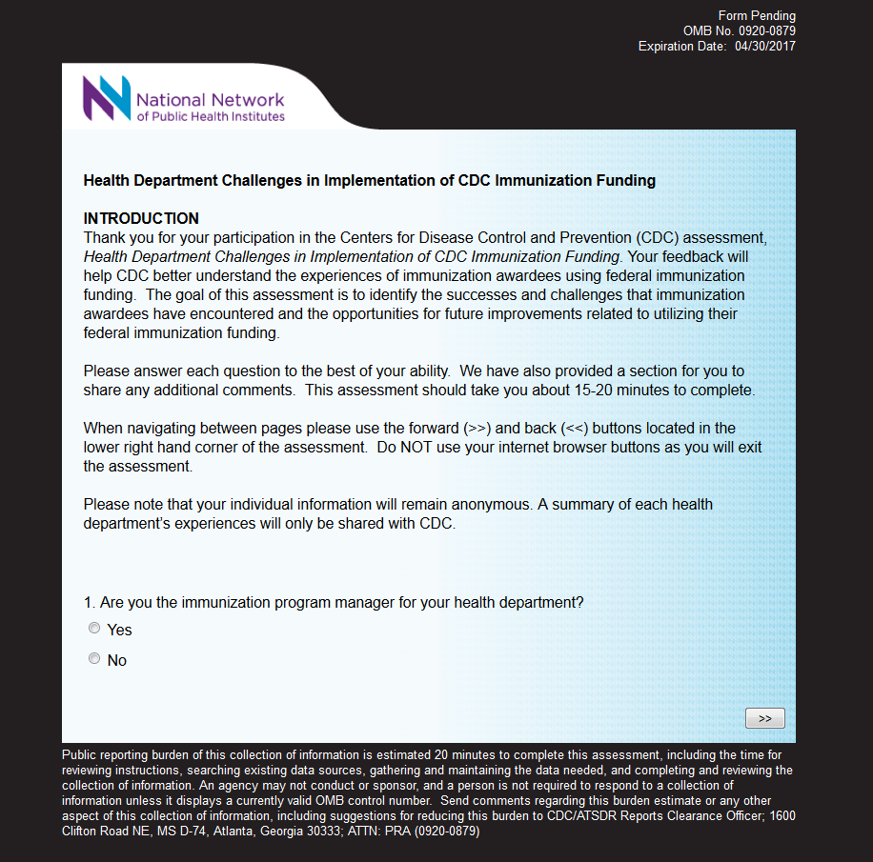

[IF RESPONDENT IS NOT THE IMMUNIZATION PROGRAM MANAGER, THEN RESPONDENT TAKEN TO A PAGE ASKING FOR THE APPROPRIATE PERSON. ALL OTHER RESPONDENTS SKIP THIS PAGE.]

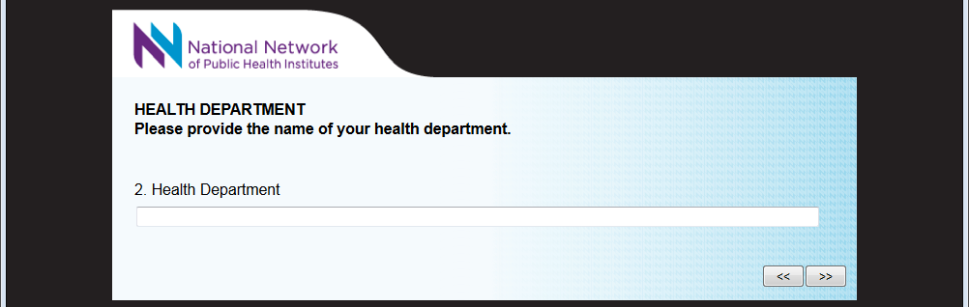
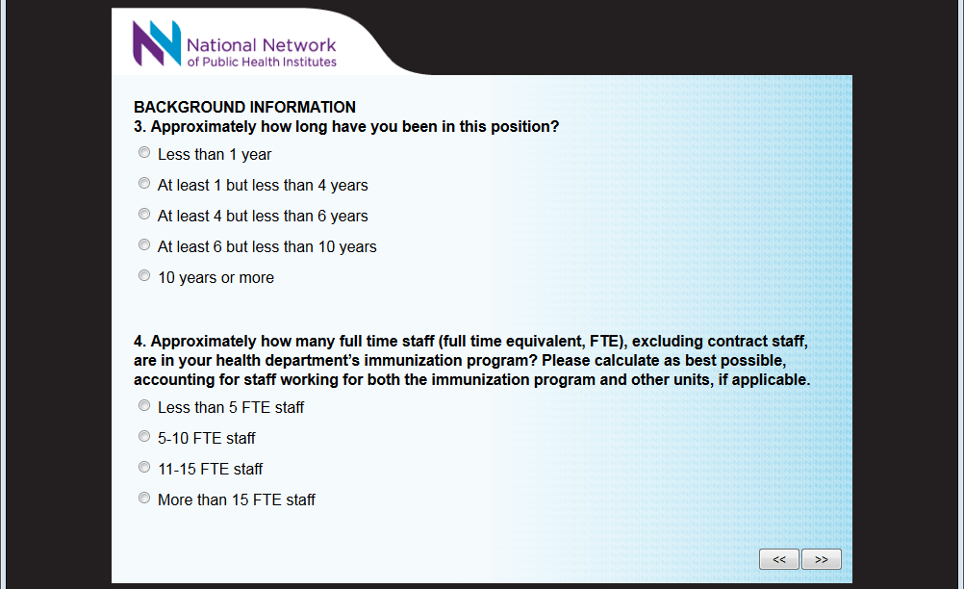

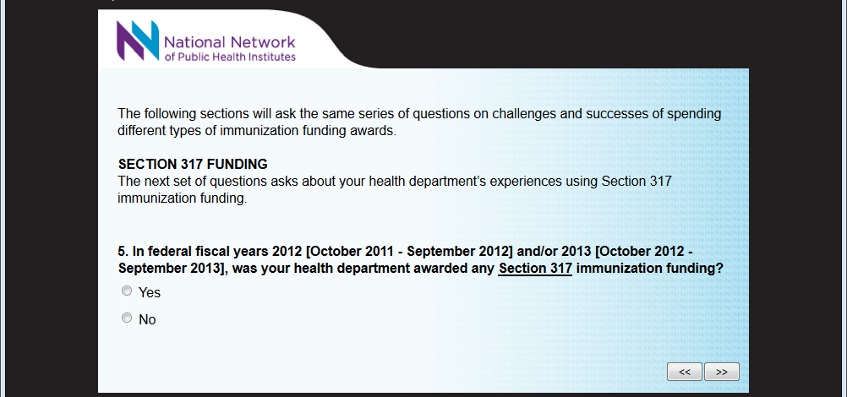

[SKIP PATTERN QUESTION: IF RESPONDENT RECEIVED FUNDING, THEN RESPONDENT PROCEEDS TO NEXT QUESTION. IF RESPONDENT DID NOT RECEIVE FUNDING, THEN RESPONDENT SKIPS SECTION AND CONTINUES TO NEXT SECTION ASKING ABOUT VFC FUNDING.]

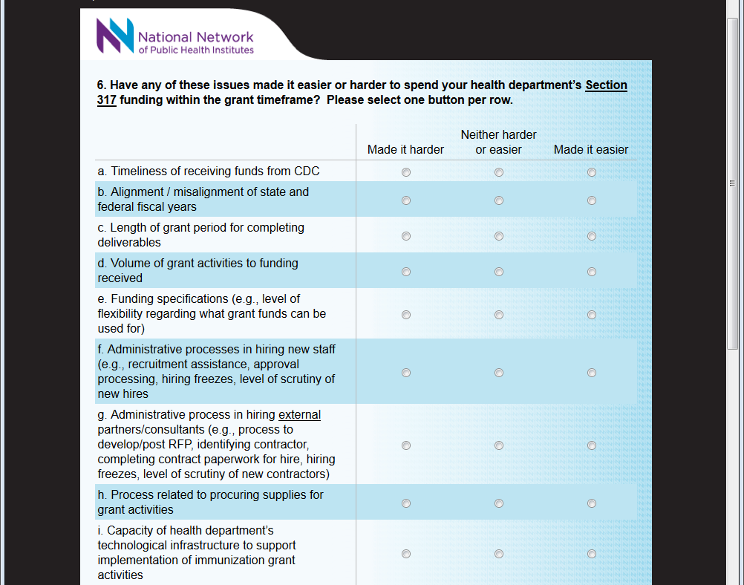
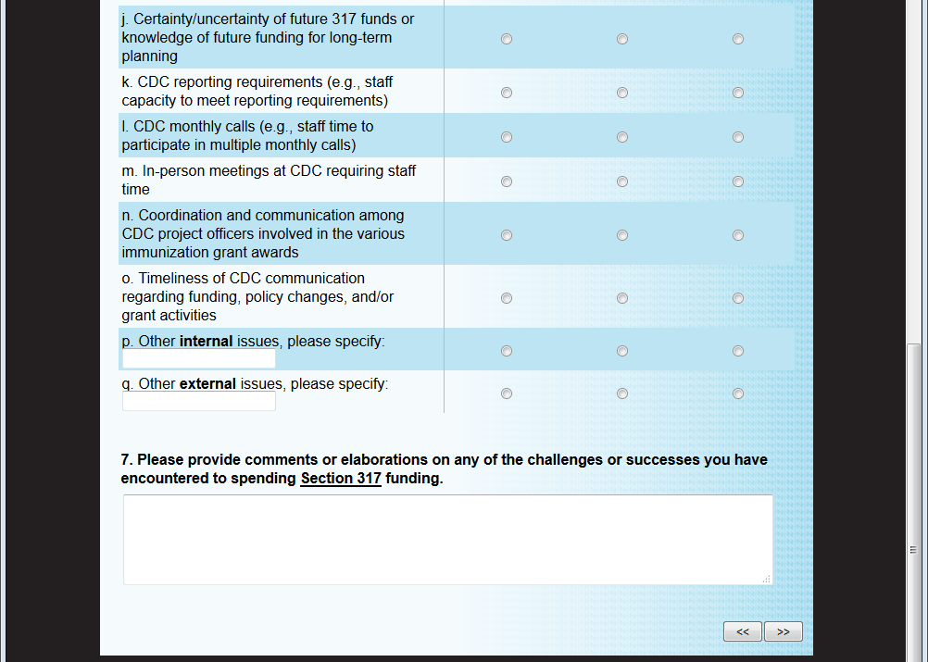
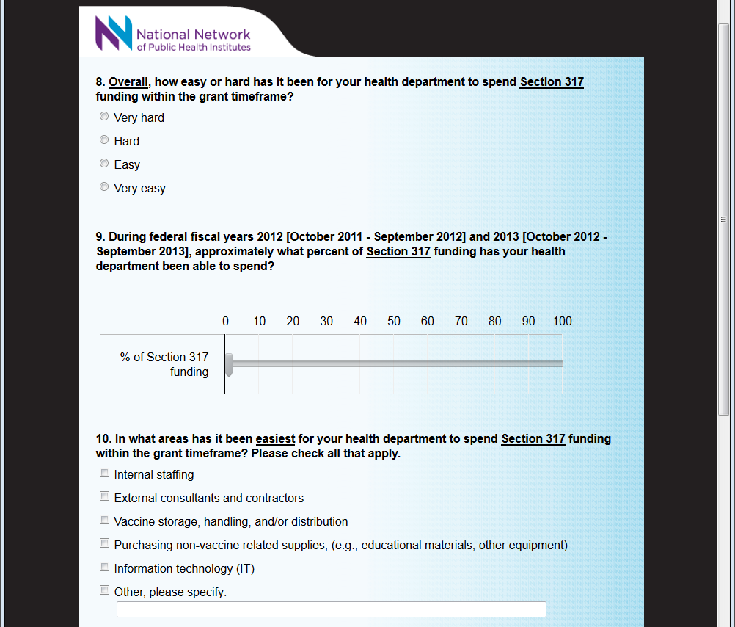
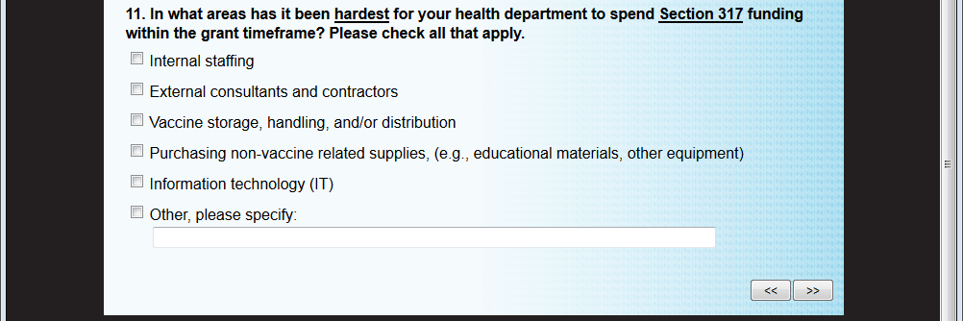
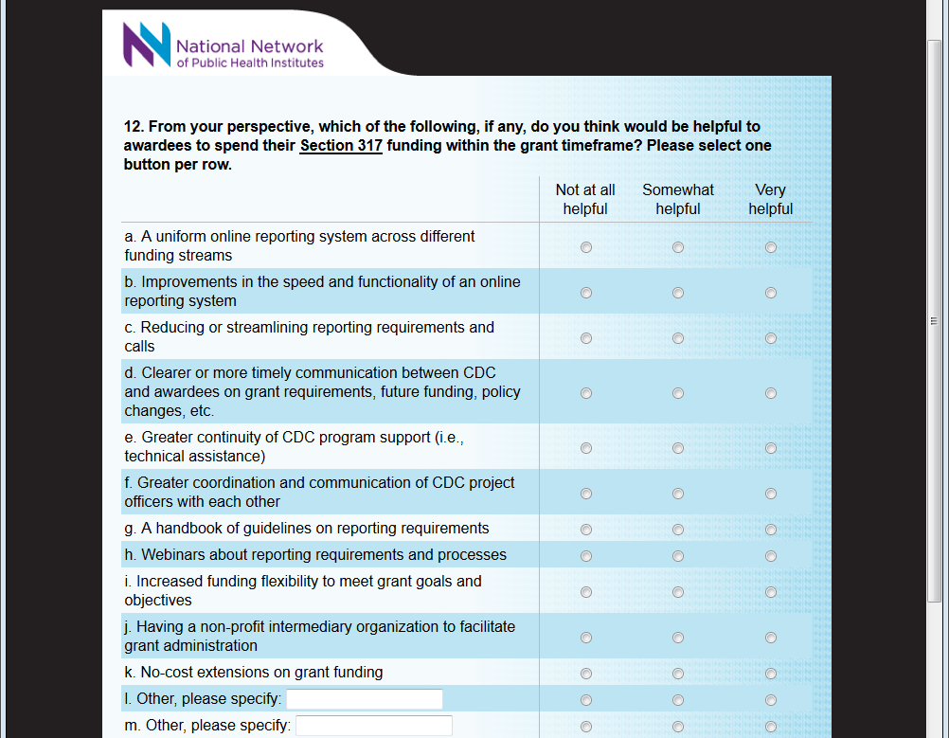
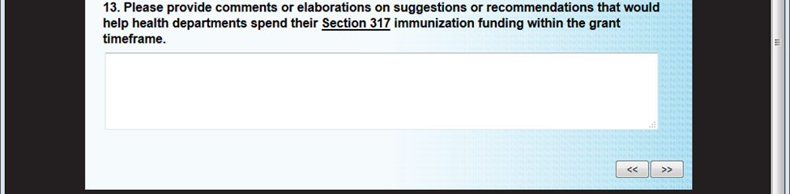
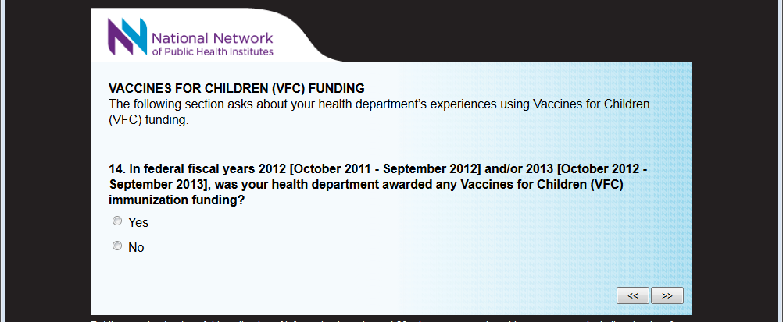
[SKIP PATTERN QUESTION: IF RESPONDENT RECEIVED FUNDING, THEN RESPONDENT PROCEEDS TO NEXT QUESTION. IF RESPONDENT DID NOT RECEIVE FUNDING, THEN RESPONDENT SKIPS SECTION AND CONTINUES TO NEXT SECTION ASKING ABOUT SPECIAL FEDERAL FUNDING.]

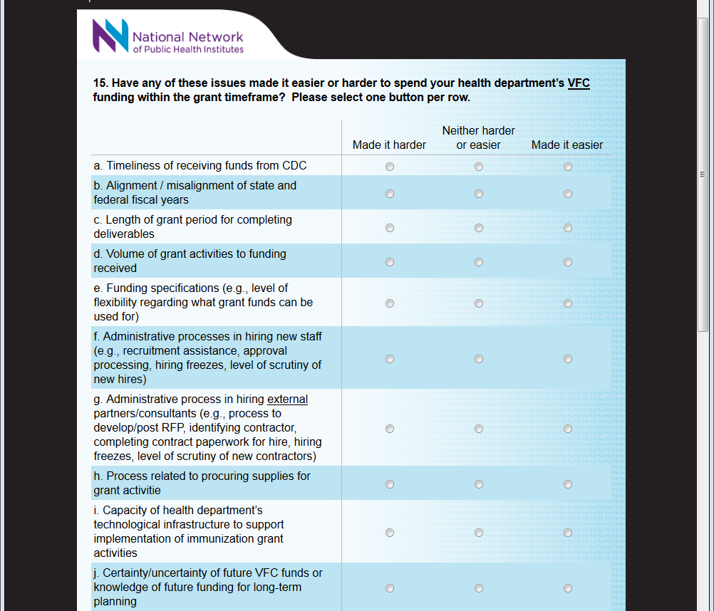
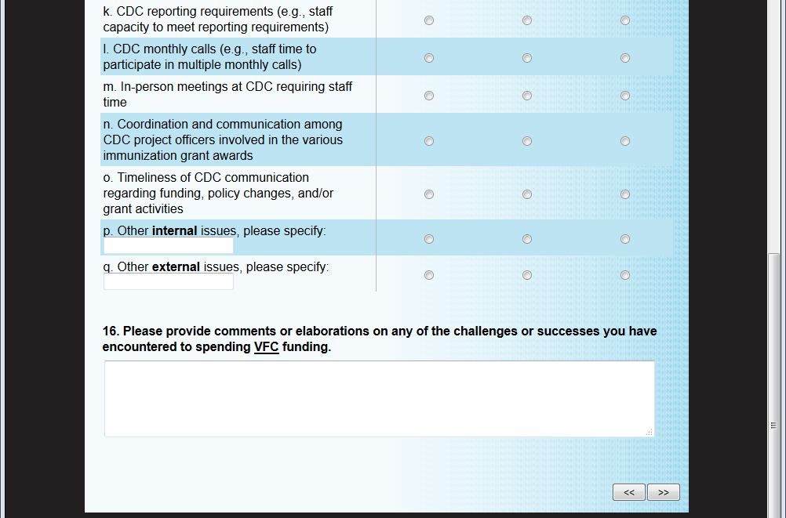
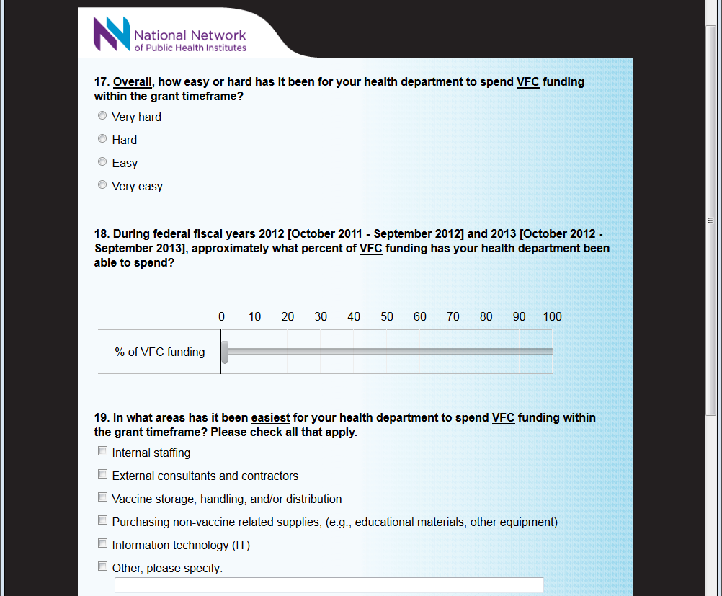
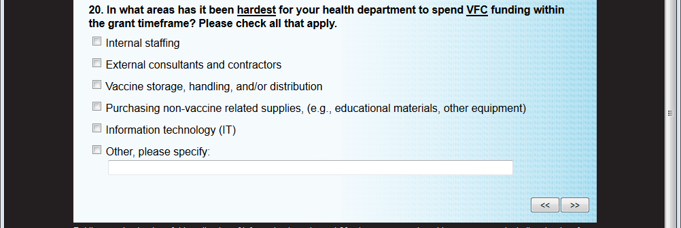
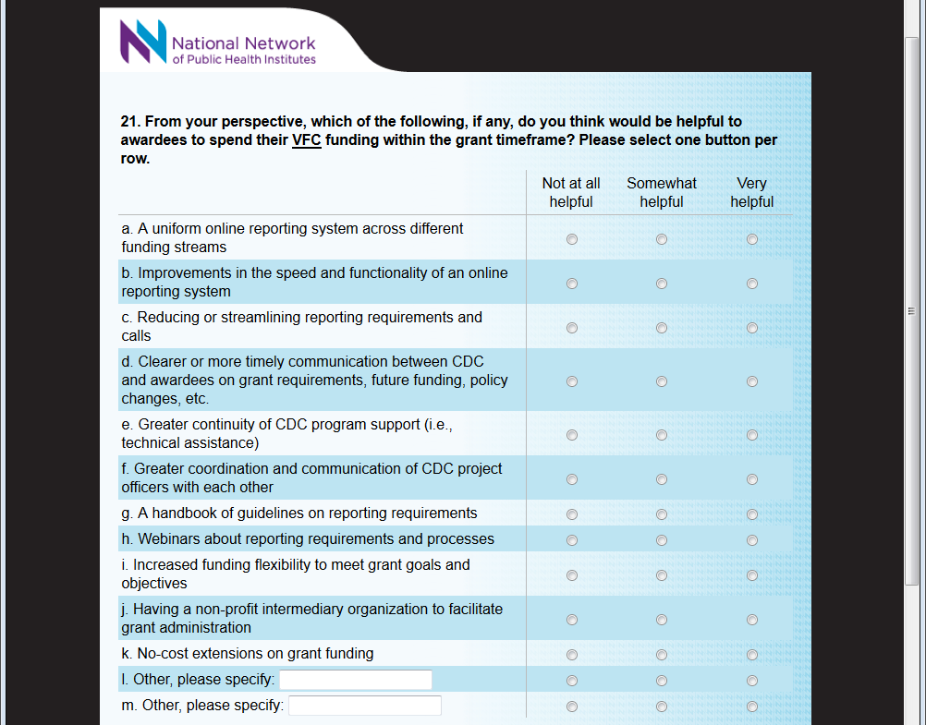
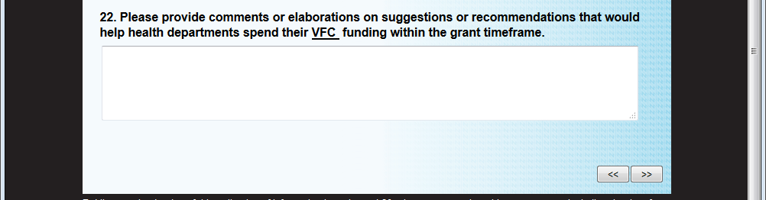
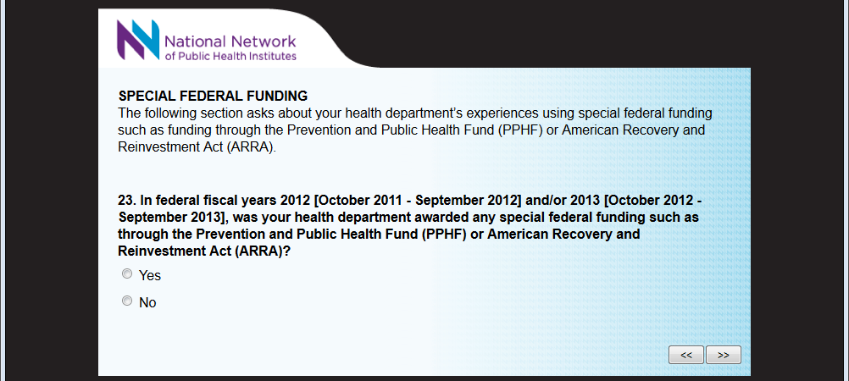
[SKIP PATTERN QUESTION: IF RESPONDENT RECEIVED FUNDING, THEN RESPONDENT PROCEEDS TO NEXT QUESTION. IF RESPONDENT DID NOT RECEIVE FUNDING, THEN RESPONDENT SKIPS SECTION AND CONTINUES TO NEXT SECTION ASKING ABOUT OTHER FUNDING.]

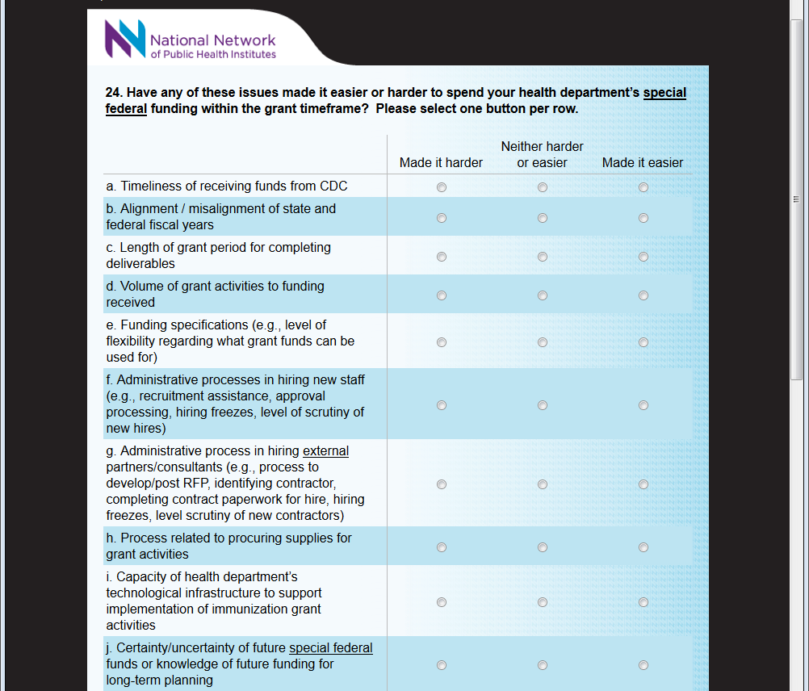
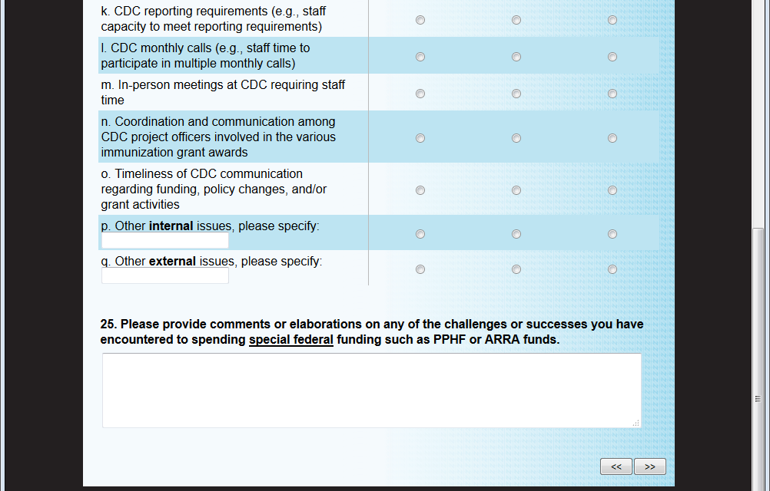
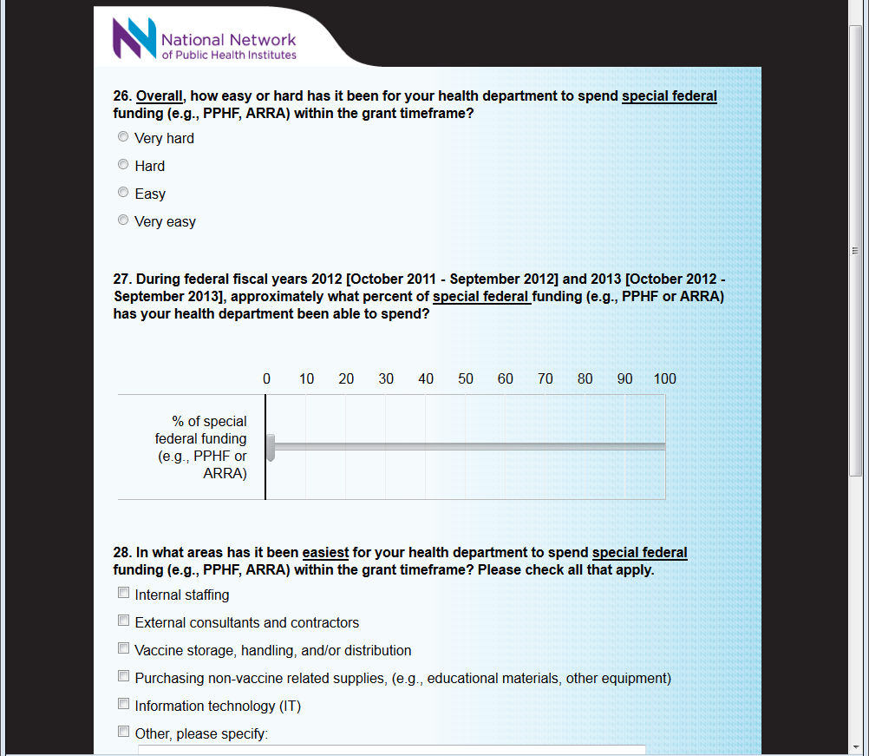
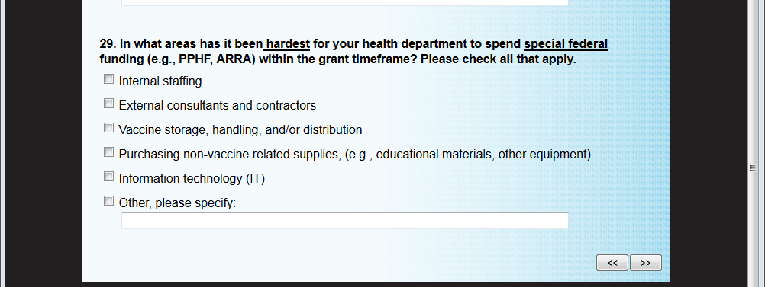
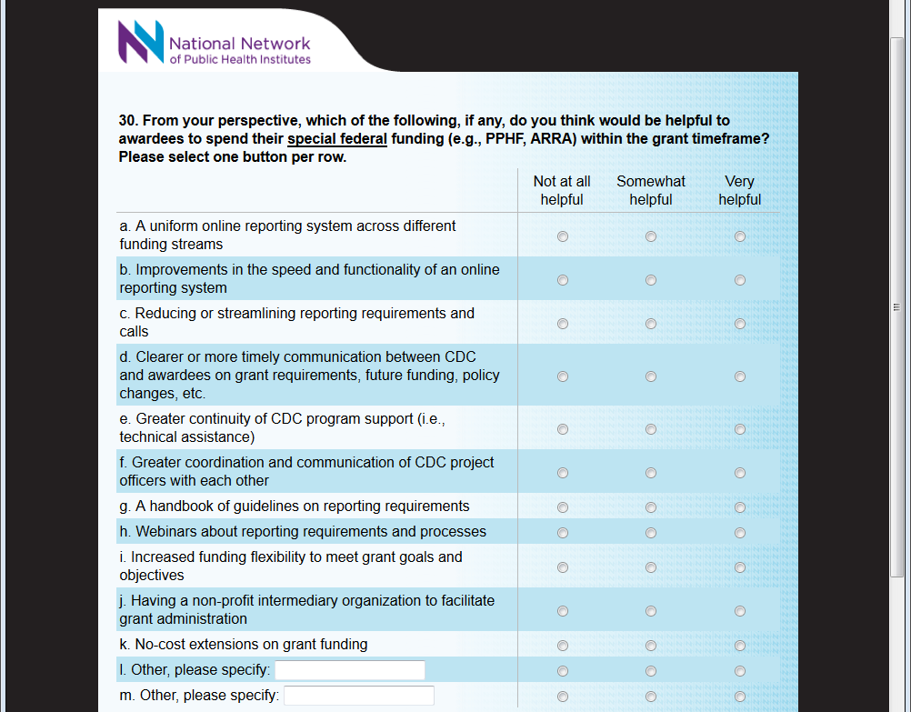
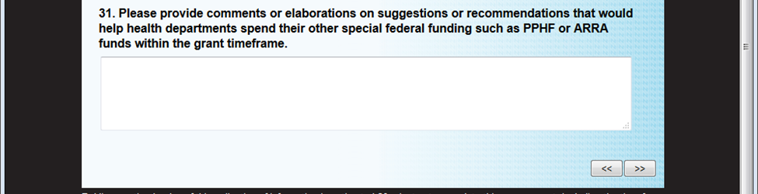
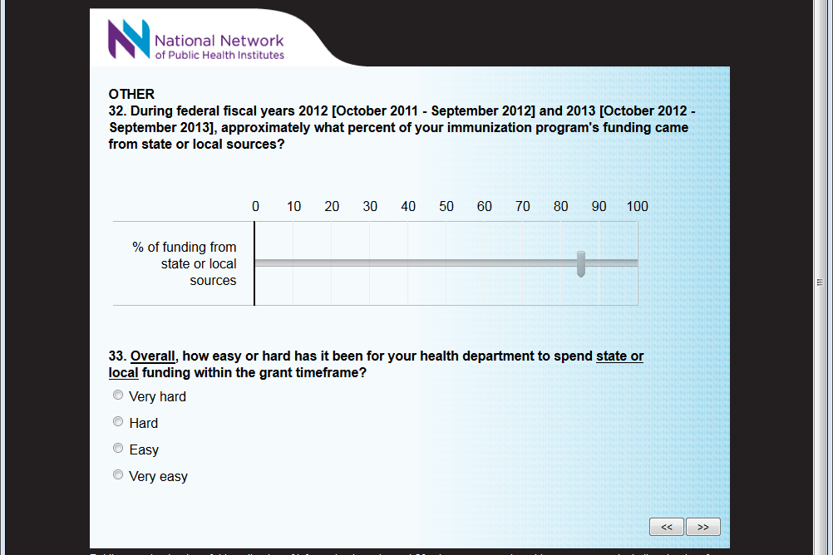

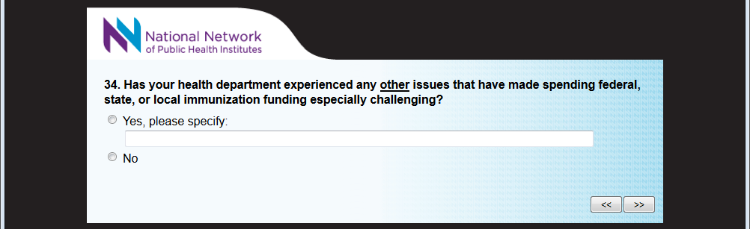

[SKIP PATTERN QUESTION: IF RESPONDENT ENCOUNTERED OTHER ISSUES, THEN RESPONDENT PROCEEDS TO NEXT QUESTION. IF RESPONDENT DID NOT ENCOUNTER OTHER ISSUES, THEN RESPONDENT SKIPS SECTION AND CONTINUES TO LAST QUESTION.]

