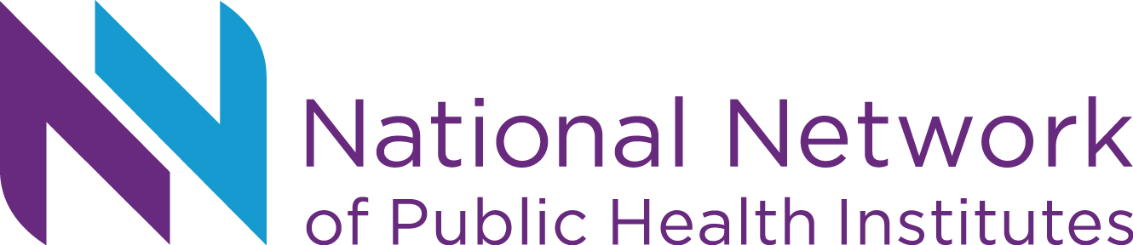
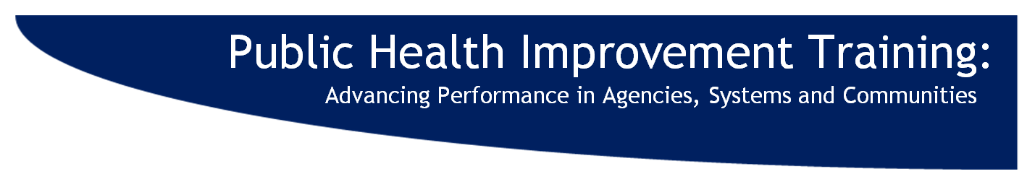
Attachment F: Executive Summary

2014 Executive Summary of Assessment Report

Context & Goals of PHIT 2014
The 12th annual Public Health Improvement Training (PHIT): Advancing Performance in Agencies, Systems and Communities, April 24-25, 2014, was co-sponsored by the National Network of Public Health Institutes and the Centers for Disease Control and Prevention (CDC) with input and contributions from six other key national organization partners.
Goal: To increase the public health workforce’s implementation of public health agency, system and community health improvement processes.
Objectives: Following PHIT, participants will be better able to
- prepare for public health agency accreditation
- structure process to assess and improve agency, systems or communities
- employ performance management systems
- utilize public health improvement tools

80% of attendees had PIM or accreditation coordinator roles

“First time here, hands down best conference.

Walked away with bountiful amount of knowledge, peers, and resources. “
Value & Gains

“Every session is critically useful and essential to our mission.”

100% reported gaining valuable resources and/or information from PHIT that will be used in their work

“One of the best trainings I’ve ever been to in my career.”

The Knowledge & Abilities chart shows a majority of participants reported moving their knowledge and abilities one or more points
(see Knowledge/Abilities Growth Scale below) in each of the four topic areas featured in PHIT 2014.
Knowledge/ Abilities Growth Scale
□ I had no knowledge
□ I had little knowledge
□ I had a basic understanding
□ I can explain it to others
□ I can do this with a team
□ I can teach this
□ Did not attend relevant sessions

“All of the sessions were a wealth of information that will be utilized.”

“PHIT does it better than any other.”

“PHIT provides critical training that we as public health practitioners need to be able to implement PM and QI in our HDs”

What do participants value in PHIT most?

“[I get] "Real" information on accreditation process”

“Peer to peer- these colleagues are awesome, intelligent and fun.
Great support system.”

“Networking was invaluable
and the sharing of tips and resources among us.”

Across all session evaluations, respondents rated sessions on average with…

“You all have had great offerings and I have a lot of tools to go home with as well as renewed energy!!!

With the loss of NPHII funding, things were dismal at my agency but I feel confident that I can go back and re-energize our team and fight for QI/PM/accreditation readiness.”

“I appreciate that all of the presenters are more than willing to share their resources to help everyone else.

This is extremely helpful as we do not have to recreate the wheel.”

Top Rated Sessions scoring 100% positive
(with 10+ respondents):
- PHAB Site Visit
- Tips for Being a Successful PHAB Applicant
- Innovative CHNA and CHIP Partnerships
- Strategic planning

Opportunities for Improvement

“Didn’t know about PHIT event”
-10 people

“I'm leaving feeling like I missed out on useful information! It was very difficult to select sessions, and after talking to colleagues, I do feel a sense of regret that I didn't get to everything I wanted to. Thank you!!! Seriously, thanks.”

Actions Planned/ Takeaways from PHIT Sessions

“Took so much from this training.

I will make it back
even if I have to cover the costs myself.”

PHIT participants described over 600 takeaways/ actions planned from sessions

“Are ya kidding- I will use EVERYTHING covered in this [Tips for Being a Successful PHAB Applicant] session with my team of leadership.”

Most & least important factors in PHIT locations (n=134)

- Walkable areas close to hotel (81%)
- Restaurants close-by (70%)
- Fun city (32%)
- Co-located with a relevant meeting (10%)
- Driving distance (5%)
- Affordability (4%)

