One-Time Study Roll-Over Interface
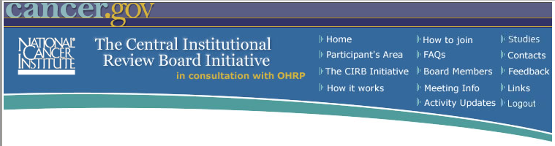
One-Time Study Roll-Over Worksheet
OMB#: 0925 – 0625
Expiry Date: 01/31/2014
Collection of this information is authorized by The Public Health Service Act, Section 411 (42 USC 285a). Rights of your participation in the National Cancer Institute (NCI) Central Institutional Review Board (CIRB) Initiative is protected by The Privacy Act of 1974, as amended. The purpose of the information collection is to conduct reviews of clinical trial studies. Although your participation in NCI-sponsored research and completion of the forms is voluntary, if you wish to participate in the CIRB, you must complete all questions on the form. The information you provide will be combined for all participants and reported as summaries. It will be kept private to the extent provided by law.
NOTIFICATION TO RESPONDENT OF ESTIMATED BURDEN
Public reporting burden for this collection of information is estimated to average 10 minutes per response, including the time for reviewing instructions, searching existing data sources, gathering and maintaining the data needed, and completing and reviewing the collection of information. An agency may not conduct or sponsor, and a person is not required to respond to, a collection of information unless it displays a currently valid OMB control number. Send comments regarding this burden estimate or any other aspect of this collection of information, including suggestions for reducing this burden, to: NIH, Project Clearance Branch, 6705 Rockledge Drive, MSC 7974, Bethesda, MD 20892-7974, ATTN: PRA (0925-0625). Do not return the completed form to this address.
