INTEROFFICE MEMO

TO: CPS Specialists, Central Region
CPS Specialists, Adoptions, Southwest Region

FROM: Karen Bulkeley, MSW
Project Director, Fostering Readiness & Permanency Project

DATE:

SUBJECT: Evaluation Information
As many of you know, the State of Arizona is participating in a federal initiative to identify new ways to address the permanency planning needs of children and youth in foster care. The Children’s Bureau created the Permanency Innovations Initiative to provide six grants to CPS agencies across the country so they can build the evidence base for innovative interventions to enhance well-being and improve permanency outcomes for children who are in or at risk for long-term foster care.
Arizona’s project is called the Fostering Readiness and Permanency (FRP) Project. As part of the FRP Project our agency will be participating in an evaluation of the program. One part of the evaluation includes interviews with CPS Specialists to get a better understanding of finding placements for children.
Westat, a research company will be leading the evaluation. You will be contacted by a Westat interviewer to explore your interest in participating in a voluntary telephone interview about your cases. I am attaching a letter from Westat that gives you further details about the study.
If you have any questions or need any clarification, please contact Jacob Schmitt, FRP Project Evaluation Liaison at 602-264-3376 x. 3332 or by email at JSchmitt@azdes.gov.

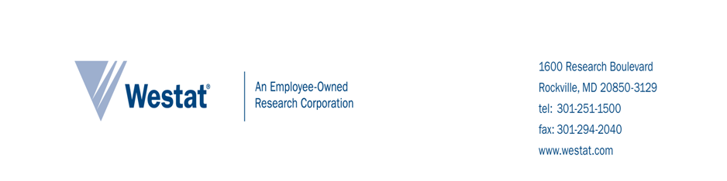
Prospective-homes-found consent

Introduction and PURPOSE OF STUDY
The U. S. Department of Health and Human Services has hired Westat, a research company, to study the Arizona Department of Economic Security (ADES), Division of Children, Youth and Families (DCYF), Fostering Readiness and Permanency Project (FRP). The FRP Project is a program supported by the Permanency Innovations Initiative (PII), a federal initiative that seeks to build the evidence base for innovative interventions to enhance well-being and improve permanency outcomes for children who are in or at risk for long-term foster care.

One part of the study will help us learn which services help children stay out of foster care or leave foster care sooner. Another part of the study will help us learn about the decision making for youth in foster care. We are asking for your help with the first part of the study now.

Procedures
We invite you to participate in a voluntary telephone interview. The interviewer will ask you about the number of prospective homes found for young people in your caseload who are enrolled in the study. The interview will take no more than 15 minutes to complete.

RISKS
We do not expect any risks to you in participating in the interview. You can skip questions that you do not want to answer.

BENEFITS
There are no direct benefits to you. However, your participation will help your organization and others come up with better ways to serve families and children.

Participant and Data PRIVACY
We will keep your information private to the extent permitted by law. Your survey interview responses will be kept private and labeled only with a unique study identification number. We will use your information for research purposes only. We will not include information that identifies you in any reports.

To help us protect your information, we received a Certificate of Confidentiality from the U. S. Department of Health and Human Services. With this Certificate, no one can force us to share information that could identify you, even in any court or legal proceeding, under a court order or subpoena.

participation decision
To ensure that your responses remain private, you will not sign a consent form to indicate your decision to complete the interview. You agree to participate in the survey interviews by providing verbal consent, which will be recorded. Please keep one copy of the consent information form for your records.

A Westat researcher will be contacting you soon to explore your interest in participating in the telephone interview. If you agree to participate, the researcher will begin the interview with you at that time or schedule a time that is convenient for you. You can indicate that you do not want to participate once the Westat researcher calls you about the interview.

QUESTIONS
If you have questions about the interview, you may also contact the individuals below.

For questions about the study, please contact:  Karla Eisen, Westat Study Contact  1-800-WESTAT1 (937-8281), x5927  KarlaEisen@westat.com | For questions about your rights as a participant in this study, contact:  The Westat Institutional Review Board (IRB) Administrator, 1-800-WESTAT1 (937-8281), x8828

