**Introduction**

The IRS is redesigning its search experience so that users are better able to find the content they are looking for on IRS.gov. We would like to get your input on a new functionality called *faceted search*, which allows users to filter search results by specific topics or audiences.

**Instructions**

This activity will take around 7-9 minutes to complete.  All responses are confidential and will help inform our final search design.

*Closed Card Sort:* Please place the search result under the existing category label. There is no wrong answer; place the result under the category that makes sense to you.

*Open Sort:* Please look at the search results and group like items in a way that makes sense. Place a label over the group to describe the items in the group. Again, there are no wrong answers. Use labels that you think make sense.

Thank you for partnering with us to improve our website.

**Closed Sort**

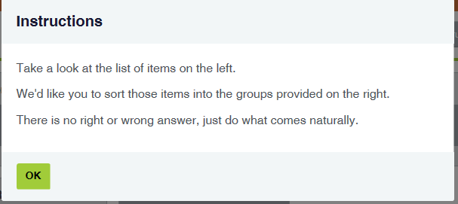

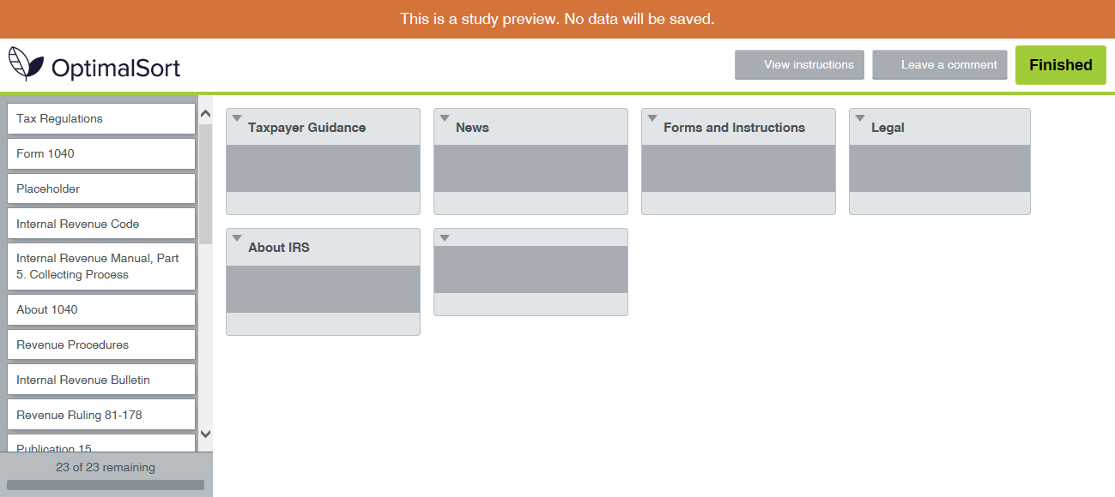

**Open Sort**

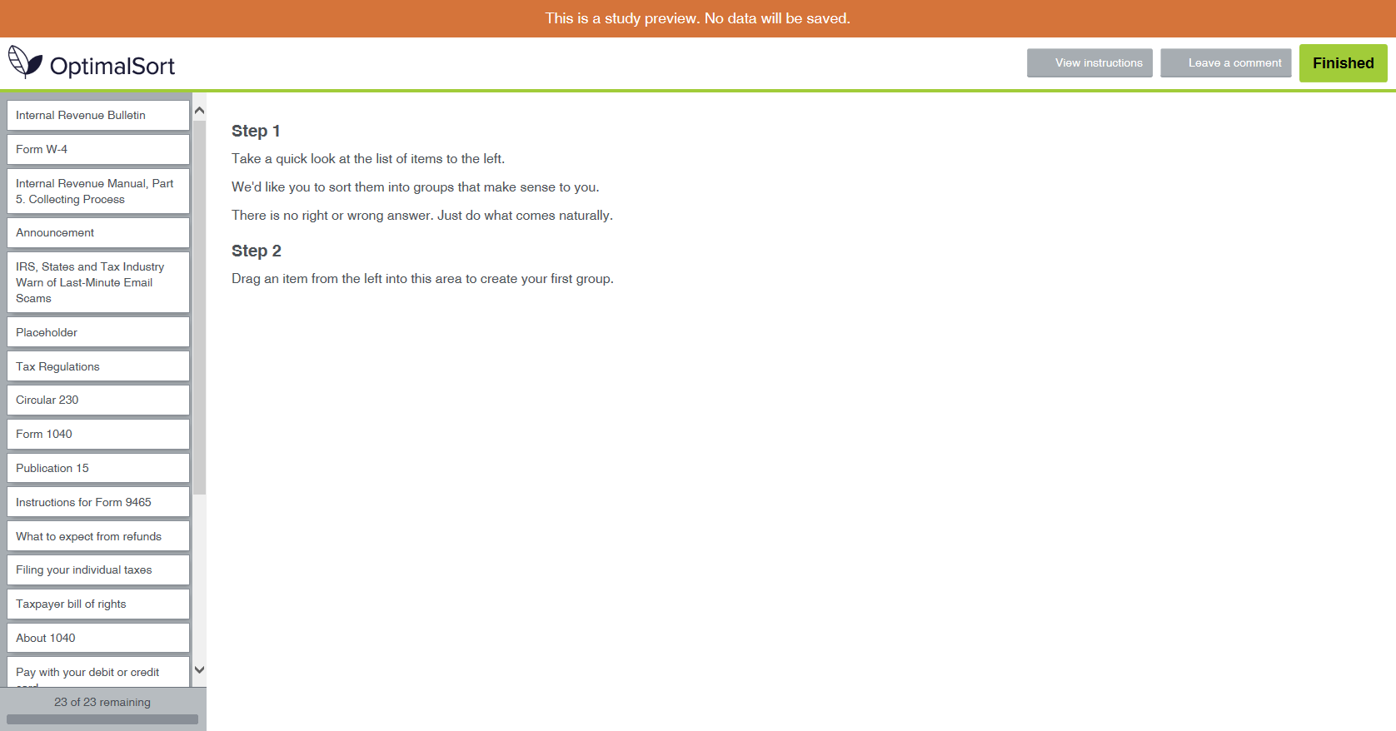

**Wrap-Up Questions**

I am:

* Individual Taxpayer
* Small business owner
* Large business owner
* Tax professional
* Own/work at a charity or non-profit
* Own/work for a government entity
* Other: _______________

How would you label content on IRS.gov that may be out of date or no longer accurate, but needs to be findable for use as reference material (ex: a press release from 1998 announcing a new IRS commissioner):

1. Archived Content
2. Historical Content
3. Retired Content
4. Other ________________

Based on what you’ve seen, please evaluate this statement: Adding filters to search results will help users better find IRS.gov content?

1. Strongly Agree
2. Agree
3. Disagree
4. Strongly Disagree

**Closing**

Thank you for participating. Your feedback will help us improve IRS.gov.