Instructions to Participant
We are planning a redesign of our homepage so that you can easily find what you need.If you have a few minutes, we want you to help us evaluate a proposed design by completing a quick activity. The responses from this 7-9 minute activity are confidential and anonymous.Thank you for helping us to improve our website.
All you need to do is click!
- We'll give you a task to complete and an image of a proposed design of the homepage to complete it on.
- Imagining you were really carrying out the task, click where you would first look.
This is not a test of your ability — there are no right or wrong answers.
Let's get started!

Tasks
1. You are applying for financial aid for college. Find information on requesting your past tax return to complete your FAFSA.

2. You want to view the website in Spanish. Where would you go to switch the content to Spanish?

3. You filed your taxes and are expecting a refund but haven’t received it yet. Where would you find the related information?

4. You want to start a new business. Where would you find information on applying for an employer identification number for the business?

5. You want to start a non-profit organization. Where would you find information on obtaining tax-exempt status?

6. Where would you find more information if you received a notice or letter from the IRS?

7. You need a tax identification number. Where would you find more information?

Example Screen Participant will see to complete task:

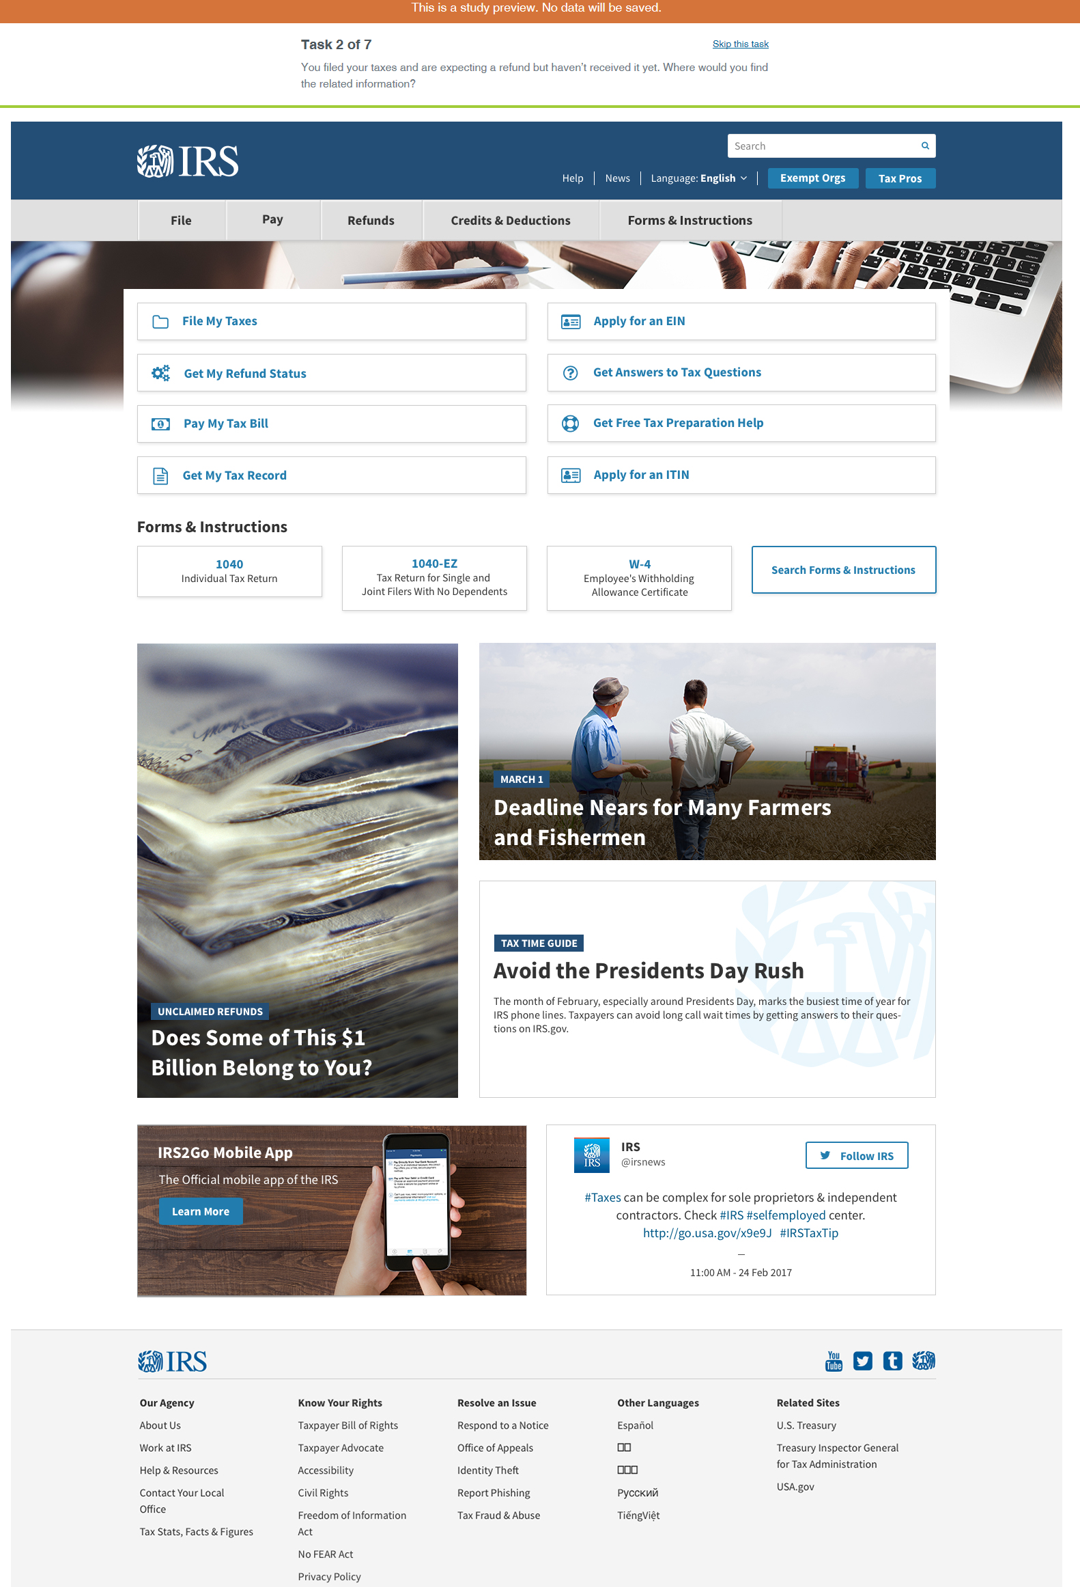

Wrap-Up Question

I am:

- Individual Taxpayer
- Small business owner
- Large business owner
- Tax professional
- Own/work at a charity or non-profit
- Own/work for a government entity
- Other: _______________

Closing
All done, awesome! Thanks again for your participation. Your feedback is incredibly useful in helping to determine how our content should be organized, so we can make our website easier to use.

You may now close this window or navigate to another web page.

