Add/Edit Activity (Activity Setup Screens)
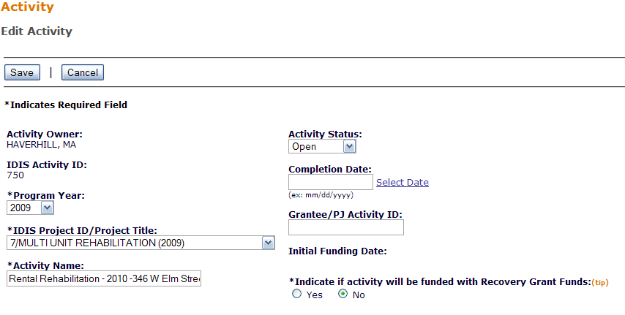
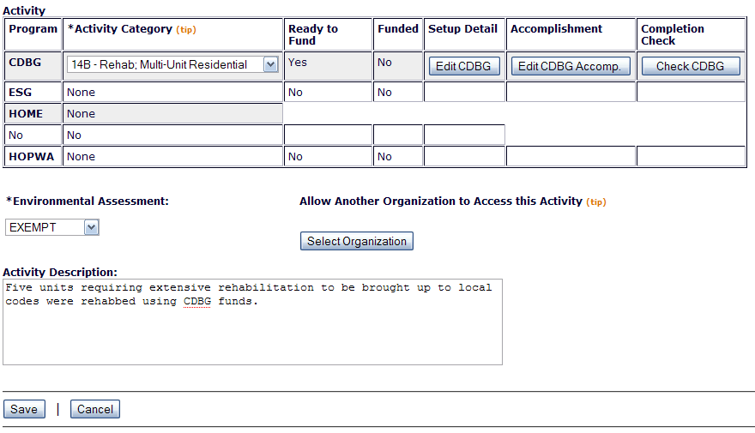
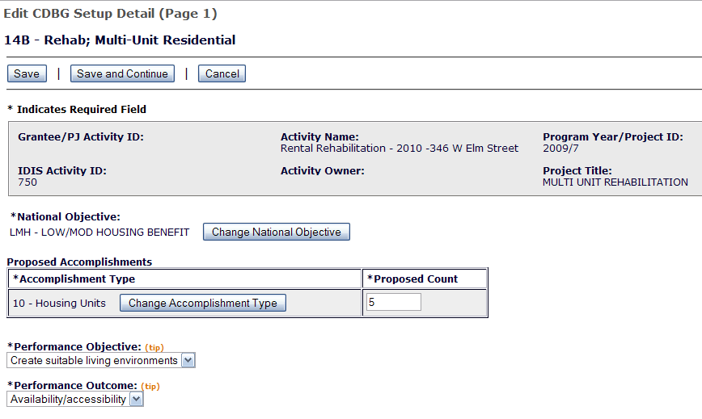
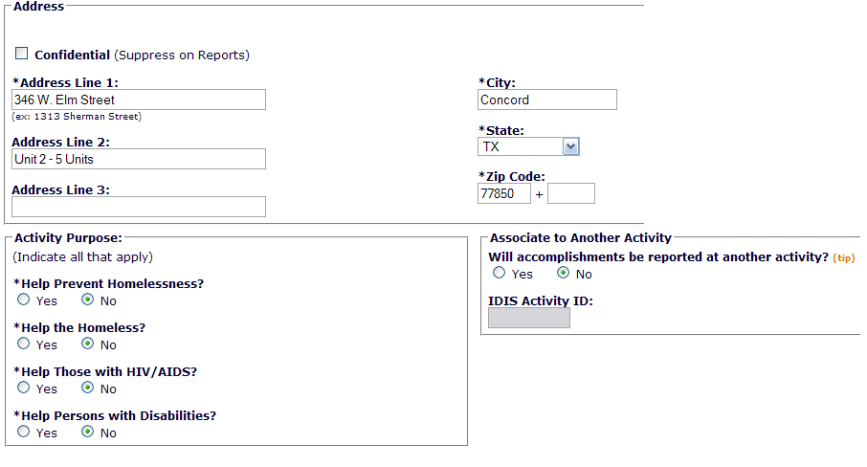
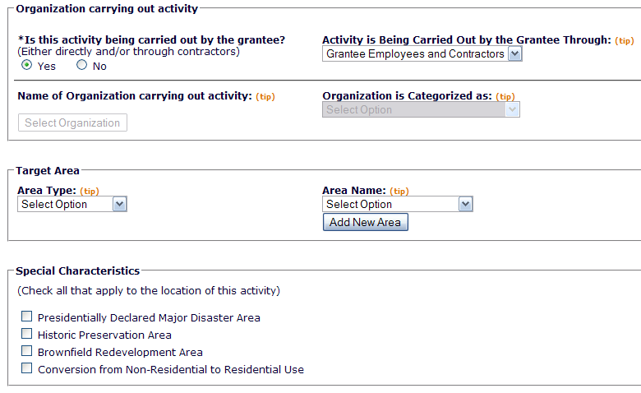
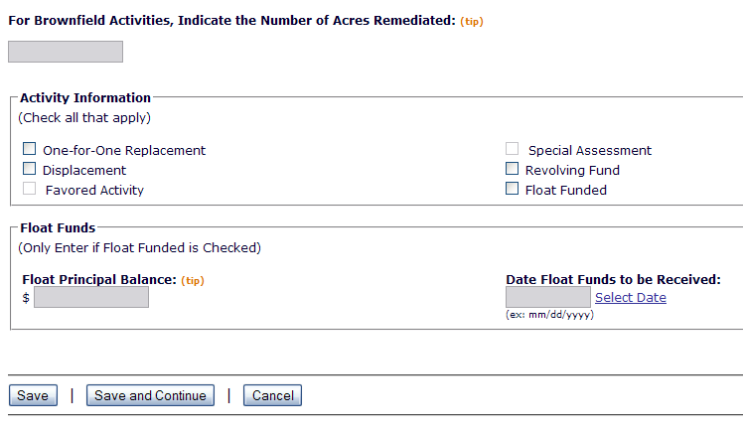
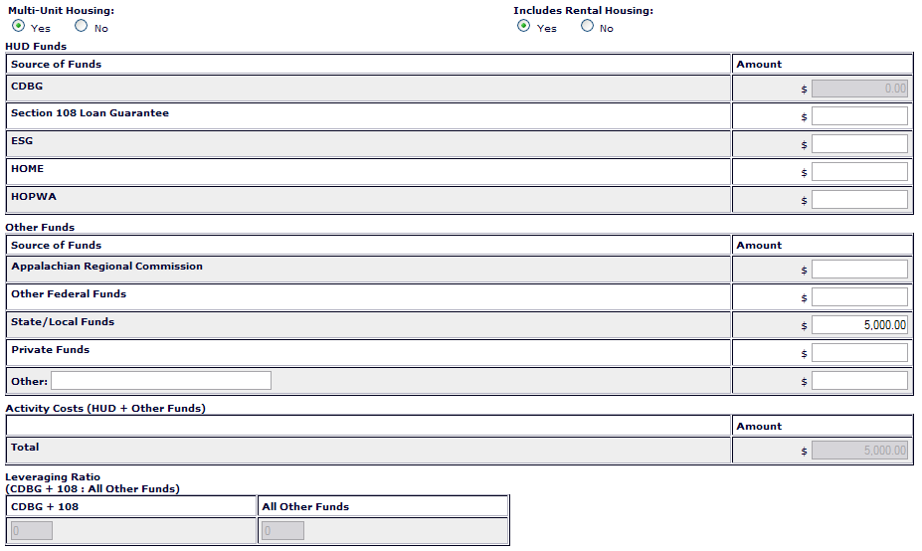
Grant/Loan Assistance
Enter the number of grants or loans provided to beneficiaries of this activity (tip)
  Grants | (tip)
  Loans | (tip)
Loan(s) provided
 | Average Interest  Rate (tip)  (ex: 99.99%) | Average Amortization Period (in Months) (tip) | Total Amount
Amortized Loan |  |  | $
Deferred Payment Loan |  |  | $

*Multi-Unit Housing
 | Total |  | Occupied (tip) |  | Occupied Low/Mod (tip) | Percent Low/Mod
Units at Start |  |  |  |  |  | %
Units Expected at Completion |  |  |  |  |  | %
*CDBG-R Data
FTE Jobs Created/Retained
Housing Rehabilitation
(Indicate if this activity is limited to one or more of the following)
Install Security Devices
Install Smoke Detectors
Operate a Tool Lending Library
Perform Emergency Housing Repairs
Provide Supplies and Equipment for Painting Houses

|

CDBG Activity Setup (LMA Only)
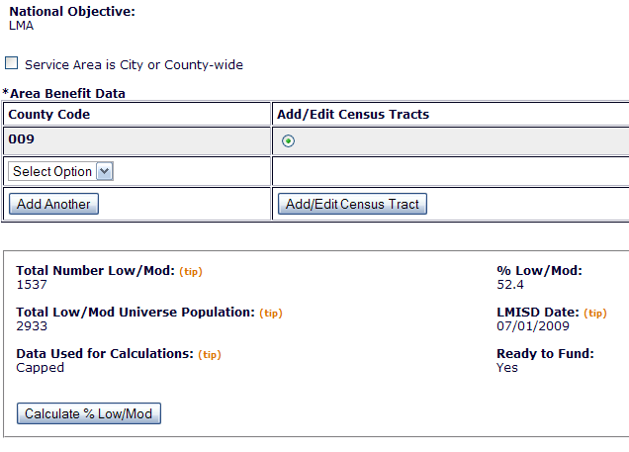
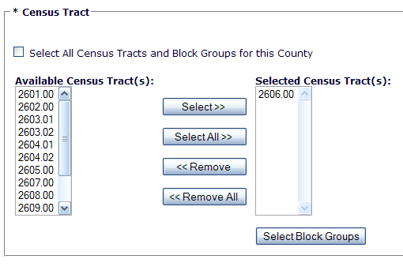
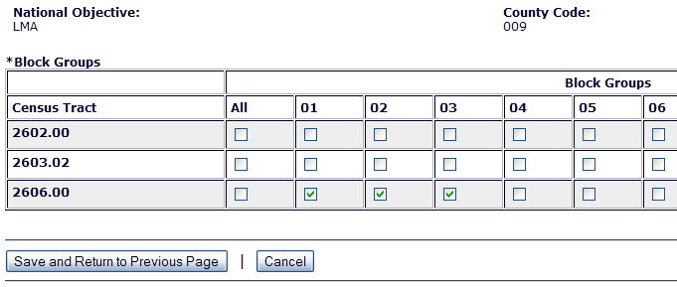
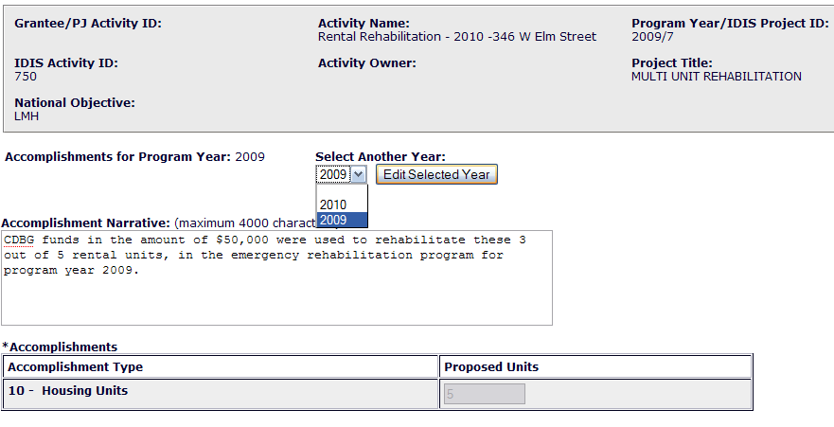
Activity Accomplishments – Activities have direct beneficiaries by Households.
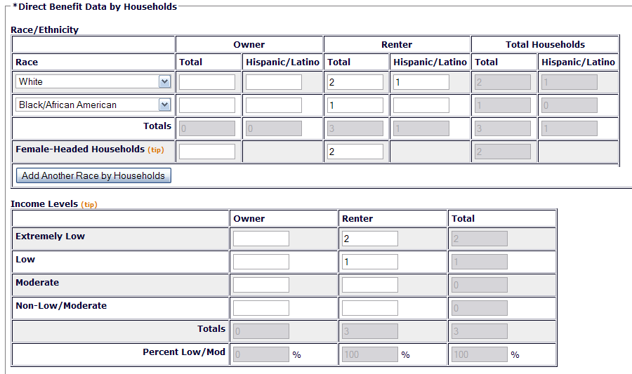

Additional Accomplishments - Activities have direct beneficiaries by Households (Rental Rehab Activity)

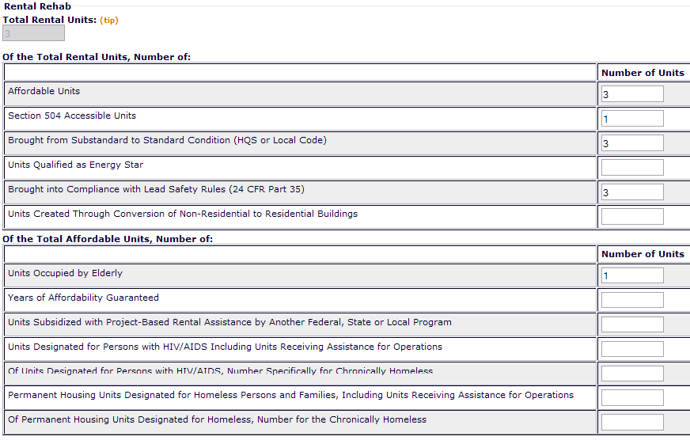
Additional Accomplishments - Activities have direct beneficiaries by Households. (Direct Financial Assistance to Homebuyers)
Additional Accomplishments - Activities have direct beneficiaries by Households. (Home Owner Rehab)
Additional Accomplishments - Activities have direct beneficiaries by Households. (New Construction, Acquisition for Homeowner Units)

Additional Accomplishments - Activities have direct beneficiaries by Households. (New Construction, Acquisition for Rental Units)

Activity Accomplishments – Activities Have Direct Beneficiaries by Persons

Additional Activity Accomplishment - Activities Have Direct Beneficiaries by Persons (LMJ Activities)
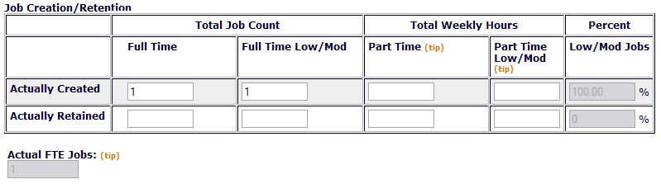
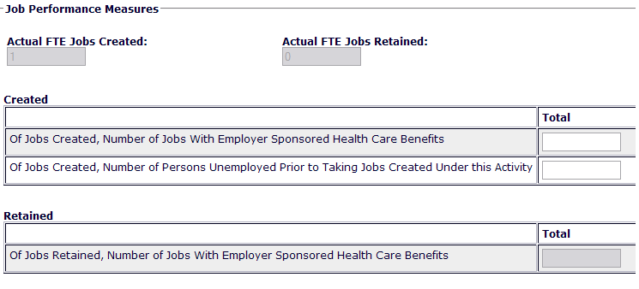
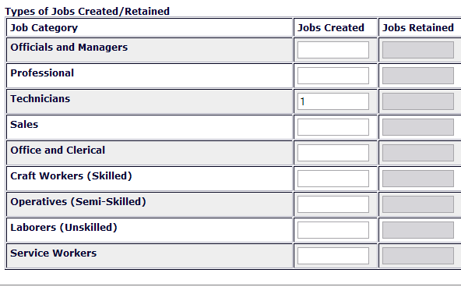
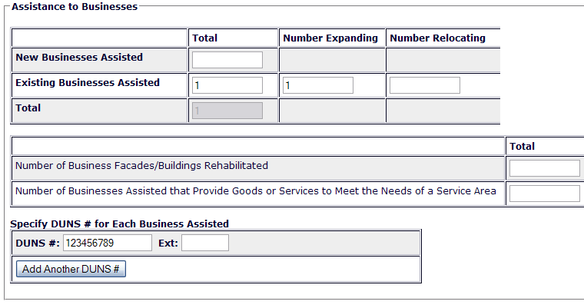
Additional Accomplishments - Beneficiaries by Persons (Public Facilities Activities)
Additional Accomplishments - Beneficiaries by Persons (Public Services Activities)
Additional Accomplishments - Beneficiaries by Persons (Homeless Prevention/Help Homeless Persons)

