|  |  |
| --- | --- |
| **Attachment B: Participant Recruitment and Screening Materials** |  |



**JOIN A DISCUSSION ABOUT HOUSING SEARCH PRACTICES**

**HOSTED BY THE URBAN INSTITUTE**

WHEN: [DAY/DATE & TIME]

WHERE: [LOCATION]

WHY: Urban Institute* is studying how people search for housing and factors affecting their search. We want to hear about your experiences.

Refreshments [and a stipend] will be provided

*Urban Institute is a nonprofit research organization located in Washington, DC.



[*Urban Institute is a nonprofit research organization located in Washington, DC.

*MDRC is a research organization located in New York, NY.]

**RESIDENTS OF [region name]**

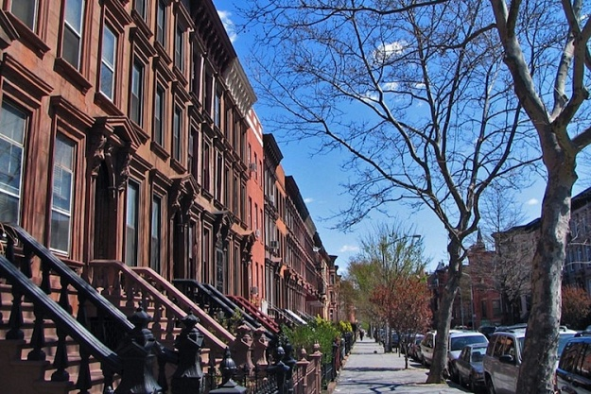

**CALL [NUMBER] FOR MORE INFORMATION**

**Call by [DATE] to see if you’re selected to participate in the focus group.**

**Focus group participation is limited to adults age 18 or older.**