APPLICATION FOR MEDIA BUREAU AUDIO AND VIDEO SERVICE AUTHORIZATION
SCHEDULE A
FCC FORM 2100
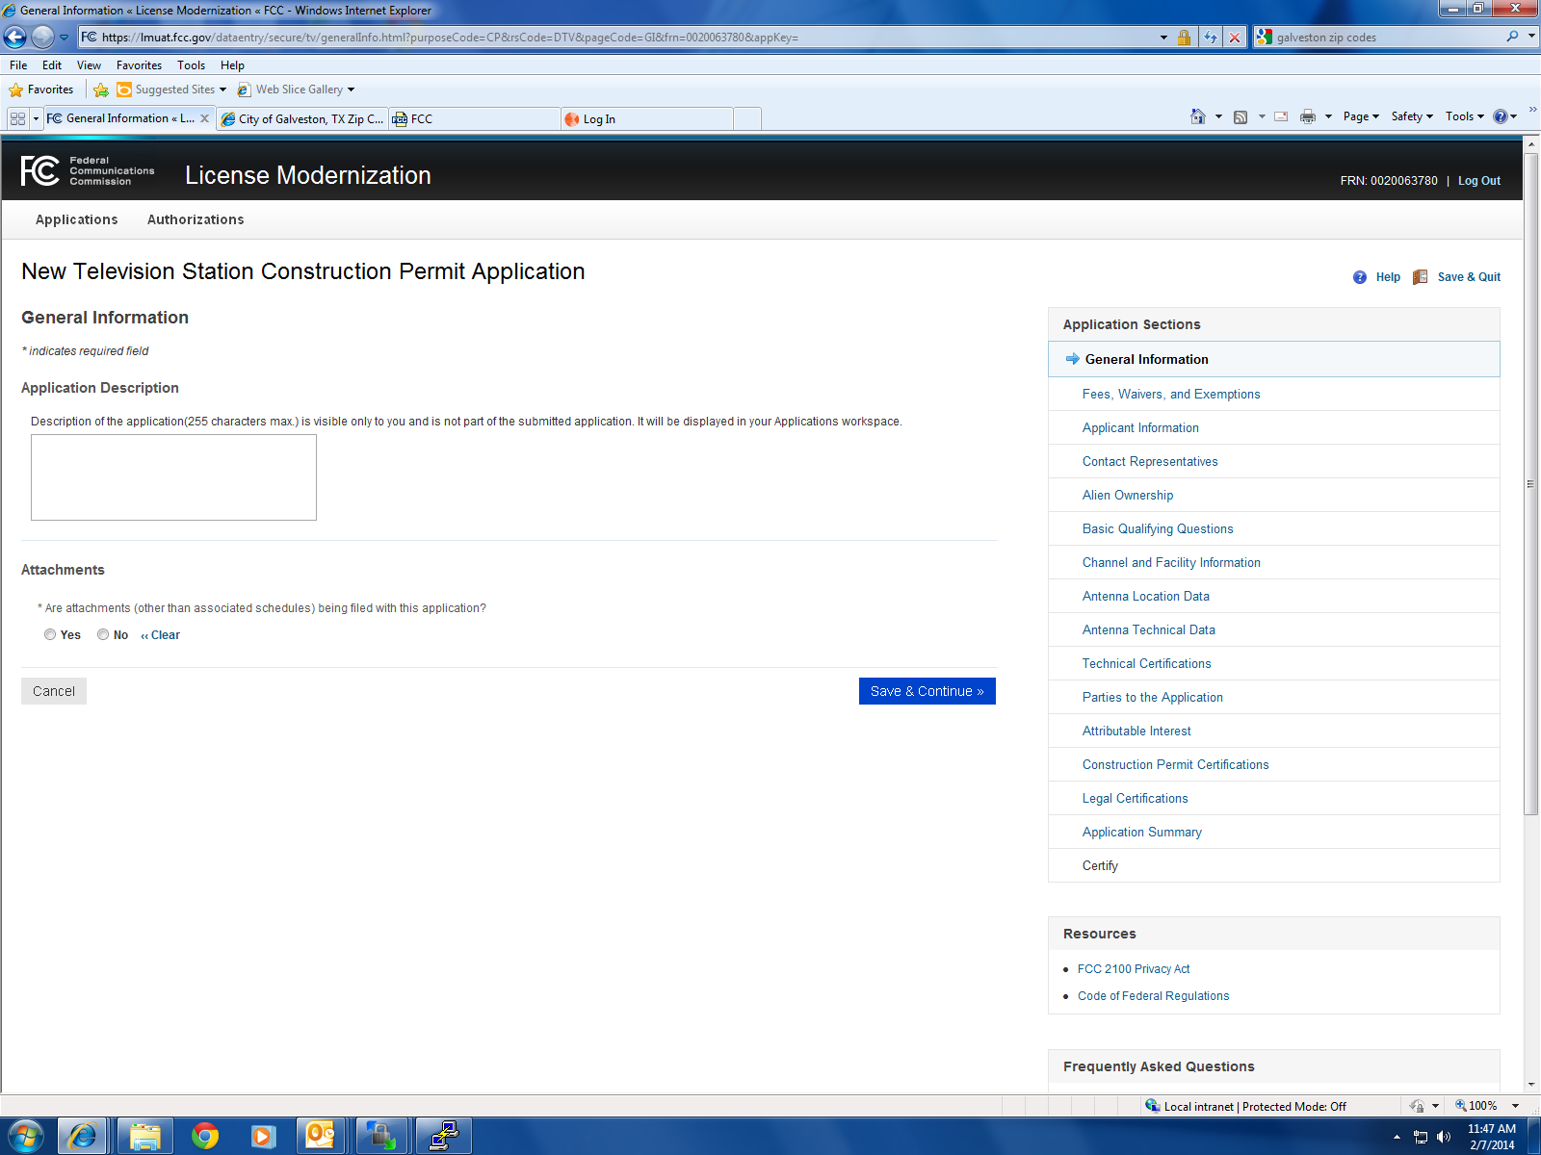

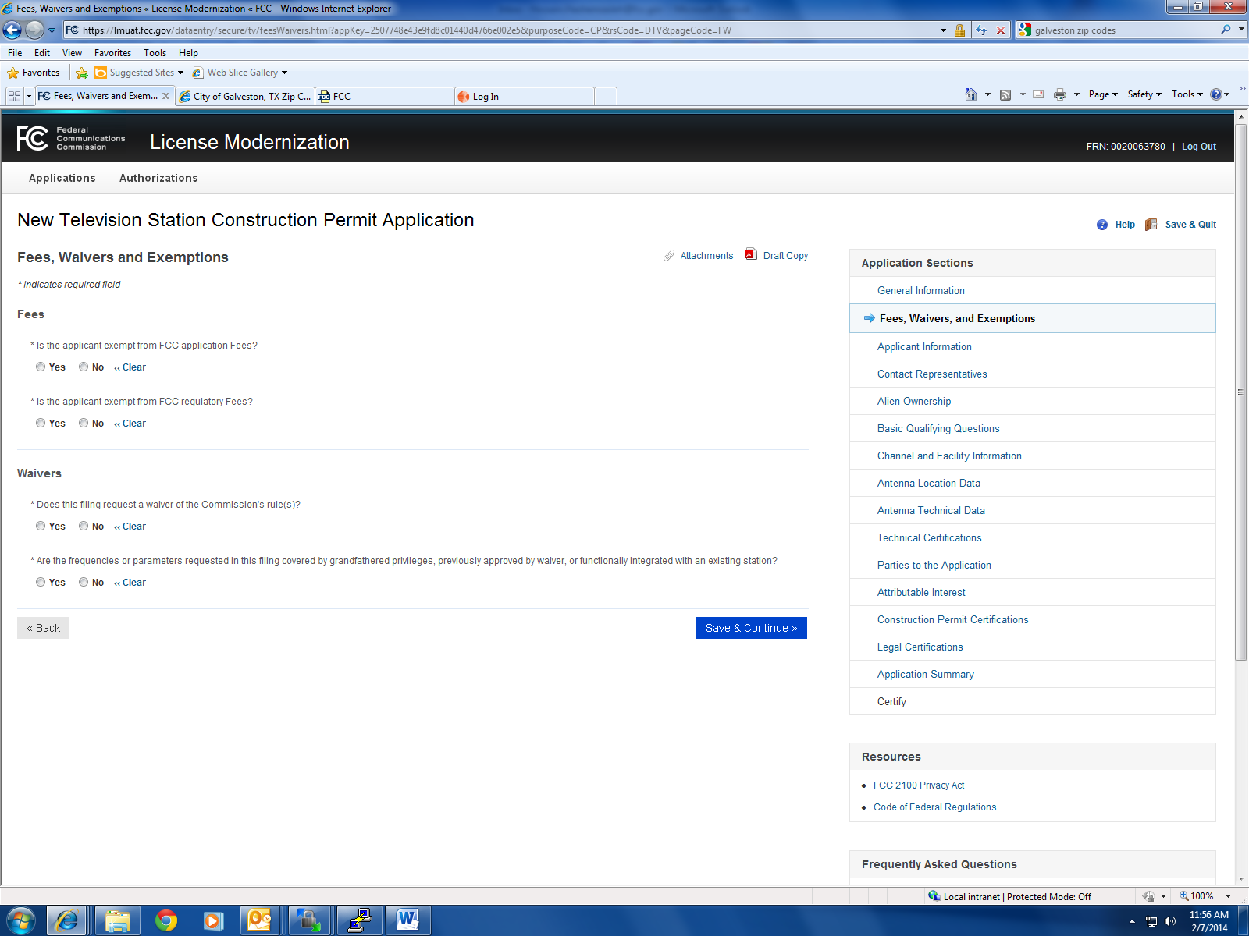

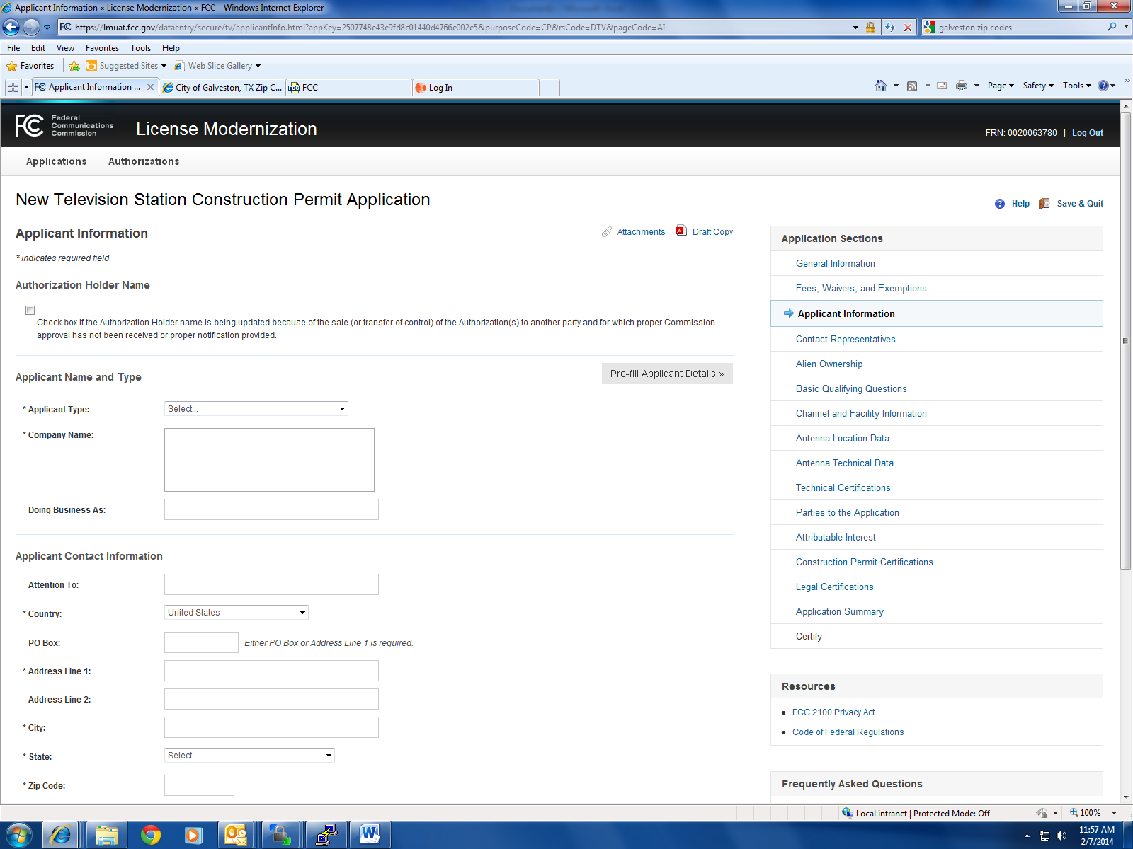

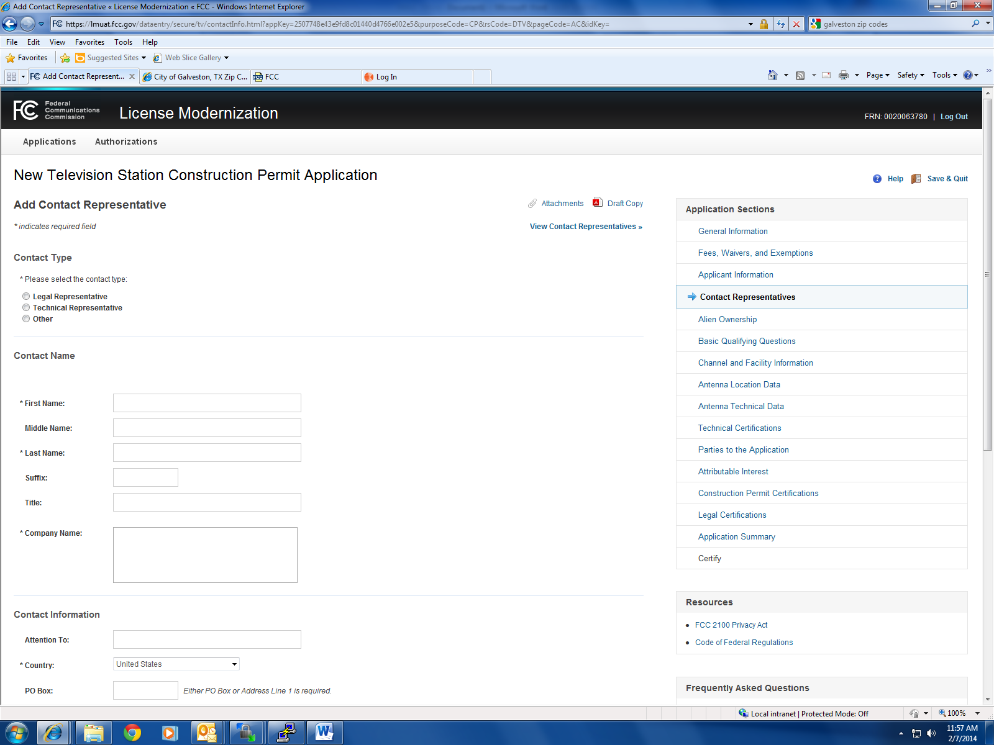

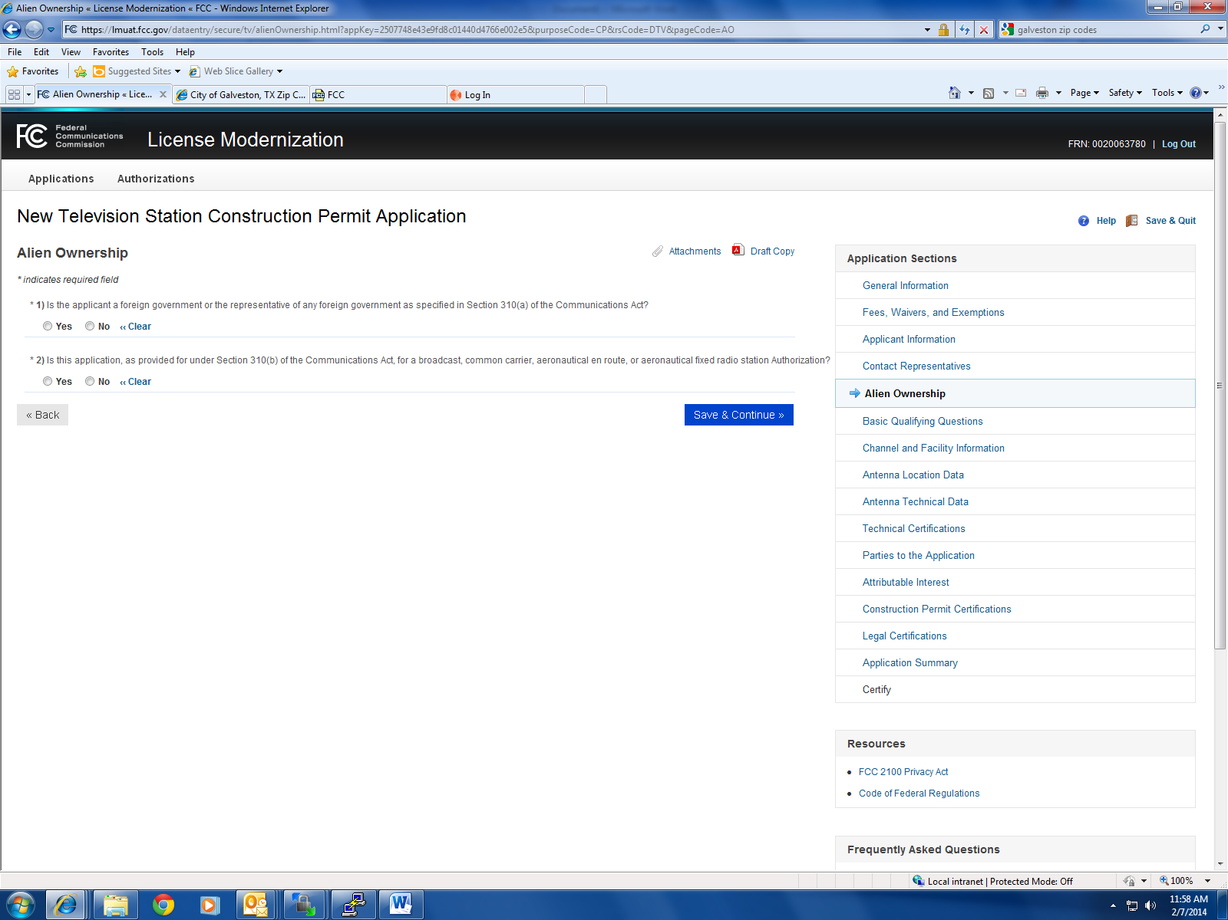

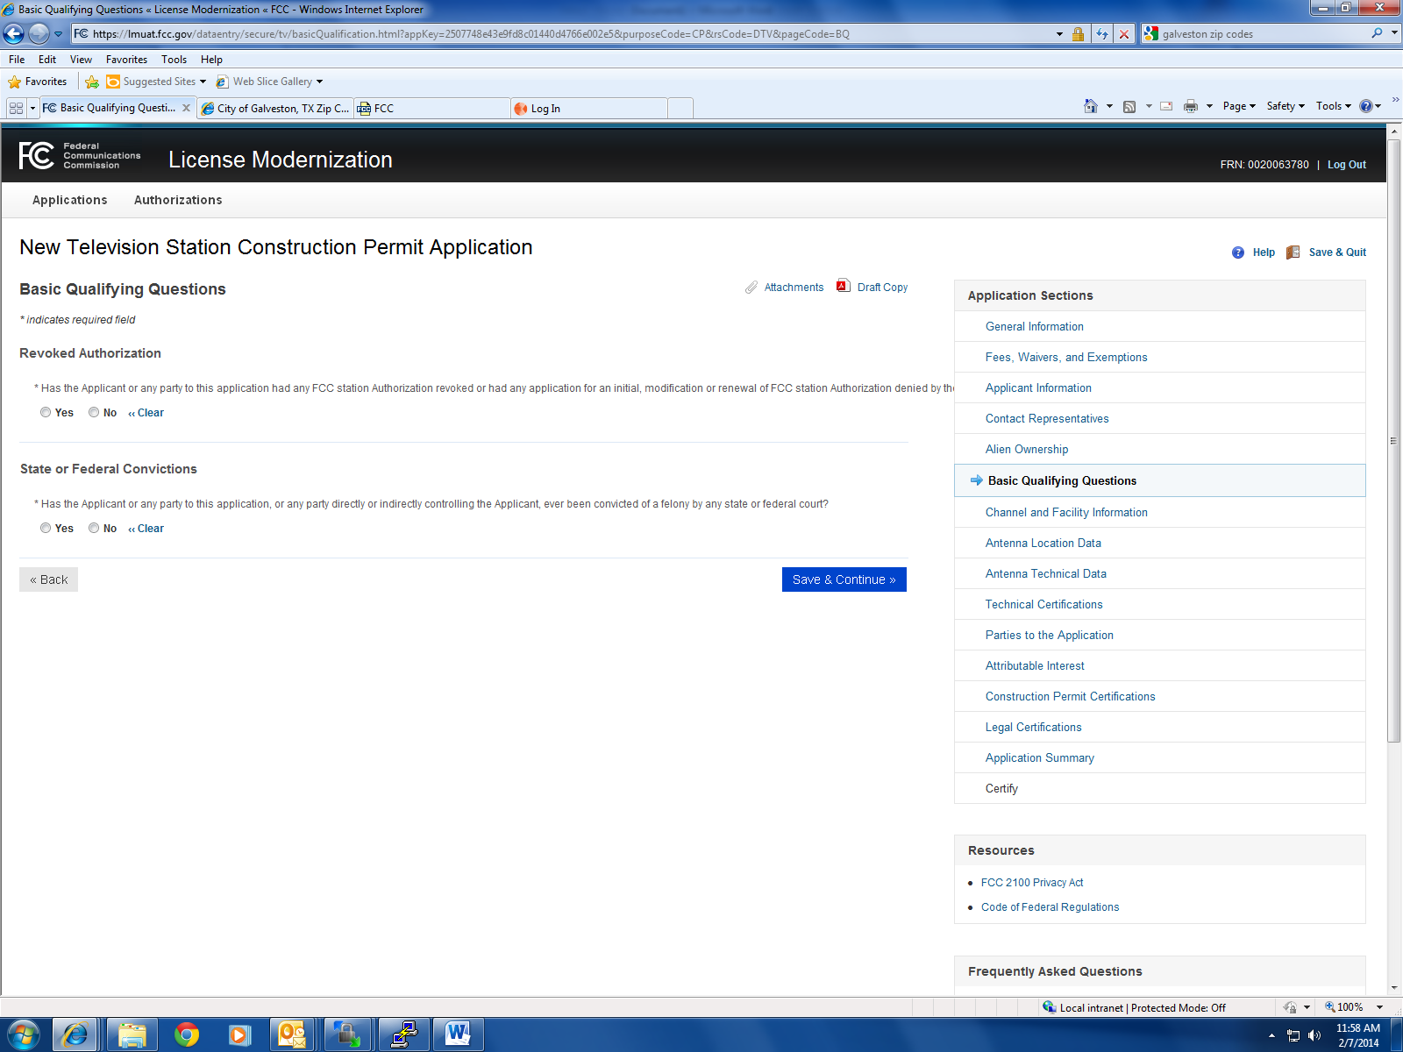

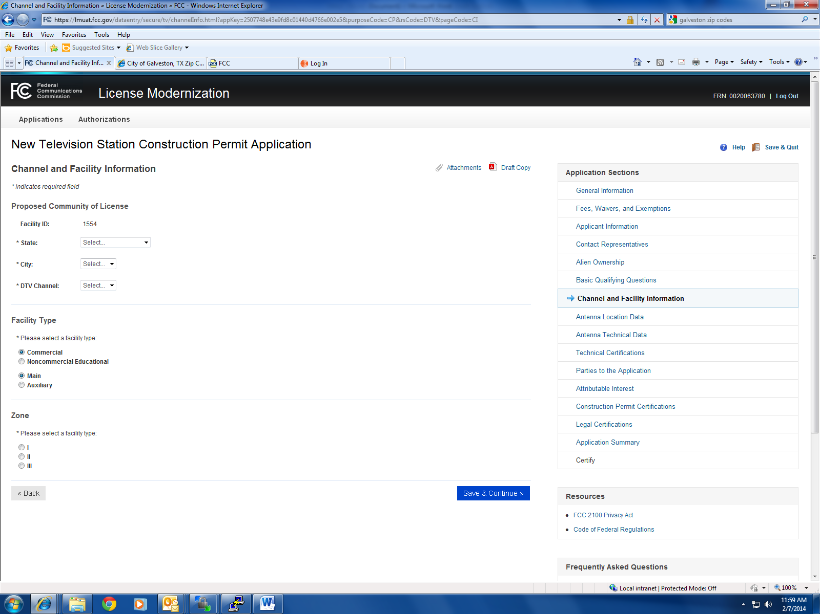

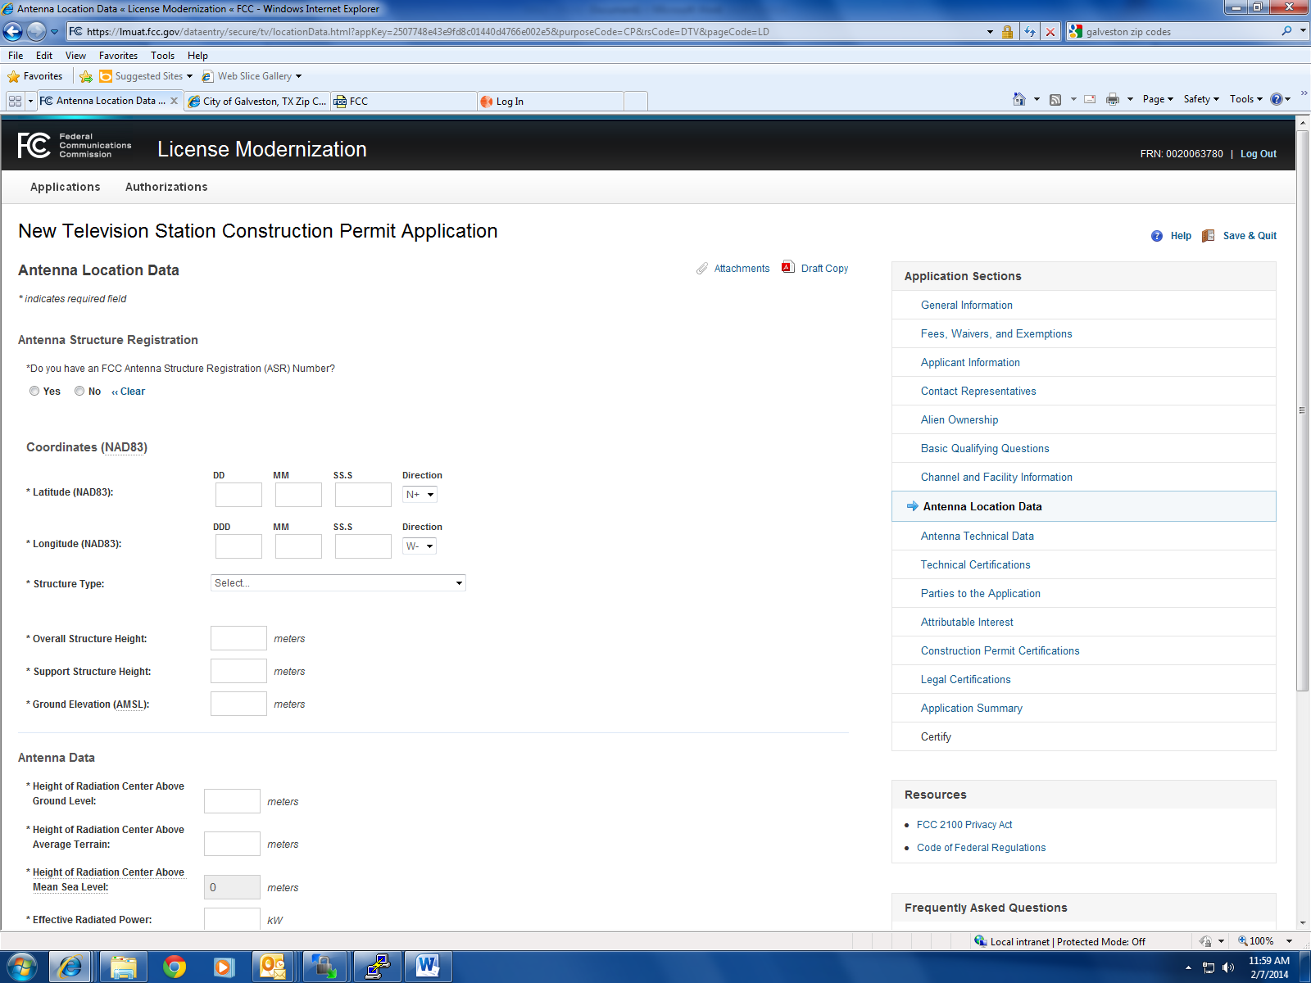

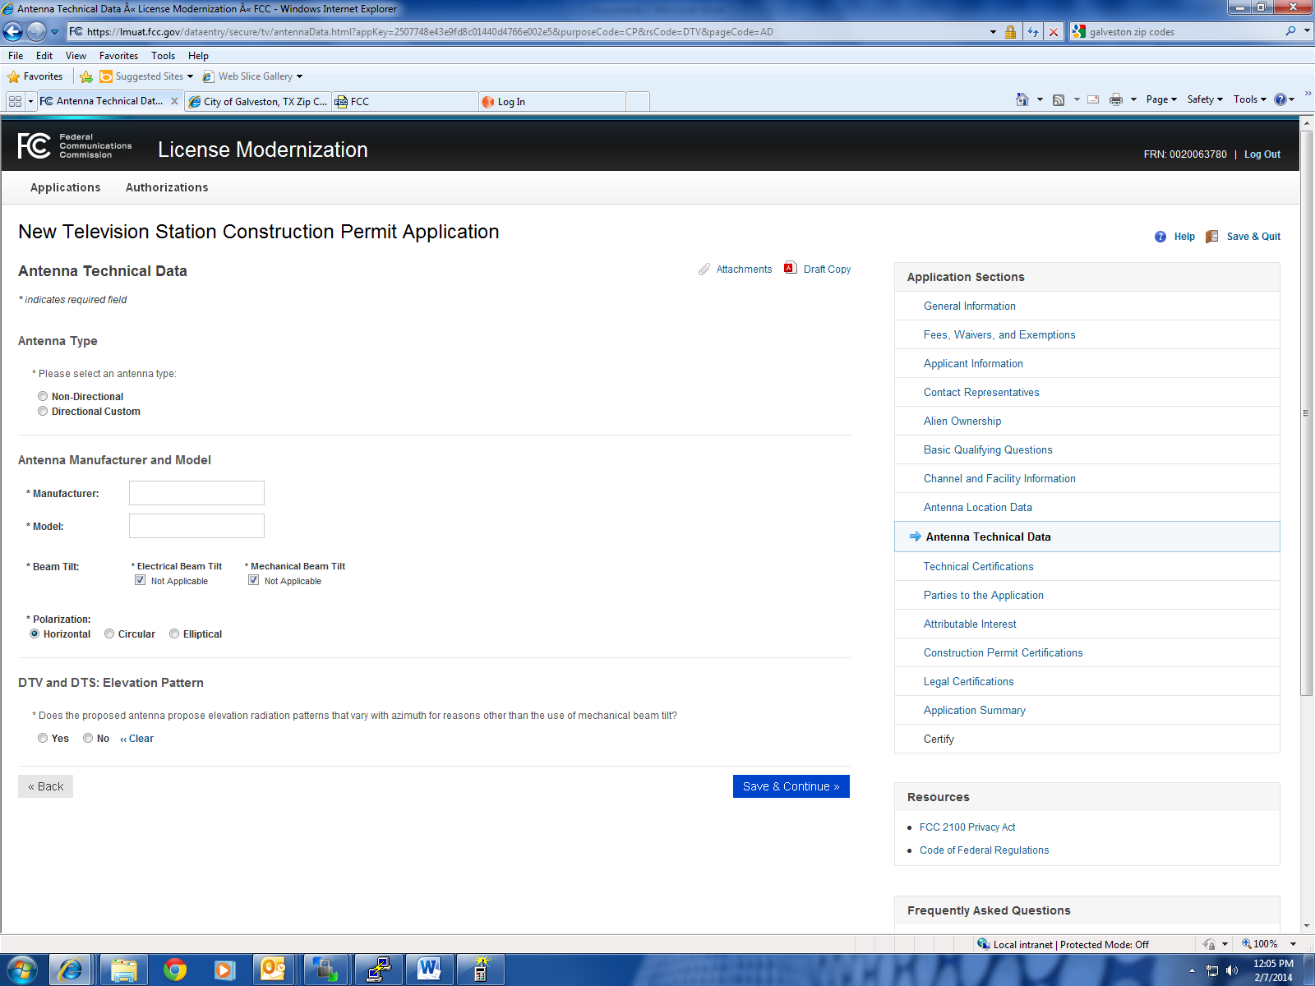

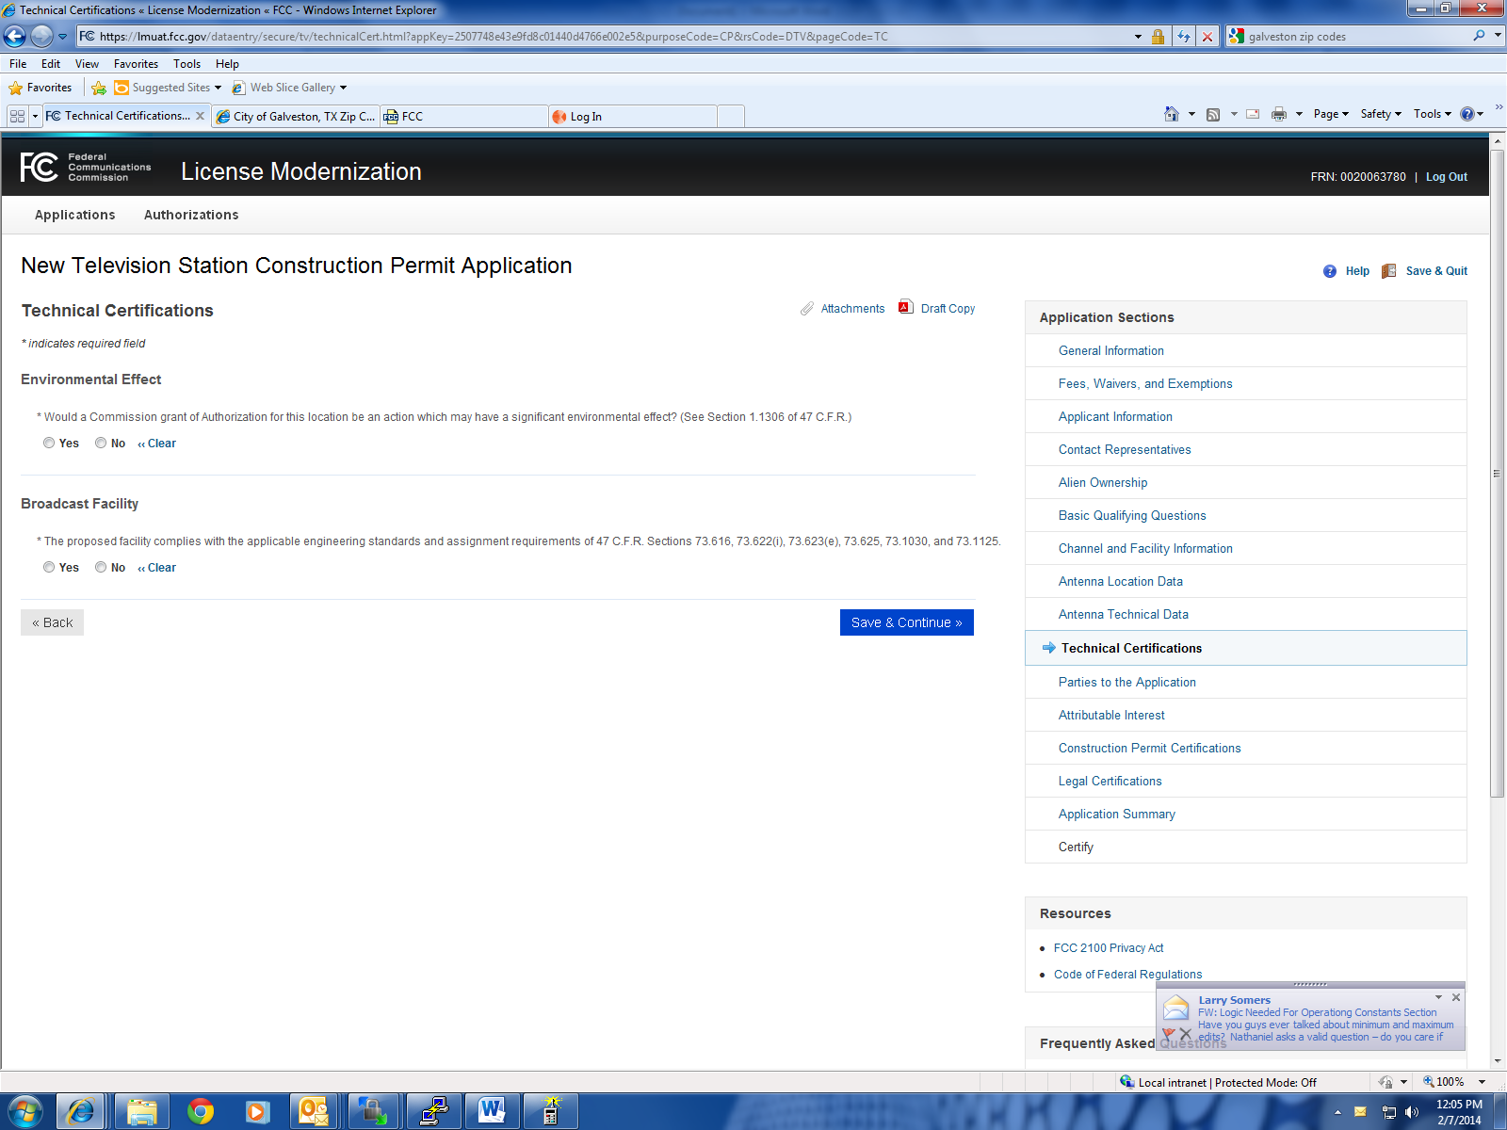

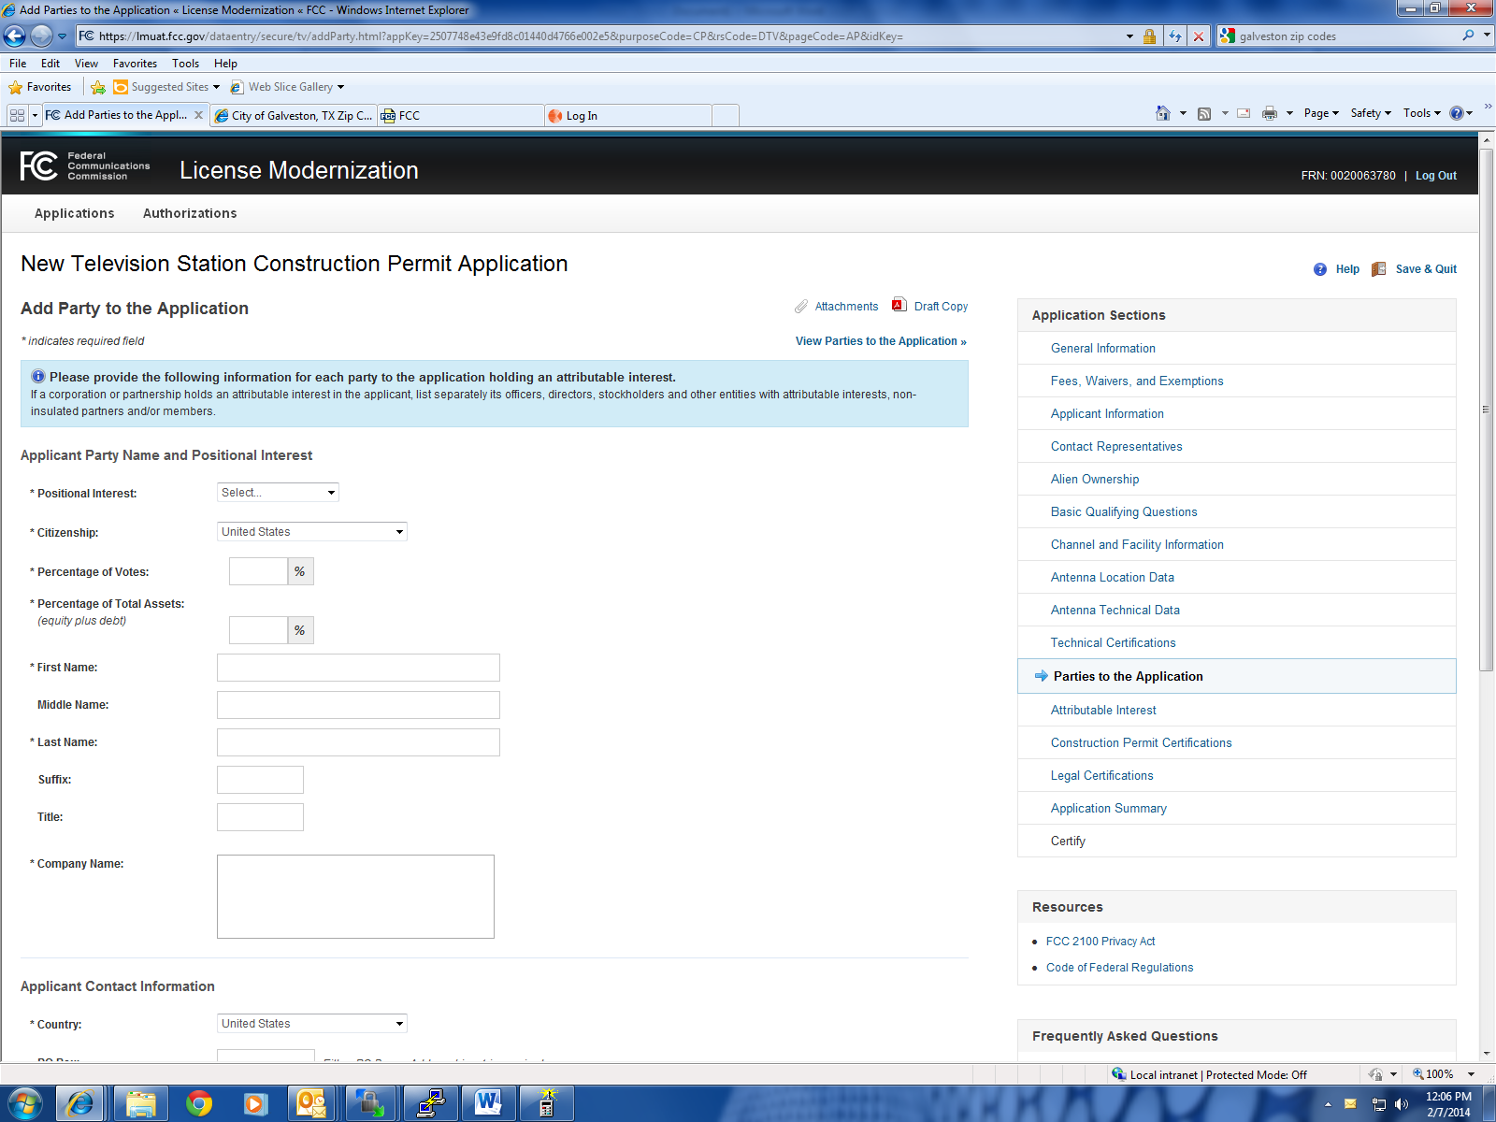

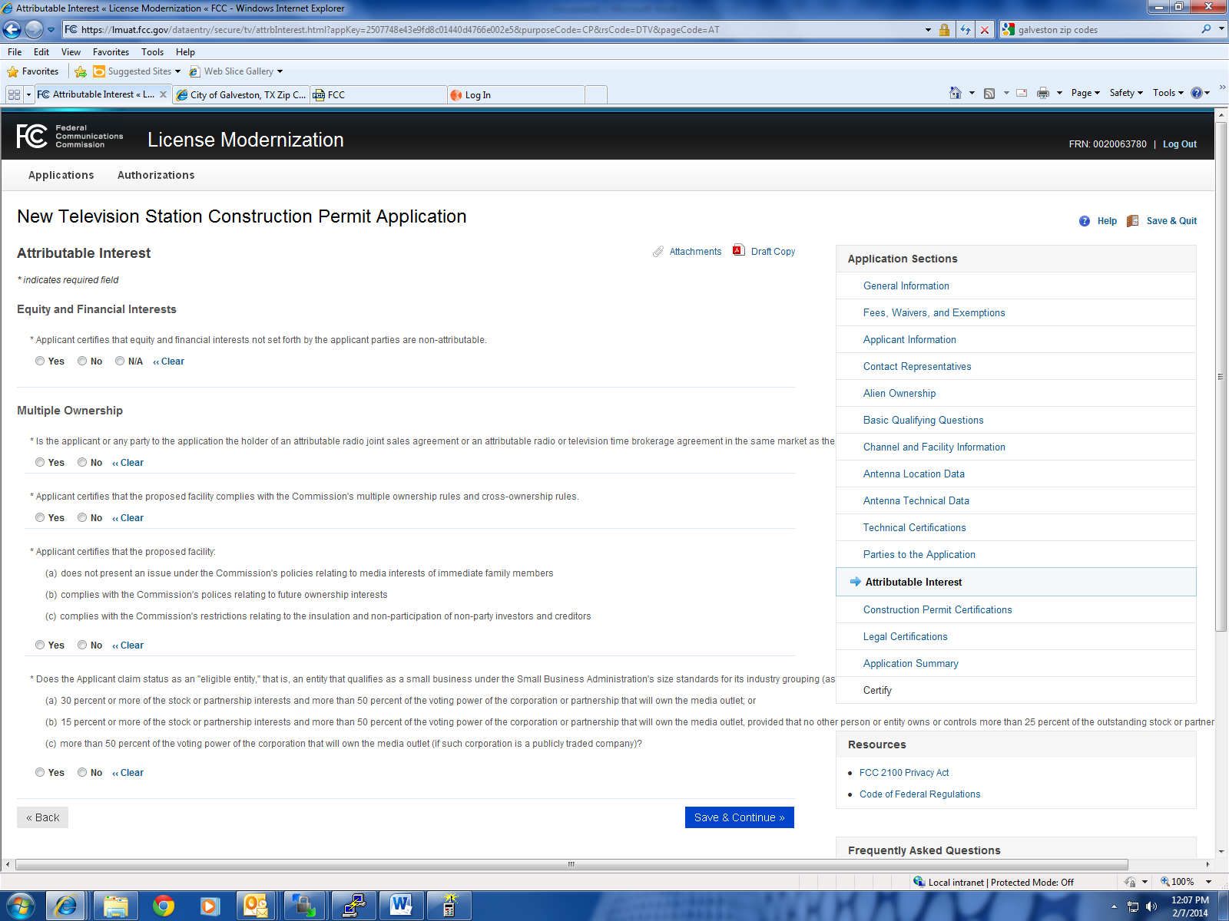

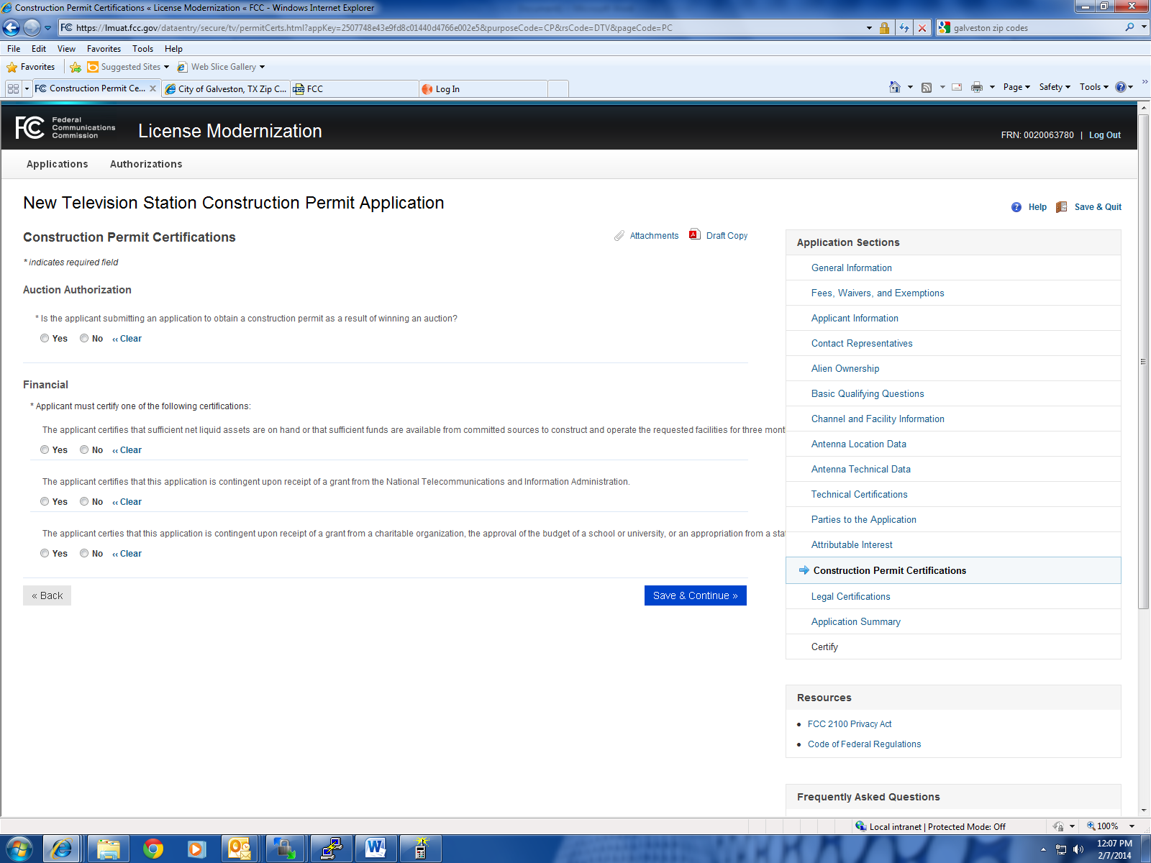

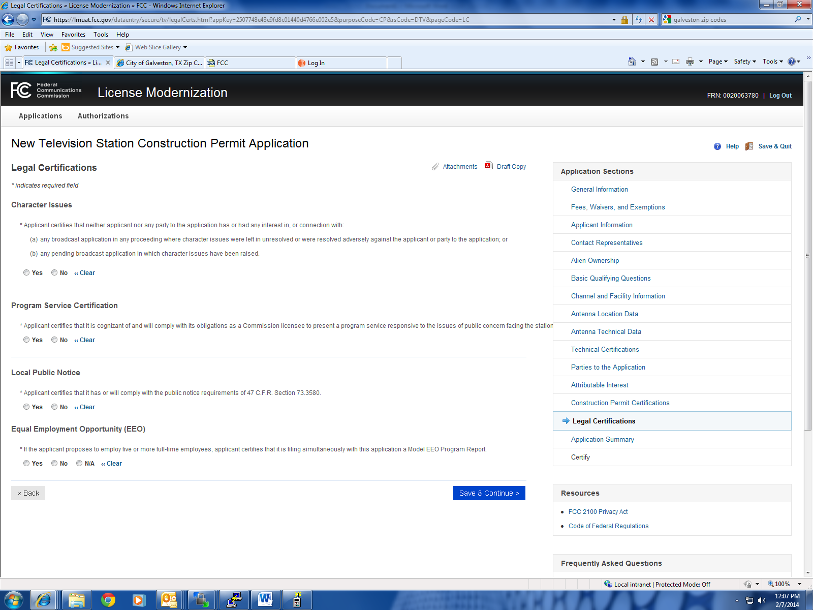

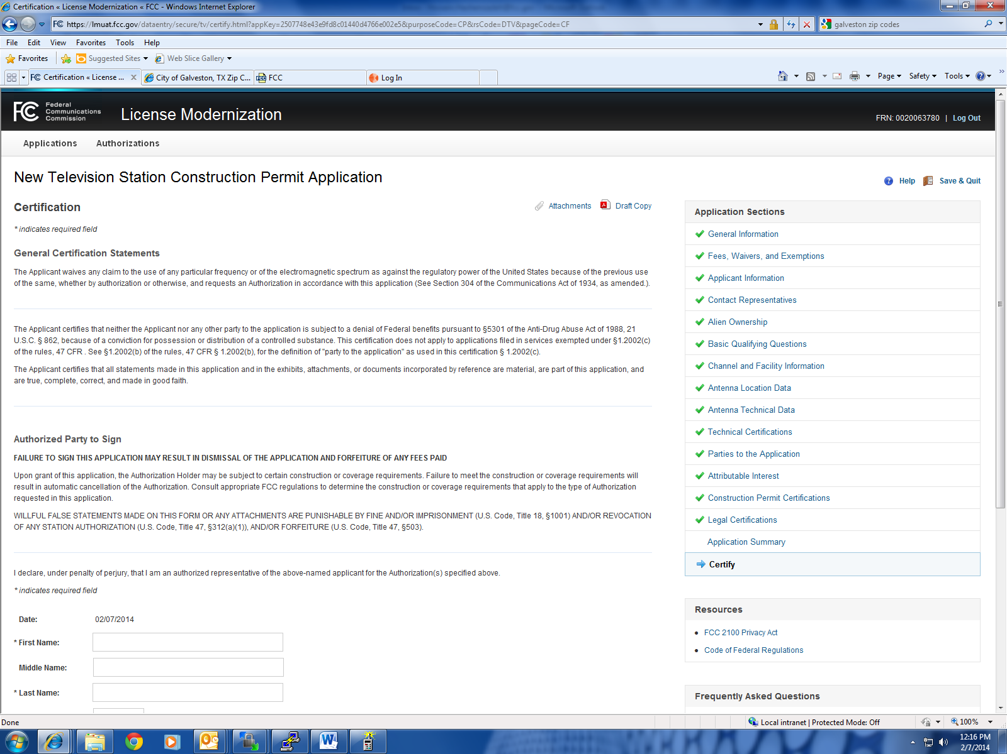
FCC NOTICE REQUIRED BY THE PAPERWORK REDUCTION ACT
We have estimated that each response to this collection of information will take from 3 to 6.25 hours. Our estimate includes the time to read the instructions, look through existing records, gather and maintain the required data, and actually complete and review the form or response. If you have any
comments on this burden estimate, or on how we can improve the collection and reduce the burden it causes you, please e-mail them to pra@fcc.gov or send them to the Federal Communications Commission, AMD-PERM, Paperwork Reduction Project (3060-0027), Washington, DC 20554. Please
DO NOT SEND COMPLETED APPLICATIONS TO THIS ADDRESS. Remember - you are not required to respond to a collection of information sponsored by the Federal government, and the government may not conduct or sponsor this collection, unless it displays a currently valid OMB control number or if we fail to provide you with this notice. This collection has been assigned an OMB control number of 3060-0027.
THE FOREGOING NOTICE IS REQUIRED BY THE PAPERWORK REDUCTION ACT OF 1995, P.L. 104-13,
OCTOBER 1, 1995, 44 U.S.C. 3507.

