Reproduce Locally Include form number and edition date on all reproductions |  |  |  | FORM APPROVED –OMB NO 0581-0272
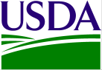 | U.S. Department of Agriculture  Agricultural Marketing Service  Dairy Programs  Request for Applicant Number |  |  |  |  |  | 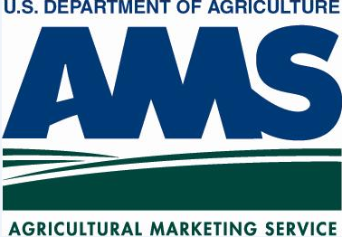
According to the paperwork reduction act of 1995, an agency may not conduct or sponsor, and a person is not required to respond to, a collection of information unless it displays a valid OMB control number. This valid OMB control number for this collection is 0581-0272. The time required to complete this information collection is estimated to average 3 minutes per response, including the time for reviewing instructions, searching existing data sources, gathering and maintaining the data needed, and completing and reviewing the collection information.

The U.S. Department of Agriculture (USDA) prohibits discrimination in all its programs and activities on the basis of race, color, national origin, age, disability, and where applicable, sex, marital status, familial status, parental status, religion, sexual orientation, genetic information, political beliefs, reprisal, or because all or part of an individual’s income is derived from any public assistance program. (Not all prohibited bases apply to all programs.) Persons with disabilities who require alternative means for communication of program information (Braille, large print, audiotape, etc.) should contact USDA’s TARGET Center at (202) 720-2600 (voice and TDD).

To file a complaint of discrimination, write to USDA, Director, Office of Civil Rights, 1400 Independence Avenue, S.W., Washington, D.C. 20250-9410, or call (800) 795-3272 (voice) or (202) 720-6382 (TDD). USDA is an equal opportunity provider and employer.

NOTE: The following statements are made in accordance with the Privacy Act of 1974 (U.S.C. 522a) and the Paperwork Reduction Act of 1995, as amended. The authority for requesting this information to be supplied on this form is the Agricultural Marketing Agreement Act of 1937, Secs. 1-19, 48 Stat. 31, as amended, (7 U.S.C. 601-674). Furnishing the requested information is necessary for the administration of this program. Submission of the Tax Identification Number (TIN) is mandatory, and will be used to determine affiliation or entity identity.
1. COMPANY NAME
AS REGESTERED WITH THE IRS
2. FEDERAL TAX ID NUMBER
3. DOING BUSINESS AS
IF APPLICABLE
4. BILLING ADDRESS LINE 1
5. BILLING ADDRESS LINE 2
6. CITY |  |  | 7. STATE |  | 8. ZIP CODE
9. CONTACT
10. PHONE NUMBER |  |  |  |  |  | EXT
11. FAX NUMBER
12. E-MAIL ADDRESS
13. COMPANY MAILING ADDRESS  (IF DIFFERENT THAN BILLING) |  | 14. P.O. BOX AND/OR STREET ADDRESS
 |  | 15. CITY, STATE, ZIP
16. CONTACT FOR MAILING ADDRESS
(IF DIFFERENT THAN BILLING)
17.E-MAIL FOR CONTACT
(IF DIFFERENT THAN BILLING)
MAIL TO: | PLEASE SUBMIT THE COMPLETED FORM TO THE DAIRY GRADING PROGRAM  PHONE: 630-437-5073  FAX: 630-437-5060  EMAIL: DairyNFO@ams.usda.gov  USDA, AMS, DAIRY  2150 WESTERN COURT, SUITE 100  LISLE, IL 60532
DA-228 (12/13)

