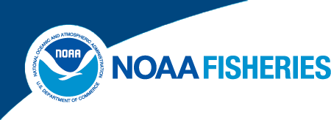

February 3, 2014

Overview of the Pacific Halibut Catch Sharing Plan for Area 2C and Area 3A
- Purpose
The Halibut Catch Sharing Plan in International Pacific Halibut Commission (IPHC) Regulatory Area 2C (Southeast Alaska) and Area 3A (South central Alaska) was adopted by the North Pacific Fishery Management Council (Council) and implemented by the National Marine Fisheries Service (NMFS) in January 2014 (Federal Register, Volume 78, pages 75844-75895, December 12, 2013). The Catch Sharing Plan (CSP) defines an annual process for allocating halibut between the charter and commercial halibut fisheries in Areas 2C and 3A. It establishes sector allocations that vary in proportion with changing levels of annual halibut abundance and that balance the differing needs of the charter and commercial halibut fisheries over a wide range of halibut abundance in each area. The CSP describes a public process by which the Council develops recommendations to the IPHC for charter angler harvest restrictions that are intended to limit harvest to the annual charter halibut fishery catch limit in each area. The CSP also authorizes limited annual leases of commercial individual fishing quota (IFQ) for use in the charter fishery as guided angler fish (GAF).
- Specification of the Annual Combined Catch Limits
Each year, at its annual meeting in January, the IPHC will specify an annual combined catch limit (CCL) for Area 2C and for Area 3A for the upcoming fishing year. Each area’s annual CCL in net pounds will be the total allowable halibut harvest for the directed commercial halibut fishery plus the total allowable halibut harvest for the charter halibut fishery under the CSP. The IPHC process for determining the annual CCL under the CSP will be similar to the process it has typically used in the past for determining annual commercial catch limits. A notable exception is how each fishery’s wastage will be deducted from the CCL. This process is detailed in Figure 1 below.
The IPHC will divide the annual combined catch limits into separate annual catch limits for the commercial and charter halibut fisheries pursuant to the CSP’s allocation formulas. The IPHC will multiply the CSP allocation percentages for each area by the annual CCL to calculate the commercial and charter halibut allocations in net pounds. Under the Catch Sharing Plan, the commercial and charter halibut fisheries are separately accountable for their discard mortality or “wastage,” such that each fishery’s wastage will be deducted from its respective allocation to obtain its catch limit (see Figure 1).

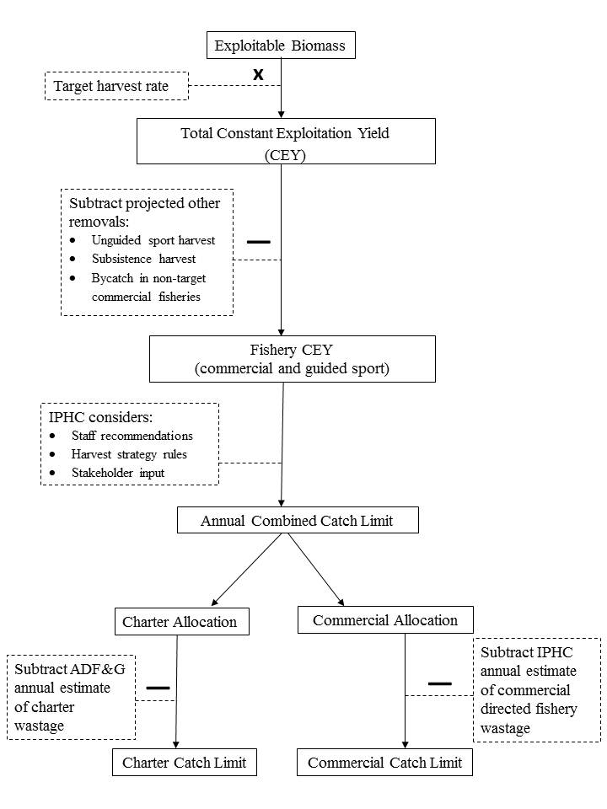
Figure 1. Process for Setting Annual Combined Catch Limits, Charter and Commercial Allocations, and Charter and Commercial Catch Limits for Area 2C and Area 3A under the Catch Sharing Plan.

The Catch Sharing Plan established three allocation tiers for Area 2C as shown in Table 1. When the IPHC sets an annual CCL of less than 5,000,000 lb in Area 2C, the commercial halibut fishery allocation is 81.7 percent and the charter halibut fishery allocation is 18.3 percent of the annual CCL. When the IPHC sets the annual CCLs at the second tier, between 5,000,000 lb and 5,755,000 lb, the allocation to the charter halibut fishery is a fixed 915,000 lb. The commercial halibut fishery is allocated the Area 2C CCL minus the 915,000 lb fixed allocation to the charter halibut fishery. When the IPHC sets the annual CCL at the third tier, greater than 5,755,000 lb, in Area 2C, the commercial halibut fishery allocation is 84.1 percent and the charter halibut fishery allocation is 15.9 percent of the Area 2C annual CCL.
For 2014, the IPHC set a CCL for Area 2C of 4,160,000 lb, resulting in an 18.3 percent allocation to the charter fishery and 81.7 percent to the commercial fishery. After subtracting an estimate of 80,000 lb wastage from the commercial sector allocation, the commercial catch limit is 3,318,720 lb. The Area 2C charter sector catch limit is 761,280 lb. A wastage estimate for the charter fishery was incorporated into projections of charter harvest under the annual management measures recommended by the Council.
Table 1. Area 2C Catch Sharing Plan (CSP) Allocations to the Charter and Commercial Halibut Fisheries Relative to the Annual Combined Catch Limit (CCL)
Area 2C annual combined catch limit  for halibut in net pounds (lb) | Charter halibut fishery CSP  allocation (% of annual  combined catch limit) | Commercial halibut fishery CSP  allocation (% of annual  combined catch limit)
0 to 4,999,999 lb | 18.3% | 81.7%
5,000,000 to 5,755,000 lb | 915,000 lb | Area 2C CCL minus 915,000 lb
5,755,001 lb and up | 15.9% | 84.1%

The Catch Sharing Plan established five allocation tiers in Area 3A as shown in Table 2. For Area 3A, when the IPHC sets the annual CCLs at the first tier of less than 10,000,000 lb, the commercial halibut fishery allocation is 81.1 percent and the charter halibut fishery allocation is 18.9 percent of the Area 3A annual CCL. For Area 3A annual CCLs between 10,000,000 lb and 10,800,000 lb, the allocation to the charter halibut fishery is 1,890,000 lb. The commercial halibut fishery is allocated the Area 3A CCL minus the 1,890,000 lb fixed allocation to the charter halibut fishery. When the CCL is greater than 10,800,000 lb and less than 20,000,000 lb, the commercial halibut fishery is allocated 82.5 percent and the charter fishery is allocated 17.5 percent. When the CCL for Area 3A is set at greater than 20,000,000 lb and less than or equal to 25,000,000 lb, the charter halibut fishery receives a fixed 3,500,000 lb allocation. The commercial halibut fishery allocation equals the CCL minus 3,500,000 lb. Finally, at CCLs greater than 25,000,000 lb, the commercial halibut fishery allocation is 86 percent and the charter halibut fishery allocation is 14 percent of the Area 3A annual CCL.
For 2014, the IPHC set a CCL for Area 3A of 9,430,000 lb, resulting in an 18.9% allocation to the charter fishery and 81.1% to the commercial fishery. After subtracting an estimate of 330,000 lb wastage from the commercial sector allocation, the commercial catch limit is 7,317,730 lb. The Area 3A charter sector catch limit is 1,782,270 lb. A wastage estimate for the charter fishery was incorporated into projections of charter harvest under the annual management measures recommended by the Council.
Table 2. Area 3A Catch Sharing Plan (CSP) Allocations to the Charter and Commercial Halibut Fisheries Relative to the Annual Combined Catch Limit (CCL)
Area 3A annual combined catch limit  for halibut in net pounds (lb) | Charter halibut fishery CSP  allocation (% of annual  combined catch limit) | Commercial halibut fishery CSP  allocation (% of annual  combined catch limit)
0 to 9,999,999 lb | 18.9% | 81.1%
10,000,000 to 10,800,000 lb | 1,890,000 lb | Area 3A CCL minus 1,890,000 lb
10,800,001 to 20,000,000 lb | 17.5% | 82.5%
20,000,001 to 25,000,000 lb | 3,500,000 lb | Area 3A CCL minus 3,500,000 lb
25,000,001 lb and up | 14.0% | 86.0%

- Annual Process for Setting Charter Management Measures
Each year, through a transparent public process, the Council will review and recommend annual management measures for implementation in the charter halibut fishery. Each fall, the Council will review an analysis of potential charter management measures for the Area 2C and Area 3A charter halibut fisheries for the upcoming fishing year. The Council will also consider stakeholder input and the most current information regarding the charter fishery and its management. After reviewing the analysis and considering public testimony, the Council will identify the charter halibut management measures to recommend to the IPHC that will most likely constrain charter halibut harvest for each area to its catch limit, while considering impacts on charter operations. The IPHC will consider the Council recommendations, along with the analysis upon which those recommendations were based, and input from its stakeholders and staff. The IPHC then will adopt either the Council’s recommendations or alternative charter halibut management measures designed to keep charter harvest in Area 2C and Area 3A to the allocations specified under the Catch Sharing Plan. These measures are necessary to limit the combined commercial and charter harvest in Area 2C and 3A within each area’s combined catch limit. NMFS will publish in the Federal Register the charter halibut management measures for each area as part of the IPHC annual management measures once accepted by the Secretary of State with the concurrence of the Secretary of Commerce.

IPHC Recommended Charter Management Measures for 2014
The IPHC and Council recommend the following management measures for the charter fisheries in Area 2C and Area 3A for 2014. These measures will be implemented for 2014 if accepted by the Secretary of State with the concurrence of the Secretary of Commerce and published in the Federal Register. NMFS anticipates that if the recommended 2014 annual management measures are approved, they will be published and effective in early March 2014. Until superseded, the management measures from 2013 remain effective.
The recommended management measures for the 2014 guided sport fishery are:
Area 2C
- One-fish daily bag limit with a U44/O76 reverse slot limit. Retained halibut must be under 44” (U44) or over 76” (O76) total length.
- If halibut are filleted at sea, the entire carcass (with head and tail connected as a single piece) must be retained onboard the vessel until all fillets are offloaded. This carcass retention requirement facilitates the enforcement of size limits.
Area 3A
- Two-fish daily bag limit with a maximum size of 29” total length for one of the two fish.
- Limit of one trip in which anglers retain halibut per vessel per calendar day.
- If halibut are filleted at sea, the entire carcass (with head and tail connected as a single piece) must be retained onboard the vessel until all fillets are offloaded. This carcass retention requirement facilitates the enforcement of size limits.

- Guided Angler Fish
The Catch Sharing Plan authorizes supplemental individual transfers of commercial halibut IFQ as guided angler fish (GAF) to qualified charter halibut permit holders for harvest by charter vessel anglers in Areas 2C and 3A. Using GAF, qualified charter halibut permit holders may offer charter vessel anglers the opportunity to retain halibut up to the limit for unguided anglers when the charter management measure in place limits charter vessel anglers to a more restrictive harvest limit.
NMFS will issue GAF in numbers of halibut. NMFS will post the conversion from IFQ pounds to GAF for Area 2C and Area 3A for each fishing year on the NMFS Alaska Region website. NMFS will post the conversion factor for the current fishing year before the beginning of the commercial halibut fishing season each year. For 2014, the conversion factor will be 26.4 lb IFQ per GAF for Area 2C and 12.8 lb IFQ per GAF for Area 3A.
Eligibility
An IFQ holder is eligible to transfer halibut IFQ as GAF if he or she holds at least one unit of halibut QS and has received an annual IFQ permit authorizing harvest of IFQ in either the Area 2C and Area 3A commercial halibut fishery. A charter halibut permit holder is eligible to receive IFQ as GAF if he or she holds one or more charter halibut permits in the management area that corresponds to the IFQ permit area from which the IFQ would be transferred. A person who holds IFQ and a charter halibut permit may transfer that IFQ to him/herself, up to the established transfer limits. Holders of military charter halibut permits and Community Quota Entities holding community charter halibut permits also are eligible to receive IFQ as GAF.
For transfers between IFQ and GAF, the IFQ holder and charter halibut permit holder receiving GAF are required to submit an application to NMFS. Charter halibut permit holders must also have reliable access to the internet for timely reporting of GAF harvests (see Reporting GAF harvests section below).
Transfers of IFQ to GAF
Transfers of IFQ to GAF must be approved by NMFS. Applications for GAF transfers are available on the NMFS website at http://alaskafisheries.noaa.gov/ram/charter/apps_permits.htm. Complete applications must be submitted to NMFS, Restricted Access Management (RAM) Program for review and approval. For assistance in completing the transfer application call NMFS, RAM at 1-800-304-4846 (select option #2) or in Juneau at 907-586-7202.
Upon completion of the transfer between IFQ and GAF, NMFS will issue a GAF permit to the holder of a charter halibut permit. The GAF permit will be assigned to the charter halibut permit specified by the GAF permit holder at the time of application. The GAF permit holder may offer GAF for harvest by charter vessel anglers on board the vessel on which the operator’s GAF permit and the assigned charter halibut permit are used.
Charter operators will be required to possess GAF in their GAF permit accounts prior to allowing charter vessel anglers to retain halibut as GAF. Transfers cannot occur after the fish have been caught. The GAF permit holder also will be required to have the GAF permit and the assigned charter halibut permit on board the vessel on which charter vessel anglers retain GAF, and to present the permits if requested by an authorized enforcement officer. GAF permit holders will be required to retain all GAF permits and GAF permit logs for two years after the date of issuance and to make them available for inspection upon request of an authorized enforcement officer. GAF permit account balances can be checked online at https://alaskafisheries.noaa.gov/webapps/efish/login.
NMFS will issue a revised GAF permit to the GAF permit holder each time during the year that it approves a transfer between IFQ and GAF for that GAF permit. Each GAF permit will be assigned to only one charter halibut permit in Area 2C or Area 3A, specified on the application for transfer between IFQ and GAF. That assignment cannot be changed during the year. Once GAF is transferred to a charter halibut permit holder and assigned to a specified charter halibut permit, it may not be transferred to another charter halibut permit holder.
Returns of unused GAF
Unused GAF may be returned to the IFQ holder by two methods: 1) a voluntary return that can be requested in August and that will be completed on or after September 1; and 2) an automatic return 15 days before the end of the commercial halibut fishing season. On and after the automatic return date, unused GAF will no longer be authorized for use in the charter fishery in the current year. Applications for transfer of IFQ to GAF will not be accepted during the one month prior to the automatic return date, to ensure that all GAF transactions are completed before the automatic return date. No application is required for the automatic return of unused GAF. NMFS will return any remaining unharvested GAF to the IFQ holder from whom it was derived. On or as soon as possible after the voluntary or automatic GAF return dates, NMFS will convert GAF in number of fish to IFQ in net pounds using the conversion factor for that year and return the converted IFQ to the IFQ holder’s account.

Restrictions on GAF transfers
The Catch Sharing Plan includes three restrictions on GAF transfers. First, IFQ holders in Area 2C will be limited to transferring up to 1,500 lb or 10 percent, whichever is greater, of their initially issued annual halibut IFQ for use as GAF. In Area 3A, IFQ holders may transfer up to 1,500 lb or 15 percent, whichever is greater, of their initially issued annual halibut IFQ for use as GAF. Second, no more than a total of 400 GAF will be assigned during one year to a GAF permit assigned to a charter halibut permit that is endorsed for six or fewer anglers. And third, no more than a total of 600 GAF will be assigned during one year to a GAF permit assigned to a charter halibut permit endorsed for more than six anglers. The Catch Sharing Plan does not limit the amount of GAF transfers for military charter halibut permits. Community Quota Entities (CQEs) that hold quota share are allowed to transfer IFQ as GAF. The limits on these transfers depend on whether the GAF permit holder is a CQE, an eligible community resident, or a non-resident.

GAF use with 2014 annual management measures
If the Secretary of Commerce approves the 2014 annual management measures as recommended by the IPHC (see Item 3 above), GAF may be used in the following ways:
Area 2C: A charter vessel angler could use 1 GAF to catch one halibut under the reverse slot limit and a second fish of any size OR a charter vessel angler could use 2 GAF to retain two halibut of any size.
Area 3A: A charter vessel angler could use 1 GAF to keep two fish of any size (i.e., the second fish would not be subject to the 29” size limit).
Charter vessel anglers and guides must ensure that there is sufficient GAF available in the GAF permit holder’s account prior to harvest of GAF and must comply with all reporting requirements described below.
Reporting GAF harvests
The Catch Sharing Plan includes new recordkeeping and reporting requirements for GAF in the Alaska Department of Fish and Game (ADF&G) saltwater charter logbooks, in addition to saltwater charter logbook reporting requirements. The logbook will continue to be used as the primary reporting method for operators in the charter halibut fishery. The person to whom ADF&G issued a saltwater charter logbook is required to retain and make available for inspection by authorized enforcement personnel the completed original logbooks for two years following the charter vessel fishing trip. The CSP also requires GAF permit holders to record information on the GAF permit log (on the back of the GAF permit); electronically report GAF harvests by 11:59 p.m. (Alaska local time) on the last day of the fishing trip in which GAF were retained; record the electronic reporting confirmation number on the GAF permit log; and retain the GAF permits and GAF permit logs for two years. Charter halibut permit holders must submit electronic reports of GAF via the NMFS, integrated on-line system, eFISH. To record GAF harvests and check GAF account balances, a GAF permit holder must set up an account in eFISH using your NMFS ID (which can be found on the GAF permit) at: https://alaskafisheries.noaa.gov/webapps/efish/login. Additional GAF permit log pages are available at http://alaskafisheries.noaa.gov/ram/charter/apps_permits.htm.
Charter guides are required to mark retained GAF by removing the tips of the upper and lower lobes of the caudal (tail) fin. Additionally, the charter vessel guide are required to retain the carcass showing caudal fin clips until the halibut fillets are offloaded so that enforcement can verify the length and that the fish was retained as GAF. For each halibut retained as GAF, charter vessel guides will immediately record on the GAF permit log the date and total halibut length in inches. GAF permit holders landing GAF on private property will be required to allow enforcement personnel access to the point of landing.

- Other Restrictions
The Catch Sharing Plan includes five additional restrictions that became effective January 13, 2014.
- The prohibition on retention of halibut by skipper and crew on a charter vessel fishing trip in Area 2C is extended to also include Area 3A.
- Individuals who hold both a charter halibut permit and commercial halibut IFQ will be prohibited from fishing for commercial and charter halibut on the same vessel during the same day in Area 2C and Area 3A.
- Individuals who hold both a charter halibut permit and a Subsistence Halibut Registration Certificate will be prohibited from using both permits to harvest halibut on the same vessel during the same day in Area 2C and Area 3A.
- Charter vessel operators will be required to indicate the date of a charter vessel fishing trip in the saltwater charter logbook and to complete all of the required fields in the logbook before the halibut are offloaded.
- The logbook signature requirement for charter anglers in Area 2C will be extended to include charter anglers in Area 3A.

- Charter Harvest Estimation
Alaska Department of Fish and Game saltwater charter logbooks will be used as the primary data source to estimate the number of halibut harvested in the charter halibut fishery following each charter halibut fishing season and to project the number of halibut harvested in the charter fishery in the following year.
- For More Information
This mailing summarizes the regulations for charter halibut fisheries in Alaska. If you are required to comply with these regulations, you should consult and rely on the actual regulatory text. Please refer to the IPHC annual management measures and regulations in the Electronic Code of Federal Regulations at 50 CFR 300 (http://www.ecfr.gov/), or contact NMFS directly.

Additional information, including Frequently Asked Questions for the CSP and GAF, is available on the NMFS Sport Halibut Management webpage at: http://alaskafisheries.noaa.gov/sustainablefisheries/halibut/sport.htm

For general information about the CSP, GAF, and the 2014 annual management measures, please contact:
Julie Scheurer, Fishery Management Specialist
NOAA Fisheries, Alaska Regional Office (Juneau)
Julie.scheurer@noaa.gov
907-586-7111

For questions about your Charter Halibut Permit or GAF permit accounts, please contact the NMFS Restricted Access Management Program: toll free 800-304-4846 option 2, or 907-586-7202 (Juneau), http://alaskafisheries.noaa.gov/ram/charter/apps_permits.htm

The 2013 Area 2C management measures for the charter fishery specified a 1-fish daily bag limit with a U45/O68 reverse slot limit and a carcass retention requirement. The 2013 Area 3A management measures for the charter fishery specified a 2-fish daily bag limit with no size restrictions.

