Appendix I.

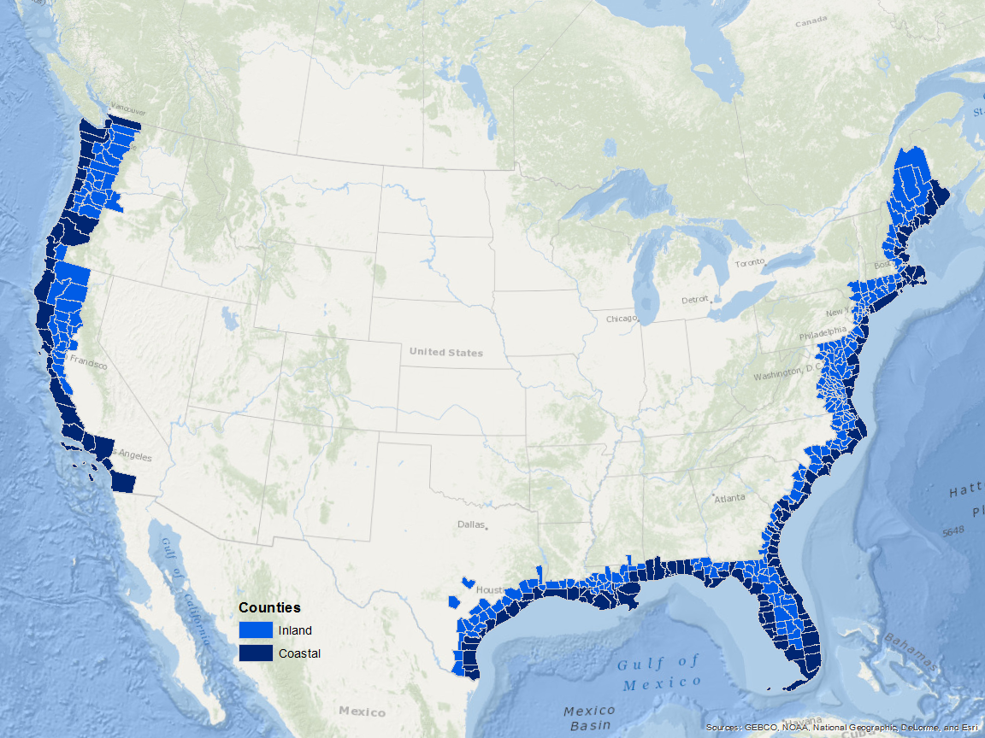
Figure 1. Map of coastal and near coastal counties in the continental United States where the proposed survey will collect economic data from independent stores and local chains that sell recreational fishing bait, tackle, and related equipment.

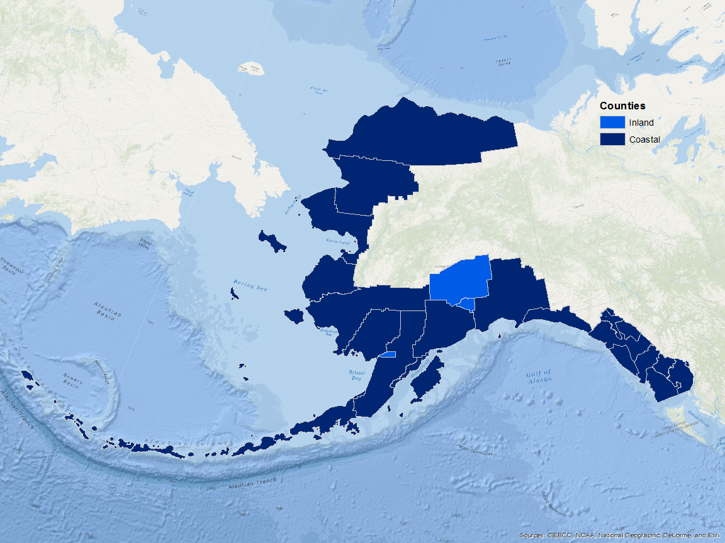

Figure 2. Map of coastal and near coastal counties in Alaska where the proposed survey will collect economic data from independent stores and local chains that sell recreational fishing bait, tackle, and related equipment.

