The Millennium Cohort Family Study
DoD Center for Deployment Health Research at the Naval Health Research Center
P.O. Box 85777, San Diego, CA 92186-5777
1-800-571-9248
www.familycohort.org
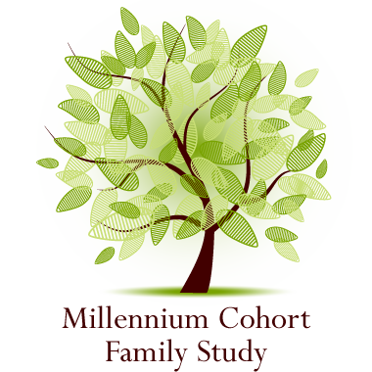

FACT SHEET

Background:

Objectives:

Approach:

Value:

Collaboration:

Support:

Contacts:

The impact of military life experiences, including deployment, on the health and well-being of service members has been well documented with potential consequences including mental or physical morbidities. Less well understood are the consequences resulting from challenges faced by military spouses and children that are related to military life experiences. While some research has indicated that families are resilient and family dynamics and overall well-being have an effect on the service member, more research is needed to determine the impact and inter-relationship of military experiences like deployment on spouses and child health and family functioning.

The overarching goal of the Family Study is to assess the impact of military service and deployment on family health. This DoD capability will be the first of its kind by using a large population-based cohort to assess the impact of military service and deployment on the health of service members, their spouses and co-resident children, and to evaluate the quality of the relationships between service members, spouses and their children.

The Millennium Cohort Family Study enrolled approximately 10,000 spouses of the 4th panel of the Millennium Cohort Study between 2011 and 2013. Panel 4 included a probability sample of military service members (active duty, Reserves, and National Guard) with 2-5 years of service and oversampled for married service members and females.

Understanding the impact of military service on family members’ health and well-being is critical for developing effective interventions and support mechanisms to build resilience and reduce stress.

Investigators include uniformed scientists from the Army, Navy, Air Force, as well as scientists from the Department of Veterans Affairs, New York University, Duke University, Abt Associates, and other leading academic institutions.

The project is supported by the US Department of Defense, Military Operational Medicine Research Program.

The Co-Principal Investigators of the Millennium Cohort Family Study are Drs John Fairbank (Duke University), Charles Marmar (New York University), Bill Schlenger (Abt Associates), and Martin White (Naval Health Research Center), and the primary performing site is the DoD Center for Deployment Health Research, Naval Health Research Center in San Diego, CA. More information on the Millennium Cohort Family Study is also available on the website, www.familycohort.org.

Millennium Cohort Family Study Products

FACT SHEET

Crum-Cianflone NF, Fairbank JA, Marmar CR, Schlenger W. The Millennium Cohort and Family Studies: A Prospective Evaluation of the Health and Well-Being of Military Service Members and Their Families. International Journal of Methods in Psychiatric Research; In press.

The Millennium Cohort Family Study is the largest prospective, epidemiologic study of military families in US history, and includes dyads of service members and their spouses. This paper provides a comprehensive description of this landmark study including details of the research objectives, study methodology, survey instrument, ancillary data sets, and plans for dissemination of research findings. The Family Study offers a unique opportunity to define the challenges that military families experience and advance the understanding of protective factors that will benefit military families today and into the future.
.

