**[2014 MilCo Follow-up WEB ONLY questions are in green)**

#59 From the following list, indicate if you have used each health practice in the last **12 months**?



"If you answered "Yes", to any item above, has your level of satisfaction with conventional medicine led you to seek alternative health practices?” No Yes

**[ONLY if YES to (a.) Acupuncture, then the following questions will appear]**

1. For which reason / condition are you using acupuncture?
   * + - 1. Chronic disease No Yes
         2. Mental health No Yes
         3. Pain No Yes
         4. General health / wellness No Yes
2. What year did you begin using acupuncture?  
3. On average, how often did you use acupuncture during the last 12 months?

* Daily
* Several times a week
* Several times a month
* Once a month
* Several times a year



**[ONLY if YES to (o.) Meditation, then the following questions will appear]**

1. For which reason/condition are you practicing meditation?
   * + - 1. Chronic disease No Yes
         2. Mental health No Yes
         3. Pain No Yes
         4. General health / wellness No Yes
         5. Performance enhancement No Yes
2. What year did you begin practicing meditation?  
3. On average, how often did you meditate during the last 12 months?

* Daily
* Several times a week
* Several times a month
* Once a month
* Several times a year



#85

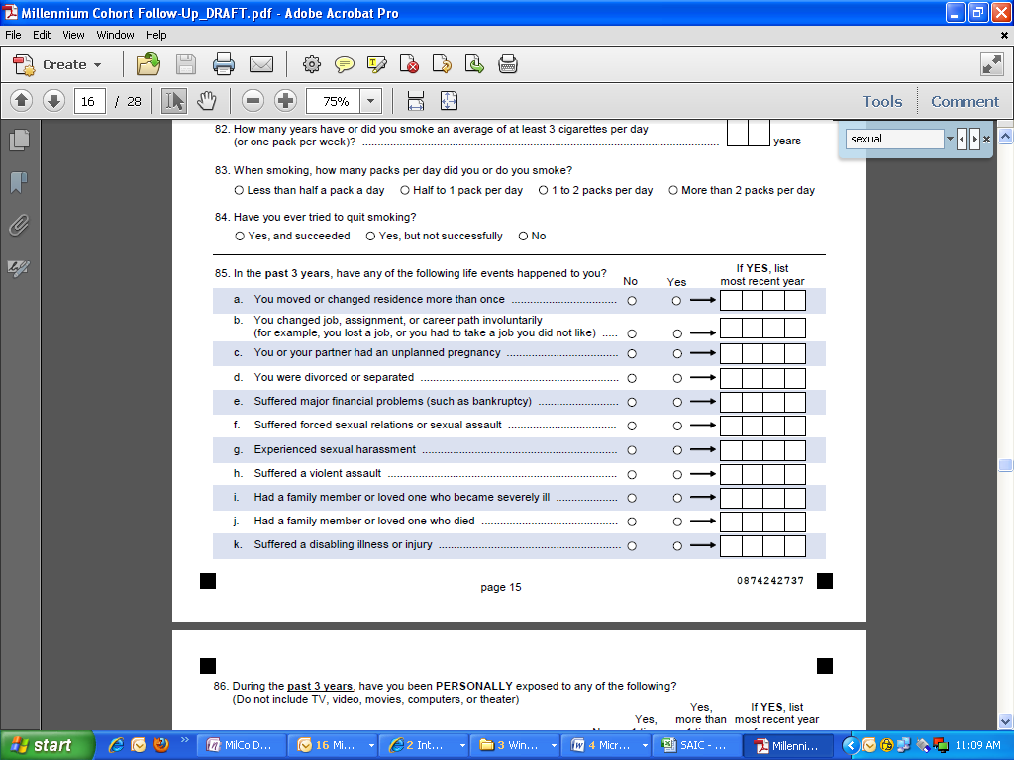

**[If YES to (f.) suffered forced sexual relations or sexual assault, then these additional questions appear]:**

**You indicated that you suffered a forced sexual relation or sexual assault. This section asks additional questions about these experiences. We are aware that many of these questions are quite personal, but we would appreciate your candid response. We'd like to remind you that all your answers are strictly confidential and will not be used to identify any persons.**

1. Please estimate how many event(s) in the **past 3 years**: 
2. Where did the event(s) occur?
3. Deployed, at a military base No Yes
4. Deployed, but outside the military base No Yes
5. Non-deployed, at your military duty station No Yes
6. Non-deployed, at a civilian location No Yes
7. Was the person or people who did this…
8. Military person(s) of higher rank/grade than you No Yes
9. Military person(s) of same or lower rank/grade than you No Yes
10. Your military supervisor(s) No Yes
11. Government civilian(s)/contractor(s) No Yes
12. Other civilian person(s) No Yes
13. Unknown person(s) No Yes
14. What was the gender(s) of the offender(s)/

* Male only
* Female only
* Both male and female
* Not sure



**[If YES to (g.) experienced sexual harassment, then these additional questions appear]:**

**You indicated that you suffered sexual harassment. This section asks additional questions about these experiences. We are aware that many of these questions are quite personal, but we would appreciate your candid response. We'd like to remind you that all your answers are strictly confidential and will not be used to identify any persons.**

1. Please estimate how many event(s) in the **past 3 years**: 
2. Where did the event(s) occur?
3. Deployed, at a military base No Yes
4. Deployed, but outside the military base No Yes
5. Non-deployed, at your military duty station No Yes
6. Non-deployed, at a civilian location No Yes
7. Was the person or people who did this…
8. Military person(s) of higher rank/grade than you No Yes
9. Military person(s) of same or lower rank/grade than you No Yes
10. Your military supervisor(s) No Yes
11. Government civilian(s)/contractor(s) No Yes
12. Other civilian person(s) No Yes
13. Unknown person(s) No Yes
14. What was the gender(s) of the offender(s)/

* Male only
* Female only
* Both male and female
* Not sure