DEPARTMENT OF HEALTH & HUMAN SERVICES Public Health Service
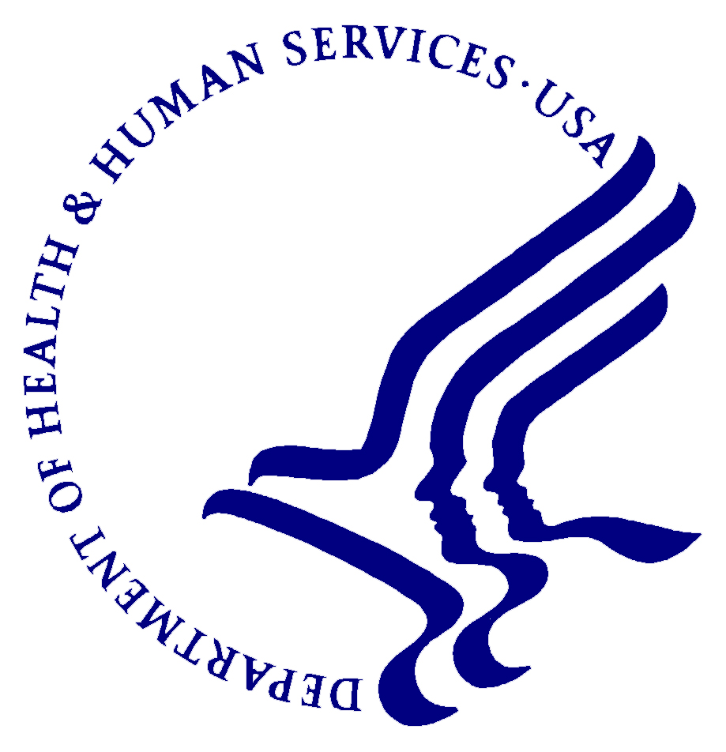

________________________________________________________________________________________________
Phone: (304) 285-5751 Centers for Disease Control
Fax: (304) 285-5820 and Prevention (CDC)
National Institute for Occupational
Safety and Health (NIOSH)
1095 Willowdale Road
Morgantown, WV 26505-2888

Dear _______,

We invite you to participate in surveys being conducted by the National Institute for Occupational Safety and Health (NIOSH) at Umicore Thin Film Products. Your participation is important to answer questions about the health effects of indium-tin oxide production and to ensure your workplace is as safe as possible. Your participation is voluntary.

NIOSH is a public health agency within the federal Centers for Disease Control and Prevention (CDC). NIOSH is responsible for conducting research and making recommendations for the prevention of work-related illnesses and injuries. NIOSH is not part of the Occupational Safety and Health Administration (OSHA) and does not enforce workplace health and safety laws.

In 2009, Umicore requested a health hazard evaluation from NIOSH. To conduct the evaluation, we looked at the company’s timeline of workplace changes, the results of workplace indium sampling, and the results of workers’ medical tests. We also interviewed managers, workers, and healthcare providers, and conducted limited air sampling. We found that Umicore has made extensive workplace changes since 2002. The workplace indium sampling showed that indium was detected in the air in all the production areas tested. The concentrations were highest in the Refinery and Reclaim areas. The medical tests showed that abnormalities on lung tests were more common than we expected, but some tests were poor quality. If you wish to have NIOSH’s interpretation of your medical tests, please contact us and provide your mailing address.

These findings mean that we have more to learn about the health effects of indium-tin oxide exposures, in order to protect workers at Umicore and other companies around the world. Because worker health is a priority for Umicore, the company has requested that NIOSH conduct its own industrial hygiene and medical surveys. The first round of NIOSH surveys took place in 2012. The second round of NIOSH surveys is planned for 2014.

During the industrial hygiene survey, we will ask you to wear sampling devices. These devices measure the amount of dust and indium in the air from your breathing zone. We will ask that you wear the devices during your entire workday for several days. We will also talk with you about workplace changes that have happened during your employment and ask that you record your work activities in a task diary.

The medical survey will include a private interview about your health and work history, blood tests that include a more sensitive indium test and newer tests that have been useful in indium workers in Japan, high quality lung tests, and low-dose high-resolution computed tomography (HRCT) scan, a sensitive type of X-ray (also known as “CT scan” or “CAT scan”). It will be helpful if you have the names of medicines you have taken in the past 12 months, as well as a list of jobs you have held at Umicore and elsewhere by date. It is important that you know that your personal medical test results will be available only to you and, if you wish, your personal physician. You may also choose to provide the results to the physician at Corporate Care, so that he has a record of your results for future comparisons. We won’t provide your personal results to your employer. We will provide a summary of the group’s results to Umicore. The summary will not contain personally identifiable information.

The industrial hygiene and medical surveys are designed to answer remaining questions about indium-tin oxide exposures and health effects. Are there newer blood tests that show lung effects early on? What indium level in the blood is safe? What indium level in the air is safe? What processes and forms of indium are especially risky? Answering these questions will help us make recommendations to Umicore to protect workers before they get sick from lung damage.

Whenever we do evaluations in a workplace, we try to get as much information as possible. The more information we have, the better we can see the whole picture and make correct conclusions about a problem. As you know, Umicore Thin Film Products is not a big facility nor a big workforce. To get as much information as possible, we will need everyone to participate.

NIOSH will be providing these surveys free of charge. They are being done at Umicore’s request, but not paid for by Umicore.

The medical testing will be offered as follows: [time, date to be filled in]. The industrial hygiene survey will take place as follows: [time, date to be filled in]. Please contact us if you have questions. Our toll-free number is (800) 232-2114.

Sincerely,

Kristin J. Cummings, MD, MPH
Medical Officer
(304) 285-6102
kcummings@cdc.gov

Jenna Armstrong, PhD
Industrial Hygienist
(304) 285-5865
jlarmstrong@cdc.gov

