OMB # 0925-0701
Expiration Date: 07/31/2017

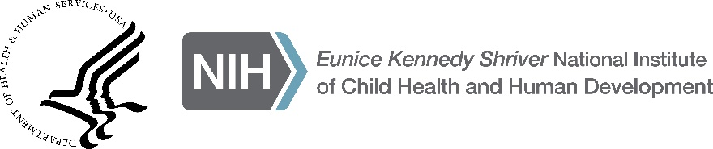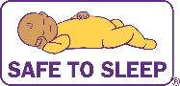

Safe Sleep Outreach Required Forms Checklist for Closing Meeting
Please bring all of these forms to the closing meeting on August 5, 2016. Use this checklist to make sure you have all of the required forms.

Public reporting burden for this collection of information is estimated to average 1 minute per response, including the time for reviewing instructions, searching existing data sources, gathering and maintaining the data needed, and completing and reviewing the collection of information. An agency may not conduct or sponsor, and a person is not required to respond to, a collection of information unless it displays a currently valid OMB control number. Send comments regarding this burden estimate or any other aspect of this collection of information, including suggestions for reducing this burden, to: NIH, Project Clearance Branch, 6705 Rockledge Drive, MSC 7974, Bethesda, MD 20892-7974, ATTN: PRA (0925-0701). Do not return the completed form to this address.

NOTE: Please be advised that the Safe Sleep Outreach Project and the data collection is sponsored by the Eunice Kennedy Shriver National Institute of Child Health and Human Development (NICHD). The purpose of collecting the information required on this form is to help mini-grantees compile all required forms associated with their mini-grant award. The completed forms will be used to confirm receipt of the required mini-grantee reporting documents. All personal information will be stored in a locked cabinet.

______ Completed Sign-In Sheets

______ Completed Safe Sleep Outreach Project Assessment Forms from event attendees

______ Completed Safe Sleep Outreach Project Activity Tracker
All Sign-In Sheets, Activity Tracker forms and Project Assessment forms
must be turned in at the Closing Meeting on August 5, 2016.

