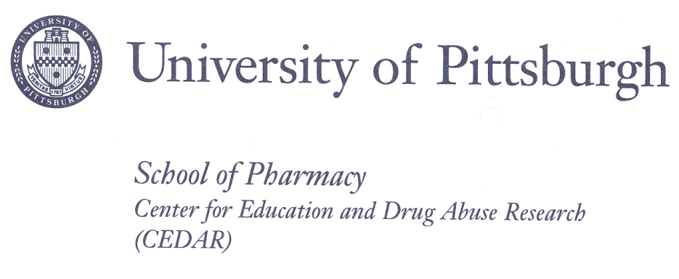
Birmingham Towers
Suite 620
2100 Wharton Street
Pittsburgh, PA 15203
412-488-5000
Fax: 412-488-4891

University of Pittsburgh
School of Pharmacy
Suite 203
3520 Forbes Avenue
Pittsburgh, PA 15213

CONSENT TO BE A SUBJECT IN A RESEARCH STUDY
Adult Twins

TITLE: Rapid Throughput Standardized Evaluation of Transmissible Risk for SUD in Youth: Validation Study

PRINCIPAL
INVESTIGATOR: Levent Kirisci, Ph.D.
University of Pittsburgh
Telephone: 412-864-2461
Email: Levent@pitt.edu

CO-
INVESTIGATORS: Maureen D. Reynolds, Ph.D.
University of Pittsburgh
Telephone: 412-488-5006
Email: maureen@pitt.edu

Sherri Mosovsky, M.S.
University of Pittsburgh
Telephone: 412-488-5009

Daniel Rusnak, B.S.
University of Pittsburgh
Telephone: 412-488-5005

SOURCE OF SUPPORT: NIH – National Institute on Drug Abuse, Contract #HHSN271201100016C

Why is this research being done?
The research team listed above invites you to be in a study looking at traits we have found may be related to future substance use problems. We need to make sure that the questions we are asking measure the traits we intended to measure. To do this, we need to compare a person’s answers on these questions with other known measures of the same or similar traits. We also want to see how young people who have the traits and those who do not differ in their answers. We study twins because their answers help us to understand if traits are inherited or are learned.

Who is being asked to take part in this research study?
You are being asked to take part in this research study because you are a twin who is 18 years old. We are asking 600 twin pairs aged 14 through 18 to take part in this study.

What procedures will be performed for research purposes?
If you agree to be a part of the study, we will email, text or call you to tell you that the questions are posted on-line at a secure website address. We will send you a pass code that will allow you to read the questions. It will take less than one hour of your time to answer all of the questions. All of your answers will be private and will not be seen by anyone else.

- You will be asked questions about yourself such as your age, race and whether you have any medical problems such as heart disease or asthma. This will take about 5 minutes.
- Your will be asked about what you are like, such as “Do you have problems sitting still?” and “Do you talk out of turn in school?” This will take about 10 minutes.
- You will be asked about your use of alcohol and other drugs. This will take about 10 minutes.
- You will be asked about how well you get along with your mom and dad, such as “Do you talk about your problems with them?” and “Do you spend time together doing fun things?” Some questions will ask about your friends, such as “Do you have friends who get into fights or steal things?” This will take about 20 minutes.
- You will be asked about how much you and your twin are alike. This will take about 5 minutes.

What are the possible risks, side effects, and discomforts of this research study?
You may feel some discomfort answering questions about your personal life. Some of the questions deal with sensitive issues, such as drug or alcohol use or illegal activities, and may be upsetting. These questions are similar to those which might be asked by health providers and are necessary for the study. All of your answers will be kept private to the extent permitted by law. The website is secure and no one other than the investigators will know who is completing the on-line questions. That is why we are giving you with a pass code for the site. It is up to you where and when you complete the on-line questions. To protect your privacy we ask that you make sure you are alone when completing the questions.

Burden Statement
Public reporting burden for this collection of information is estimated to average 5 minutes per form, including the time for reading instructions and reviewing the form. An agency may not conduct or sponsor, and a person is not required to respond to, a collection of information unless it displays a currently valid OMB control number. Send comments regarding this burden estimate or any other aspect of this collection of information, including suggestions for reducing this burden, to: NIH, Project Clearance Branch, 6705 Rockledge Drive, MSC 7974, Bethesda, MD 20892-7974, ATTN: PRA (0925-XXXX). Do not return the completed form to this address.

What are the possible benefits from taking part in this study?
There is no direct benefit for taking part in this research project. The information from this study is to assure that the questions we are testing are measuring the traits we want to measure. By doing this, doctors and other health providers will be able to use this tool to assess risk for future substance use problems in young people.

Will I be paid if I take part in this research study?
When you complete all of the questions, you will receive an on-line gift certificate for $10.00 from your choice of either iTunes or Amazon.com.

Who will know about my participation in this research study?
Dr. Kirisci and Dr. Reynolds will be responsible for the data from this study. Only the research team members listed on this form will know you are taking part in the study. All paper research materials will be stored in locked file cabinets and all electronic records will be stored on password protected computers. Your records will be filed with a case number, not your name. The code linking your name to this number will be stored in a different secure file which only certain research team members will see. You will not be identified by name in any reports of the research results unless you sign a separate consent form giving your permission (release).

Who will have access to my identifiable information related to my participation in this research study?
No information about who you are will be available to anyone other than those research team members involved in this research. We may use some information from this study in other research studies looking at the same traits. This information may also be shared with other researchers but they will never be given any personal identifiers that would allow them to learn who you are.
To help us protect your privacy, we have obtained a Certificate of Confidentiality from the National Institutes of Health. The researchers can use this Certificate to legally refuse to disclose information that may identify you in any federal, state, or local civil, criminal, administrative, legislative, or other proceedings, for example, if there is a court subpoena. The researchers will use the Certificate to resist any demands for information that would identify you, except as explained below.
The Certificate cannot be used to resist a demand for information from personnel of the United States Government that is used for auditing or evaluation of Federally funded projects or for information that must be disclosed in order to meet the requirements of the federal Food and Drug Administration (FDA).
You should understand that a Certificate of Confidentiality does not prevent you or a member of your family from voluntarily releasing information about yourself or your involvement in this research. If an insurer, employer, or other person obtains your written consent to receive research information, then the researchers may not use the Certificate to withhold that information.
If the researchers learn that you or someone with whom you are involved is in serious danger of harm they will voluntarily inform the appropriate agencies.

For how long will the investigators be permitted to use my personal information?
University of Pittsburgh policy requests that research records be kept for a period of seven years after the study ends. Thus, the investigators may continue to use your information from this research study indefinitely, but for at least seven years after this study ends.

Is my participation in this research study voluntary?
You may withdraw, at any time, your consent to participate in this research study, to include the use of your information. The investigators may continue to use research data from you that was collected prior to the date that you formally withdrew your consent.

To formally withdraw your consent for your participation in this research study you should send a written and dated notice of this decision to the principal investigator at the address listed on the first page of this form.

Your decision to withdraw your consent for your participation in this research study will have no effect on your current or future relationship with the University of Pittsburgh. Your decision to withdraw your consent for participation in this research study will have no effect on your current or future medical care at a UPMC hospital or affiliated health care provider or your current or future relationship with a health care insurance provider.

If I agree to take part in this research study, can I be removed from the study without my consent?
You should also understand that you may be removed from the study by the investigators, if the data are found to be inaccurate.

*************************************************************************************************************
VOLUNTARY CONSENT
All of the above has been explained to me and all of my current questions have been answered. I understand that I am encouraged to ask questions about any aspect of this research study during the course of this study, and that future questions will be answered by the researchers listed on the first page of this form. Any questions which I have about my rights as a research participant will be answered by the Human Subject Protection Advocate of the IRB Office, University of Pittsburgh (1-866-212-2668).

By signing this form, I agree to participate in this research study. A copy of this consent form will be given to me.

____________________________________ ____________________
Participant’s Signature Date

CERTIFICATION OF INFORMED CONSENT

I certify that I have explained the nature and purpose of this research study to the above –named individual, and I have discussed the potential benefits and possible risks of study participation. Any questions this individual has about this study have been answered, and we will be available to address future questions as they arise. I further certify that no research component of this protocol was begun until after this consent form was signed.

_____________________________________ ____________________________
Printed Name of Person Obtaining Consent Role in Research Study

_____________________________________ ____________________________
Signature of Person Obtaining Consent Date

