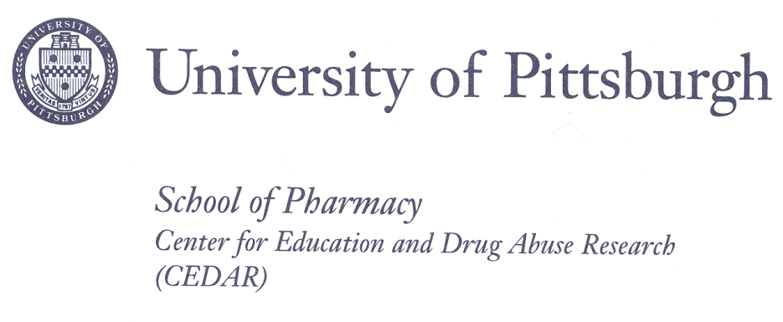

**CONSENT TO BE A SUBJECT IN A RESEARCH STUDY**

**Parental Consent for Subjects 14-17 Years Old**

**TITLE: Rapid Throughput Standardized Evaluation of Transmissible Risk for SUD in Youth: Validation Study**

**PRINCIPAL**

**INVESTIGATOR**: Levent Kirisci, Ph.D.

University of Pittsburgh

Telephone: 412-864-2461

Email: Levent@pitt.edu

**CO-**

**INVESTIGATORS**: Maureen D. Reynolds, Ph.D.

University of Pittsburgh

Telephone: 412-488-5006

Email: maureen@pitt.edu

Sherri Mosovsky, M.S.

University of Pittsburgh

Telephone: 412-488-5009

Daniel Rusnak, B.S.

University of Pittsburgh

Telephone: 412-488-5005

**SOURCE OF SUPPORT**: NIH – National Institute on Drug Abuse, Contract #HHSN271201100016C

***Why is this research being done?***

The research team invite your children to be in a study to complete a set of questions that we have found may be related to future substance abuse problems. To assure that the questions measure what they are intended to measure, we need to compare a person’s performance on these questions with other questions known to measure the same or similar traits. We also want to see if the questions can discriminate between young people who have the traits and those who do not.

***Who is being asked to take part in this research study?***

Your children are being asked to take part in this research study because they are twins between the ages of 14 and 17. Approximately 600 twins between the ages of 14 to 18 are being asked to participate in this study. Twins are being studied because they can best inform us about both the heritable or biological and the environmental sources of the behavior traits.

***What procedures will be performed for research purposes?***

If you and your children agree to participate, your children will be contacted via email or telephone call that the questions are posted on-line at a secure website address. A code number will be provided that will allow them to access the questions. The entire set of questions will take less than one hour of your children’s time. All of your twins’ responses will be private, to the extent of the law and will not be seen by anyone else who may be completing the questions on-line.

1. Your twins will be asked basic information about themselves such as their age, race and whether they have any major medical problems, such as heart disease or asthma. This will take about 5 minutes of their time.
2. Your twins will be asked to complete a set of questions about their behavior, such as whether or not they have problems sitting still or talking out of turn in school. This will require about 10 minutes of your children’s time.
3. Your twins will be asked to complete a set of questions regarding any use of alcohol and other drugs. This will require about 10 minutes of their time.
4. Your twins will be asked to answer a set of questions about how well they get along with both their mom and dad, such as whether or not they share their problems with you and if you spend time together doing fun things. They will also be asked about their friends, such as whether they have friends who get into fights or steal things. This will require about 20 minutes of their time.
5. Your twins will be asked a set of questions about how much they are alike as twins. This will take about 5 minutes of their time.

***What are the possible risks, side effects, and discomforts of this research study?***

Some of the questions deal with sensitive issues, such as drug or alcohol use or illegal activities, and may be upsetting to sensitive individuals. These questions are similar to those which might be asked by health professionals and are necessary for the study. All of your twins’ answers will be kept private to the extent permitted by law. The website is secure and no one other than the investigators will know who is completing the on-line questions. That is why we are providing each twin with a unique passcode to access the questions. It is up to your twins where and when they complete the on-line questions. To protect their privacy and to keep their answers private we ask that you make sure they are alone when completing the questions.

***Burden Statement***

Public reporting burden for this collection of information is estimated to average 5 minutes per form, including the time for reading instructions and reviewing the form. An agency may not conduct or sponsor, and a person is not required to respond to, a collection of information unless it displays a currently valid OMB control number. Send comments regarding this burden estimate or any other aspect of this collection of information, including suggestions for reducing this burden, to: NIH, Project Clearance Branch, 6705 Rockledge Drive, MSC 7974, Bethesda, MD 20892-7974, ATTN: PRA (0925-XXXX). Do not return the completed form to this address.

***What are the possible benefits from taking part in this study?***

Your children will receive no direct benefit at this time by taking part in this research project. The information gained from this research study is intended to assure that the instrument we have developed is measuring the traits we believe it measures. With this assurance, doctors and other health professionals will be able to use this instrument to assess risk for future substance use problems in young people.

***Will my child be paid if they take part in this research study?***

Upon completion of all questions your twins will each receive an electronic gift certificate for $10.00 from their choice of either iTunes or Amazon.com for participation.

***Who will know about my participation in this research study?***

Dr. Kirisci and Dr. Reynolds will be responsible for the data from this study. Any information about your children obtained from this research will be accessed only by research team members. All records related to your children’s involvement in this research study and all research material, all electronic records, and consent forms will be stored indefinitely in locked file cabinets and password protected computers. Your children’s identity on these records will be indicated by a case number rather than by their name, and the code linking their name to this number will be maintained separately with very limited access to research team members. Your children will not be identified by name in any publication of the research results unless you sign a separate consent form giving your permission (release).

***Who will have access to my identifiable information related to my participation in this research study?***

No identifiable information will be made available to anyone other than those investigators directly involved in this research. It is possible that we may use the information obtained from this study in other research studiesexamining the behavioral characteristics being measured. This information may also be shared with other researchershere, and at other research centers, but those researchers will never be provided with any personal identifiers that would allow them to learn who your twins are.

To help us protect your privacy, we have obtained a Certificate of Confidentiality from the National Institutes of Health. The researchers can use this Certificate to legally refuse to disclose information that may identify you in any federal, state, or local civil, criminal, administrative, legislative, or other proceedings, for example, if there is a court subpoena. The researchers will use the Certificate to resist any demands for information that would identify you, except as explained below.

The Certificate cannot be used to resist a demand for information from personnel of the United States Government that is used for auditing or evaluation of Federally funded projects or for information that must be disclosed in order to meet the requirements of the federal Food and Drug Administration (FDA).

You should understand that a Certificate of Confidentiality does not prevent you or a member of your family from voluntarily releasing information about yourself or your involvement in this research. If an insurer, employer, or other person obtains your written consent to receive research information, then the researchers may not use the Certificate to withhold that information.

If the researchers learn that your child(ren) or someone with whom you are involved is in serious danger of harm they will voluntarily inform the appropriate agencies.

***For how long will the investigators be permitted to use my personal information?***

University of Pittsburgh policy requires that research records be kept for a period of seven years after the study ends. Thus, the investigators may continue to use and disclose, for the purposes described above, information related to your child’s participation in this research study indefinitely, but for at least seven years after completion of this research study.

***Is my child’s participation in this research study voluntary?***

Your children’s participation in this research study is completely voluntary. Whether or not you provide your consent for participation in this research study will have no effect on your children’s current or future relationship with the University of Pittsburgh. Whether or not you provide your consent for participation in this research study will have no effect on your children’s current or future medical care at a UPMC hospital or affiliated health care provider or your current or future relationship with a health care insurance provider.

***May I withdraw, at a future date, my consent for my child’s participation in this research study?***

You may withdraw at any time, your consent for your children’s participation in this research study. Any research information recorded for, or resulting from, your children’s participation in this research study prior to the date that you formally withdraw your consent may continue to be used and disclosed by the investigators for the purposes described above. To formally withdraw your consent for your children’s participation in this research study you should provide a written and dated notice of this decision to the principal investigator of this research study at the address listed on the first page of this form. Your decision to withdraw your consent for your children’s participation in this research study will have no effect on your children’s current or future relationship with the University of Pittsburgh. Your decision to withdraw your consent for participation in this research study will have no effect on your children’s current or future medical care at a UPMC hospital or affiliated health care provider or your current or future relationship with a health care insurance provider.

***If I agree to take part in this research study, can I be removed from the study without my consent?***

You should also understand that your children may be removed from the study by the investigators, if the data are found to be inaccurate.

*************************************************************************************************************

**Parental Permission.**

All of the above has been explained to me and all of my current questions have been answered. I understand that I am encouraged to ask questions about any aspect of this research study during the course of this study, and that future questions will be answered by the researchers listed on the first page of this form. Any questions which I have about my child’s rights as a research participant will be answered by the Human Subject Protection Advocate of the IRB Office, University of Pittsburgh (1-866-212-2668).

__________________________________ __________________________________

Printed name of participant (child) Printed name of participant (child)

I understand that as minors (age less than 18 years), the above named children are not permitted to participate in this research study without my consent. Therefore, by signing this form, I give my consent for their participation in this research study.

____________________________________ ___________________________

Printed name of parent Relationship to child

____________________________________ ___________________________

Signature of parent Date

ASSENT: This research study has been explained to me and I agree to participate.

________________________________ ___________________________

Signature of Child Participant Date

________________________________ ___________________________

Signature of Child Participant Date

VERFICATION OF EXPLANATION

I certify that I have carefully explained the purpose and nature of this research to _______________

and _________________ (names of twins) in age appropriate language. They have had an opportunity to discuss it with me in detail. I have answered all their questions and each child has provided affirmative agreement (i.e., assent) to participate in this research.

_____________________________________ ____________________________

Printed Name of Person Obtaining Consent Role in Research Study

_____________________________________ ____________________________

Signature of Person Obtaining Consent Date