Attachment J: Example Screen Shots of Pharmacy Survey on Patient Safety Culture Data Submission Web Site Information Collection

Figure 1: Submit questionnaire and link questionnaire to pharmacy(s)

**Questionnaires**

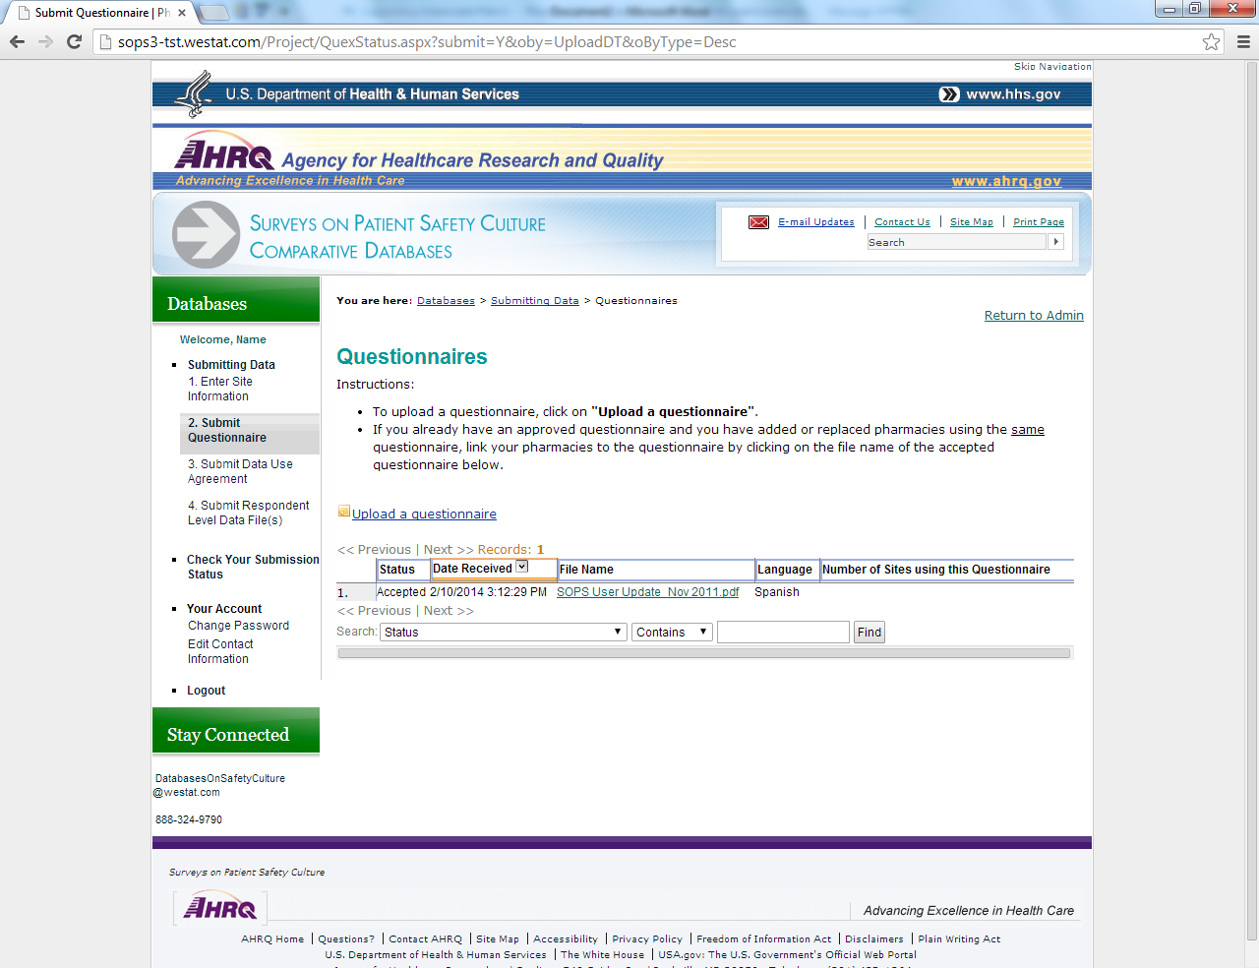

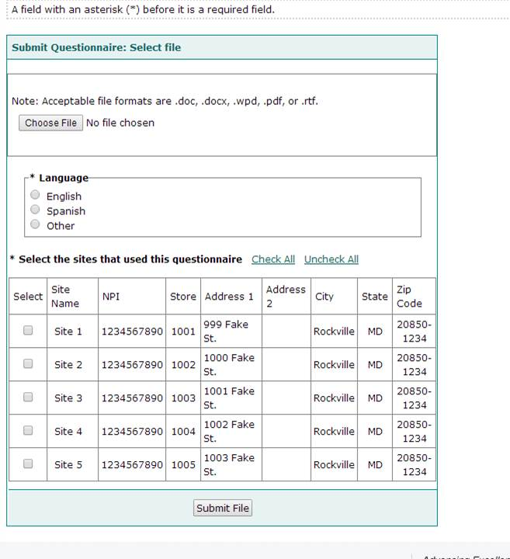

**Figure 2:** Upload data for each participating pharmacy

One at a Time

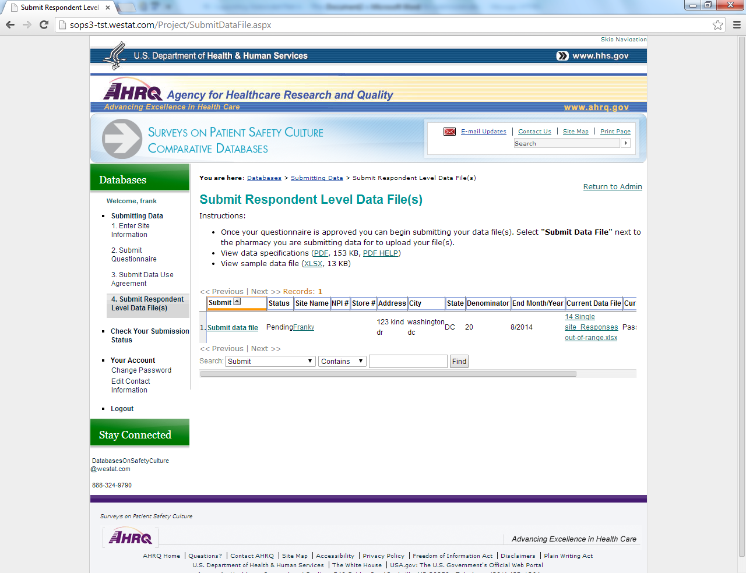

All At Once

