**Measure One**--Effectiveness rating of COPS knowledge resources (e.g., training, publications, technical assistance) in increasing community policing capacity of grantees.

The COPS Office requires grantees to complete a progress report each quarter to determine what extent COPS resources have assisted the agency to increase community policing capacity. Note: The progress report has a detailed series of questions which were used to enhance the methodology for this measure. For example:

How has the training and/or technical assistance that you received from the COPS Office increased your agency’s capacity to do the following?

* Develop collaborative partnerships with individual and organizational stakeholders in the community.
* Engage in problem-solving to prevent, respond to, and/or better analyze crime.
* Institute organizational changes that support the implementation of community policing strategies.
* Improve technological capabilities to better prevent and/or respond to crime and disorder incidents.
* Effectively implement the strategies presented to better prevent and/or respond to crime and disorder incidents.

**Questions from progress report:**

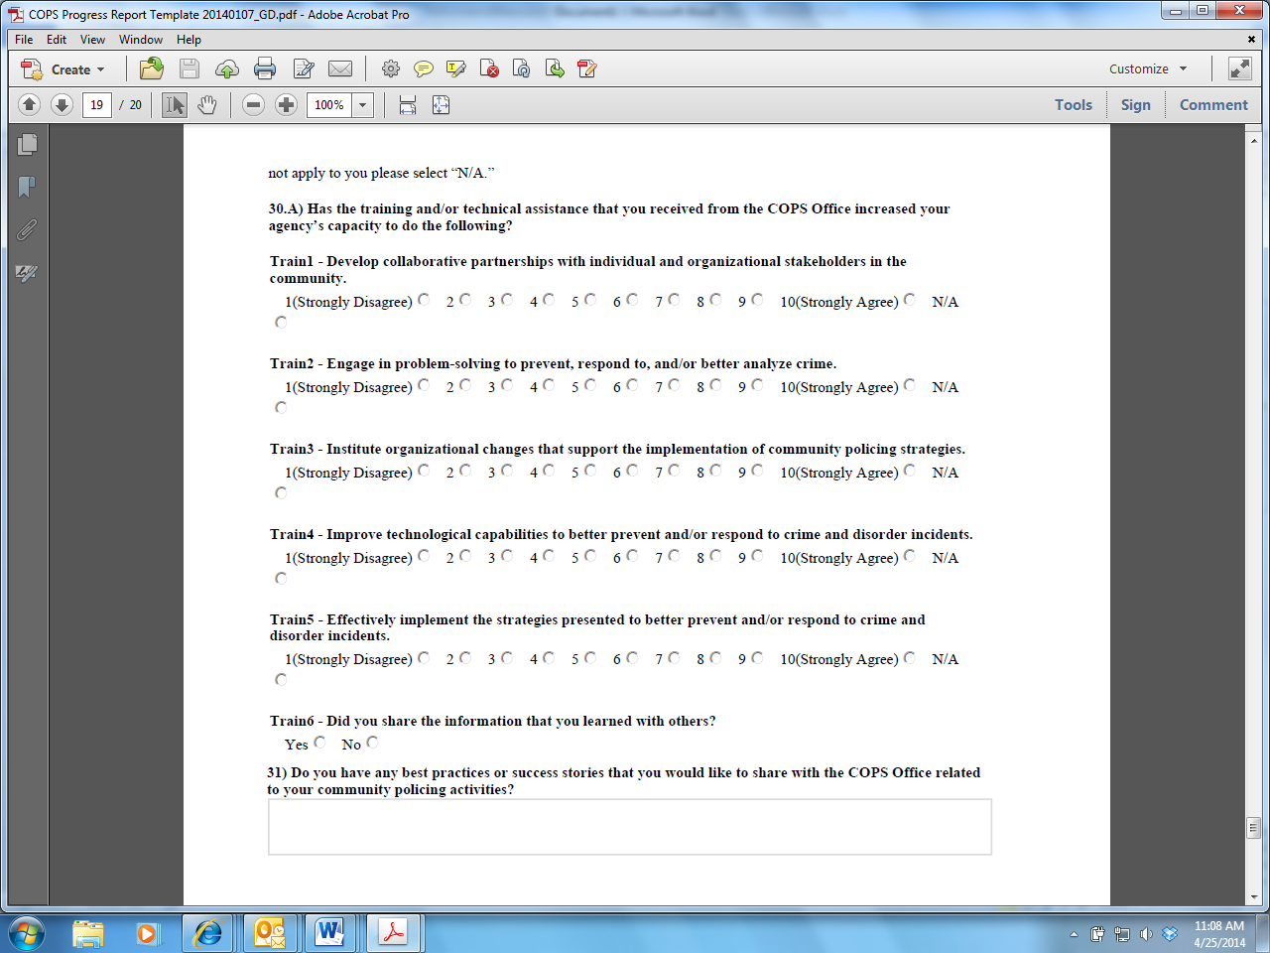



**Measure Two**--Effectiveness rating of COPS grant resources (e.g., personnel) in increasing community policing capacity of grantees.

The COPS Office requires grantees to complete a progress report each quarter to determine what extent COPS funds have assisted the agency to increase capacity to develop collaborative partnerships, use problem-solving techniques and to transform your agency environment, organizational structure, personnel, and practices. Note: The progress report has a detailed series of questions which were used to enhance the methodology for this measure. For example:

* Please identify the specific crime and public safety problems that your agency is addressing through this grant funding. Please describe your progress in addressing the problem(s) and how you are measuring the impact of your efforts.

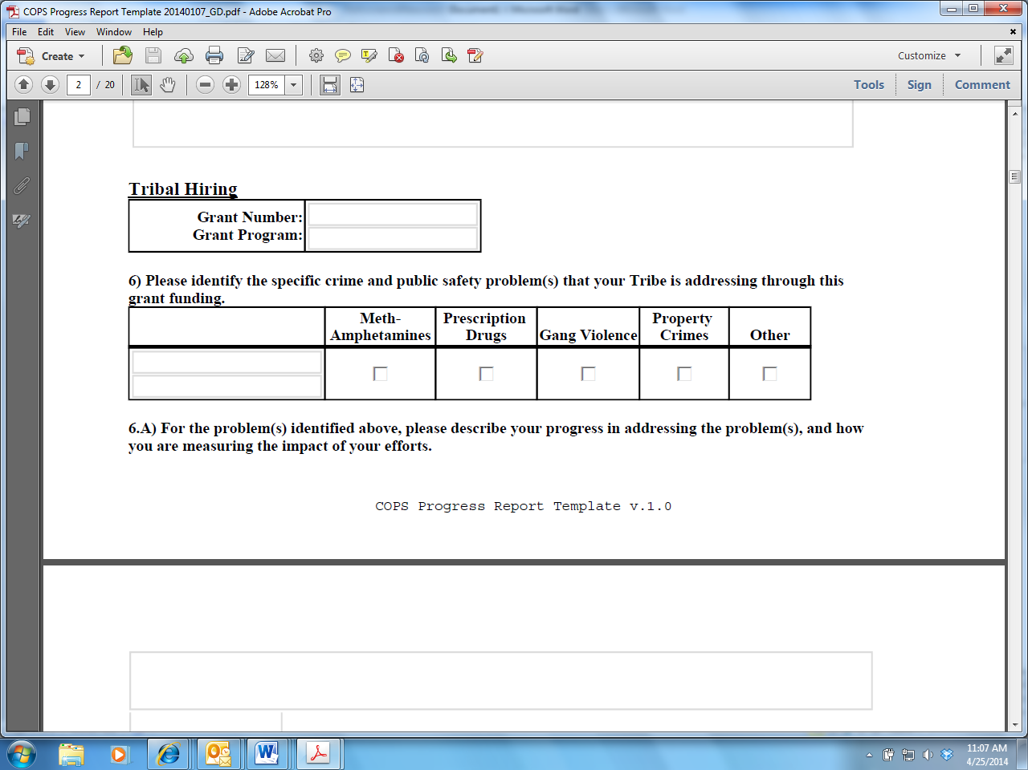**Questions from progress report:**

* Please address specific information gathering and activities

**Questions from progress report:**

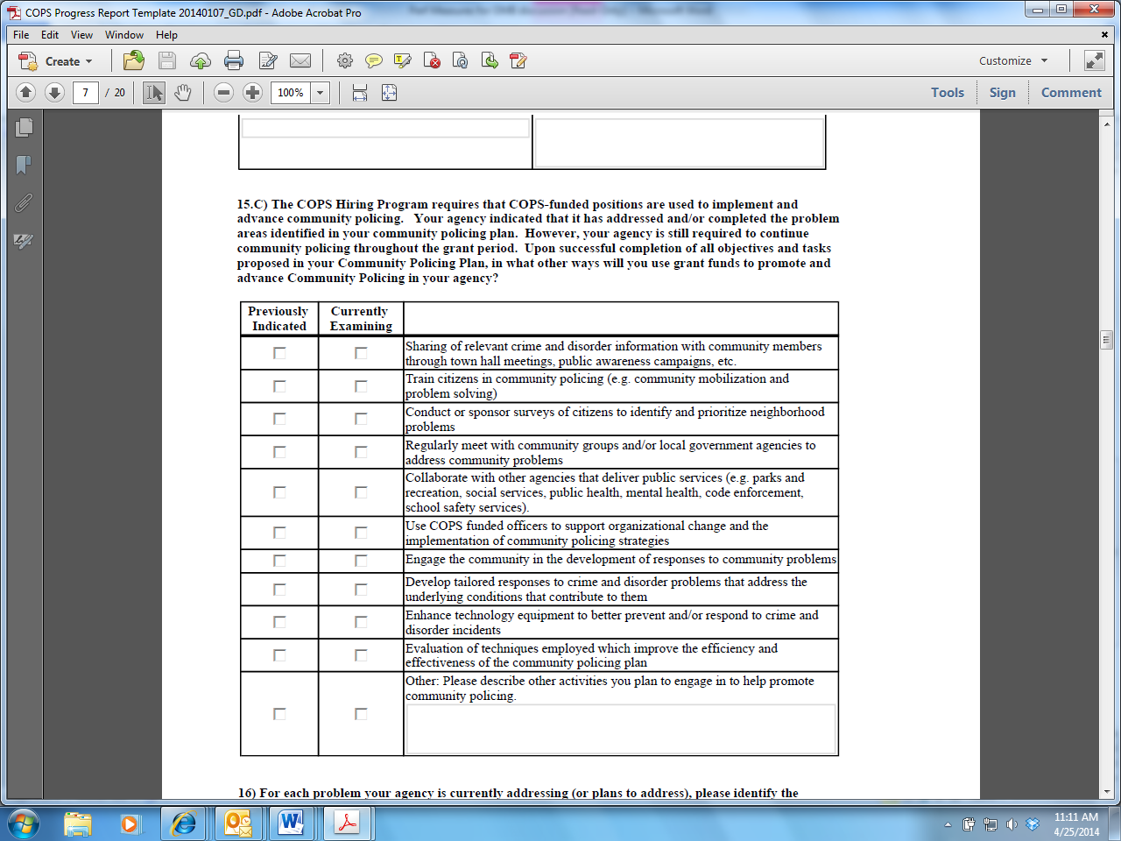

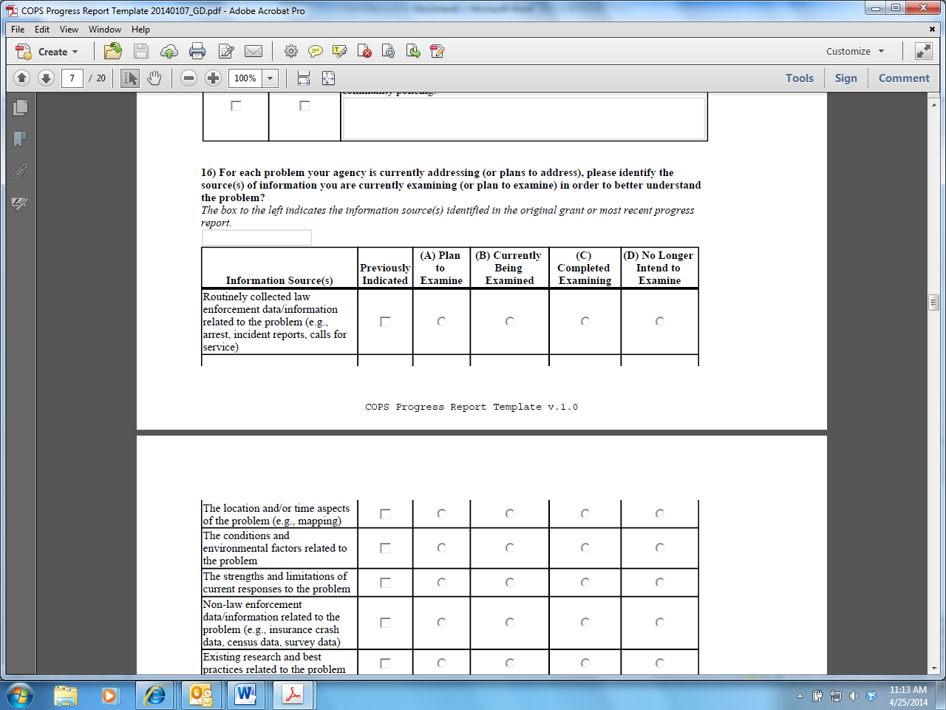

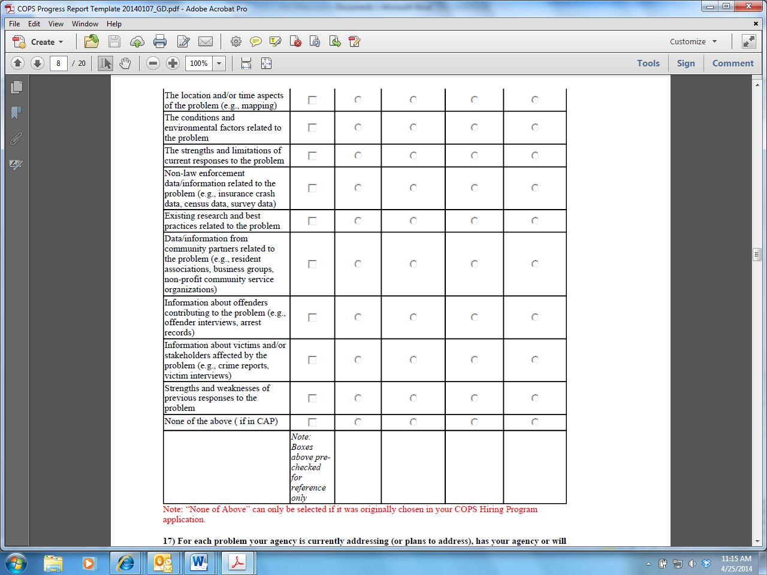

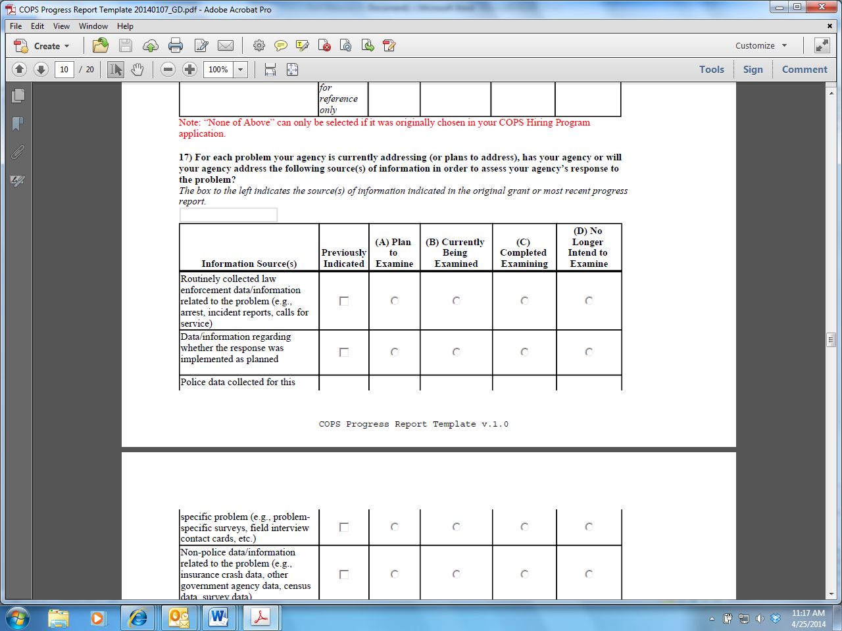

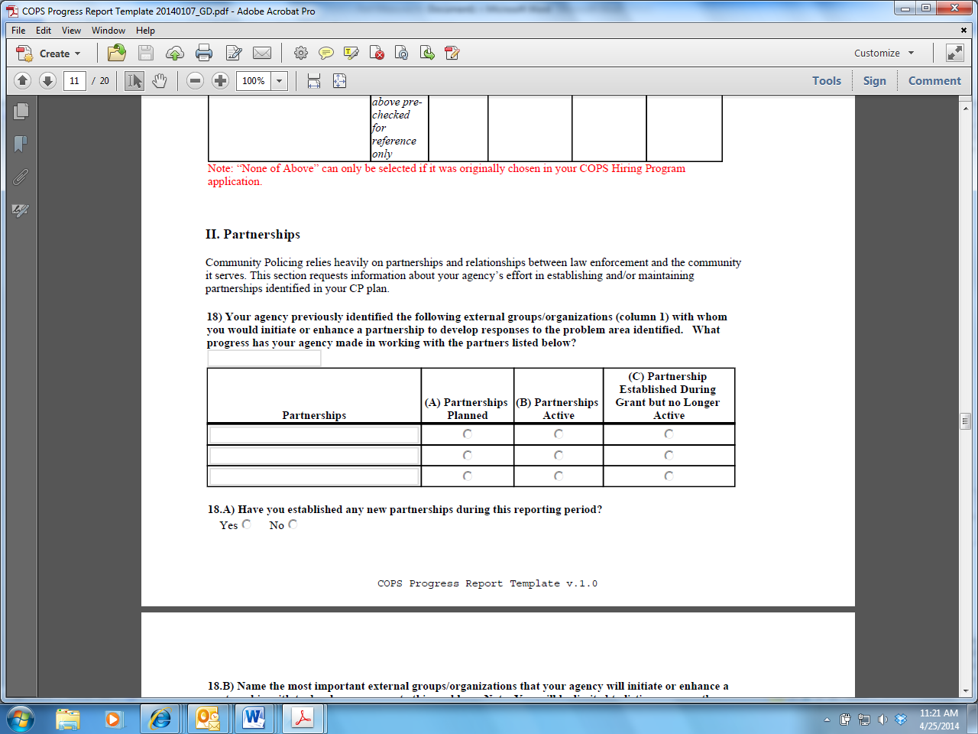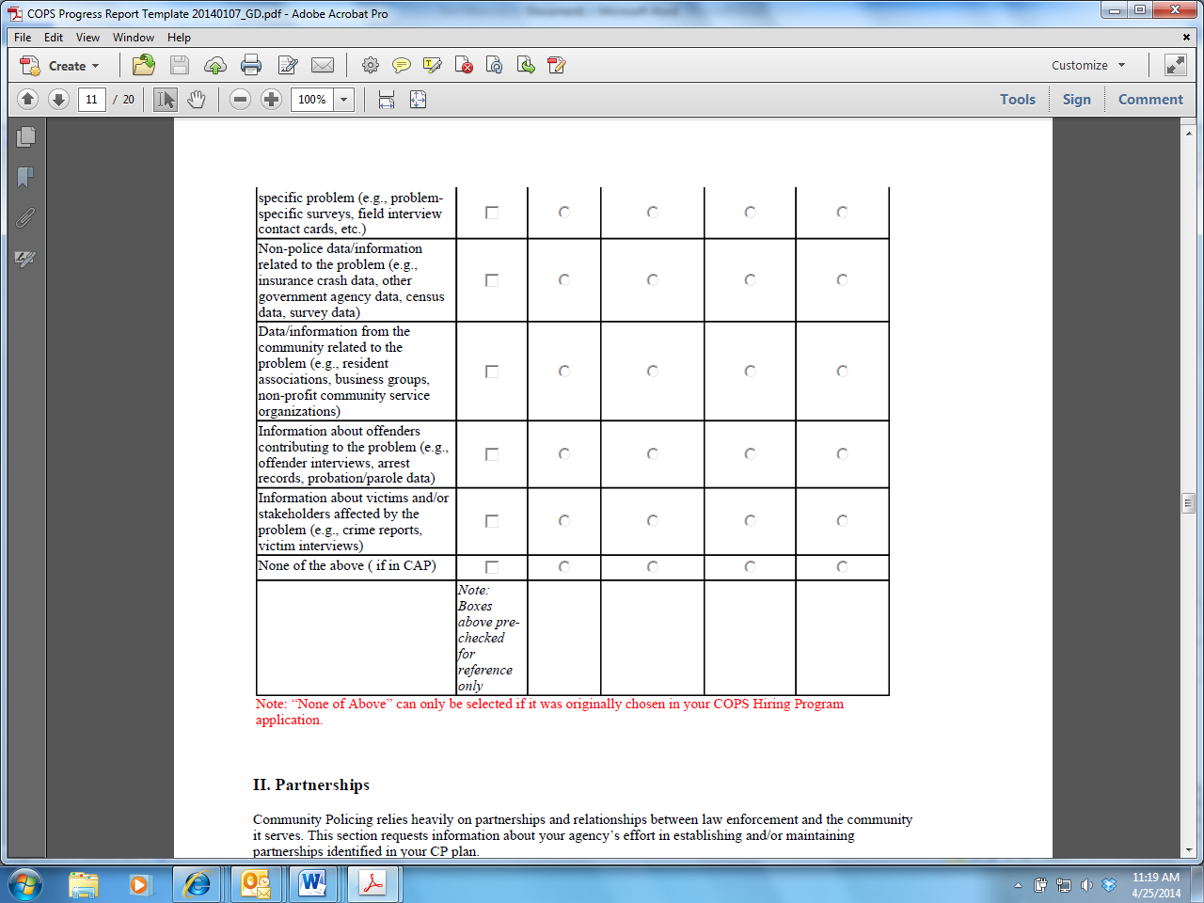

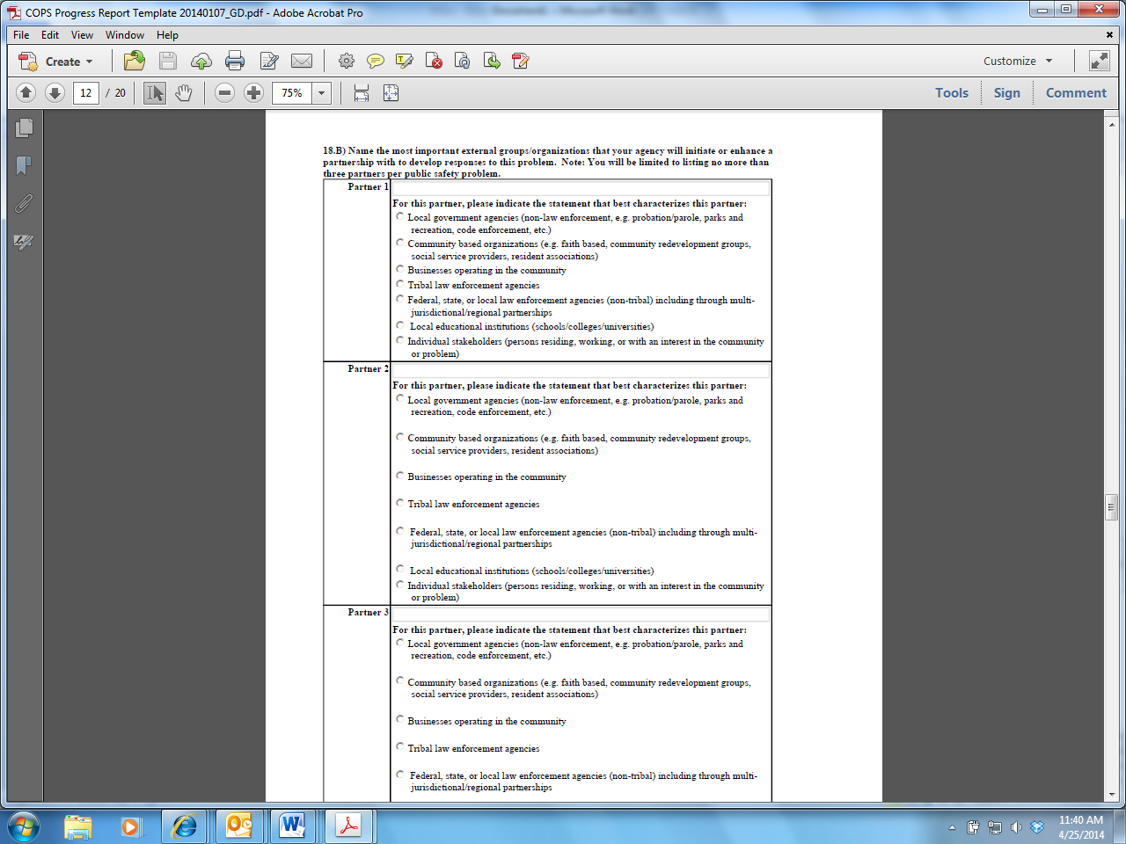

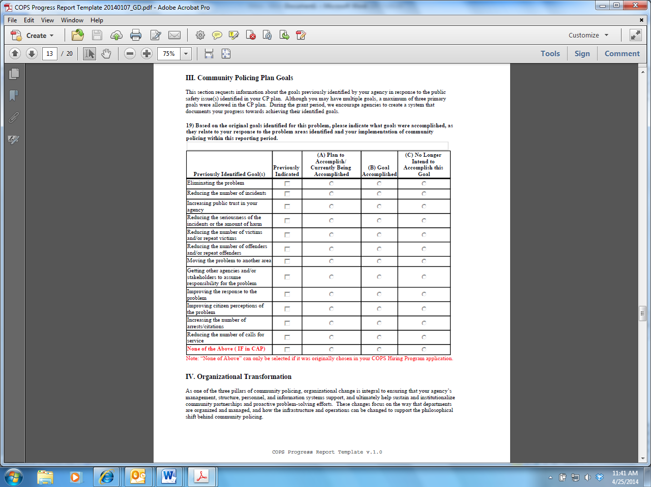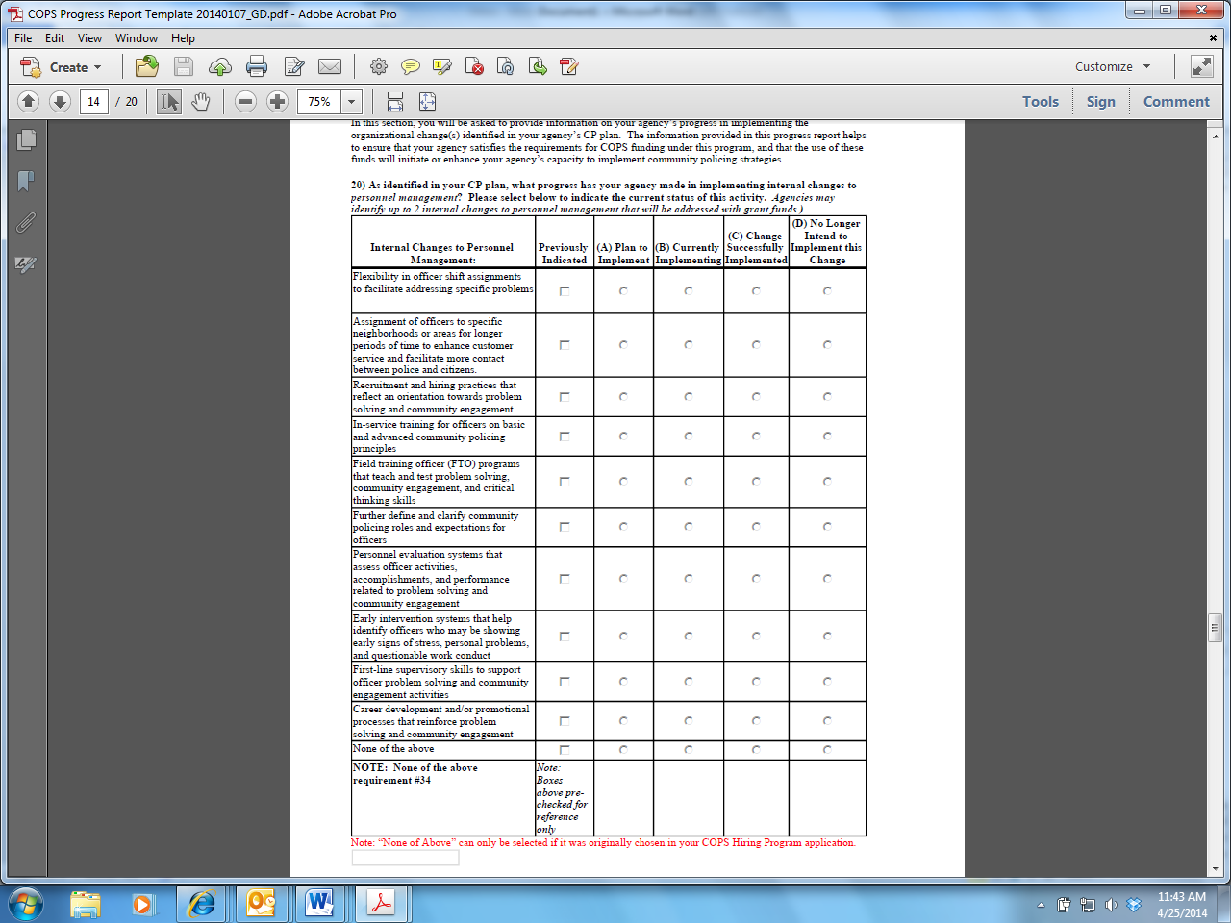

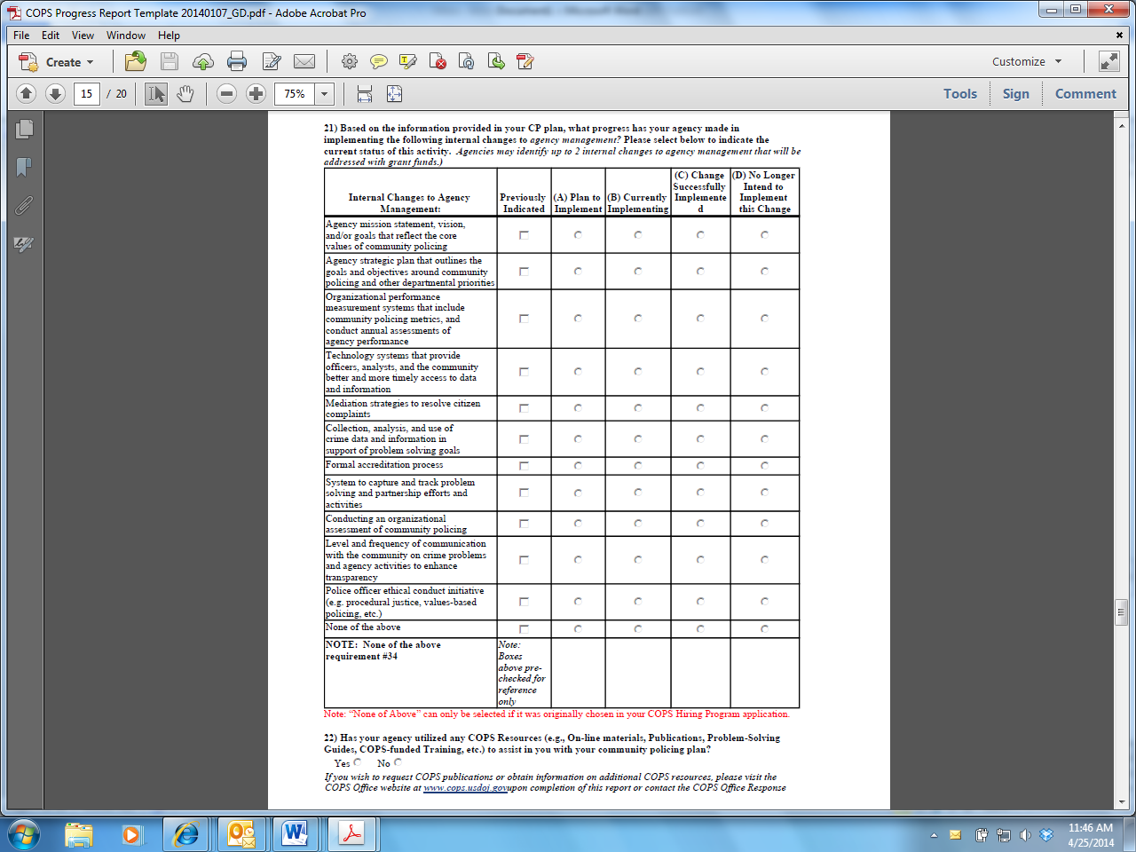

* Please address increased agency capacity and promising practices

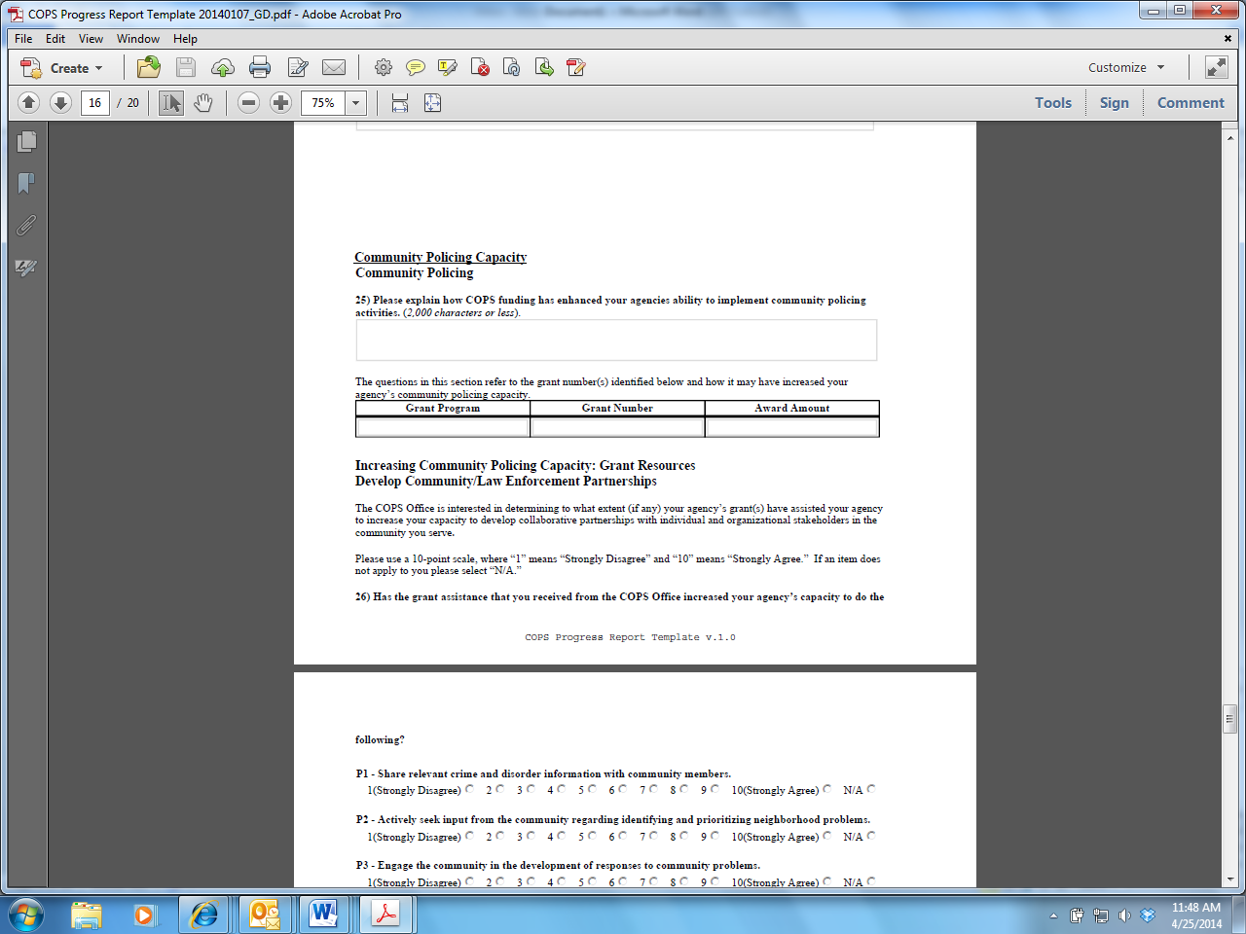

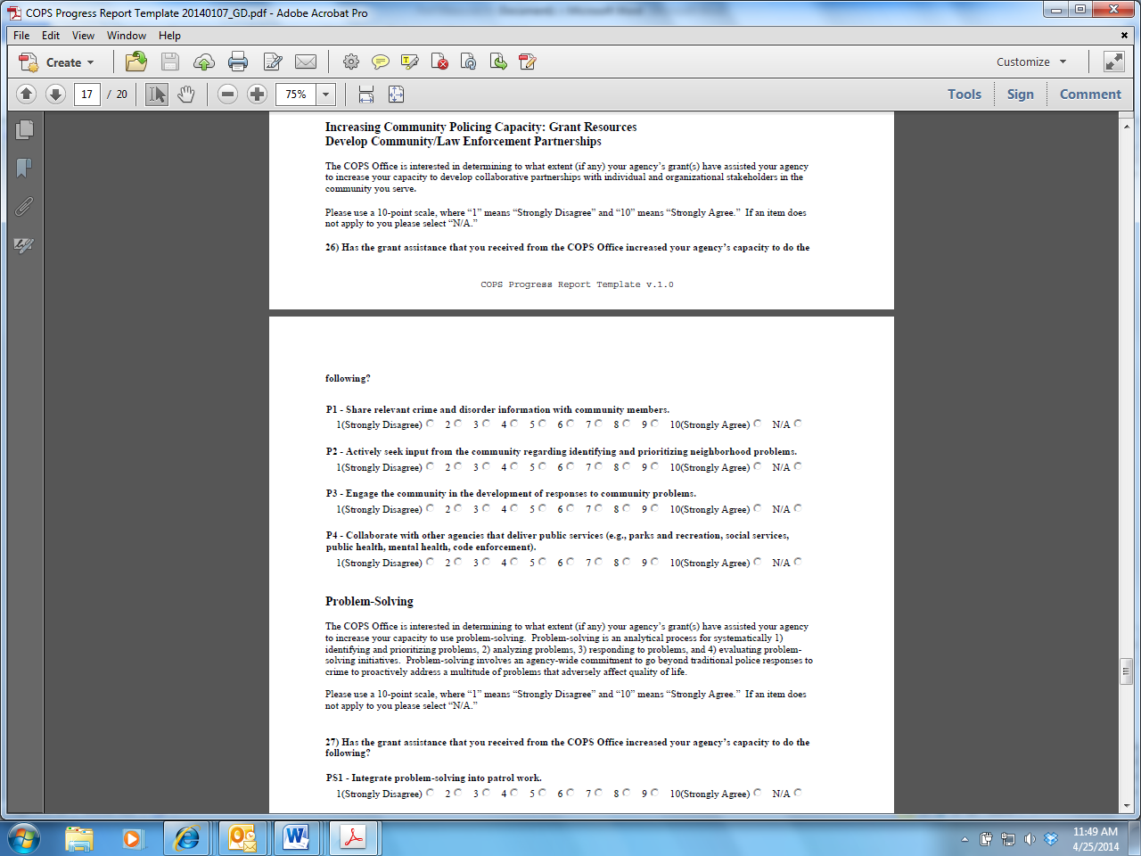

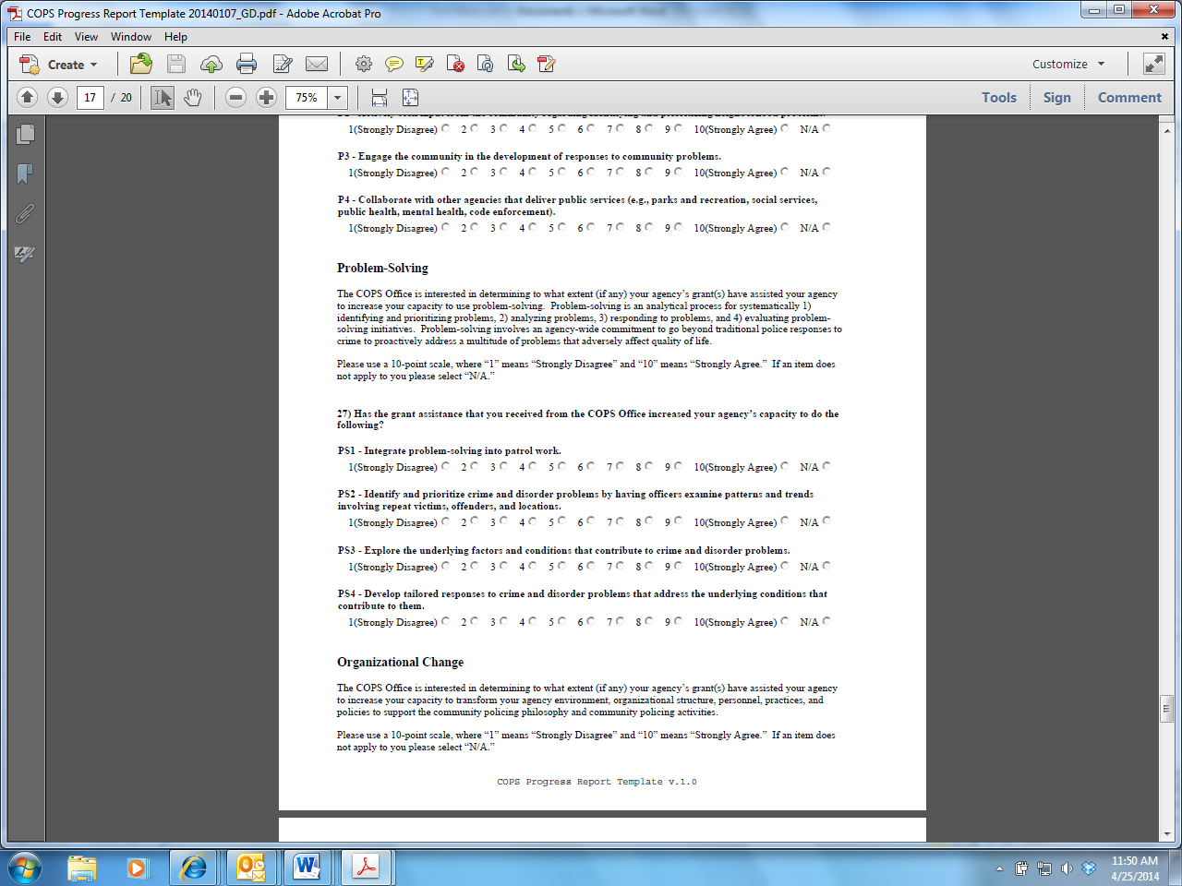

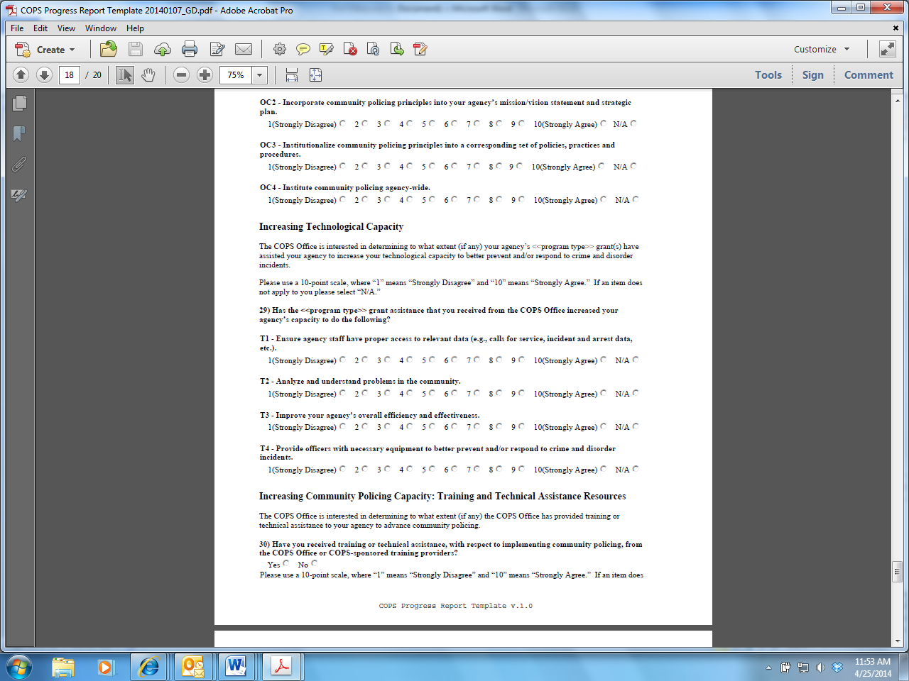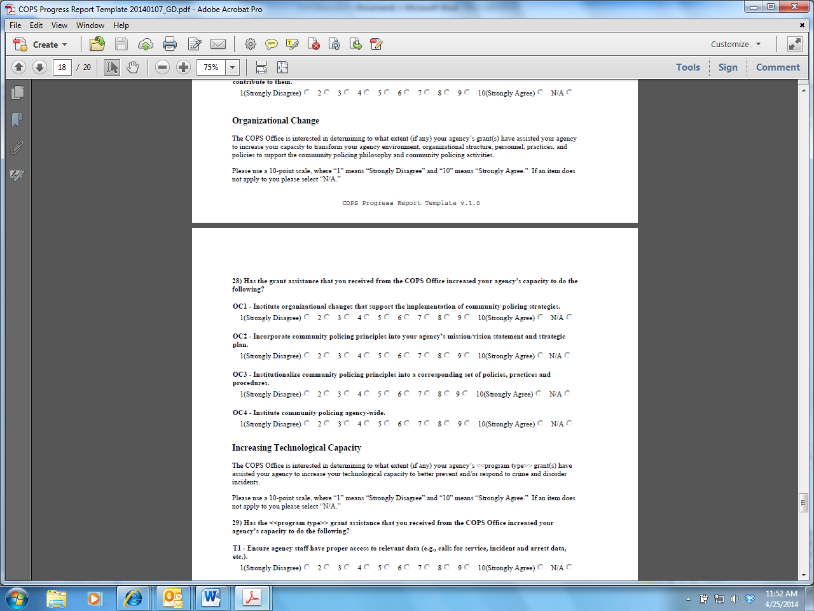

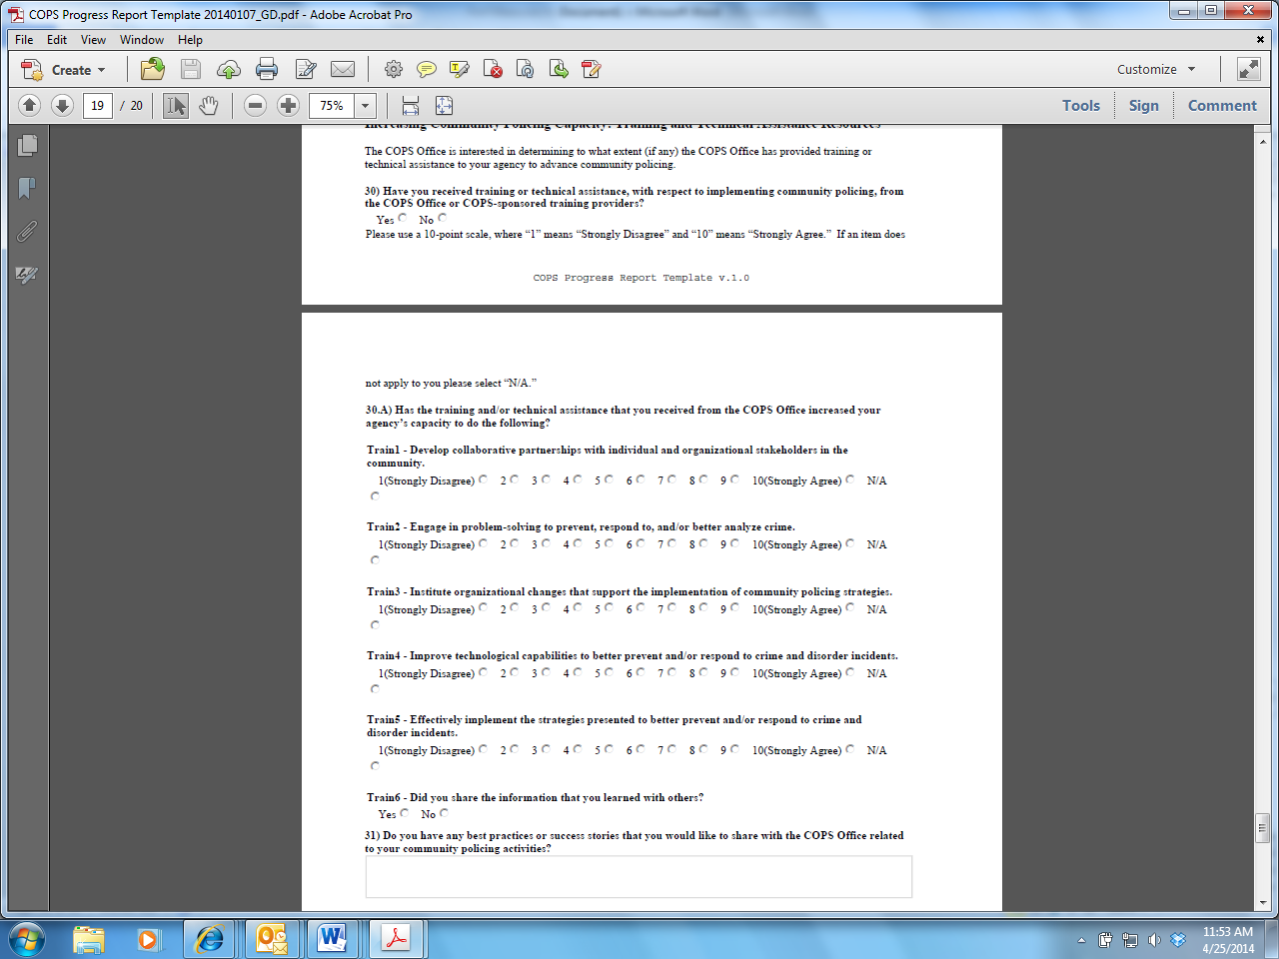

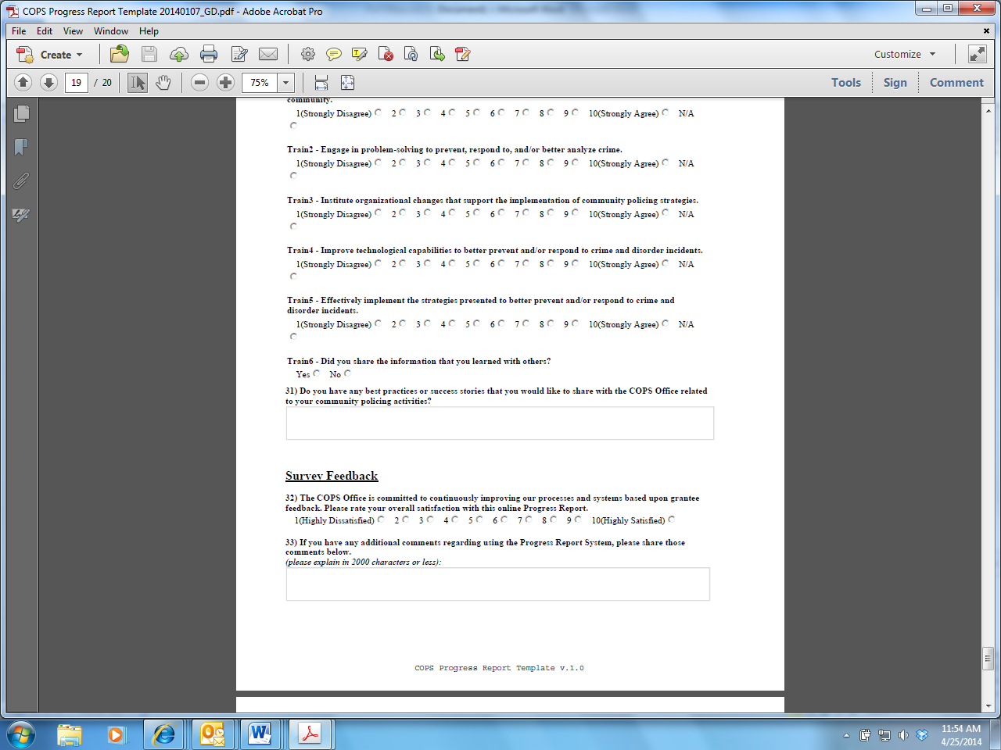

**Measure Three**--Successful purchase and implementation of all items and grant activities listed in the application.

The COPS Office requires grantees to complete a progress report each quarter to determine if all grant funding items have been implemented successfully and were used to increase their community policing capacity. For example:

* During the reporting period, did your agency complete the purchase of all the equipment, technology, training or other cost items in your approved project budget?

**Questions from progress report:**

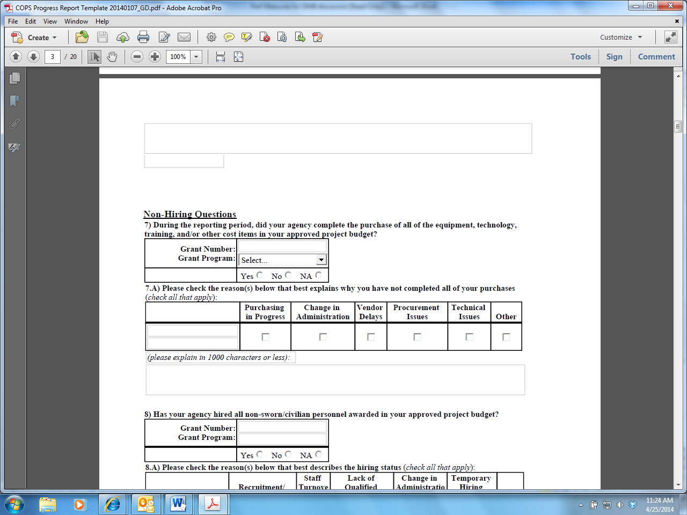

* Has your agency hired all the non-sworn civilian personnel awarded in your approved project?

**Questions from progress report:**

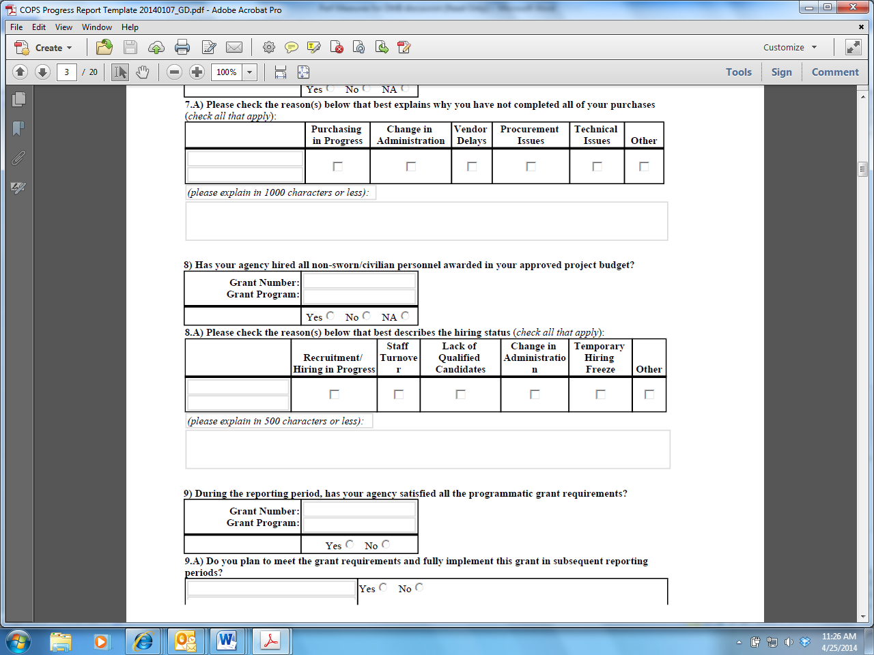

* During the reporting period, has your agency satisfied all the programmatic grant requirements?

**Questions from progress report:**