WAP Sub-Programs Plan Worksheet Summary Screen:
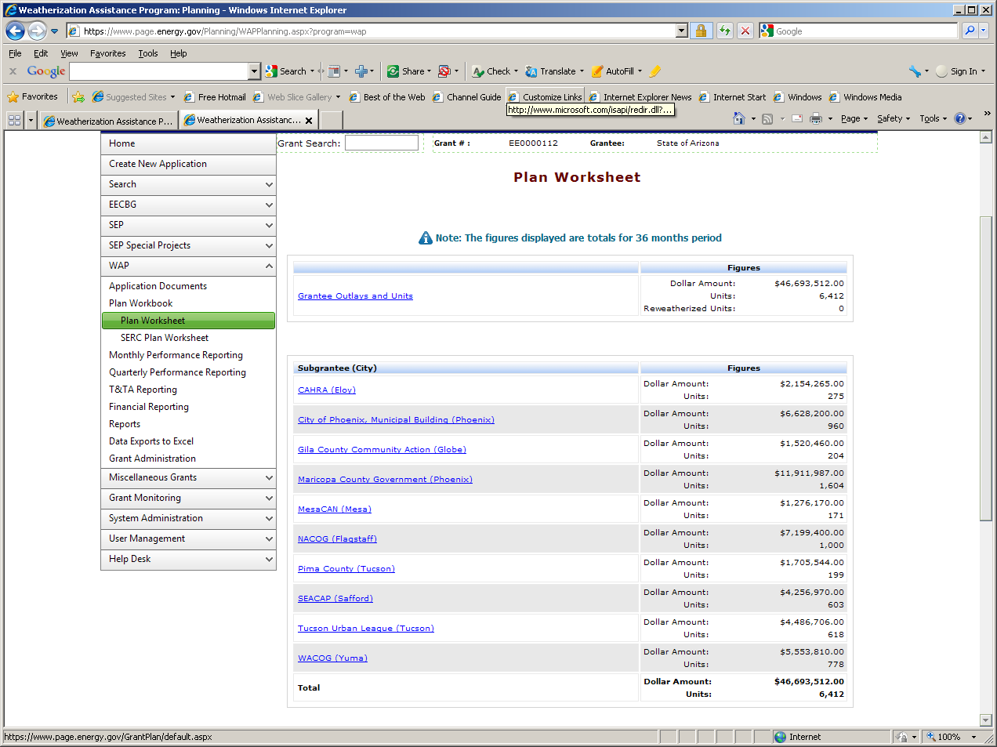

WAP Sub-Programs Plan Worksheet Subgrantee edit screen:
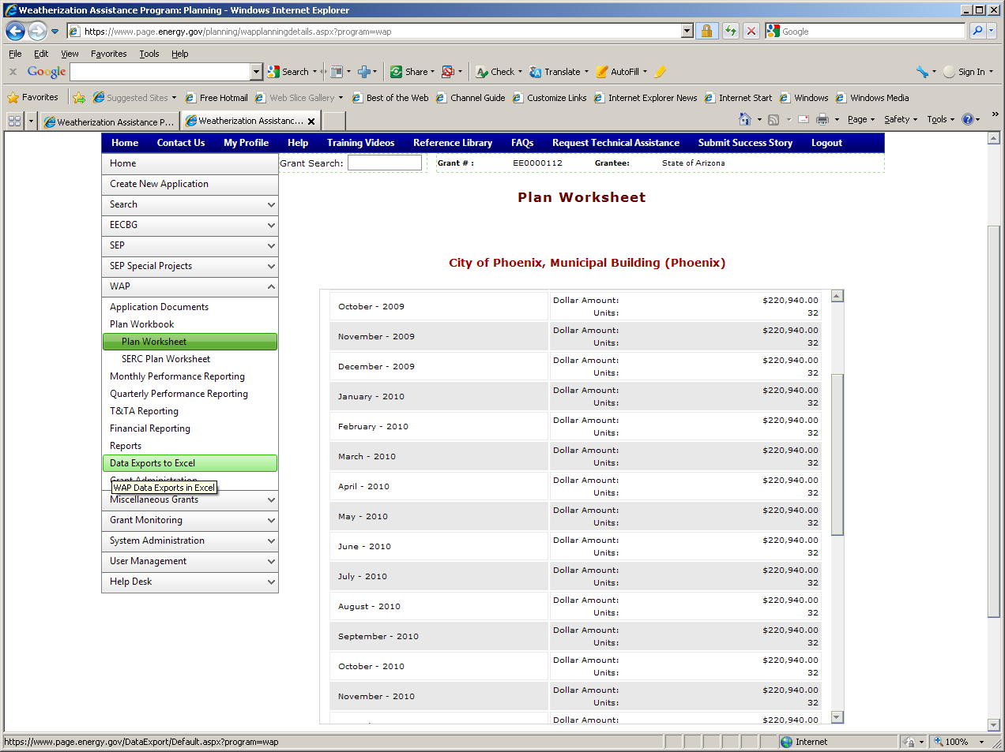

WAP Sub-Programs Quarterly Progress Report screen (#1):
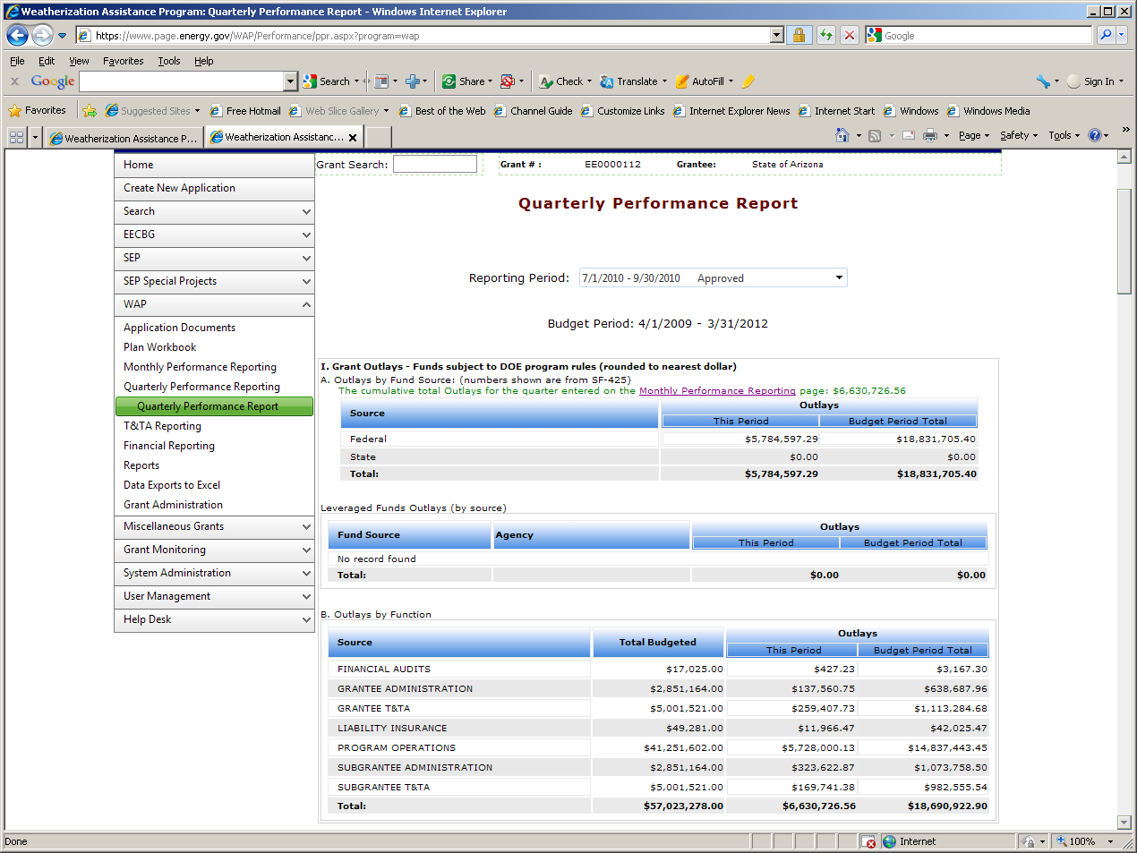

WAP Sub-Programs Quarterly Progress Report screen (#2):
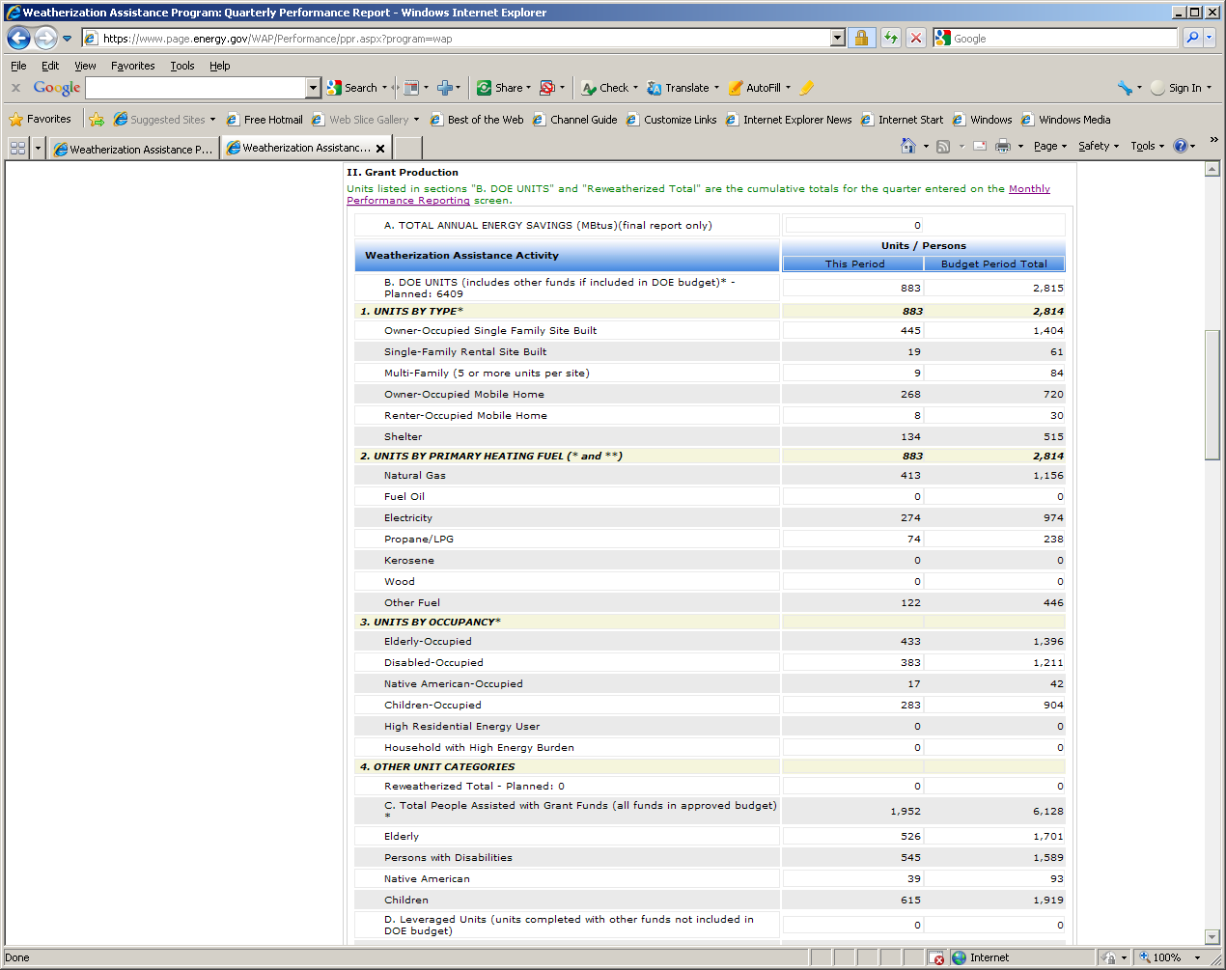

WAP Sub-Programs Quarterly Progress Report screen (#3):
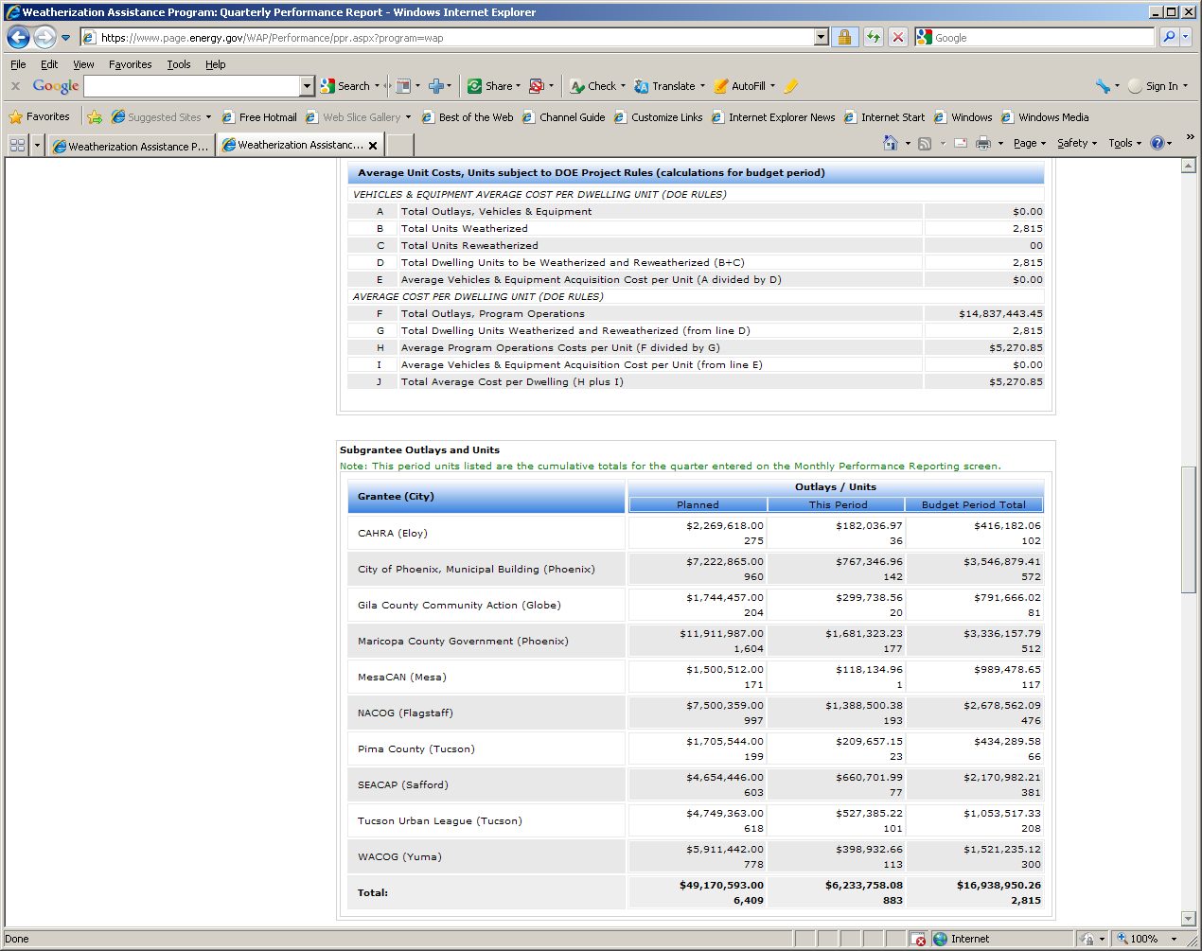

WAP Sub-Programs Quarterly Progress Report screen (#4):
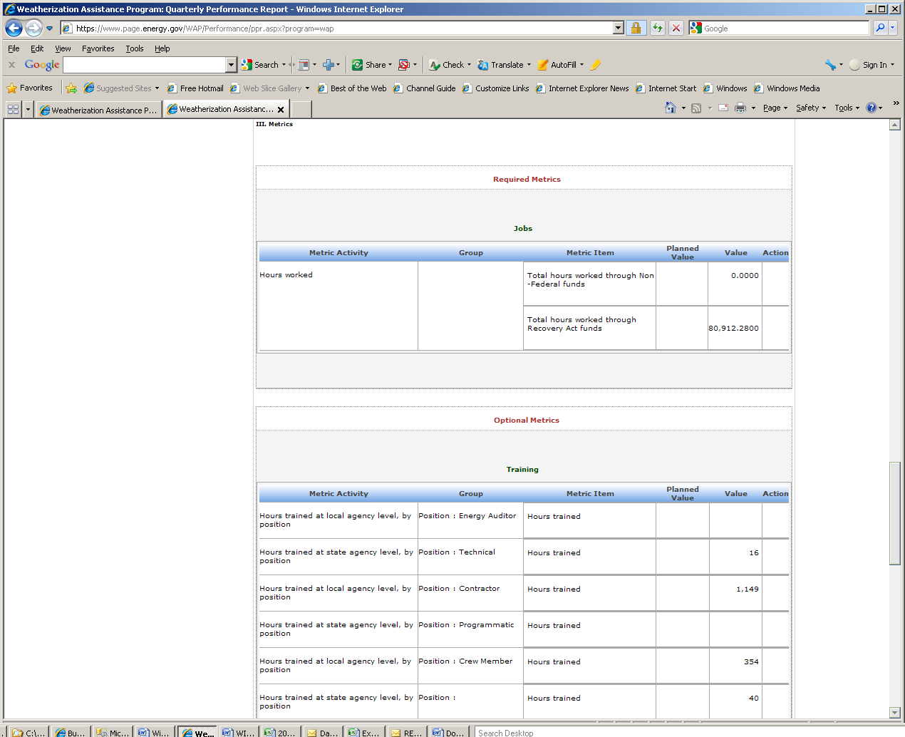

WAP Sub-Programs Quarterly Progress Report screen (#5):
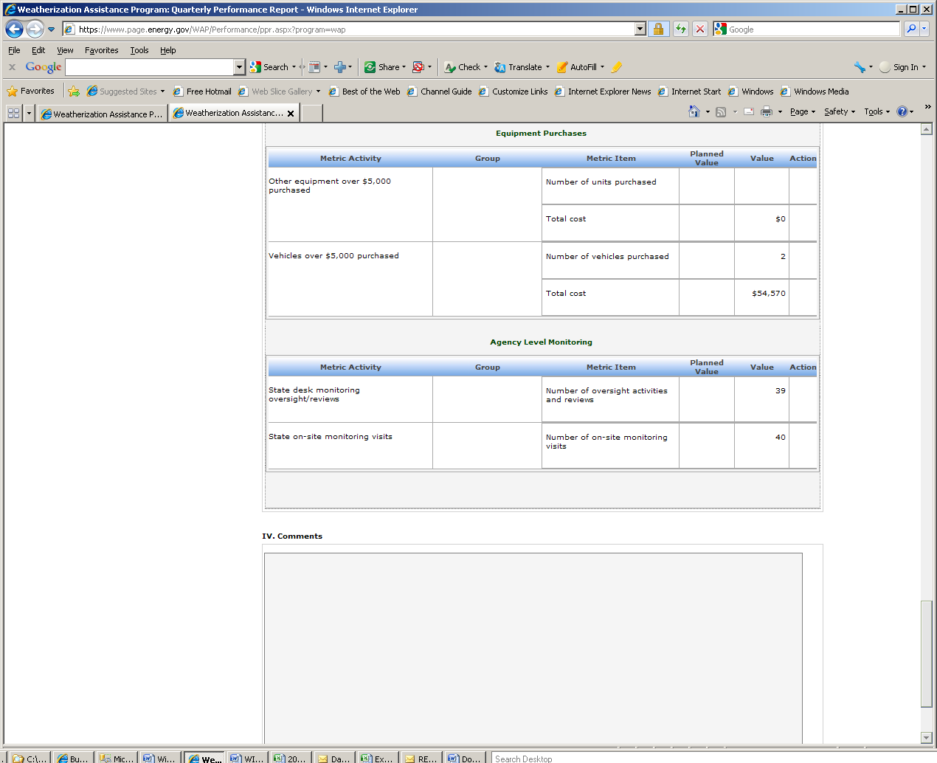

Developers are working to change the OMB statement, it will look like this (but with the correct OMB number) by April 7,2014

