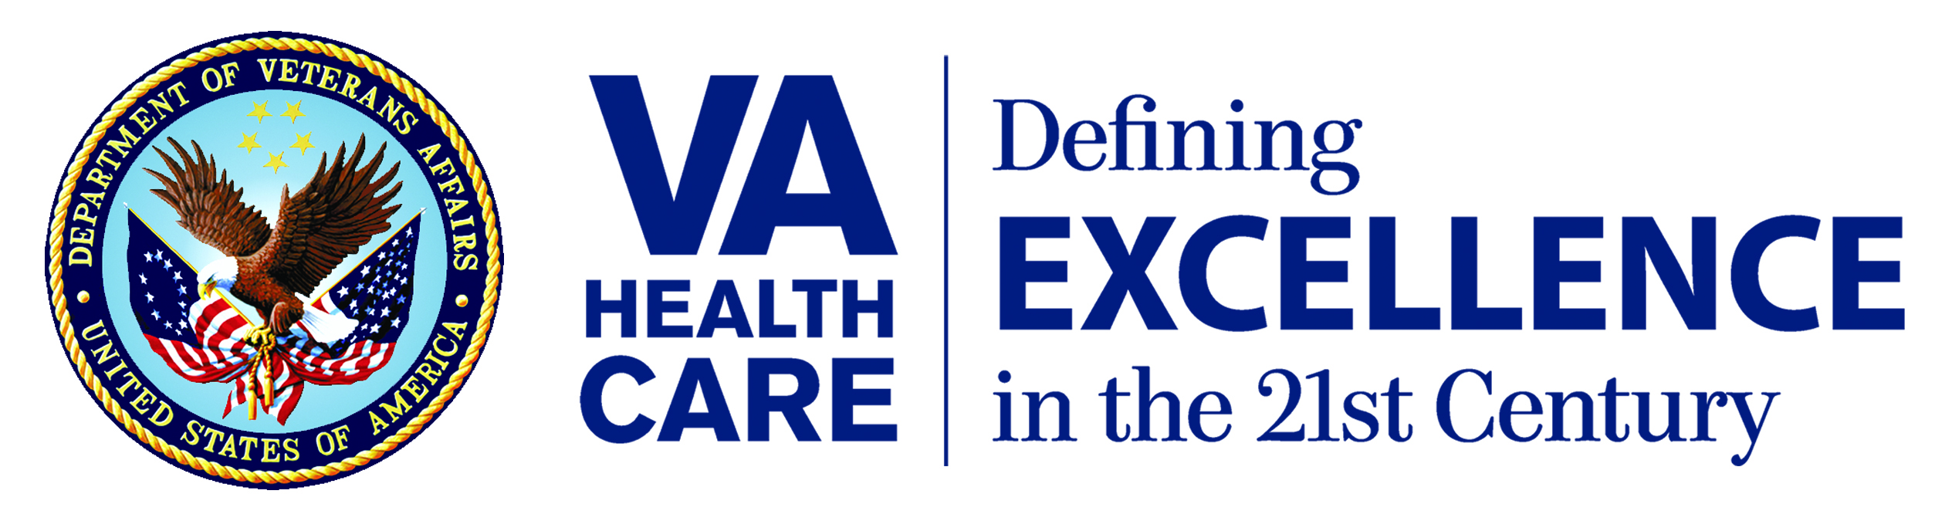

[MONTH] 2011

[Salut] [First name] [Last name]

[Address 1]

[Address 2]
[City], [State] [Zipcode]

Dear [Salut] [Last name]:

The Veterans Health Administration (VHA) is dedicated to providing Veterans the best health care possible and we want to hear your opinions about the service you received from the Project ARCH health care provider during your visit on [Month Date, Year].

Project ARCH (Access Received Closer to Home) is designed to provide you with improved access to health care by connecting you to high quality services closer to your home. We need your help to find out if Project ARCH is meeting the needs of our Veterans.

As a Veteran utilizing Project ARCH services, you have been randomly selected to complete the brief Project ARCH Patient Satisfaction Survey. The survey (OMB 2900-0770, VA Form 10-0522) should only take about 10-12 minutes and will ask questions related to your recent visit with the Project ARCH provider on [Month Date, Year].

Your privacy is of the highest priority, and I assure you that your responses will be kept private, to the extent of the law. No information about you as an individual will ever be released. To ensure total privacy, we have partnered with Altarum Institute, a not-for-profit research company. They will conduct the survey and tabulate the results for the VA. You may notice a number on the survey. This number is used ONLY by Altarum Institute to know if you have returned the survey so they don’t bother you with reminders.

Your input is very important to us, but your participation in this survey is entirely voluntary. Your health benefits and health care will not be affected in any way if you choose to complete or not participate in the survey.

We welcome your feedback, so please take the time to complete the survey. We’ve included a pre-paid envelope to make it easy for you to return the survey. Any other correspondence you send in the envelope will be forwarded to your Project ARCH Care Coordinator. Your participation is greatly appreciated!

ID PLACE HOLDER
If you have questions about your health care benefits or claims, please call the number below:
Questions about health care benefits or claims: 1-877-222-8387
Questions about other VA benefits: 1-800-827-1000

Sincerely,

Appropriate VA Official
Title, Agency Department

