## Request for Approval under the “Generic Clearance for the Collection of Routine Customer Feedback” (OMB Control Number: 2900-0770)

**TITLE OF INFORMATION COLLECTION:**

**VA HSR&D Women’s Health Research Network Phase 2 (WHRN 2.0): Multilevel Engagement**

**PURPOSE:**

**To identify barriers to and facilitators of effective engagement of VA stakeholders in VA Women’s Health (WH) research by:**

**a. Examining the perspectives, insights, and recommendations of Women Veteran (WV) patients**

**b. Providing aggregated, de-identified results to the Women’s Health Research Consortium (led by Dr. Elizabeth Yano) and Women’s Health Practice-Based Research Network (PBRN; led by Dr. Susan Frayne) for real-time application to support improved VA WH intervention research capabilities, implementation readiness, and impact.**

**Our goal is to support HSR&D’s advancement of the scientific evidence base needed to improve WVs’ care and address VA gender differences through a sustainable WH research infrastructure. We anticipate that the lessons learned through this project will provide critical insights that demonstrate value well beyond our focus on WVs and WH research.**

**DESCRIPTION OF RESPONDENTS**:

Respondents include WV patients.

Patients: Approximately 70 women Veterans are expected to participate in individual telephone interviews. Ten of these women (n=10) will be WV community leaders/advocates (“Patient Group A”), identified based on the PIs’ connections with WVs who lead WV networks and organizations. The other 60 WVs (“Patient Group B”) will represent three age clusters from both urban and rural areas. All participants will be adults aged 18 and over. Inclusion criteria for Patient Group B (n=60) (determined from an administrative database available to Dr. Susan Frayne) are: identified as female, aged 18 and over, and receiving the preponderance of care from one of 15 purposively selected PBRN sites. Exclusion criteria determined upon approaching a potential subject are: lack of capacity to consent, lack of access to a telephone for the interview, non-English speaking, and incarcerated. Pregnant women, technically a vulnerable population, will potentially be involved, though we will not be enrolling on pregnancy status and the study procedures should not affect this population in any untoward way. Furthermore, we feel that it would be unethical to exclude women on the basis of pregnancy status, as it would not give them an opportunity to voice their perspectives about engagement in research.

**For more details, see sampling plan (*page 4*).**

**TYPE OF COLLECTION:** (Check one)

[ ] Customer Comment Card/Complaint Form [ ] Customer Satisfaction Survey

[ ] Usability Testing (e.g., Website or Software [ ] Small Discussion Group

[ ] Focus Group [**X**] Other: brief qualitative interview by telephone

**CERTIFICATION:**

I certify the following to be true:

1. The collection is voluntary.
2. The collection is low-burden for respondents and low-cost for the Federal Government.
3. The collection is non-controversial and does not raise issues of concern to other federal agencies.
4. The results are not intended to be disseminated to the public.
5. Information gathered will not be used for the purpose of substantially informing influential policy decisions.
6. The collection is targeted to the solicitation of opinions from respondents who have experience with the program or may have experience with the program in the future.

Name:_ Alison Hamilton, PhD_______________________________________________

To assist review, please provide answers to the following question:

**Personally Identifiable Information:**

1. Is personally identifiable information (PII) collected? [ ] Yes [X] No
2. If Yes, will any information that is collected be included in records that are subject to the Privacy Act of 1974? [**X** ] Yes [] No
3. If Yes, has an up-to-date System of Records Notice (SORN) been published? [ ] Yes [ ] No

**Gifts or Payments:**

Is an incentive (e.g., money or reimbursement of expenses, token of appreciation) provided to participants?

[**X**] Yes [] No

**BURDEN HOURS**

|  |  |  |  |
| --- | --- | --- | --- |
| **Category of Respondent** | **No. of Respondents** | **Participation Time** | **Burden** |
| Patients (Women Veterans, WVs) | 70 | 30 minutes (.50 hour) | 0.58 |
|  |  |  |  |
| **Totals** |  |  | **0.58** |

**FEDERAL COST:** The estimated annual cost to the Federal government is $0

**If you are conducting a focus group, survey, or plan to employ statistical methods, please provide answers to the following questions:**

**The selection of your targeted respondents**

1. Do you have a customer list or something similar that defines the universe of potential respondents and do you have a sampling plan for selecting from this universe? [**X**] Yes [ ] No

If the answer is yes, please provide a description of both below (or attach the sampling plan). If the answer is no, please provide a description of how you plan to identify your potential group of respondents and how you will select them?

See sampling plan below.

**Administration of the Instrument**

1. How will you collect the information? (Check all that apply)

[ ] Web-based or other forms of Social Media-

[**X**] Telephone

[ ] In-person

[ ] Mail

[ ] Other, Explain

1. Will interviewers or facilitators be used? [**X**] Yes [ ] No

**Please make sure that all instruments, instructions, and scripts are submitted with the request.**

**Attached**

## 

**Sampling plan**

We will interview a total of 70 WVs, including 10 WV community leaders/advocates, identified based on existing connections with WVs who lead regional and/or national WV networks and organizations and input from WHS and the WHRN Steering Committee. The other 60 WVs will represent three age clusters of VA patients from both urban and rural areas, as we anticipate that age and geographic issues (e.g., distance to WH care) may impact engagement in VA research since they are known to impact utilization of VA care.(1, 2)

We will create the sampling frame for these WVs from national VA databases, which draws on the Women’s Health Evaluation Initiative (WHEI) Master database (available to Dr. Susan Frayne, a WHRN PI), to identify all WVs receiving the preponderance of their VA care at one of the 15 purposively selected PBRN sites, stratified by age group and urban/rural residence. Based on prior analyses of WVs by age and urban-rural location (3), for 15 PBRN sites, a conservative estimate of sampling frame size for the 6 cells is shown (**Table**, *below*). In prior telephone-based interviews of WV VA users/non-users, we achieved an 86% response rate, using methods such as advance information packets mailed to prospective participants (4), so we conservatively assume a 60% response rate (i.e., we need to contact 17 WVs to enroll 10 WVs per cell). Our sampling frame is ample for achieving this. We will thus ensure 20 WVs per age cohort and 30 WVs per type of geographic setting, thereby meeting criteria for thematic saturation in both strata and in the overall sample.(5)

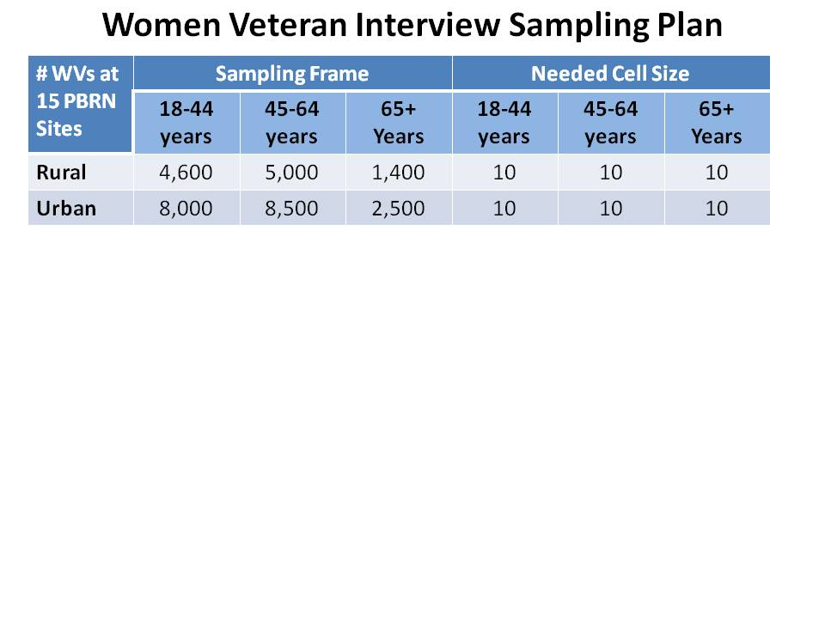

**Recruitment Procedures**: Prior to contacting potential participants, the research team will query VHA’s Vital Status file (updated monthly) to assure that those in the sampling frame are living. We will first use WHEI-Master Database to identify the list of scrambled SSNs of eligible WVs, then use the crosswalk and Corporate Data Warehouse data to generate real SSNs, names and addresses of eligible WVs. The address list should be quite up-to-date, even for WVs who have not used VA recently, as addresses for current and prior VA users are updated quarterly with VA administrative data and US Post Office Change of Address information (personal communication, Chase Gatlin, PSSG, 12/2/2011). We will mail a randomly selected batch of potential participants a letter notifying them that they will be contacted by study staff regarding potential participation, unless they choose to opt out via postcard or phone. Among a random sample of WVs who do not opt-out, study staff will contact potential participants by phone to ascertain interest in participating and, if interested, to arrange an appointment for a telephone interview. The 30-minute interview will be conducted by trained interviewers with extensive experience interviewing WVs, using a semi-structured interview guide. For the ***WV community leader/advocate sample***, individuals will be contacted initially by email. Email invitations will include information about study requirements and opt-out information. Individuals will also be called if they do not respond via email. For those agreeing to participate, a trained interviewer will conduct the 30-minute interview by phone using a semi-structured interview guide. Phone interviews make it feasible and economical to reach a large number of respondents at geographically dispersed facilities; our group has extensive and successful experience with this approach.

**References**

1. Washington DL, Bean-Mayberry B, Hamilton AB, et al. Women veterans' healthcare delivery preferences and use by military service era: findings from the national survey of women veterans. J Gen Intern Med 2013;28 Suppl 2:571-576

2. Mooney C, Zwanziger J, Phibbs CS, et al. Is travel distance a barrier to veterans' use of VA hospitals for medical surgical care? Soc Sci Med 2000;50:1743-1755

3. Frayne S, Phibbs C, Friedman S, et al. Sourcebook: Women Veterans in the Veterans Health Administration. Volume 2. Sociodemographics and Use of VHA and Non-VA Care (Fee). 2012. Available at: <http://www.womenshealth.va.gov/WOMENSHEALTH/docs/SourcebookVol2_508c_FINAL.pdf>. Washington, D.C.: Women's Health Evaluation Initiative (WHEI), Women's Health Services, Veterans Health Administration, Department of Veterans Affairs. Accessed July 2013.; 2012

4. Washington DL, Yano EM, Simon B, et al. To Use or Not to Use - What Influences Why Women Veterans Choose VA Health Care? Journal of General Internal Medicine 2006;21:S11-S18

5. Guest G, Bunce, A., Johnson, L. . How Many Interviews Are Enough? An Experiment with Data Saturation and Variability. *Field Methods* 2006;18:59-82

6. Veterans Health Administration. Health Care Services for Women Veterans (VHA Handbook 1330.01). Washington, DC: US Department of Veterans Affairs; 2010

7. Haskell S. Women’s Assessment Tool for Comprehensive Health: The WATCH Self- Assessment National Roll-Up. Invited Presentation at National VA HSR&D CyberSeminar: Spotlight on Women's Health2013

## Instructions for completing Request for Approval under the “Generic Clearance for the Collection of Routine Customer Feedback”

**TITLE OF INFORMATION COLLECTION:** Provide the name of the collection that is the subject of the request. (e.g. Comment card for soliciting feedback)

**PURPOSE:** Provide a brief description of the purpose of this collection and how it will be used. If this is part of a larger study or effort, please include this in your explanation.

**DESCRIPTION OF RESPONDENTS**: Provide a brief description of the targeted group or groups for this collection of information. These groups must have experience with the program.

**TYPE OF COLLECTION:** Check one box. If you are requesting approval of other instruments under the generic, you must complete a form for each instrument.

**CERTIFICATION:** Please read the certification carefully. If you incorrectly certify, the collection will be returned as improperly submitted or it will be disapproved.

**Personally Identifiable Information:** Provide answers to the questions. Note: Agencies should only collect PII to the extent necessary, and they should only retain PII for the period of time that is necessary to achieve a specific objective.

**Gifts or Payments:** If you answer yes to the question, please describe the incentive and provide a justification for the amount.

**BURDEN HOURS:**

**Category of Respondents:** Identify who you expect the respondents to be in terms of the following categories: (1) Individuals or Households;(2) Private Sector; (3) State, local, or tribal governments; or (4) Federal Government. Only one type of respondent can be selected per row.

**No. of Respondents:** Provide an estimate of the Number of respondents.

**Participation Time:** Provide an estimate of the amount of time required for a respondent to participate (e.g. fill out a survey or participate in a focus group)

**Burden:** Provide the Annual burden hours: Multiply the Number of responses and the participation time and divide by 60.

**FEDERAL COST:** Provide an estimate of the annual cost to the Federal government.

**If you are conducting a focus group, survey, or plan to employ statistical methods, please provide answers to the following questions:**

**The selection of your targeted respondents.** Please provide a description of how you plan to identify your potential group of respondents and how you will select them. If the answer is yes, to the first question, you may provide the sampling plan in an attachment.

**Administration of the Instrument:** Identify how the information will be collected. More than one box may be checked. Indicate whether there will be interviewers (e.g. for surveys) or facilitators (e.g., for focus groups) used.

**Submit all instruments, instructions, and scripts are submitted with the request**