VHA Voice of the Veteran (VOV) Satisfaction Survey

Office of Strategic Integration (OSI) Conjoint Analysis

OMB No. 2900-0770
Estimated Burden: 15 minutes

Expiration Date: 08/31/2017

The Paperwork Reduction Act of 1995: This information is collected in accordance with section 3507 of the Paperwork Reduction Act of 1995. Accordingly, we may not conduct or sponsor and you are not required to respond to, a collection of information unless it displays a valid OMB number. We anticipate that the time expended by all individuals who complete this survey will average 15 minutes. This includes the time it will take to follow instructions, gather the necessary facts and respond to questions asked. Customer satisfaction is used to gauge customer perceptions of VA services as well as customer expectations and desires. The results of this telephone/mail survey will lead to improvements in the quality of service delivery by helping to achieve health services. Participation in this survey is voluntary and failure to respond will have no impact on benefits to which you may be entitled.

Conjoint Survey- External Communication

Section Name | Section Title | Level | Order Group | Order
Introduction | Introduction | 1
Choice Tasks | Choice Tasks | 1
Follow-up Questions | Additional Questions | 1
Demographics | About You | 1

INTRODUCTION

Welcome. You have been selected to participate in a J.D. Power study regarding your access to healthcare.

This survey will take approximately 15 minutes to complete. We look forward to your participation.

Click here for our privacy and cookie notice.

S1 Are you a Veteran of the United States Military?

1 Yes

0 No [TERMINATE]

99 Don’t know [TERMINATE]

S2. Do you qualify for health care from the Department of Veterans Affairs?
- Yes—and I currently receive healthcare from VA
- Yes—but I don’t currently receive healthcare from VA

0 No [TERMINATE]
[PROG: Quota Minimum 200 S2=1, Quota Min 200 S2=2 respondents]

S3. In what wartime, what period did you serve?

1 WWII

2 Korean Conflict

3 Vietnam Era

4 Gulf War

97 Other [PROG: SPECIFY, FIXED]
[PROG: Quota 200 Vietnam Era (S3=3) respondents]

D1. In what year were you born?

Year of birth [A: Age] [PROG: DROPDOWN, FORCED, RANGE = 1914- 1997]

9998 Prefer not to answer [PROG: EXCLUSIVE]

D2. Are you…? [A: Gender] [PROG: SINGLE RESPONSE, FORCED]

1 Male

0 Female

98 Prefer not to answer
[PROG: Quota 200 women (D2=0)]

CHOICE TASKS

Thank you for your responses so far. We’d now like you to go through an exercise that will better help us understand your opinions about how you prefer to receive VA communication.

In the following exercise, you will be presented choices with different features that fall into 5 different categories as specified below. Your task is to select the choice you would prefer the most regarding how you would access VA information. When making your selection, you can assume everything is the same except the differences shown for each choice.

You will be asked to make a selection for a total of 30 screens, 10 for each different reason for visit. Each screen may look very similar. However the choices are different so please be careful in making your selection.

Modality: How the information is being communicated to you
Face to Face
Email
Social Media/Blog
Phone
Listserv (e.g., Gov Delivery)
Mail/Postcard

Communicator: From whom the communication is being sent
Secretary McDonald [PROG: Do not show if Modality = Face to Face]
VA Central Office [PROG: Do not show if Modality = Face to Face]
Peer
VHA medical facility staff
Secondary source (e.g. newspaper, TV, VSO)

Timeliness of Communication: How quickly the information is provided
Same day
Next day
Within 1 week
Within 1 month

Length of Communication: How long it takes to review the information
Less than 1 minute
1-5 minutes
6-10 minutes
More than 10 minutes

Importance of Material:
Low importance
Average importance
High importance
Urgent

Communication Content: What the communication is about
Policy related
Medical services
General VA information
Medical benefits
Veteran services (not medical)

[PROG NOTE: SHOW 30 SCREENS (EXAMPLE BELOW), RANDOMLY MANIPULATING THE FEATURE SET WITHIN THE THREE CHOICES FOR EACH SCREEN]
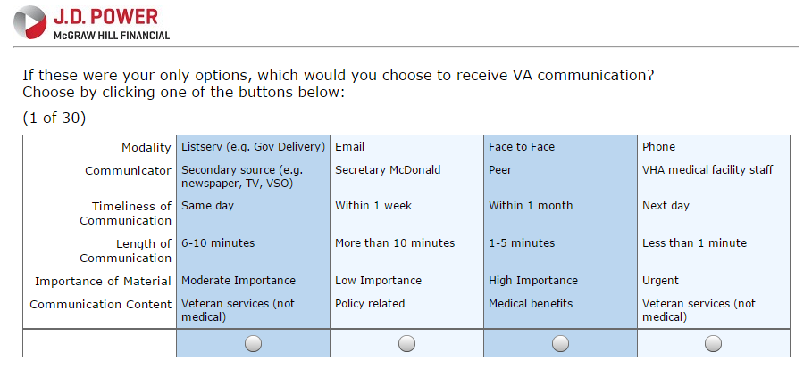
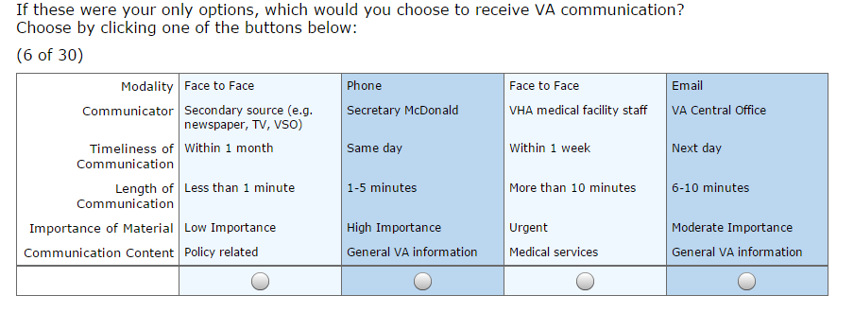
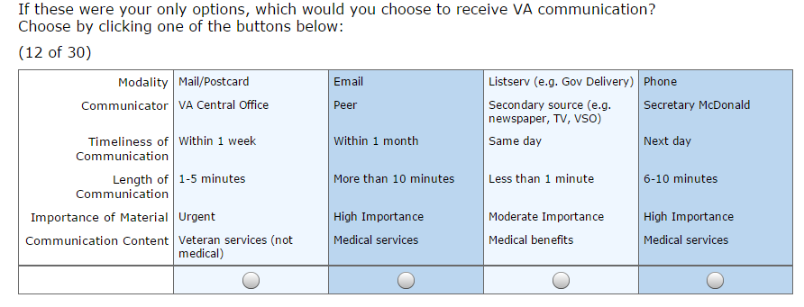
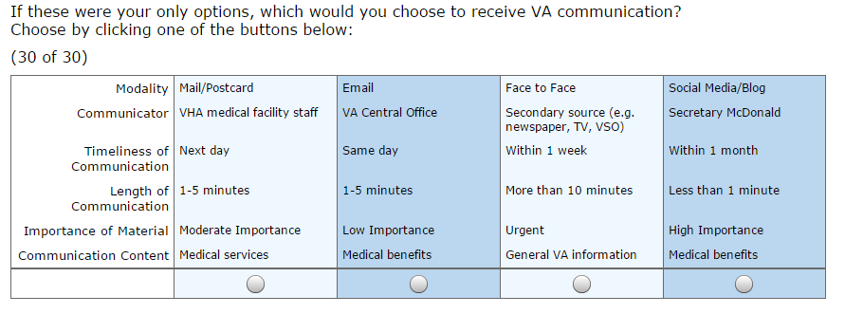
FOLLOW-UP

V1. What are your top 3 preferred methods of communication from VA?

Prog Column:
1 Most preferred communication method: PROG [drop down box]
2 Second choice PROG [drop down box- exclude V1_1 selection from options]
3 Third choice PROG [drop down box- exclude V1_1 and V1_2 selection from options]

[PROG: Drop Down List]

1 Face to face

2 Phone

3 Email

4 Text message

5 Newsletter/Listserv (e.g., Gov Delivery)

6 Social media (e.g. Twitter, Facebook)

7 External Media Sources (e.g. newspaper, TV, VSO)

8 Video message

9 Mail (e.g. letter/postcard)

10 Website

11 MyHealtheVet

12 Annual Report

13 Word of mouth

14 Mobile Apps (e.g., 311Vet, Moving Forward, PE Coach)

15 Blog (e.g., Vantage Point)

97 Other [PROG: SPECIFY, FIXED]

V2. How often do you hear about an initiative, policy, or change first through the press rather than directly from VA?
[PROG: SINGLE RESPONSE, FORCED, ORDER=Fixed]

1 Never

2 Not very often

3 Somewhat often

4 Very often

99 Don’t know

How much do you agree or disagree with the following statements?

V3.

A. I trust VA information communicated from my peers.

B. I trust VA information communicated from VA.

C. I trust VA information communicated from external news outlets.

D. I trust VA information communicated from Veteran Service Organizations.
[PROG: STANDARD AGREEMENT GRID, SINGLE RESPONSE, FORCED]

1 Strongly disagree

2 Somewhat disagree

3 Neither disagree nor agree

4 Somewhat agree

5 Strongly agree

V4. What would be the one thing VA could do to improve communication between Veterans and VHA Employees?

[PROG: Text Box up to 1000 characters]

98 No comment [PROG: EXCLUSIVE]

V5a. If “coffee with VA” events where you could have one-on-one discussions about topics you are interested in with VA facility directors and staff were available in your hometown, how likely would you be to attend in person?

1 Definitely will not

2 Probably will not

3 Probably will

4 Definitely will

99 Don’t know

V5b. If “coffee with VA” events where you could have one-on-one discussions about topics you are interested in with VA facility directors and staff were available virtually, how likely would you be to attend?

1 Definitely will not

2 Probably will not

3 Probably will

4 Definitely will

99 Don’t know

V6. Do you see a distinction between the Veterans Health Administration (VHA) and the Veterans Benefits Administration?

1 Not at all

2 Partially

3 Completely

99 Don’t Know

V7. From what you have heard, what is the primary mission of VHA?

[PROG: Text Box up to 1000 characters]

98 No comment [PROG: EXCLUSIVE]

V8. Thinking about your relationship with VA, how much do you agree with each of the statements listed below?

a. I feel loyal to VA.

b. I am proud to be a Veteran.

c. If I were unable to use VA services, I would be disappointed.

d. I am committed to VA.

[PROG: STANDARD AGREEMENT GRID, SINGLE RESPONSE, FORCED]

1 Strongly disagree

2 Somewhat disagree

3 Neither disagree nor agree

4 Somewhat agree

5 Strongly agree

V9. In the past 12 months, have you attempted to reach a VHA employee to book an appointment or ask a question, concern, or express a complaint?

1 Yes

0 No

[PROG: Show if V9=1]

V9a. How easy was it to reach a VHA employee?

1 Very difficult

2 Somewhat difficult

3 Somewhat easy

4 Very easy

V10. If you were VA facility director for the day, what would be one thing you would like to change?

[PROG: Text Box up to 1000 characters]

V10a. How would you communicate that change to Veterans?

[PROG: Text Box up to 1000 characters]

V11. If VHA were to provide a 24 hour call center where Veterans can ask questions, get information, and get referrals, how likely would you be to use this service?
[PROG: STANDARD LOYALTY GRID, SINGLE RESPONSE, FORCED]

1 Definitely will not

2 Probably will not

3 Probably will

4 Definitely will

99 Don’t know

V12. Thinking about the most recent VHA communication you received by mail, please rate the following attributes on a 10-point scale
[PROG: STANDARD ATTRIBUTE GRID, SINGLE RESPONSE, FORCED]

[PROG: COLUMN]

1= Unacceptable, 5 = Average, 10 = Outstanding

[PROG: ROW, ORDER=RANDOMIZE]

A. Appearance of the communication

B. Clarity of information provided

C Depth of information provided

D. Follow-up on topic

E. Overall communication experience

V13. Do you have any final thoughts about communication between VHA and Veterans you would like to share?

[PROG: Text Box up to 1000 characters]

VA BRAND AND EXPERIENCE

We are now going to ask you a few questions about VA overall.

__________________________________________________________________________________________

B1. Please tell us how you feel about the following statement:
[PROG: STANDARD AGREEMENT GRID, SINGLE RESPONSE, FORCED]

I trust VA to fulfill our country’s commitment to Veterans.

1 Strongly disagree

2 Somewhat disagree

3 Neither disagree nor agree

4 Somewhat agree

5 Strongly agree

B2. Consider all your recent experiences with VA (which may have included healthcare, benefits programs, or memorial services). Please tell us how you feel about the following statements:
[PROG: STANDARD AGREEMENT GRID, SINGLE RESPONSE, FORCED]

[PROG: Column]

1 Strongly disagree

2 Somewhat disagree

3 Neither disagree nor agree

4 Somewhat agree

5 Strongly agree

[PROG: Row, Order- Rotate]

A I got the service I needed.

B It was easy to get what I needed.

C I felt like a valued customer.

1 Strongly disagree

2 Somewhat disagree

3 Neither disagree nor agree

4 Somewhat agree

5 Strongly agree

About You

These last few questions are for classification purposes only.

D3. What was the last year of school you completed? [A: Education] [PROG: SINGLE RESPONSE, FORCED]

1 8th grade or less

2 Some high school

3 High school graduate

5 Some college

6 4-year college degree

9 More than 4 year degree

98 Prefer not to answer

D4. Which, if any, of the following best describes your employment status? [A: Employment status]
[PROG: SINGLE RESPONSE, FORCED]

1 Full-time

2 Part-time

3 Retired

4 Unemployed

5 Self-employed

98 Prefer not to answer

D5. Which one of the following best describes your household's total annual income before taxes in 2014 [A: Household income before taxes]
[PROG: SINGLE RESPONSE, FORCED]

1 Under $25,000

2 $25,000 - $29,999

3 $30,000 - $39,999

4 $40,000 - $49,999

5 $50,000 - $59,999

6 $60,000 - $69,999

7 $70,000 - $79,999

8 $80,000 - $89,999

9 $90,000 - $99,999

10 $100,000 - $124,999

11 $125,000 - $149,999

12 $150,000 - $174,999

13 $175,000 - $199,999

14 $200,000 - $249,999

15 $250,000 - $299,999

16 $300,000 - $349,999

17 $350,000 - $399,999

18 $400,000 - $449,999

19 $450,000 - $499,999

20 $500,000 or more

98 Prefer not to answer

D6. Is the area in which you live most of the time a/an…?
[PROG: SINGLE RESPONSE, FORCED]

1 Rural area

2 Suburban area

3 Urban area

97 Other [PROG: SPECIFY, FIXED]

99 Don't know

D7. What is your current marital status? [A: Marital status]
[PROG: SINGLE RESPONSE, FORCED]

1 Married

2 Single (never married)

3 Widowed

4 Divorced/separated

5 Living with domestic partner

98 Prefer not to answer

D8. Are you…? Mark all that apply. [A: Ethnicity]
[PROG: MULTIPLE RESPONSE, FORCED]

1 White/Caucasian

2 Black/African American

3 Asian/Asian American

4 Latino/Hispanic

5 Native American

6 Pacific Islander

97 Other

98 Prefer not to answer [PROG: EXCLUSIVE]

D9. What is your zip code? [A: Zip code]
[PROG: NUMERIC, 5 DIGITS, FORCED]

[TEXT BOX]

D10. Which of the following best describes your health status? [PROG: SINGLE RESPONSE, FORCED]

1 Excellent

2 Very Good

3 Good

4 Fair

5 Poor

98 Prefer not to answer

[PROG: SHOW TEXT: That concludes our survey. J.D. Power thanks you for participating.]

