**M1. PARENT PASSIVE CONSENT RESPONSE FORM**

**This page has been left blank for double-sided copying.**

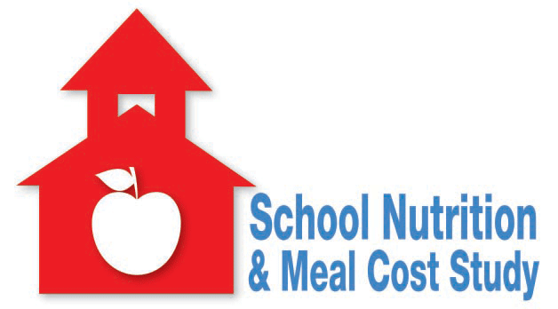Consent for Study Participation

OMB Clearance Number: 0584-xxxx

Expiration Date: xx/xx/xxxx

The School Nutrition and Meal Cost Study

The U.S. Department of Agriculture invites you to be a part of the *School Nutrition and Meal Cost Study*. This form explains what it means to be in the study. If you do not wish to take part in the study, please sign and return this form.

**What is the School Nutrition and Meal Cost Study?**

Mathematica Policy Research, a research firm, is conducting this study for the U.S. Department of Agriculture (USDA). This study will help the USDA learn about federally sponsored school meal programs. It will also help the USDA learn about students who take part in those programs. The study will examine how well schools are following new nutrition guidelines for school meals. We will also look at whether school meals meet students’ nutritional needs. School districts, schools, and students were scientifically selected for the study.

**What is expected of me and my child?**

A study team from Mathematica Policy Research will visit your child’s school. We will meet with students, staff, and parents (MS/HS: by phone). We will meet with students who eat school meals and those who do not eat them.We will ask students and their parents about school meals, students’ diets, and student characteristics. Survey questions will be age appropriate. Students and parents may skip any questions they do not wish to answer. Students’ height and weight will also be measured.

**Will my answers be kept private?**

All information will be kept private to the fullest extent allowed by law. The information you provide will be used for statistical purposes only. No information on individual students or families will be shared outside the study. No students or parents will be named or identified in any way. The study complies with the Family Educational Rights and Privacy Act (FERPA).

**Are there any risks or benefits?**

There are no known risks to taking part in this study. Your responses will not affect services you or your student receive or may apply for in the future. Parents and students who choose to participate will receive a small payment to thank them for their help. Parents will receive [ES: $30 / MS/HS: $15] after completing an interview. Students will receive [ES: $5 / MS/HS: $15].

**Do I have to participate?**

No. Taking part in the study is voluntary. We hope you take part in this important study, but it is your decision. Please read the enclosed materials to learn more about the study. If you do not want to participate, sign the back of this form and return it by [DATE]. If you do not return this form, we will contact you directly. You or your child can choose whether you want to participate at that time.

If you have any questions, please contact [SCHOOL LIAISON] at xxx-xxxx or call [MATHEMATICA CONTACT NAME] at 1-866-xxx-xxxx.

According to the Paperwork Reduction Act of 1995, no persons are required to respond to a collection of information unless it displays a valid OMB control number. The valid OMB control number for this information collection is 0584-XXXX. The time required to complete this information collection is estimated to average 3 minutes per response, including the time to review instructions, search existing data resources, gather the data needed, and complete and review the information collection.



School Nutrition and Meal Cost Study

I, the undersigned, do not wish to participate in the School Nutrition and Meal Cost Study.

Parent Name:

*(Please Print)*

Parent/Guardian Signature

STUDENT’s School: [PRE-FILLED]

NAME OF STUDENT: [PRE-FILLED]

IF YOU DO NOT WISH TO PARTICIPATE, PLEASE RETURN THIS FORM IN THE ENCLOSED STAMPED ENVELOPE BY [DAY, DATE].