N1. CHILD’S FOOD DIARY, DAY 1 AND DAY 2

This page has been left blank for double-sided copying.

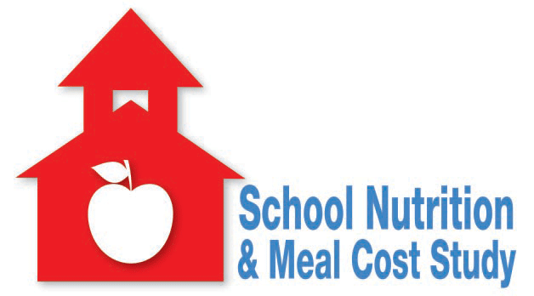

OMB Clearance Number: 0584-XXXX
Expiration Date: XX/XX/XXXX

school nutrition and meal cost study

Child’s Food Diary

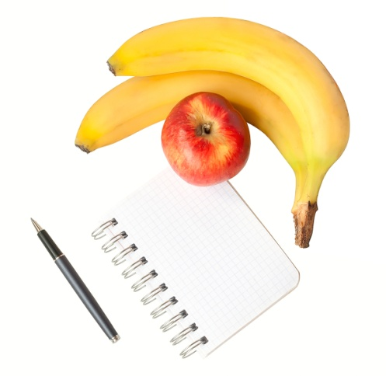

Child’s Name: ______________________________________________________

School: ___________________________________________________________

Interview Date and Time: _____________________________________________

Location: __________________________________________________________

According to the Paperwork Reduction Act of 1995, no persons are required to respond to a collection of information unless it displays a valid OMB control number. The valid OMB control number for this information collection is 0584-XXXX. The time required to complete this information collection is estimated to average 10 minutes per response, including the time to review instructions, search existing data resources, gather the data needed, and complete and review the information collection.

As part of the School Nutrition and Meal Cost Study, we will be interviewing you and your child together to learn more about what children eat both in and outside of school. Completing this food diary before the interview will help it go more quickly. Please bring the diary with you to the interview. Your interview appointment is written on the front cover.

Directions
Please write down everything your child eats and drinks on [DAY/DATE] from midnight to midnight. Start on the next page, after the “Example.” For each food and drink your child ate or drank, record the time (to the nearest 15 minutes) and the name and description of the food using the tips below. Then, please check the box to tell us where your child ate the food.
- Write one food or drink per line. Include any food your child takes at least a bite or sip of, including water.
- Include brand names if you know them. For food eaten at restaurants, write the name of the restaurant. For example, was the food from McDonald’s, Denny’s, Applebee’s, or Red Robin?
- Include additions to food. For example, was butter or jelly on toast, sugar on cereal, ketchup on French fries, mayonnaise on a sandwich, or salsa on a burrito?
- Remember to ask your child to tell you about foods eaten away from home. Write these foods in the food diary.
- There is no need to record the amounts of each food and drink. Amounts will be discussed together with you and your child.

Tips for Descriptions of Foods and Drinks
Drinks  Milk  White, chocolate, or other flavor?  Whole, 2%, 1%, or skim (nonfat)?  Juice  Type: orange, apple, grape, etc.  100% juice or juice drink?  Added calcium or other vitamins/minerals?  Water  Tap or bottled?  Sweetened or flavored?  Soda/Vitamin Water/Sport Drinks  Brand name, flavor  Regular or diet?  Meat, Poultry, Fish, and Dairy Foods  Meat  Type: beef, pork, lamb, etc.  Cut: ground, ribs, chops, steak  Chicken or turkey  Piece: breast, wing, thigh, drumstick, or light or dark meat  Nuggets, strips, or patty?  Fish or Shellfish  Type: tuna, catfish, shrimp, bass, etc.  Frozen, fresh, or canned (oil or water pack)?  Cheese  Type: cheddar, American, mozzarella, Swiss, string, etc.  Regular or low fat?  Eggs  Type: scrambled, fried, boiled  Sandwiches, Pizza, Burritos, and Other Mixed Dishes  Kind of sandwich: grilled cheese, peanut butter and jelly, etc.  Kind of burrito/taco: beef, bean, chicken, vegetable, etc.  Type of pizza: cheese, pepperoni, vegetable, etc.  Name of dish/recipe and main ingredients: macaroni and cheese, beef and bean chili, chicken stir-fry with rice, etc. | Fruits and Vegetables  Fruits  Kind: orange, peach, banana, raisins, etc.  Fresh, canned (syrup, water, or juice), frozen, or dried?  Vegetables  Type: corn, broccoli, refried beans, French fries, peas, etc.  Fresh, canned, or frozen?  Breads, Muffins, Tortillas, Cereal, Rice, and Pasta  Bread: sliced, roll, bagel, biscuit, white, whole wheat, cheese, etc.  Muffins: corn, blueberry, chocolate chip, etc.  Tortillas: flour, corn, whole wheat, soft, hard, fried, etc.  Cereal name and brand  Rice: white, brown, convenience mix?  Pasta/noodles: regular or whole grain?  Snacks, Candy, and Desserts  Chips, Crackers, or Popcorn  Brand name, flavor  Type: potato, tortilla, cheese curls, pork rinds, saltines, etc.  Regular, baked, or air-popped?  Candy or Baked Desserts  Kind: Candy, cookies, cakes, donuts, pies, pastries, etc.  Type: chocolate candy, oatmeal cookie, yellow cake, glazed donut, apple pie, toaster pastry, etc.  Yogurt, Ice Cream, or Frozen Yogurt  Brand, flavor  Regular, low-fat, or low sugar?  Salads and Salad Dressing  Type: green, pasta, tuna, chicken, coleslaw, bean, etc.  Salad dressing: Ranch, French, Italian, etc., regular, lite (low calorie), or low-fat?  Spreads and Fats  Butter: regular, whipped, butter margarine blend  Margarine: stick, tub, spray, regular, light, fat free  Mayonnaise: real, Miracle Whip-type, regular, or low-fat?

Time | Name and Description of Food or Drink | Home | School | Restaurant | Other
EXAMPLE:
6:30 AM | Orange Juice, Tropicana, 100 % Juice | X
 | Cheerios with 1% white milk | X
11:15 AM | Chicken patty sandwich on whole grain roll |  | X
 | Fresh baby carrots with regular Ranch dressing |  | X
 | Skim milk, chocolate |  | X
 | Red grapes, fresh |  | X
2:30 PM | Tap water | X
 | Apple, fresh | X
 | Peanut butter, Skippy, reduced fat | X
6:00 PM | Grilled chicken, Ruby Tuesdays (kids menu) |  |  | X
 | Broccoli, Ruby Tuesdays |  |  | X
 | Mashed potatoes with cheddar cheese (Ruby Tues) |  |  | X
 | Kids super fruit punch, Ruby Tuesdays |  |  | X
7:45 PM | 1% white milk | X
 | Chocolate chip cookies, Chips Ahoy | X
Start recording foods and drinks for your child here:

