L9. HOUSEHOLD MIDDLE AND HIGH SCHOOL BROCHURE

This page has been left blank for double-sided copying.

Who is conducting the study?

SCHOOL NUTRITION AND MEAL COST STUDY
Mathematica Policy Research is conducting this study for the U.S. Department of Agriculture (USDA). Mathematica has more than 25 years of experience studying school nutrition programs.
Am I required to participate?
No. You are not required to participate. However, we need your help for the study to succeed! The information you provide will help USDA learn about students’ nutritional needs. Your participation will also help us learn how well schools are following nutrition guidelines.
As thanks for participating, students will receive $15 and parents will receive $15. The study complies with the Family Educational Rights and Privacy Act (FERPA).
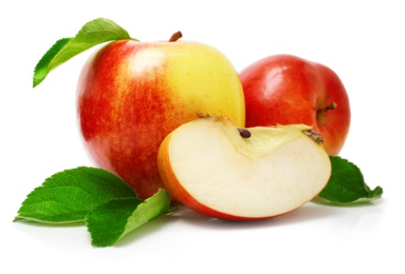

For further information contact:
OMB Control #: 0584-xxxx
Expiration Date: xx/xx/xxxx
Eric Zeidman
School Nutrition and Meal Cost Study
P.O. Box 2393
Princeton, NJ 08543-2393
Phone: 866-xxx-xxxx
Fax: 609-799-0005
The School Nutrition Study is on Facebook:
http://facebook.com/abcde
Visit our website:
According to the Paperwork Reduction Act of 1995, no persons are required to respond to a collection of information unless it displays a valid OMB control number. The valid OMB control number for this information collection is 0584-XXXX. The time required to complete this information collection is estimated to average 11 minutes per response, including the time to review instructions, search existing data resources, gather the data needed, and complete and review the information collection.

www.mathematica-mpr.com
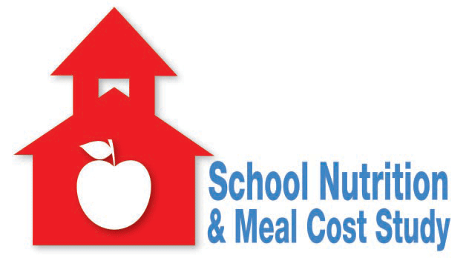

Schools and Families Working Together to Support Healthy Students
Sponsored by the
U.S. Department of Agriculture
USDA is an equal opportunity provider and employer

SCHOOL NUTRITION AND MEAL COST STUDY

Why is this study being done?
Schools are working to follow new rules aimed at offering healthier foods to children. Schools are also trying to promote healthy eating and exercise habits. USDA is sponsoring this study to learn how federally sponsored school meal programs are operating after these changes.
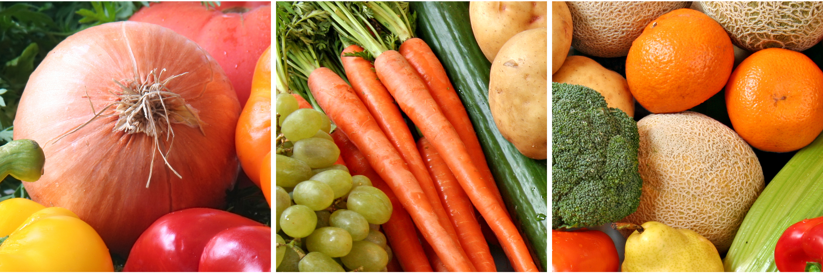
How will the study work?
We will interview students and their parents. We will ask about what students eat, the types of activities they do, and opinions about school meals. The study is designed to represent all public school students across the country. The information you and your child provide helps to ensure that all types of families and students are included in the study. Your experiences and opinions matter!
My child does not eat the school breakfast or lunch. Should I still participate?

Yes! This study is about all students. It is important that we interview students who eat school meals and those who do not. Even if your child has never eaten the school breakfast or lunch, we need your help. We want to understand why some families choose not to participate in the school meal program.
Will my answers be kept private?
All information gathered for the study will be kept private to the fullest extent allowed by law. No information on individual students or families will be shared or reported. No students or parents will be named or identified in any way.
What will I be asked?
The person who interviews you may ask about:
- How often your child eats schools meals
- What your child typically eats and what he or she ate on a specific day
- General student characteristics, such as height and weight, and exercise habits
- Satisfaction with the school meal program
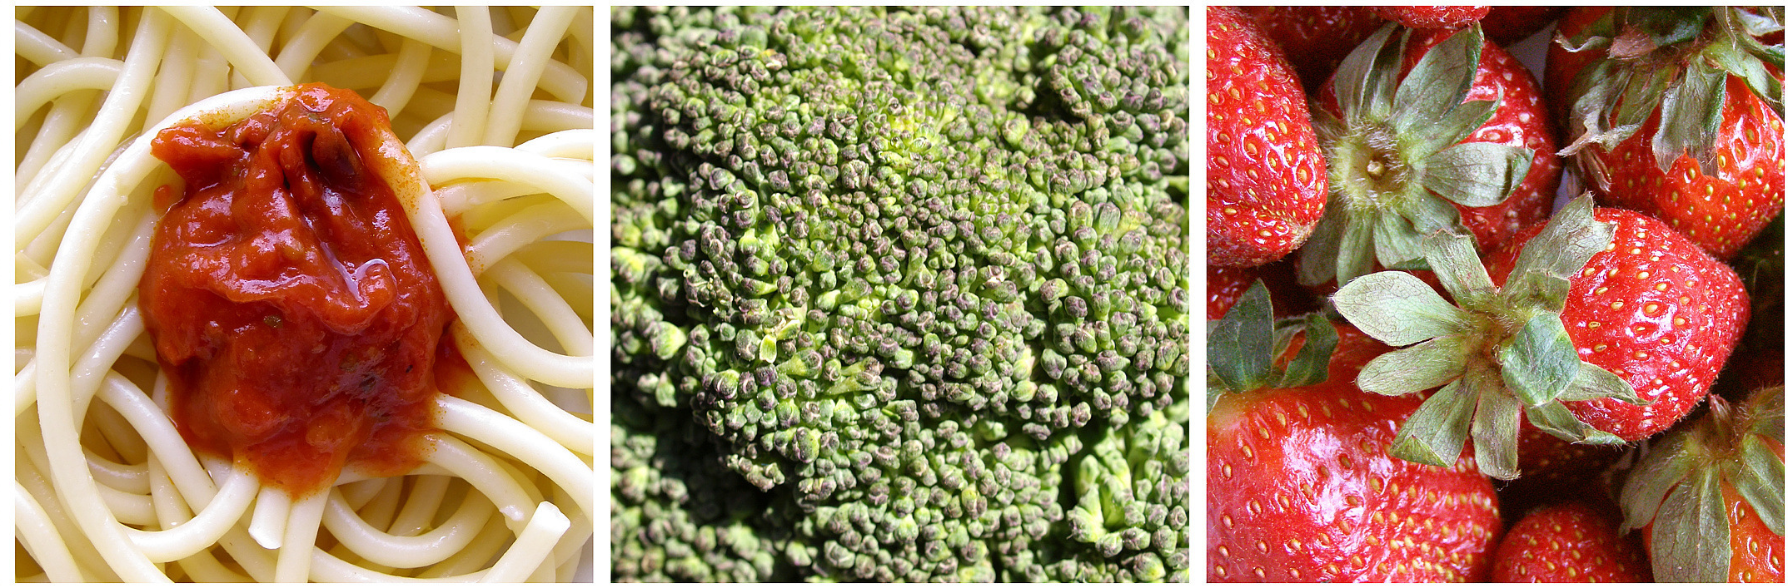
How long will the interview take?
The student interview will take place in school. It will last about 60 minutes. The parent interview will take place by phone and will last about 25 minutes.
What do I get for participating?
As thanks for participating, parents will receive $15 after completing an interview. Students will receive $15.

