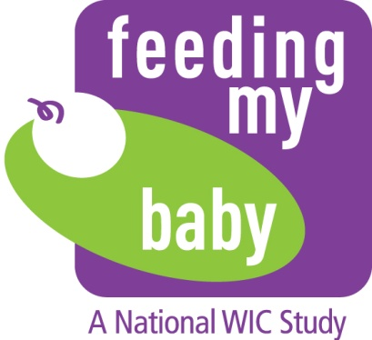

**Appendix HH**

**Frequently Asked Questions**

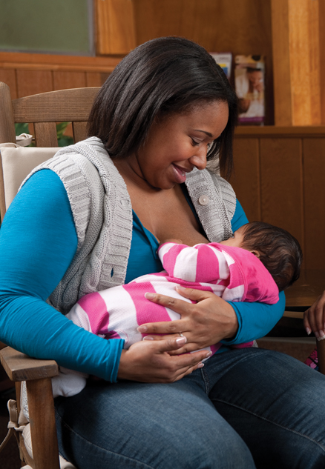

Frequently Asked Questions Related To:

Dates and Administrative Details 1

Study Requirements for State Agencies 4

Study Requirements for Local Sites 5

Study Participants 6

Study Specifics and Logistics for States and Local Sites 7

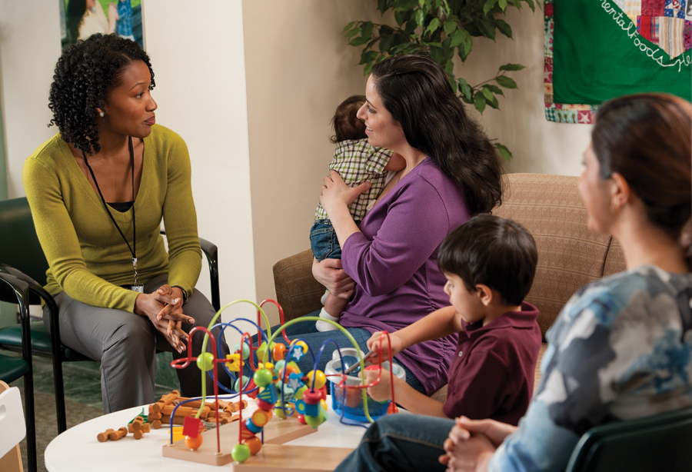

# DATES AND ADMINISTRATIVE DETAILS

**Q. My State/local agency has an Institutional Review Board (IRB) approval requirement for studies pertaining to individuals who are participants of programs administered by the Agency. How will the study team work with my Agency to complete this process?**

Westat’s IRB has reviewed and approved the study. If your State or Local Agency has IRB approval requirements, we will provide you with a copy of the Westat IRB approval and relevant materials that you can use to submit a request for review to your IRB. Westat will provide responses to specific questions related to IRB approval if the information is not included in the materials provided. If IRB approval is required by your State/Local Agency, we request that you determine your IRB’s submission and review timelines to ensure approval can be obtained prior to the start of the study.

**Q. What is the timing of seeking IRB approval in terms of the start of the study activities?**

In the event your State Agency or local site requires IRB approval, it should be in place before any study activities begin (e.g. key informant interviews, recruiting participants).

**Q. Will State or Local Sites be provided with funds to participate in the study? If so, how much and how will the funds be provided?**

No, we are not able to offer funds to WIC sites for this study.

**Q. Who are the study personnel who will be working with the States and Local Sites?**

Westat, headquartered in Rockville, Maryland, is the lead research organization on this study, working on behalf of the USDA’s Food and Nutrition Service. Westat has a subcontract with the Altarum Institute. Together with FNS, Westat and Altarum have designed the study and the survey instruments.

**Regional Coordinators** from Altarum Institute will be responsible for initial discussions with state and local agencies about the project and the participant recruitment process. They will conduct site visits to local WIC agencies in the spring of 2013.

**Study Liaisons** from Westat will work with the Regional Coordinators and the sites to design site-specific participant recruitment plans. Once recruitment starts in the sites in spring 2013, Study Liaisons will supervise Westat field staff conducting the recruitment and enrollment activities.

A Westat staff person will be onsite during the participant-recruitment period. The Regional Coordinators and Study Liaisons will work individually with sites to determine the best arrangement, but the two models are:

1. Westat Recruiter Model: the **Westat Recruiter** will be onsite to speak with eligible participants to see if they are interested in participating in the study. If a participant is interested, the Recruiter will **answer any questions** the participant may have, **obtain consent**, and **administer the enrollment survey**.
2. Westat Helper: A **Westat Helper** will be onsite during the study recruitment period to speak with eligible WIC participants. Like recruiters, they will explain the study and invite eligible WIC clients to participate in the study. If they are, the Helper will **answer any questions** the participant may have, and **connect the WIC participant to the Westat Telephone Research Center (TRC)** wherethe TRC will conduct the enrollment and survey activities.

Our preferred staffing arrangement is to use a field recruiter since the recruiter can build more rapport while talking with the new enrollees in-person, and will more often be able to enroll the woman immediately into the study.

We will determine the best technology for conducting the recruitment interviews, which will partly influence the staffing model we use in a particular site. If a site has WiFi, accessible ethernet connectivity, or cellular coverage we can staff the site with a Westat field recruiter. If a site indicates they do not have enough space or privacy for a Westat field recruiter to have a conversation with a WIC enrollee, but could accommodate a Westat person handing a phone to a potential enrollee, we will use the helper model. If there is no cellular coverage we cannot accommodate either model and will request the WIC staff keep a referral form on each new enrollee (discussed in Section 4.5.3) and send to Westat on a regular basis in a secure communication mode (i.e., secure fax, encrypted email, or tracked mail).

Altarum Regional Coordinators will begin talking with officials from State Agencies and local sites in August to provide study details, respond to questions, identify challenges, describe the Recruiter and Helper models, and work with the sites to determine which model the site will use. Regional Coordinators are individuals who have past experience working in State or local WIC programs and/or experience working with State and local WIC agencies on other studies or projects conducted by Altarum. A Westat Study Liaison will be assigned to each site and will work together with Altarum to develop the best approach for recruiting and enrolling women onsite.

The Regional Coordinators will also conduct an interview with State Agency staff and an onsite visit with local site staff to obtain information about policies and operations. Altarum will also conduct an online survey of all staff in the local sites.

**Q. Are Westat study staff hired locally?**

Typically, the staff will live locally; however, in some cases Westat may bring in experienced Westat staff from other locations.

**Q. How will the Westat study recruiters and helpers be supervised?**

The Westat 80 recruiters/helpers will be supervised by 10Westat Study Liaisons. The Study Liaisons are geographically dispersed across the United States and work from their homes. Each Study Liaison will be assigned 8 sites.. They will communicate regularly with their recruiters/helpers and may make site visits if recruiters/helpers encounter problems at the site. They will be in regular communication with the WIC sites to make sure all recruitment activities are going smoothly.

**Q. How many hours per week will the Westat study staff work?**

This will vary depending on the number of hours the site is open for prenatal and infant enrollment.

**Q. Our WIC agency requires all staff to be background screened. Will you pay for that screening?**

Westat conducts a background screening of all study staff hired. If a local site requires additional screening (such as health screens), we will pay for the type of screening required by the State or local agency.

**Q. Is it possible to obtain the details/criteria for site selection?**

The sampling summary will be published on the internet in spring 2013 as part of the Office of Management and Budget (OMB) package.

# STUDY REQUIREMENTS FOR STATE AGENCIES

Q. What will State Agency staff be asked to do to assist with recruiting the Local Sites for the study?

State Agencies will be asked to assist with informing the Local Sites about the study, providing a name and contact information for a local point of contact for each site, and garnering participation from the sites.

Q. What will the State Agency staff be asked to do during the period when study personnel are in the Local Sites?

State Agency staff may choose to participate in the onsite visit conducted by the Regional Coordinators; however, it is not essential for State Agency staff to be at the site during the visit. During the period when participants are being recruited for the study, State Agency staff may be asked to help with planning for implementation of the study in the local sites.

Q. What will the State Agency staff be asked to do after the participants have been selected (after recruitment is complete)?

When participants who are enrolled in the study are being interviewed by phone, State Agency staff will be asked to provide data elements from WIC records for these participants. The data elements include weight, length, and date of measurements for infants/toddlers, and the type of food package prescribed to the mother/child three times over 3 years (once a year 2014-2016). All of the data items are part of the FNS required Minimum Data Set (MDS) included in State management information systems. However, in order to provide interim data to FNS we need these data before they are published in the MDS. Westat staff will work with each State Agency to determine the easiest way to obtain this information.

# STUDY REQUIREMENTS FOR LOCAL SITES

Q. What are the Local Site’s responsibilities for the study?

All sites will be asked to (1) host an onsite visit by the Regional Coordinators to obtain key informant information and conduct an observation to build a site profile; (2) have local WIC staff complete an on-line survey; (3) identify new WIC enrollees during the recruitment process; (4) allow a recruiter or helper to recruit new enrollees during a fixed period of time in the spring through summer 2013 timeframe; (5) possibly provide length/weight and food package data 3 times over 3 years on participants (if SA does not provide information); and provide updated participant contact information if Westat requests it for tracing purposes. These items are described more fully below.

Q. What are the Local Sites expected to provide in terms of space and equipment for study personnel?

The local sites will be asked to provide a space where the study staff can conduct the recruitment interview with as much privacy as feasible. Each site will make the determination as to whether they have enough space to accommodate a recruiter. However, we would expect that recruiters on site would need more privacy to talk with the new enrollee than helpers would need (since helpers are providing the women with a phone to talk to a Westat telephone recruiter). Westat will provide laptops and cell phones needed for Westat recruiters/helpers to conduct the recruitment and enrollment interviews on site. .

Q. What will the Local Site staff be asked to do relative to identifying/recruiting participants for the study?

The Local Sites will be asked to identify women and infants eligible for the study and write some demographic information about the eligible woman/infant on a referral form. They may also be asked to provide the women with the Feeding My Baby Study flyer, which we will provide to sites pre-printed for their use.

Q. What will the local site staff be asked to do after the participants have been selected (i.e., after recruitment is complete)?

If weight, height, and food package type data for participants enrolled in the study cannot be easily obtained from the State Agency, local sites may be asked to provide data 3 times over 3 years.

After the recruitment phase, the study liaison may contact the site periodically to request updated contact information for women enrolled in the study who are still on WIC, but who Westat has been unable to reach for a follow-up telephone interview.

**Q. Is the local site responsible for providing an interpreter for Spanish-speaking participants?**

No, Westat will hire Spanish-speaking staff for sites that need them.

# STUDY PARTICIPANTS

Q. What responsibilities do participants have in the study?

During enrollment, participants will be assigned to either a “core” or a “supplemental” group and their babies will be followed over a 2-year period. After their babies are born, participants assigned to the core group will be contacted 10 times over the 2-year period to complete a telephone interview; participants assigned to the supplemental group will be contacted 4 times over the 2-year period to complete an interview. Telephone interviews will ask about what their baby ate the day before the interview as well as general feeding practices, attitudes, and behaviors about feeding.

Q. How will participants’ privacy be protected?

As part of the recruitment process we will obtain informed consent from all women that assure them that participating is completely voluntary, and if they choose to participate: (1) they may refuse to answer any questions; (2) we will continue to get records from WIC about them unless they tell us to stop; (3) they can stop participating at any time; and (4) their WIC services or other benefit will not be affected if they decide to stop participating. In addition, the consent will explain that we will take many steps and precautions to protect their privacy, assigning a study idea to their data rather than using their name; storing study information on secure computer servers at Westat; and promising not to share personal information about them with WIC or with anyone else who is not on the study staff.

Q. What incentives will be offered to study participants?

Each participant will receive $50.00 for enrolling in the study and $20.00 for each interview she/he completes. The incentives will be loaded onto a prepaid Payoneer mastercard. The participants will receive the Payoneer card preloaded with $50 by mail within 2 weeks of their enrollment interview, as part of their Welcome packet. Incentives for subsequent interviews will be loaded onto the Payoneer card within 2 business days of the completed interview.

Q. How will the study team work with study participants?

During the enrollment interview (as part of the consent process), the Westat study staff will inform participants about all future interviews during the 2-year study period and will assure participants that their study information will be kept private and will not have any impact on their WIC benefits (or any other benefits). In addition, study liaisons will keep in touch with enrollees periodically during the study period; first to find out when their baby was born (prenatal enrollees only), and then to remind them of upcoming interviews and to update contact information.

**Q. If women don't have phone access, but are interested in study, will they be eligible?**

Yes. We will provide cell phones and minutes for those who do not have home or cell phones. We will add minutes to the phone before every interview. How the minutes will be provided will be determined by the type of phone and provider plan.

**Q. If women drop off the WIC program during the course of the study, will they be dropped from the study?**

No, once enrolled, women stay in the study even if they leave WIC.

**Q. What will happen with participants in the study who transfer out of the Site or State?**

They will remain in the study. We ask participants to let us know when they are moving so we can contact them at their new location for the interviews.

**Q. Are the infants included in the study to be full-term only?**

No.

**Q. Are mothers/infants who have a home birth or use a birthing center eligible?**

Yes.

**Q. We have a significant number of participants whose first language is not English or Spanish, however, their second language is English. Will they be included?**

As long as the participants are able to speak and understand either English or Spanish, they will be included.

**Q. What information will be requested from hospital records and who will handle those requests?**

State Plans for FY 2012 will be used to gather several pieces of information about State Agency policies and State/local agency operations. A key informant interview will be conducted with one or more State Agency staff members to gather information unavailable in the State Plan such as details of policies on local staff qualifications and training requirements, protocols for nutrition education and policies for issuance of breast pumps.  We will ask the state agency for their Policy and Procedures Manual to obtain as much of this information as possible.  The interview will be conducted by phone and will take approximately 45 minutes. The interview questions will be provided in advance to enable the State Agency to determine the most appropriate individual(s) for the interview.

# STUDY SPECIFICS AND LOGISTICS FOR STATES AND LOCAL SITES

Q. What are the criteria for a site to be selected as part of the sample for the study?

Sites must have an average of at least 1.5 new enrollments of prenatal women and infants under age 2.5 months per day. Data from the WIC Participant and Program Characteristics data file for 2010, supplemented with information on site participation and enrollment, were used to determine sites that were eligible for selection.

Q. What if a selected site is unable to participate?

FNS and the study team will make every effort to address challenges that may prevent a selected site from participating. However, there may be circumstances outside a site’s control that may make it very difficult for them to participate in the study. These may include site closures, construction during the assigned recruitment period, or another unforeseen circumstance. In these scenarios, the study will replace the site with an alternate site that has similar characteristics to the original site. We anticipate that the new site will likely be in the same state and have similar size and other characteristics as the original site.

**Q. Participation tends to fluctuate in our clinic. What happens if we are not getting the 1.5 new enrollees per day needed for the study?**

When we set the recruitment time period for each site, we will use the site enrollment information to set a “window” that is expected to provide the opportunity to recruit 98 participants. We will recruit during the length of the recruitment window anticipating that, in some sites, we may recruit more than 98 and in others we will recruit fewer. As a result, it should average out in the end. Once the recruitment time period is set, it will not be shortened or extended.

Q. What information about the State Agency will be needed and how will it be collected?

State Plans for FFY 2012 will be used to gather several pieces of information about State Agency policies and State/local agency operations. A key informant interview will be conducted with one or more State Agency staff members to gather information unavailable in the State Plan such as details of policies on local staff qualifications and training requirements, protocols for nutrition education and policies for issuance of breast pumps. We will ask the state agency for their Policy and Procedures Manual to obtain as much of this information as possible. The interview will be conducted by phone and will take approximately 45 minutes. The interview questions will be provided in advance to enable the State Agency to determine the most appropriate individual(s) for the interview.

Q. What information about the local sites will be needed and how will it be collected?

State Agency staff will be asked for information about the sites, such as the name and type of agency that administers the site and racial/ethnic demographics of participants.

Local agencies will be asked for information about hours of operation, appointment schedules, staffing, and enrollment processes. During a short onsite visit study personnel will gather observational information about the facilities, staffing, educational materials, breastfeeding supplies, and enrollment processes for prenatal women and infants. Also, during the onsite visits, a key informant interview will be conducted with one or more individuals who are most knowledgeable about the services and operations at the site (anticipated to be a site supervisor or coordinator). The key informant interview will take about one hour and will cover topics including nutrition and breastfeeding services, qualifications and training of the staff at the site, opinions about educational materials, breastfeeding supplies, and food package issuance practices. Sites will be asked to maintain their usual schedule during the onsite visit. The Regional Coordinators will work around the site’s normal schedule of services during the time of the onsite visit.

The local onsite visits will occur during the period of spring 2013. The visits will take about 3 hours and will be scheduled at a time when a supervisor or coordinator who has direct responsibility for overseeing the site operations is available. Staff from the State Agency or local agency that administers the site may also join for the onsite visit. State Agency does not need to send a staff person out to the site during the time of the visit. Requiring them to do so could be a burden in terms of staff time and travel costs. Similarly, if there is a local agency, e.g. county health department, that oversees the site, they may choose to send a staff person from the agency to the site during the time of the onsite visit but we will not require it. Only the site staff are required to be present during the onsite visit.

All staff members who work directly with participants (including nutritionists, nurses, paraprofessional “competent professional authorities”, clerks, breastfeeding peer counselors and others) at the study sites will be asked to respond to a survey to collect information about their experience and opinions. The survey will be conducted online with paper surveys available for sites that do not have Internet access. It will take between 20-30 minutes for a staff member to respond to the questions. The questions will be available in both English and Spanish. Staff surveys will be submitted anonymously.

Q. When will onsite visits occur, how long will they take, and who will need to be involved?

The Regional Coordinators will visit all sites that have agreed to participate. The visits are planned for the period of spring 2013. The visits will take about 3 hours and will be scheduled at a time when a supervisor or coordinator who has direct responsibility for overseeing the site operations is available. If State or local agency staff personnel want to observe the onsite visit, they are welcome. However, we will not collect any information from these staff. Ideally the visit will occur when most of the staff members who work at the site are present so they can participate in a brief study orientation and ask questions. However, written material will be provided for staff members who are cannot attend the orientation. There is no need to change the normal schedule of services during the time of the visit.

During the onsite visit, the Regional Coordinators will provide information about the study to site staff that are present, gather information about the sites (e.g., facilities, staffing), confirm the logistics for the participant recruitment period and for the period after recruitment, and interview the site supervisor/coordinator.

Q. When will participant recruitment take place and how long will it last?

Participants will be recruited in all 80 sites from spring through summer, 2013. Each site will have a specific window for recruitment that will be between 1-13 weeks, depending on the rate of prenatal women and infants who are newly enrolled in WIC at the site. In January 2013, each site will receive the specific dates for the participant recruitment.

Q. How will the details of the approach for recruiting participants for the study be determined with the local sites?

The Regional Coordinators and Study Liaisons will work with the sites to help each site determine the approach for recruiting study participants at the site that will be least disruptive to the site and most effective for the study. Email and telephone communications will be used to discuss options for conducting the recruitment of participants and other logistics. . Our preferred staffing arrangement is to use a field recruiter since the recruiter can build more rapport while talking with the new enrollees in-person, and will more often be able to enroll the woman immediately into the study. However, the model will be determined by the technology capabilities for conducting the recruitment interviews and the amount of space a site has. If a site has WiFi, accessible ethernet connectivity, or cellular coverage we can staff the site with a Westat field recruiter. However, if a site indicates they do not have enough space or privacy for a Westat field recruiter to have a conversation with a WIC enrollee, but could accommodate a Westat person handing a phone to a potential enrollee, we will use the helper model. If there is no cellular coverage we cannot accommodate either model and will request the WIC staff keep a referral form on each new enrollee and send to Westat on a regular basis in a secure communication mode (i.e., secure fax, encrypted email, or tracked mail) that is simplest for the WIC site.