**Appendix A2**

**WIC Local Agency Web Survey**

**Exhibit 1: Agency Login**

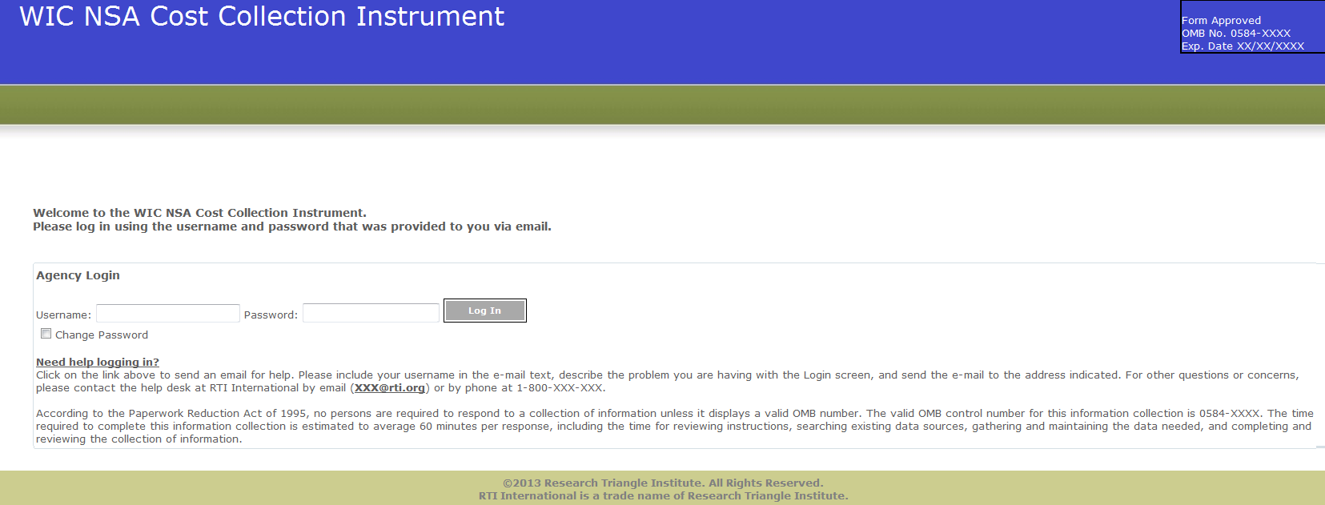

According to the Paperwork Reduction Act of 1995, no persons are required to respond to a collection of information unless it displays a valid OMB number. The valid OMB control number for this information collection is 0584-XXXX. The time required to complete this information collection is estimated to average 60 minutes per response, including the time for reviewing instructions, searching existing data sources, gathering and maintaining the data needed, and completing and reviewing the collection of information.

**Exhibit 2: Home Screen**

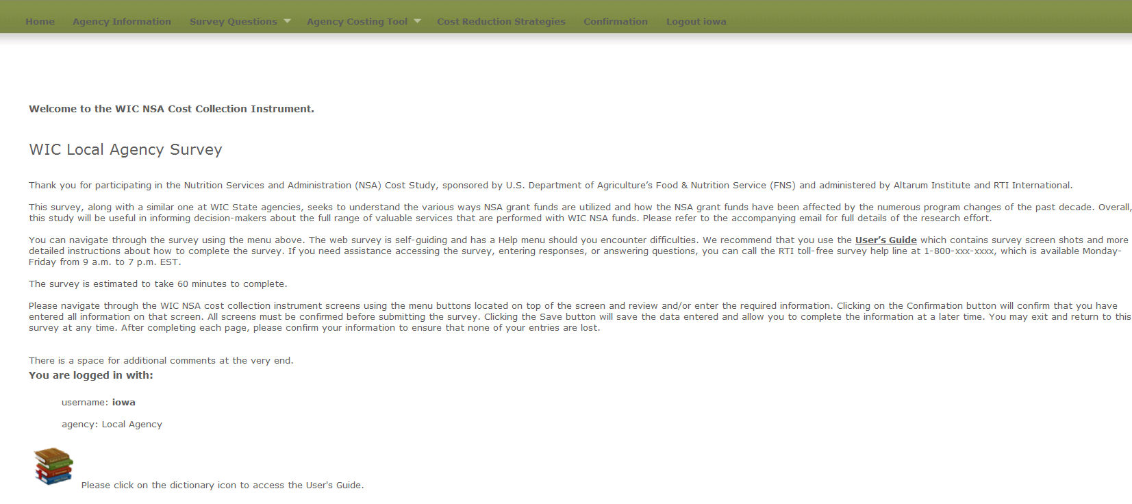

**Exhibit 3: Agency Information Screen**

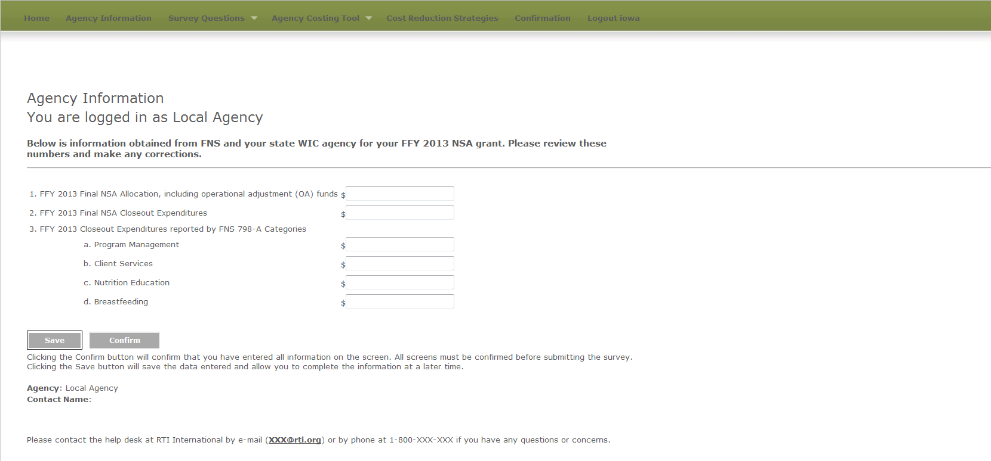

**Survey Questions**

**Exhibit 4: Demographic Questions screen**

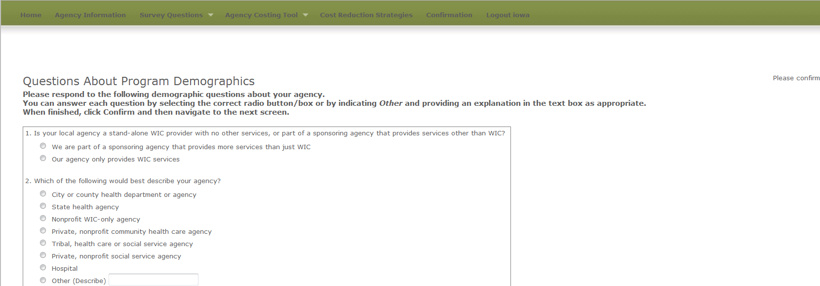

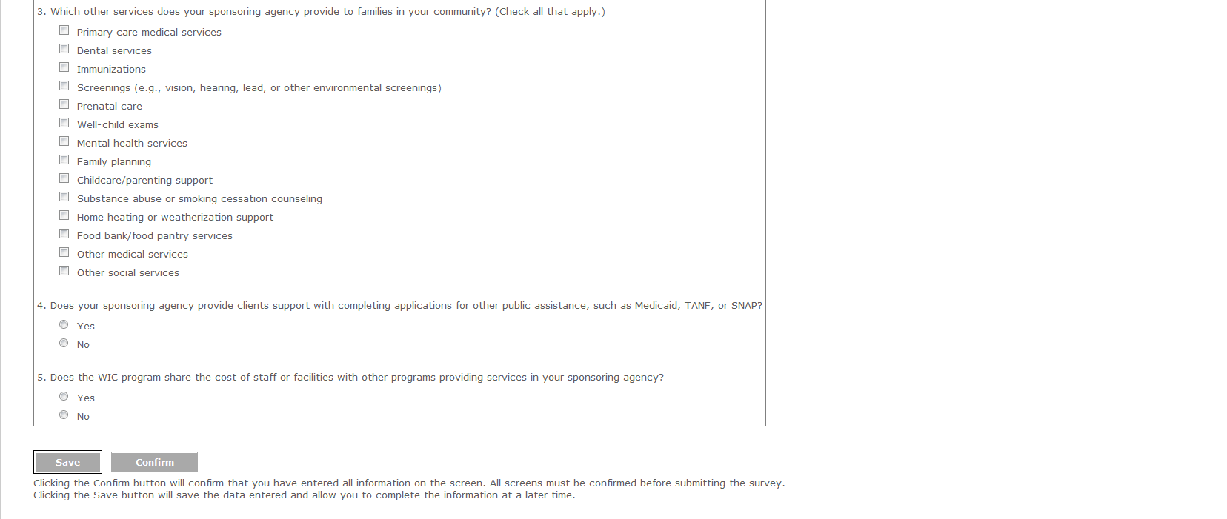

**Exhibit 5: Services Provided Questions Screen**

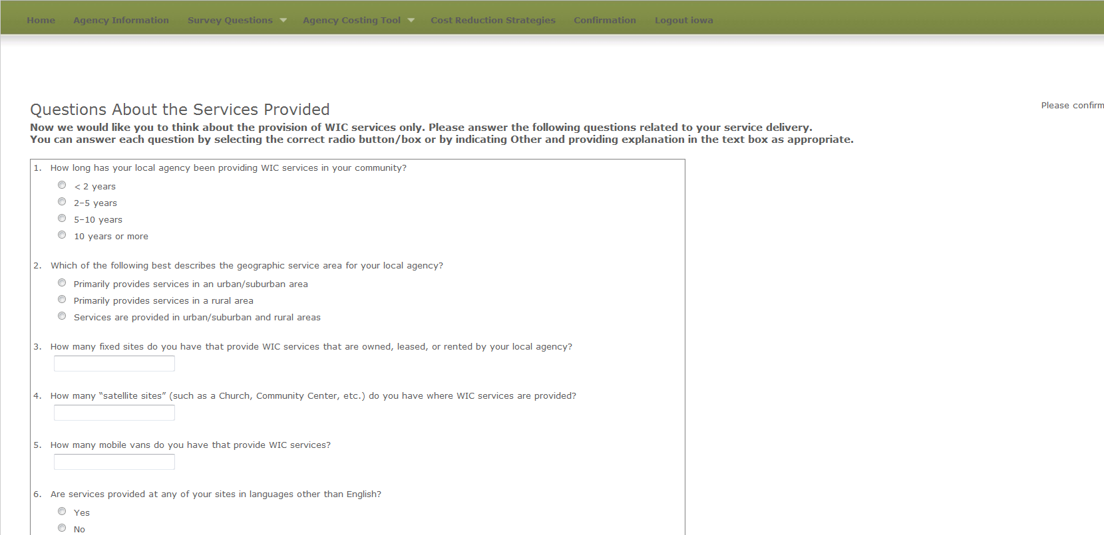

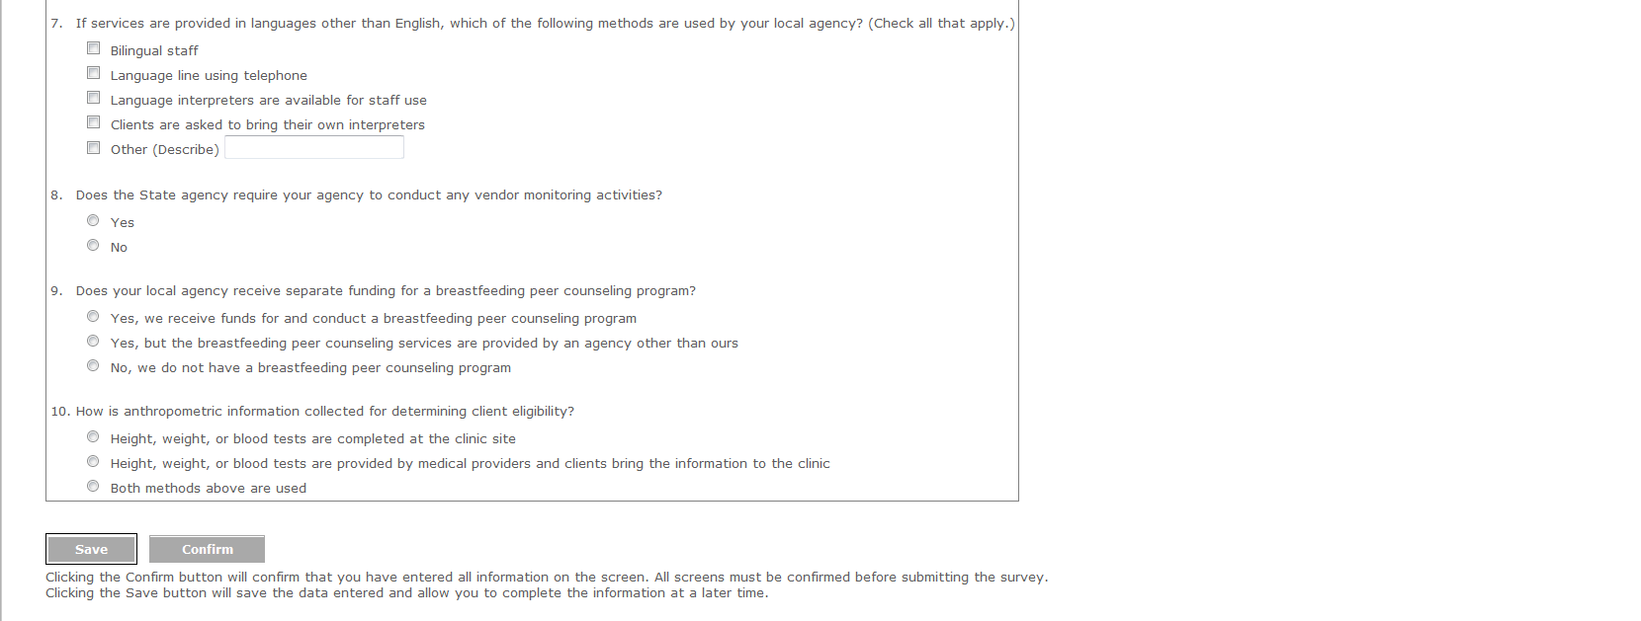

**Exhibit 6: Change in Costs Questions Screen**

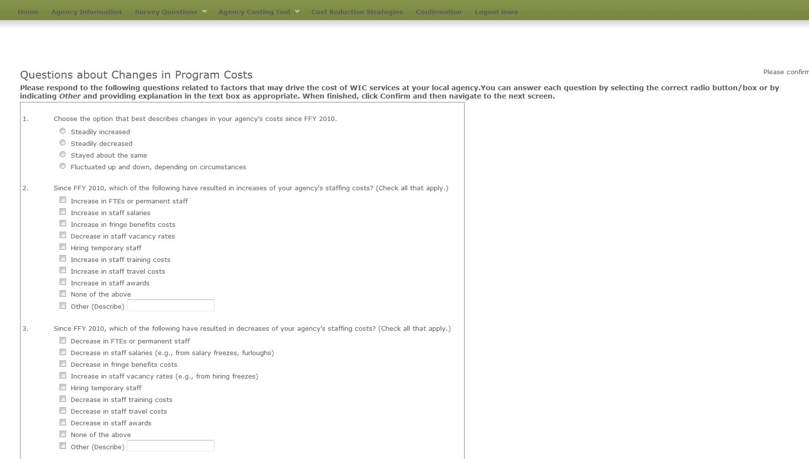

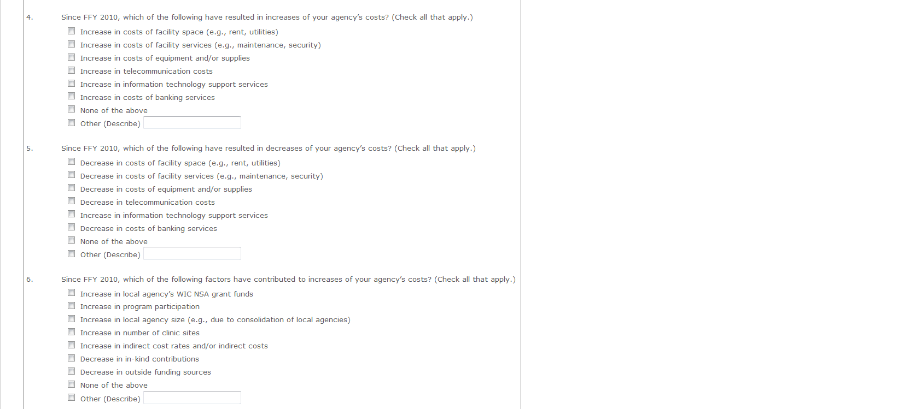 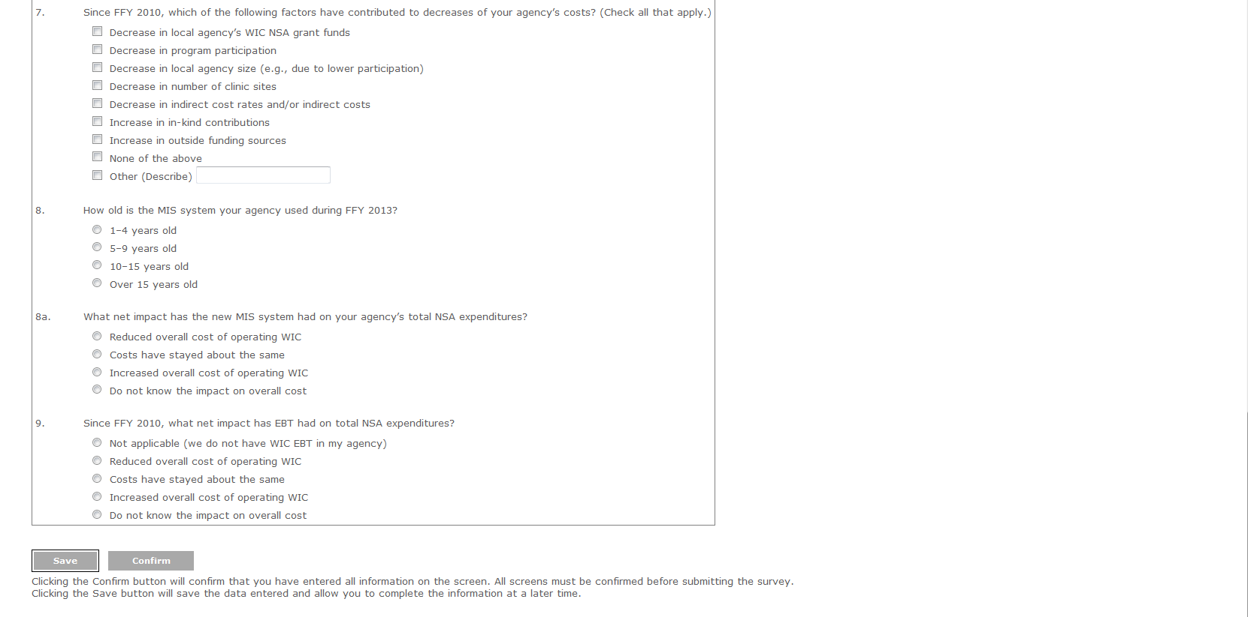

**Exhibit 7: Labor/Personnel Expenditure**

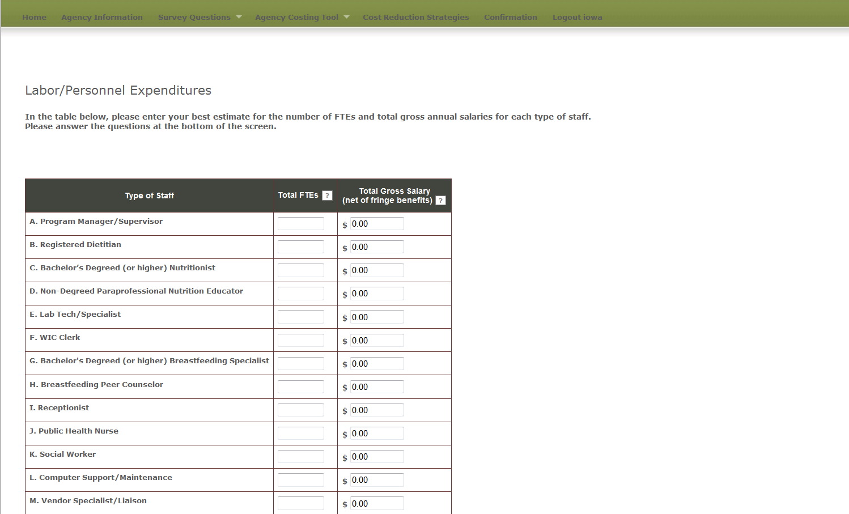

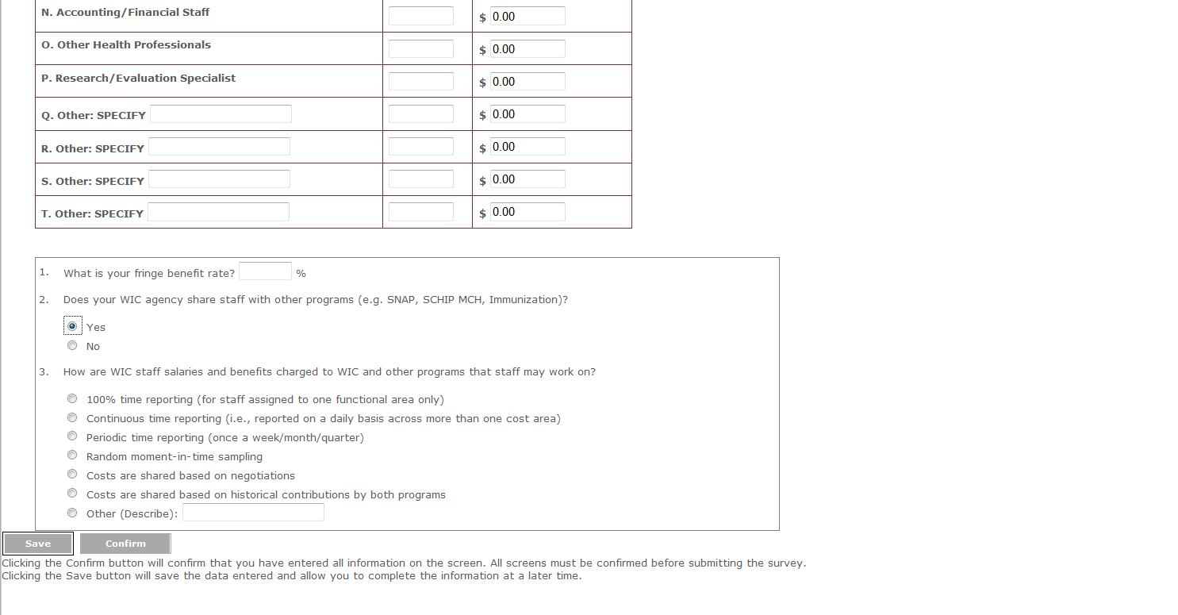

**Exhibit 8: Contracted Services Screen**

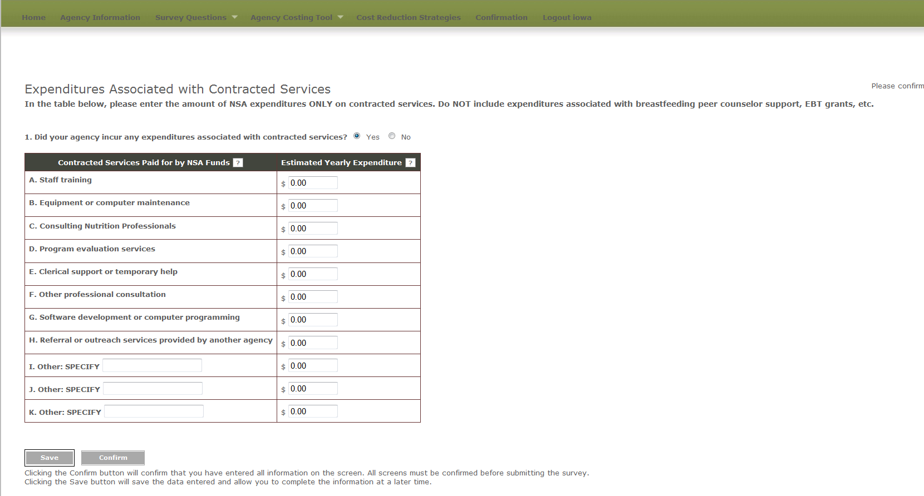

**Exhibit 9: Materials, Services, and Travel Screen**

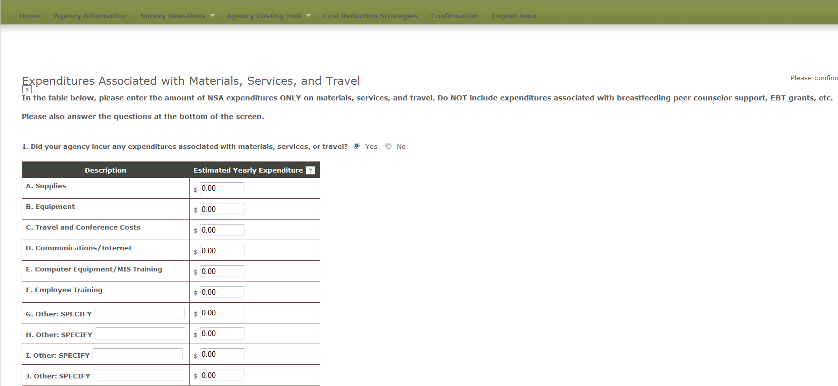

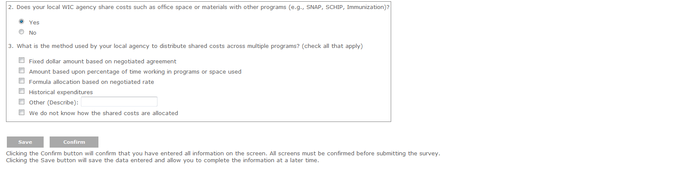

**Exhibit 10: Indirect Costs**

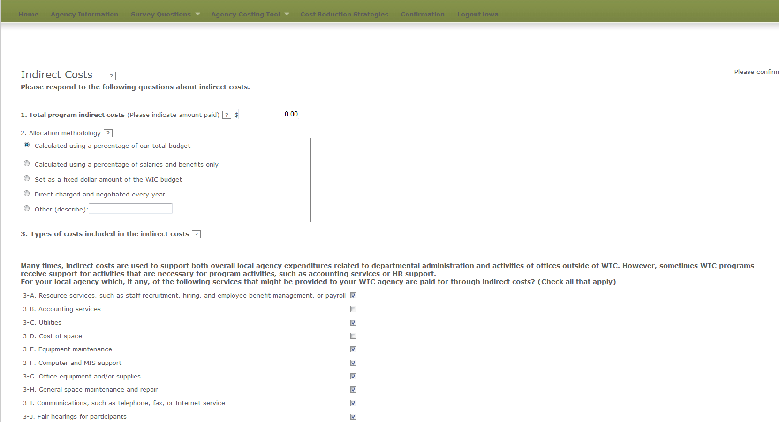



**Exhibit 11: Other Sources of Funds**

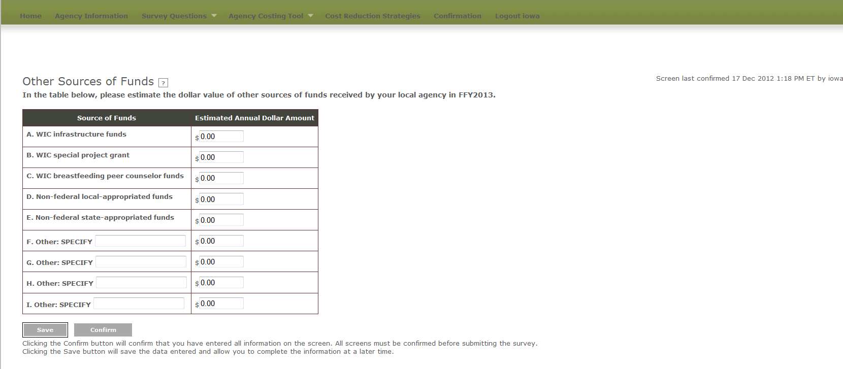**Exhibit 12: In-kind Contributions**

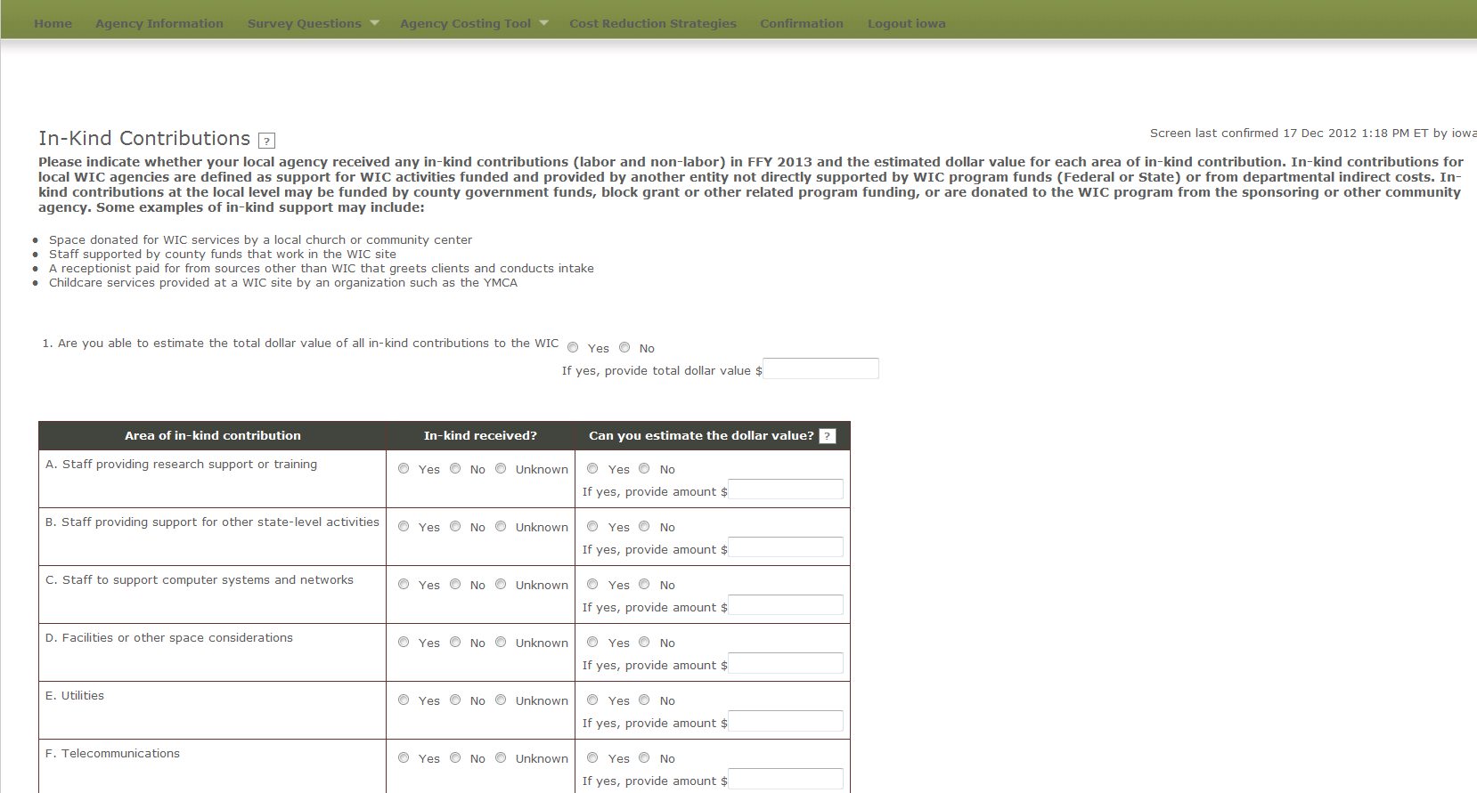

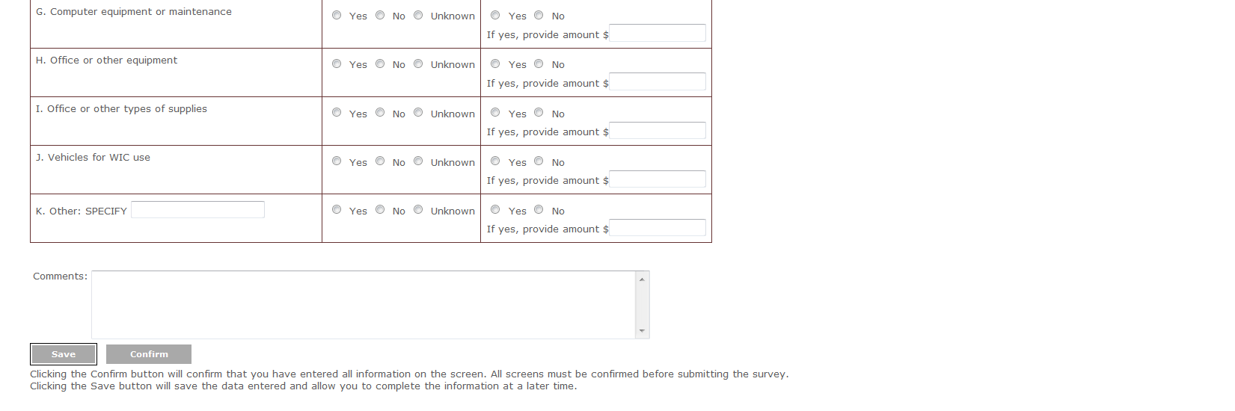

**Exhibit 13: Cost Reduction Strategies**

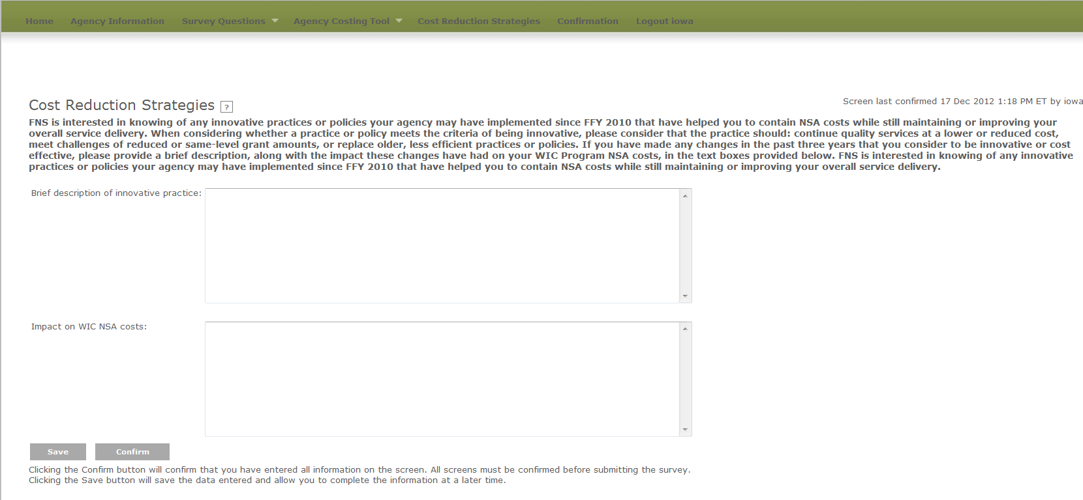

**Exhibit 14: Confirmation Screen**

