Número de aprobación de la OMB 0584-XXXX

Fecha de vencimiento: XX/XX/20XX
Appendix A4

Spanish Language WIC Combination Web Survey
Exhibit 1: Agency Login
Note that this screen is in English because users can only be identified as needing the spanish version of the survey once they login
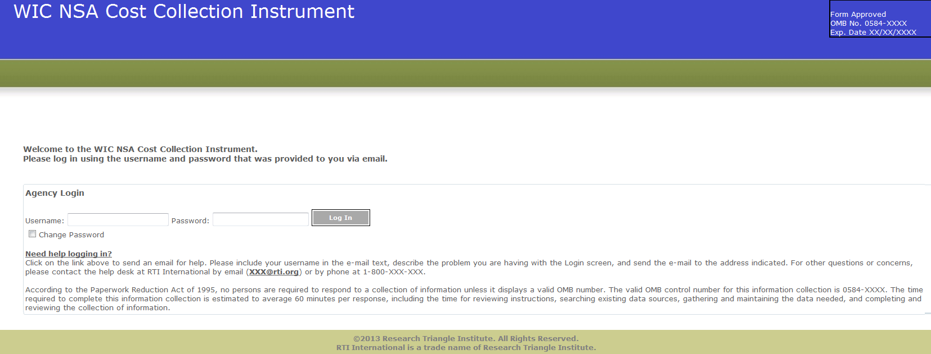
De acuerdo con la Ley de reducción de papeleo de 1995 (Paperwork Reduction Act of 1995), ninguna persona está obligada a responder a una recolección de información a menos que esta tenga un número válido de la OMB. El número de control válido de la OMB para esta recolección de información es 0584-XXXX. Se calcula que el tiempo requerido para contestar esta recolección de información es de 60 minutos en promedio por formulario, incluyendo el tiempo para revisar las instrucciones, buscar fuentes existentes de datos, reunir y mantener los datos necesarios y completar y revisar la recolección de información.
Exhibit 2: Home Screen
De acuerdo con la Ley de reducción de papeleo de 1995 (Paperwork Reduction Act of 1995), ninguna persona está obligada a responder a una recolección de información a menos que esta tenga un número válido de la OMB. El número de control válido de la OMB para esta recolección de información es 0584-XXXX. Se calcula que el tiempo requerido para contestar esta recolección de información es de 2 minutos en promedio por formulario, incluyendo el tiempo para revisar las instrucciones, buscar fuentes existentes de datos, reunir y mantener los datos necesarios y completar y revisar la recolección de información.
De acuerdo con la Ley de reducción de papeleo de 1995 (Paperwork Reduction Act of 1995), ninguna persona está obligada a responder a una recolección de información a menos que esta tenga un número válido de la OMB. El número de control válido de la OMB para esta recolección de información es 0584-XXXX. Se calcula que el tiempo requerido para contestar esta recolección de información es de 2 minutos en promedio por formulario, incluyendo el tiempo para revisar las instrucciones, buscar fuentes existentes de datos, reunir y mantener los datos necesarios y completar y revisar la recolección de información.
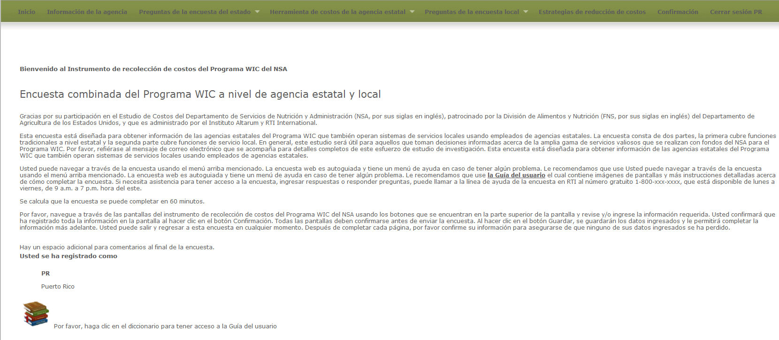
Exhibit 3: Agency Information Screen
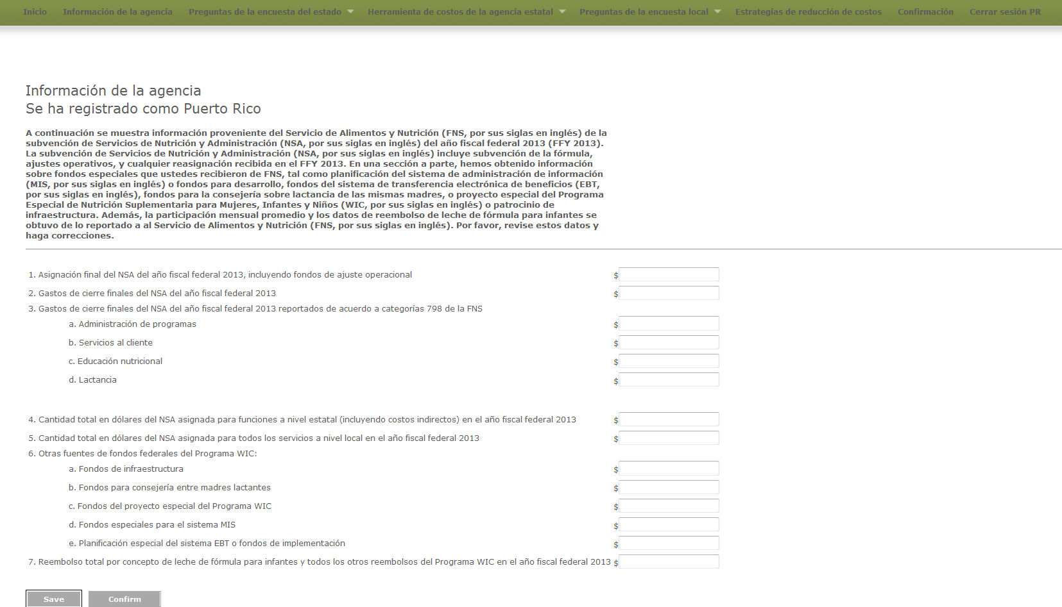

State Level Survey Questions
Exhibit 4: Demographic Questions screen
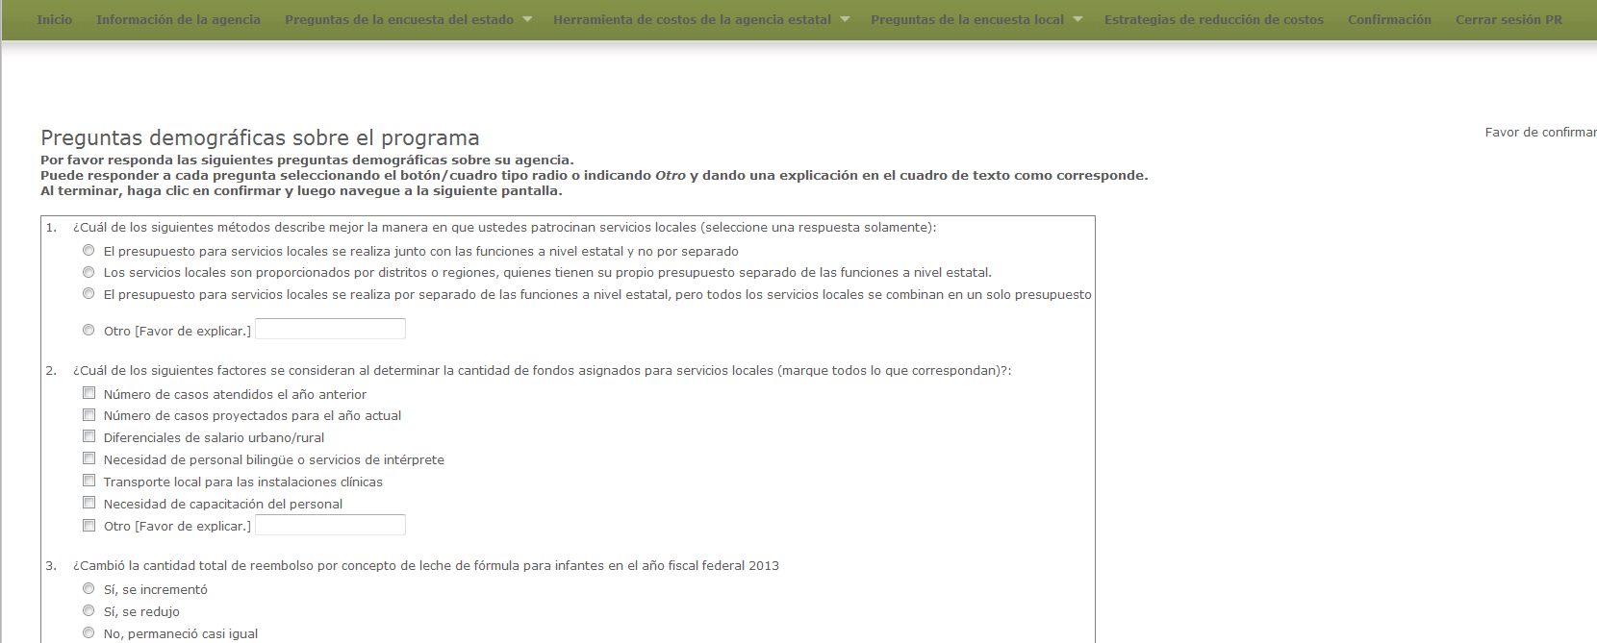
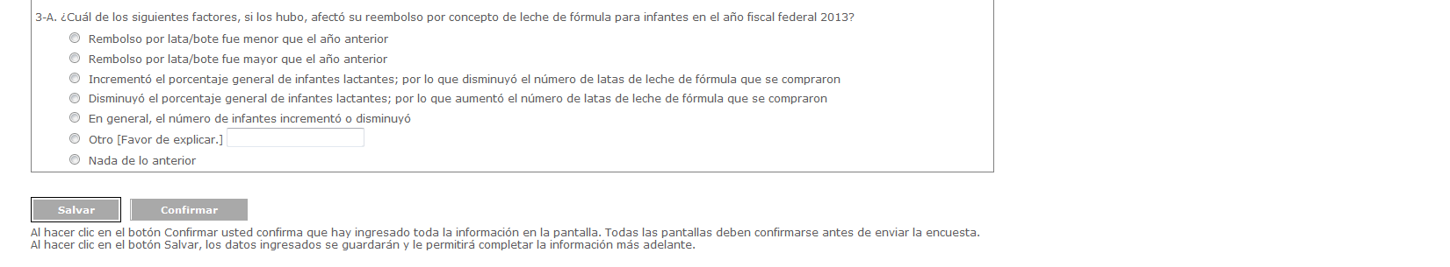

Exhibit 5: Change in Costs Questions Screen
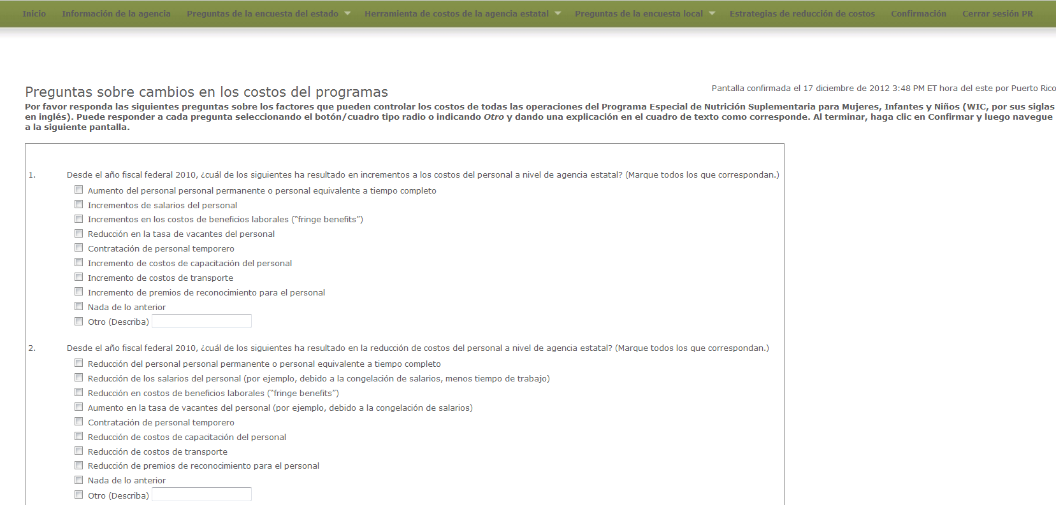
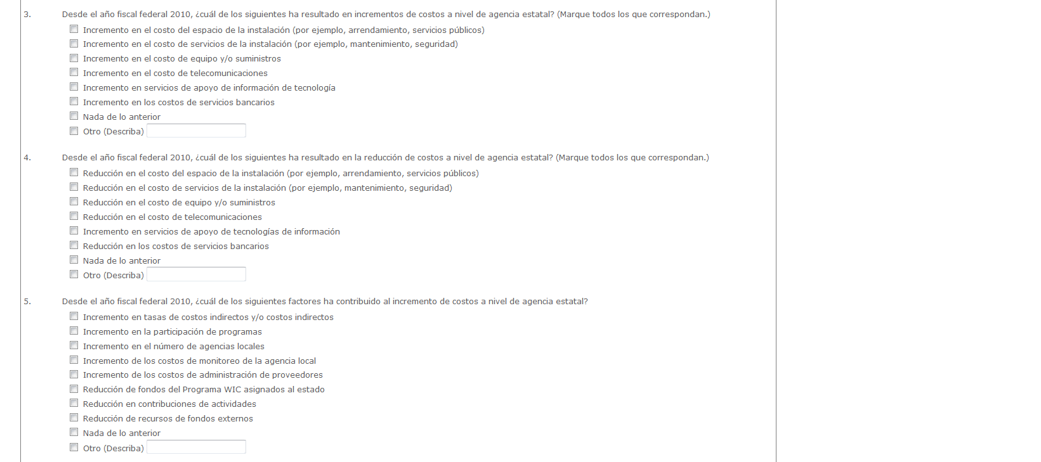

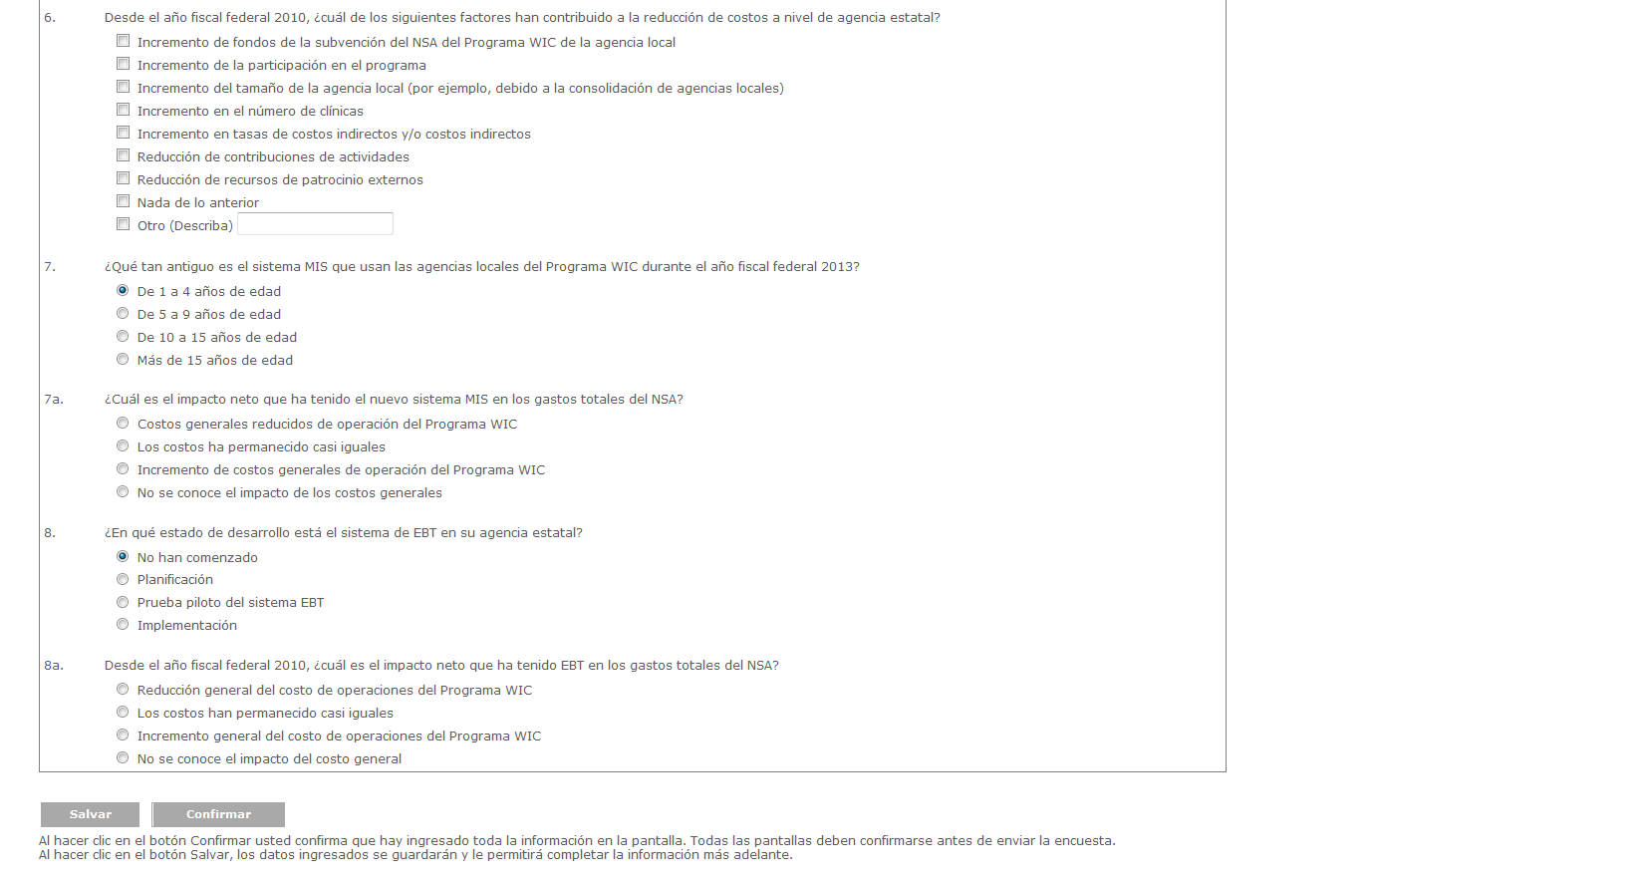

Agency Costing Tool
Exhibit 6: Labor/Personnel Expenditure
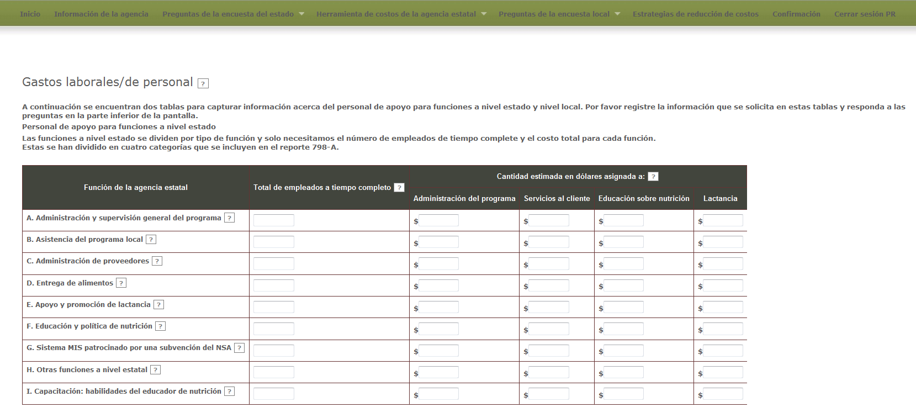
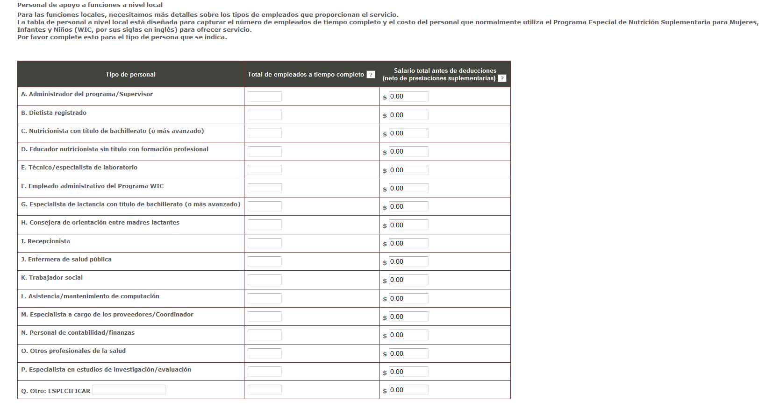
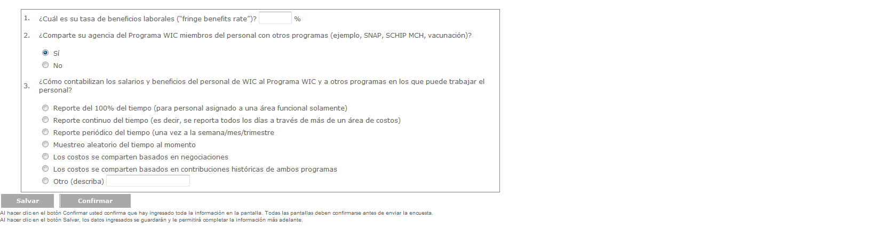
Exhibit 7: Contracted Services Screen
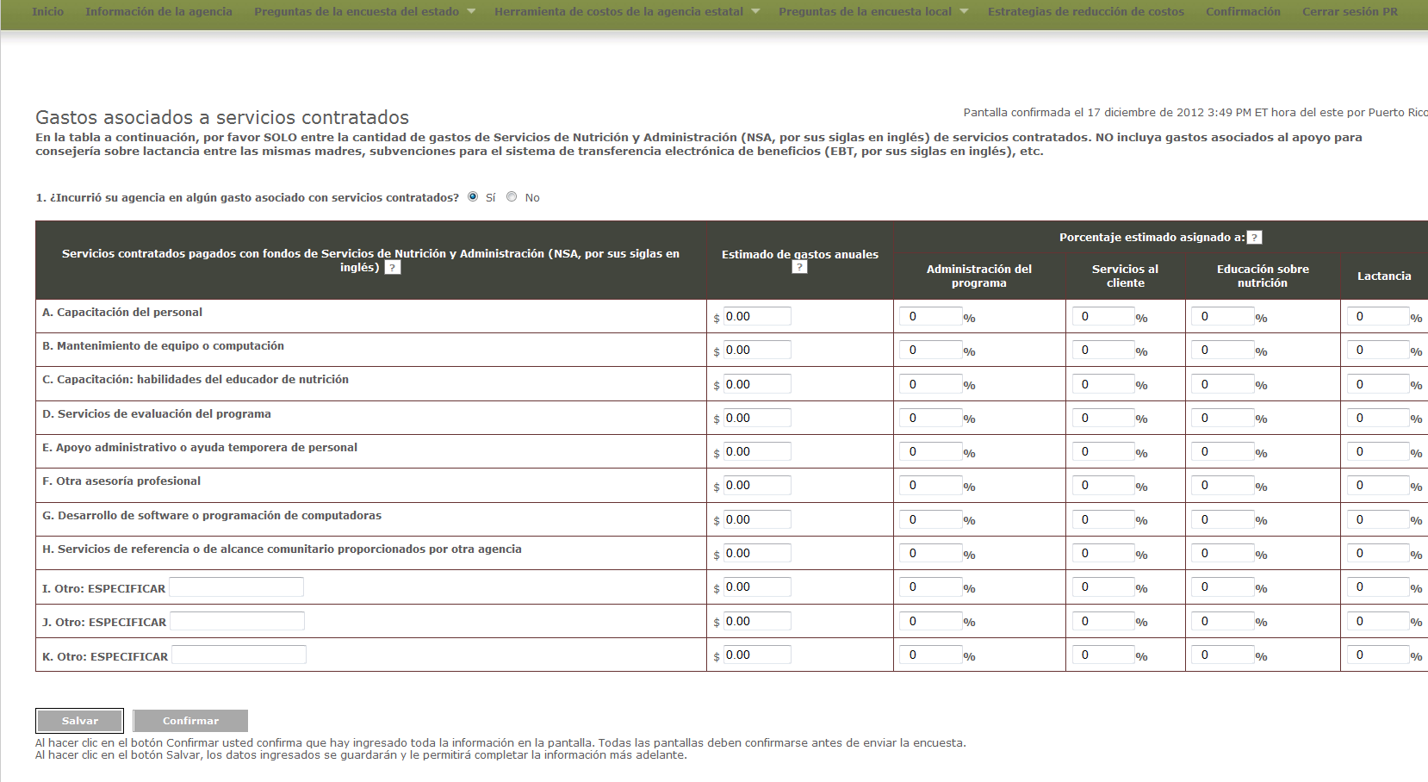
Exhibit 8: Materials, Services, and Travel Screen
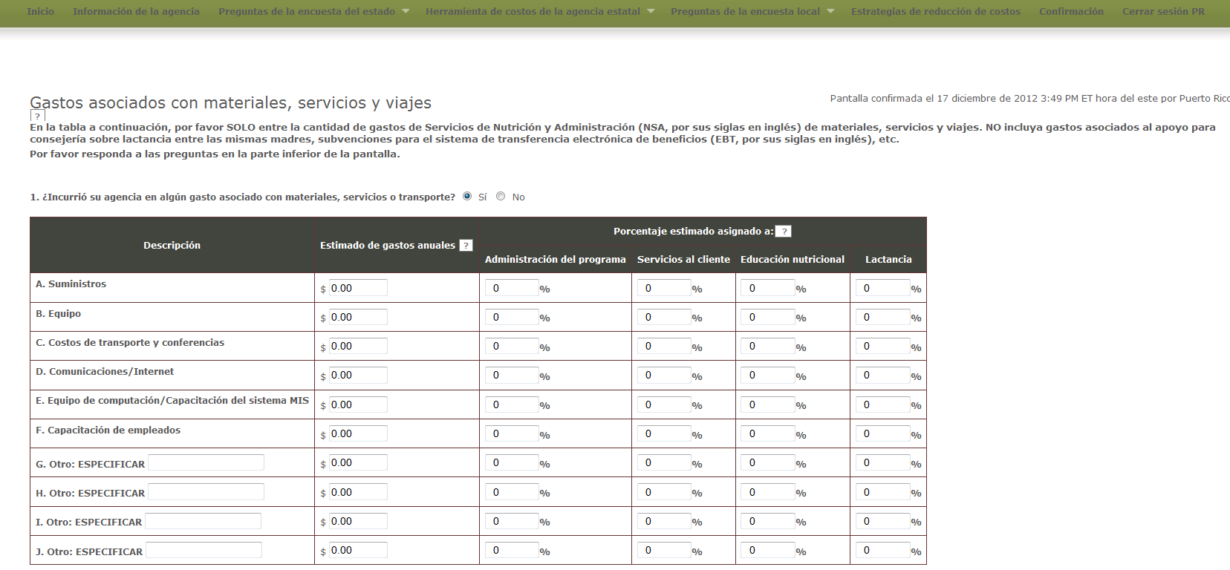
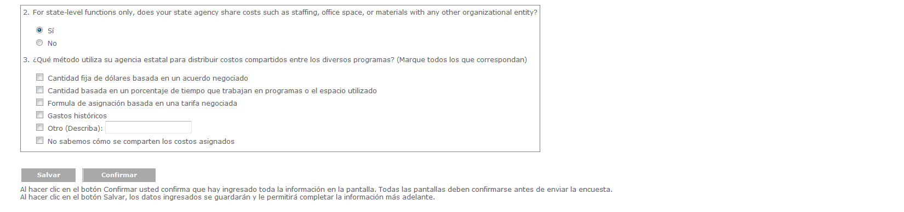
Exhibit 9: Indirect Costs
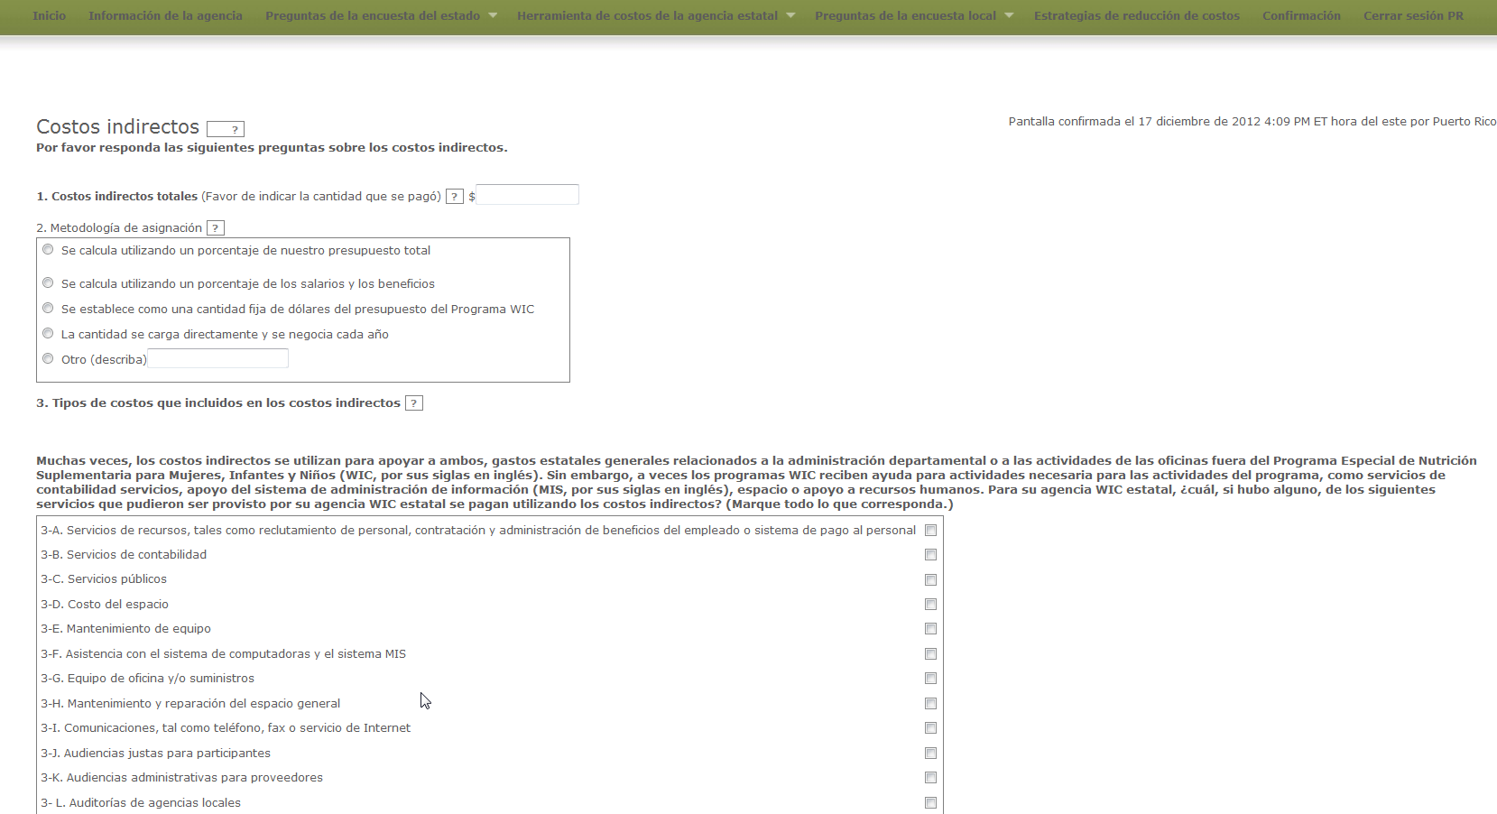

Exhibit 10: Other Sources of Funds
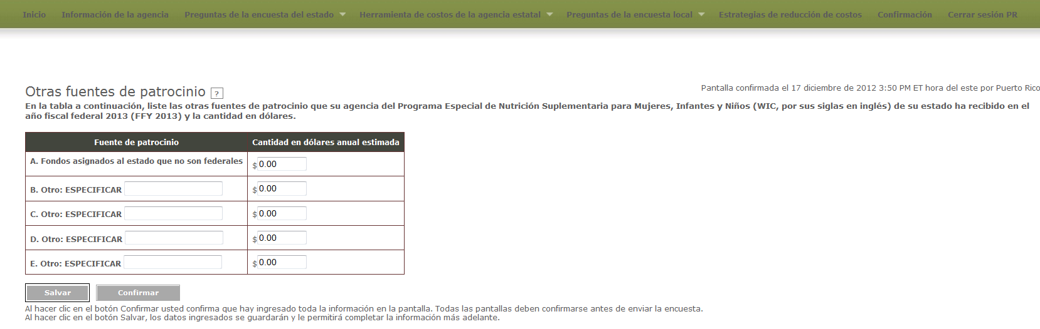

Exhibit 11: In-Kind contributions
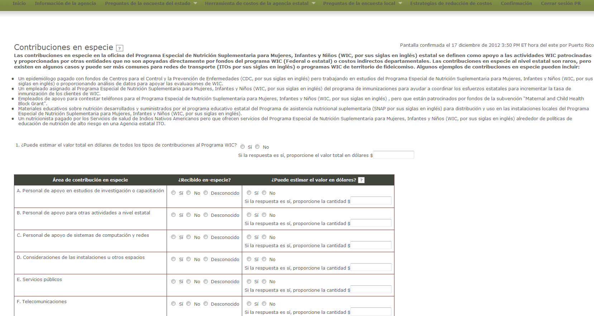

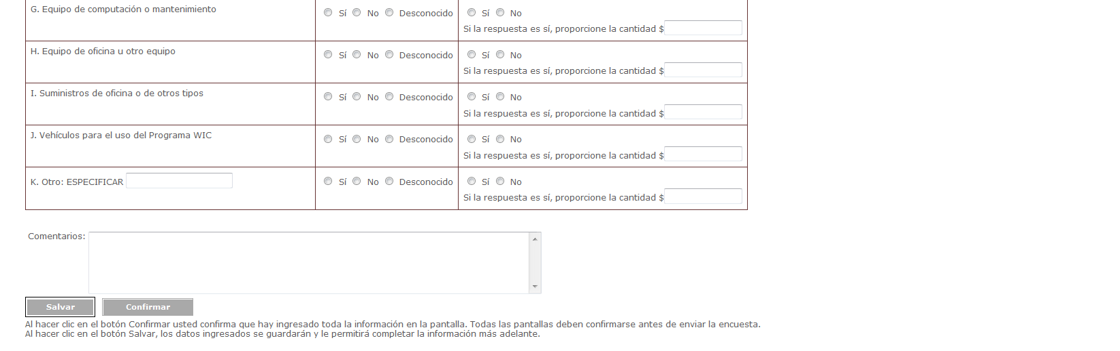

Local Level Survey Questions
Exhibit 12: Demographic Questions Screen
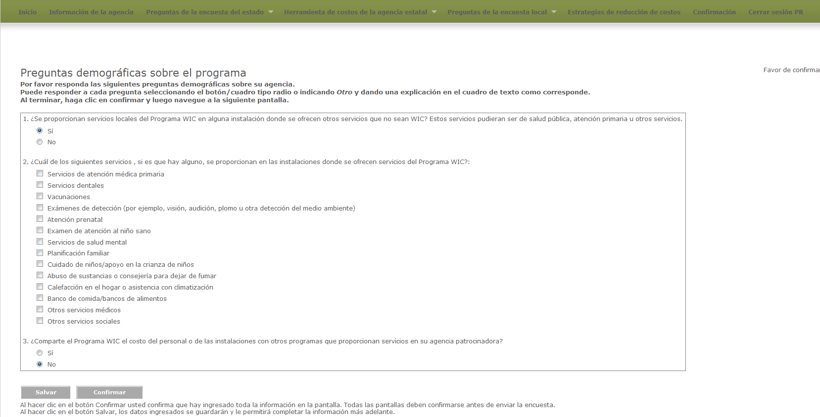

Exhibit 13: Services Provided Questions Screen
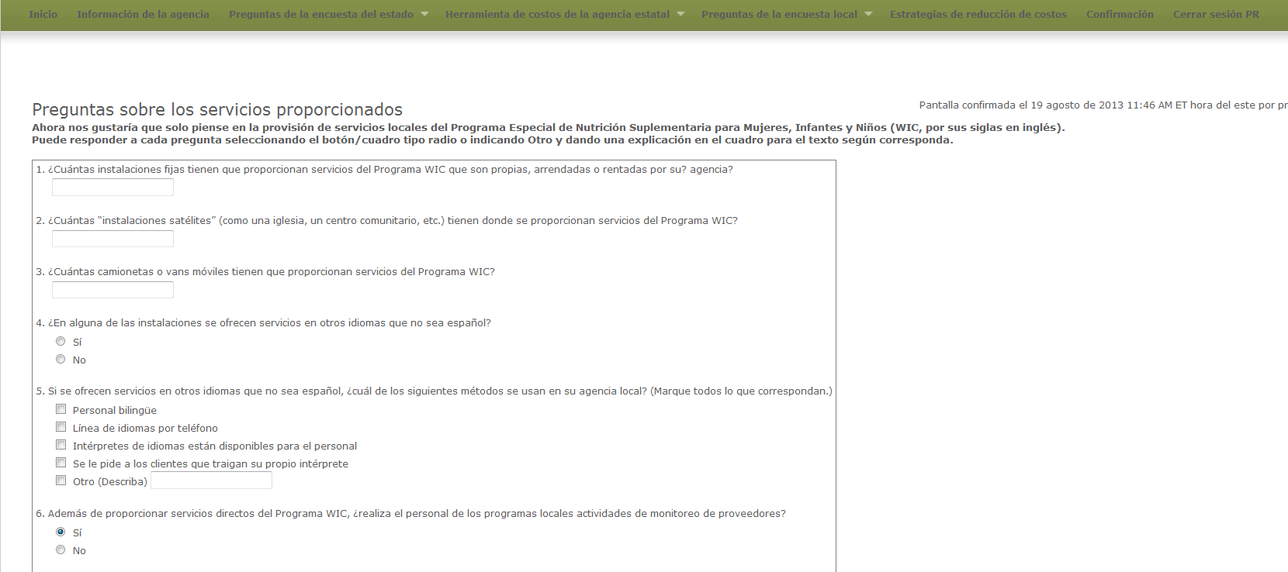

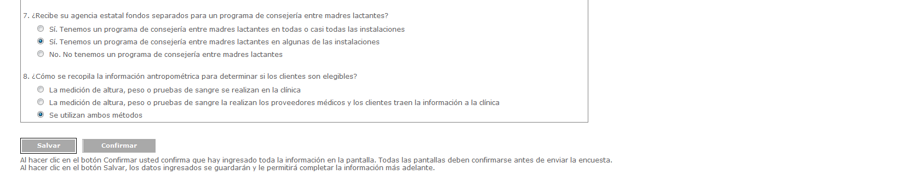

Exhibit 14: Change in Costs Questions Screen
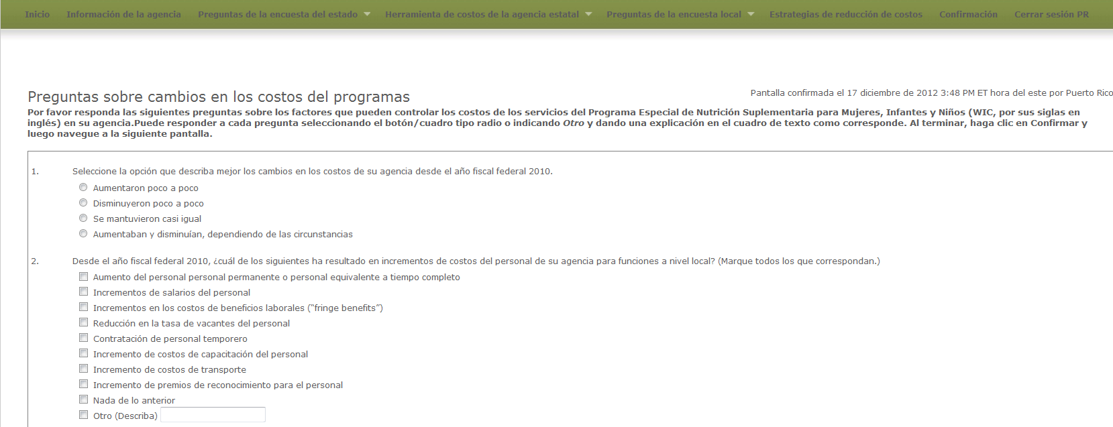

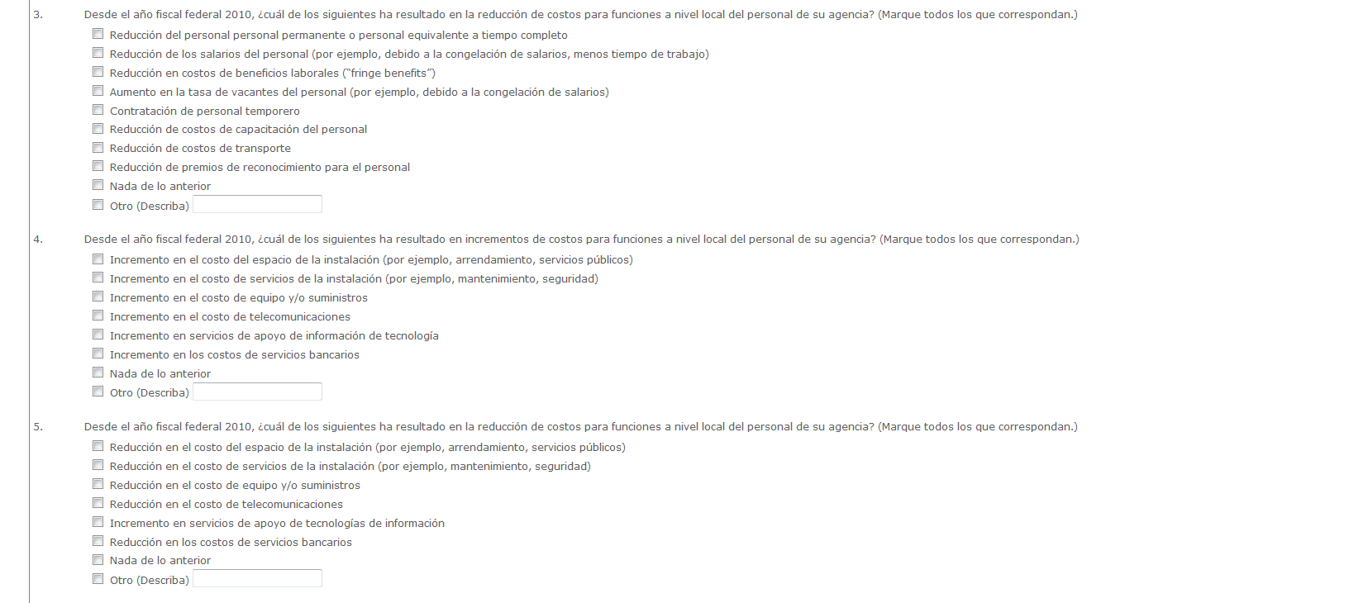
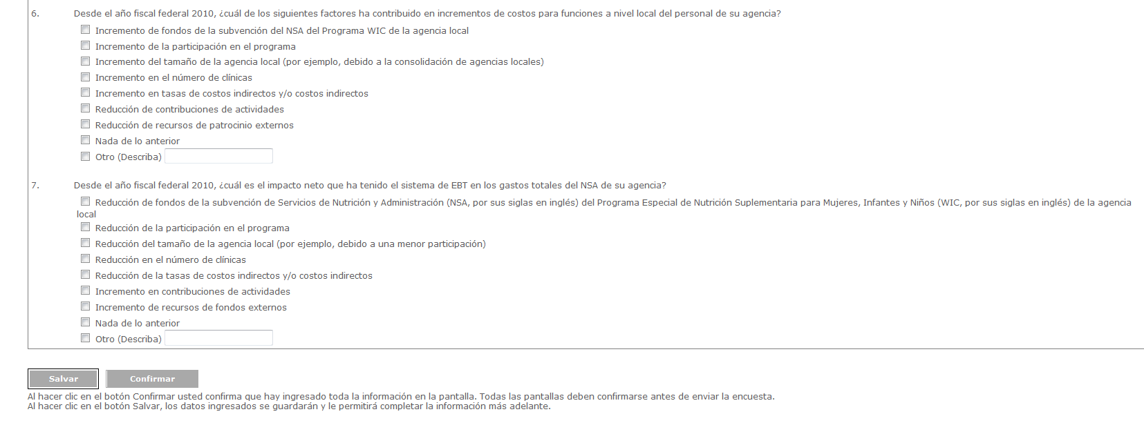
Exhibit 15: Cost Reduction Strategies
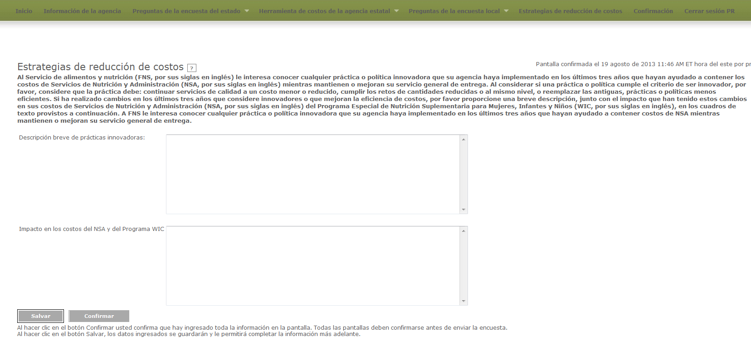
Exhibit 16 Confirmation Screen
