WIC NSA Cost Collection Instrument: State Agency
Exhibit 1: Agency Login
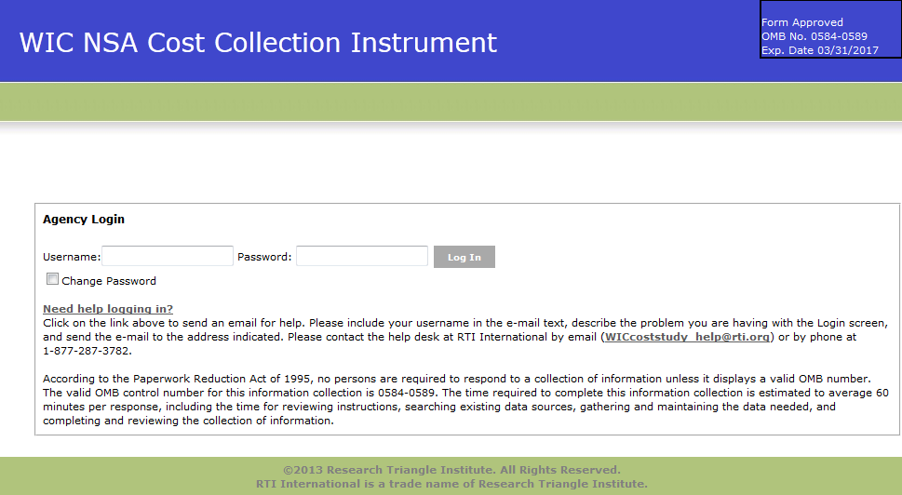

Exhibit 2: Home Screen
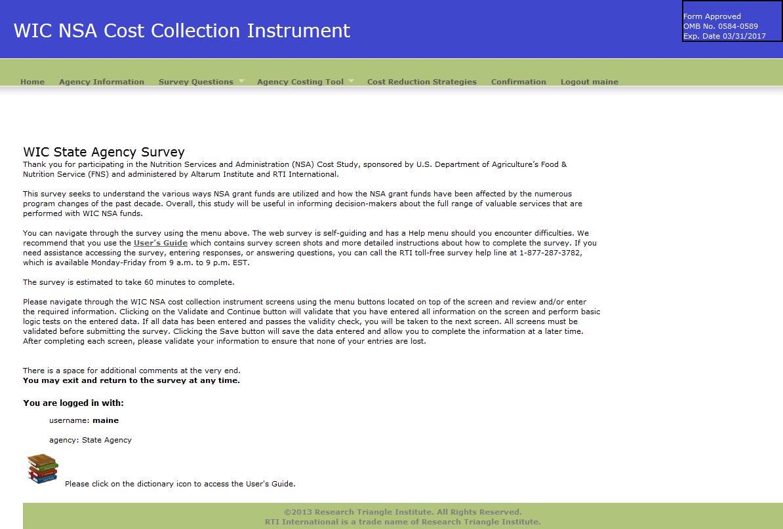
Exhibit 3: Agency Information Screen
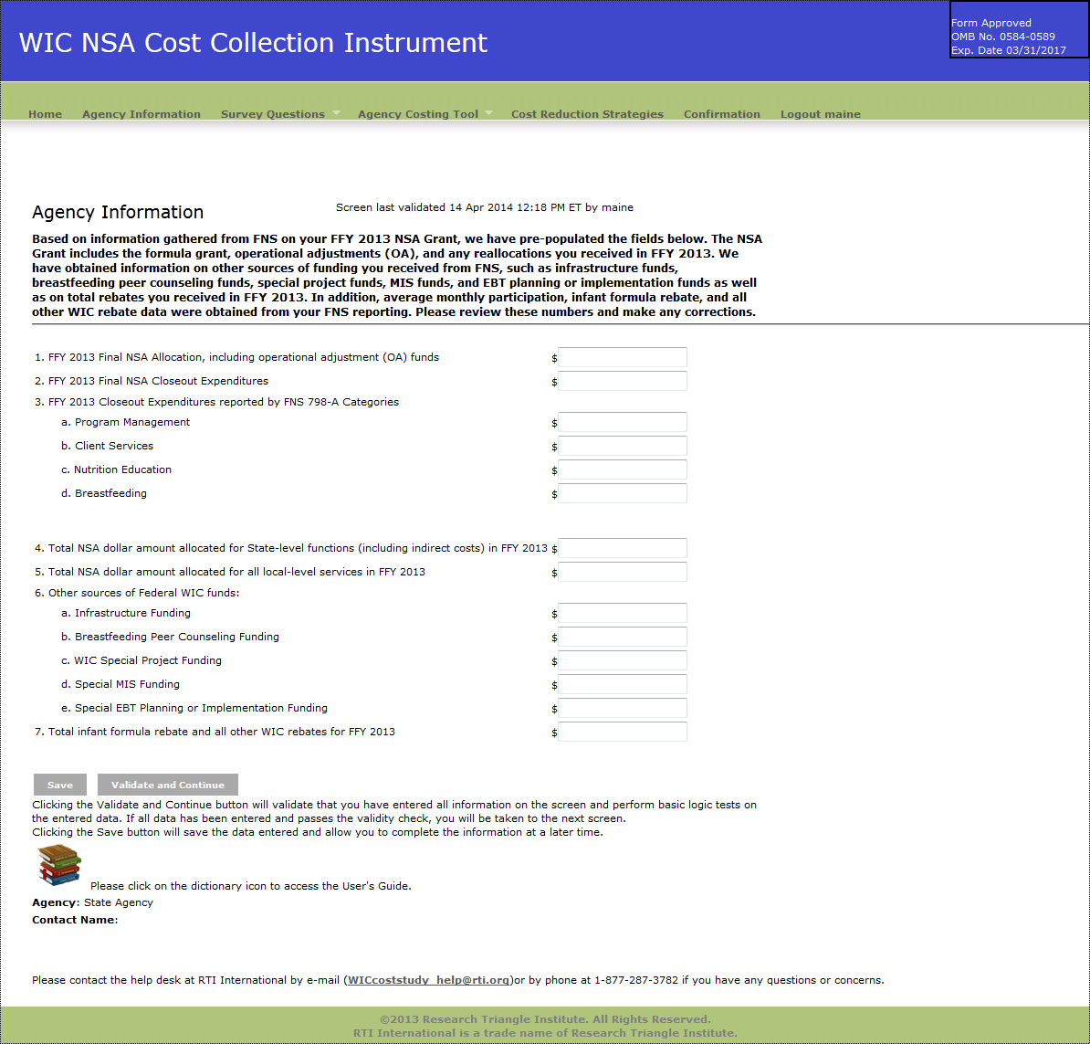

Exhibit 4: Demographic Questions Screen
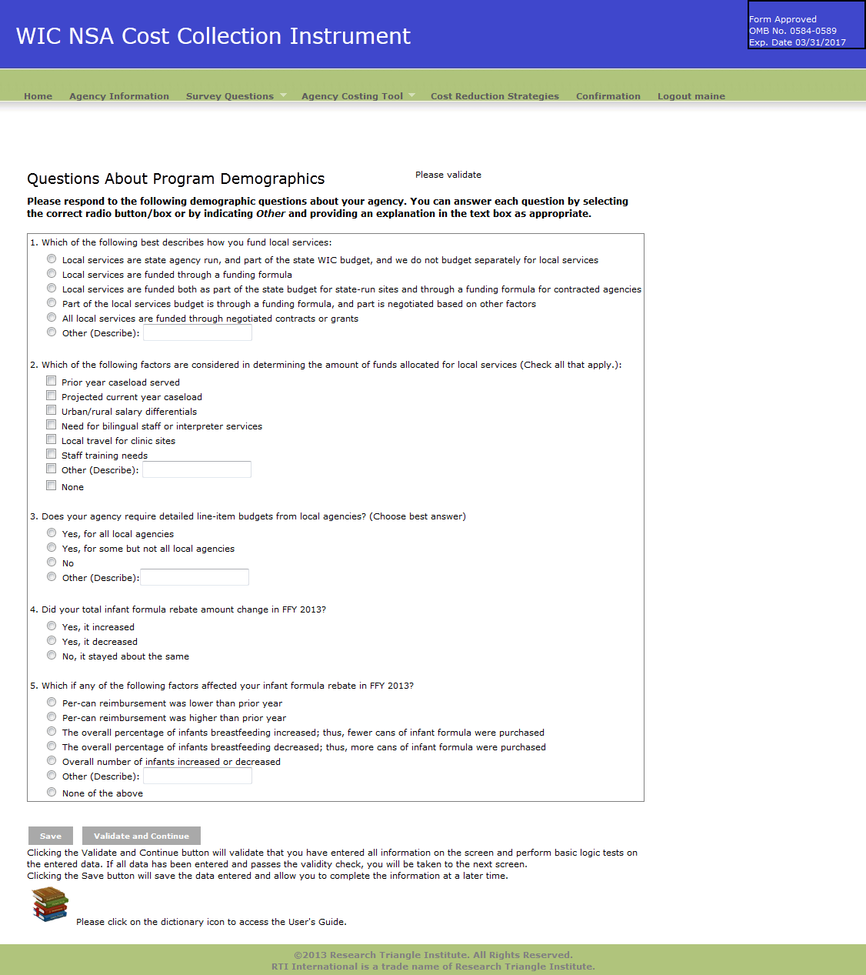

Exhibit 5: Change in Costs Questions Screen
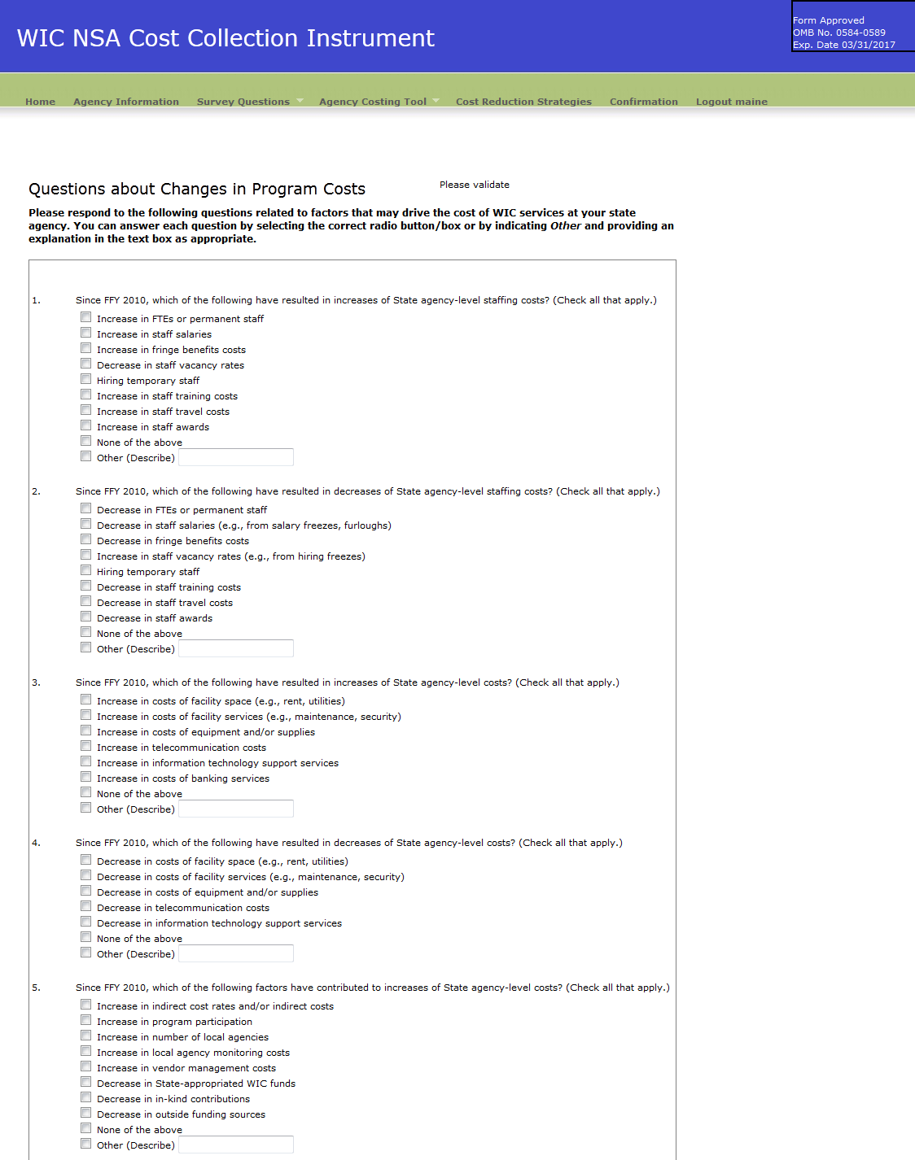

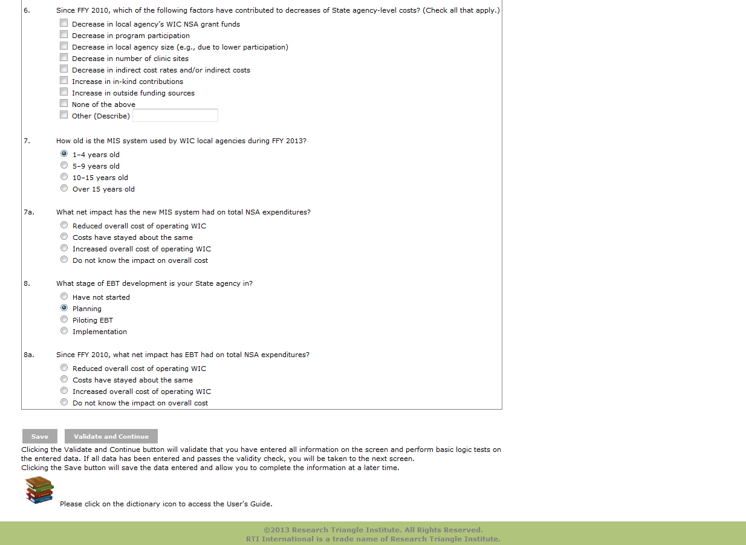

Exhibit 6: Labor/Personnel Expenditure
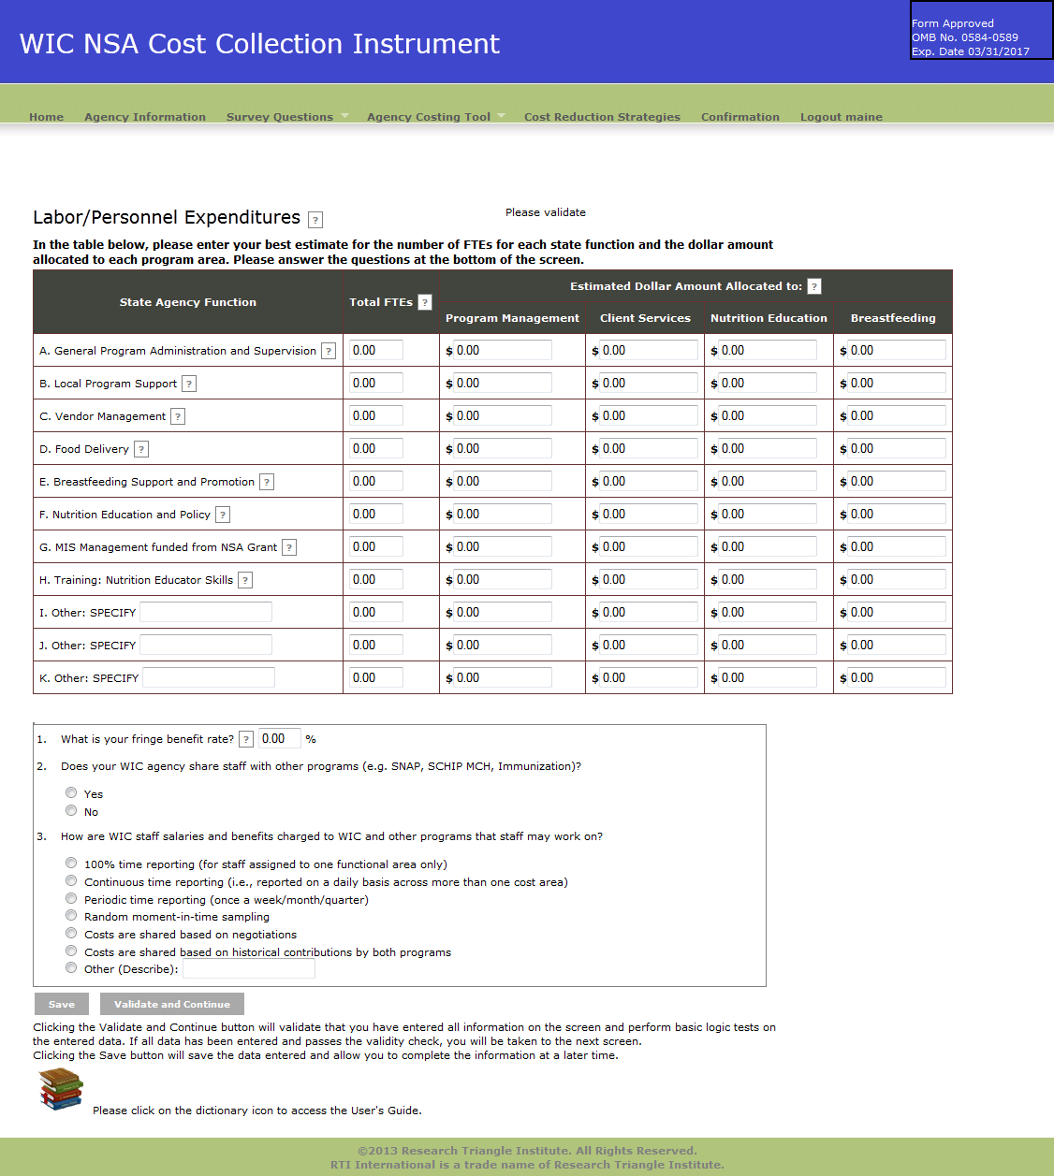
Exhibit 7: Contracted Services Screen
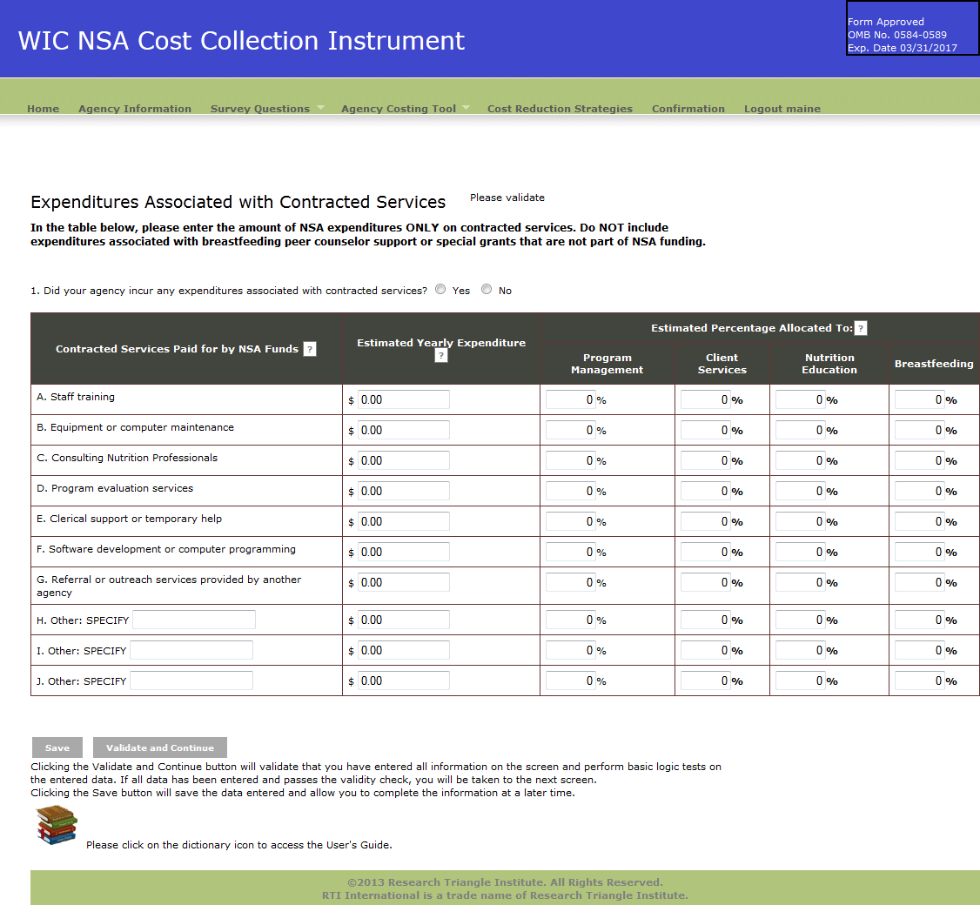

Exhibit 8: Materials, Services, and Travel Screen
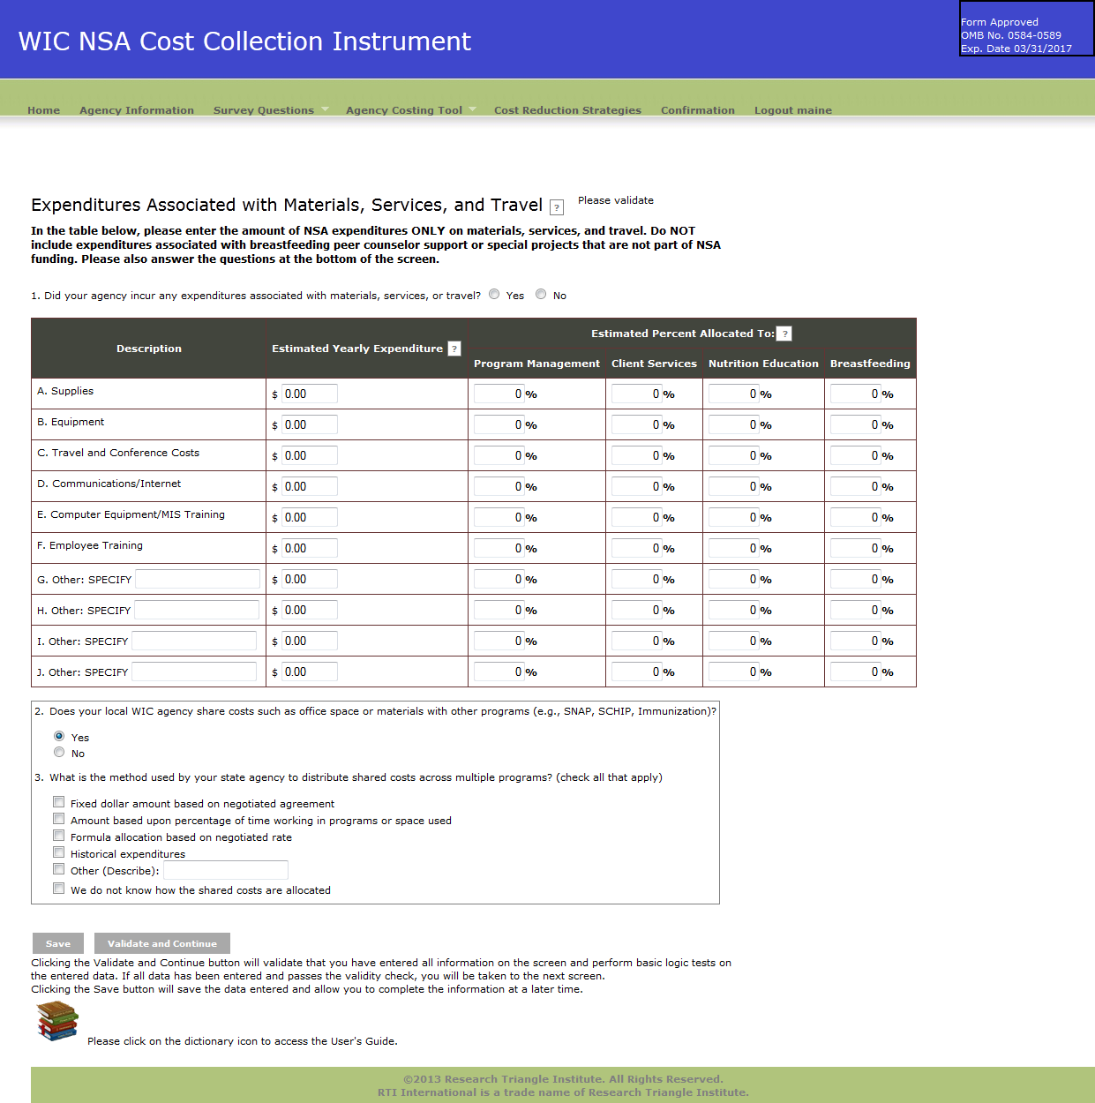

Exhibit 9: Indirect Costs
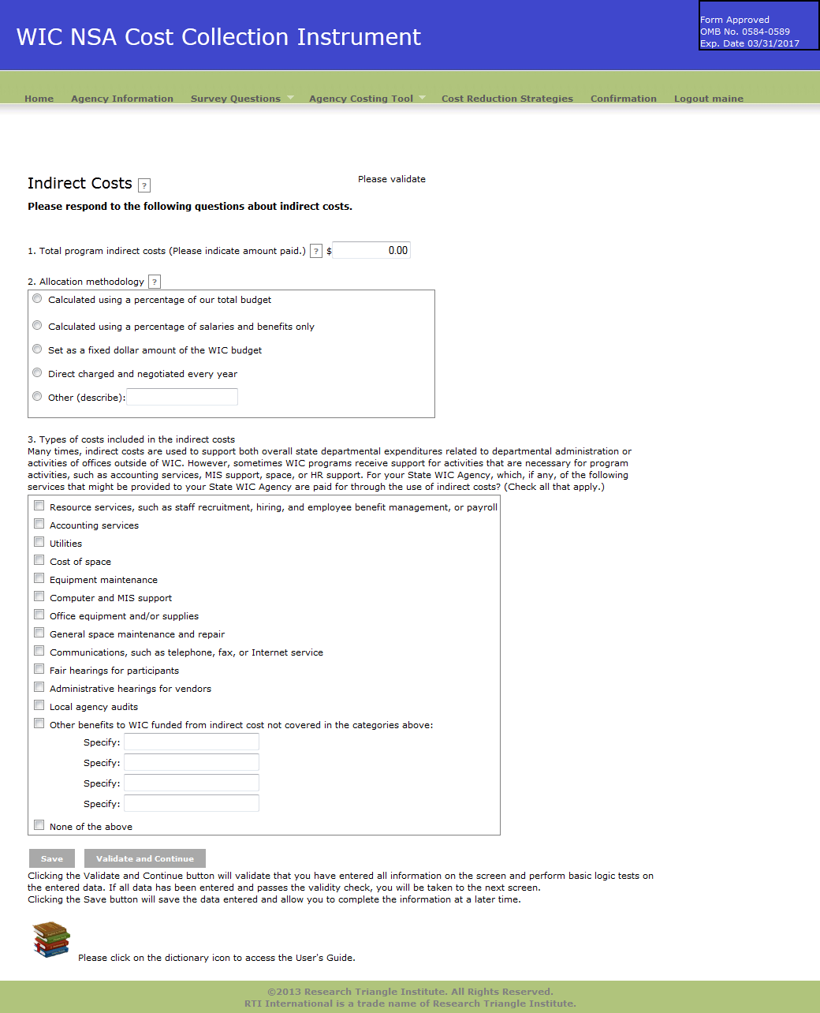

Exhibit 10: Other Sources of Funds
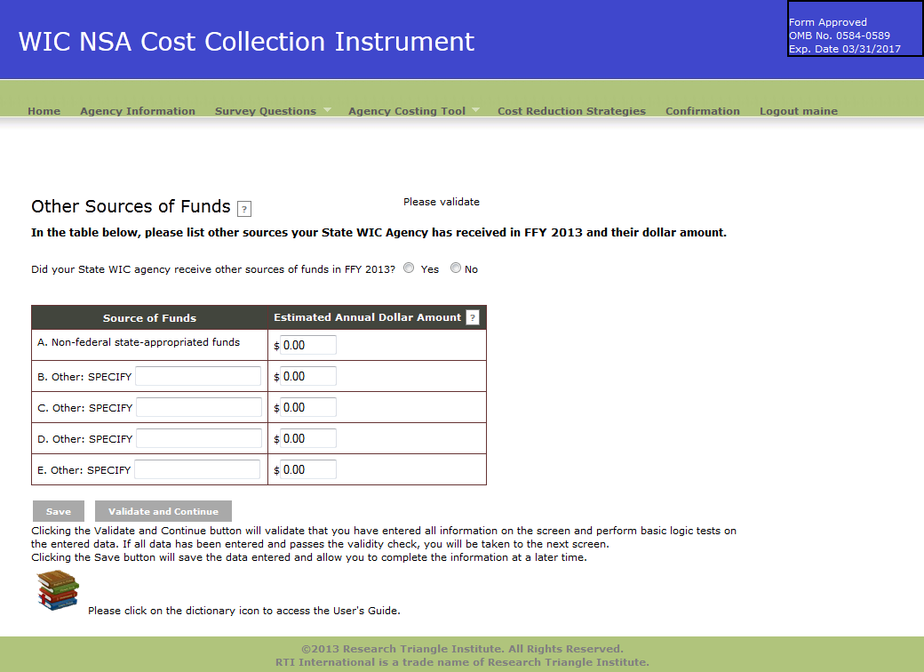

Exhibit 11: In-kind Contributions
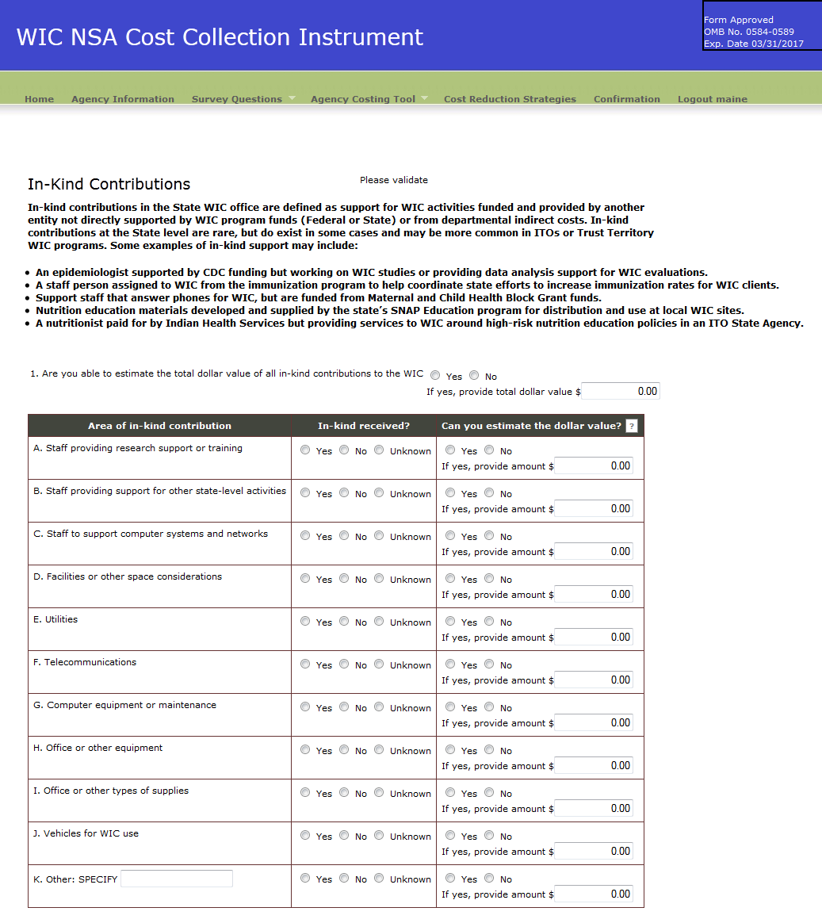

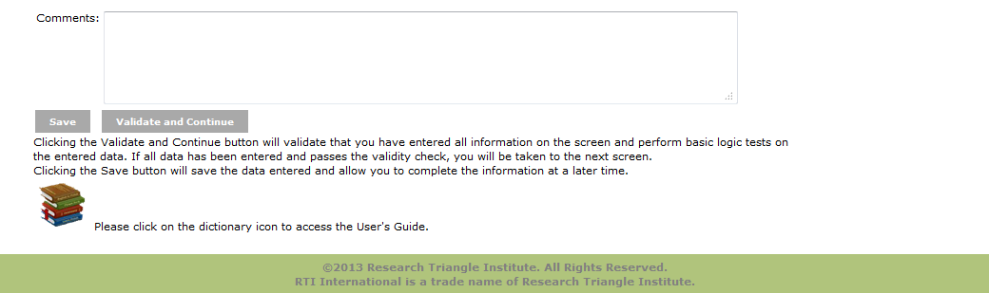

Exhibit 12: Cost Reduction Strategies
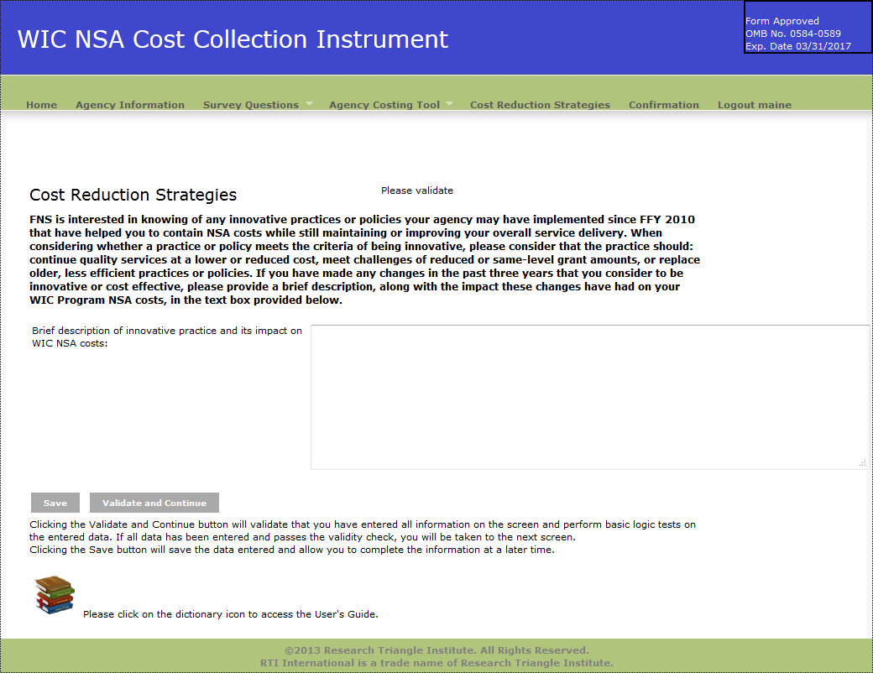

Exhibit 13: Confirmation Screen
