WIC NSA Cost Collection Instrument: Local Agency
Exhibit 1: Agency Login
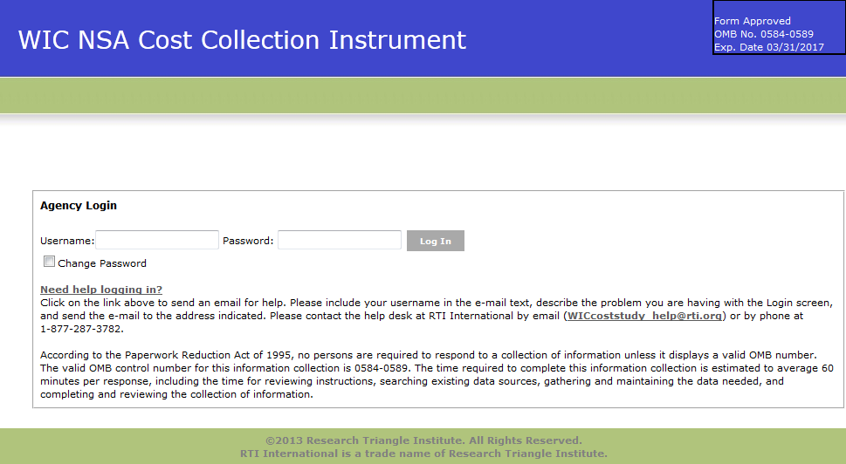

Exhibit 2: Home Screen
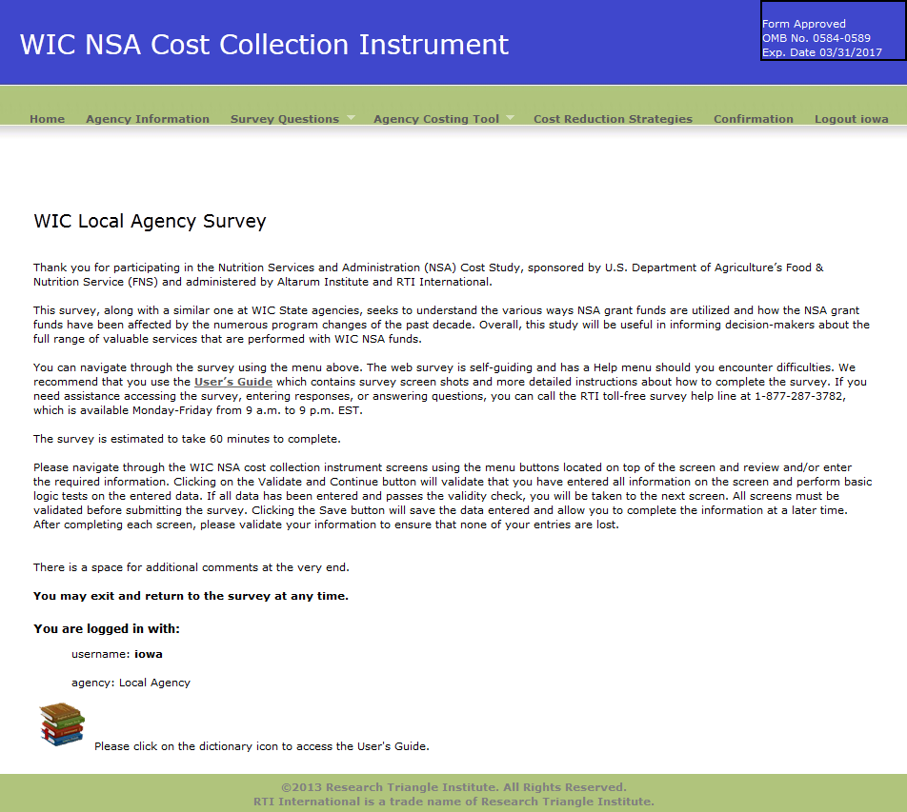
Exhibit 3: Agency Information Screen
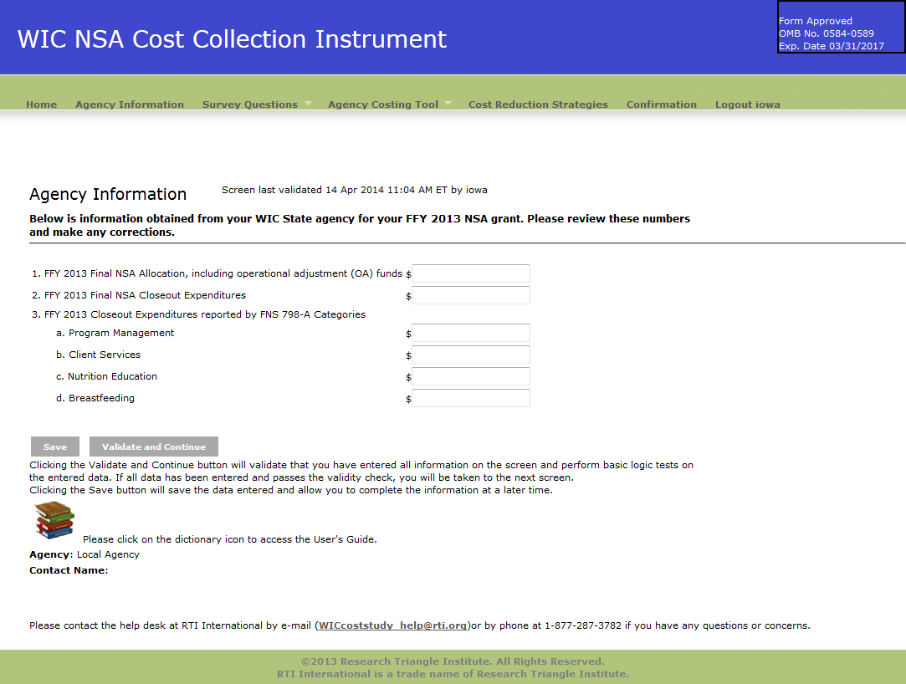

Exhibit 4: Demographic Questions screen
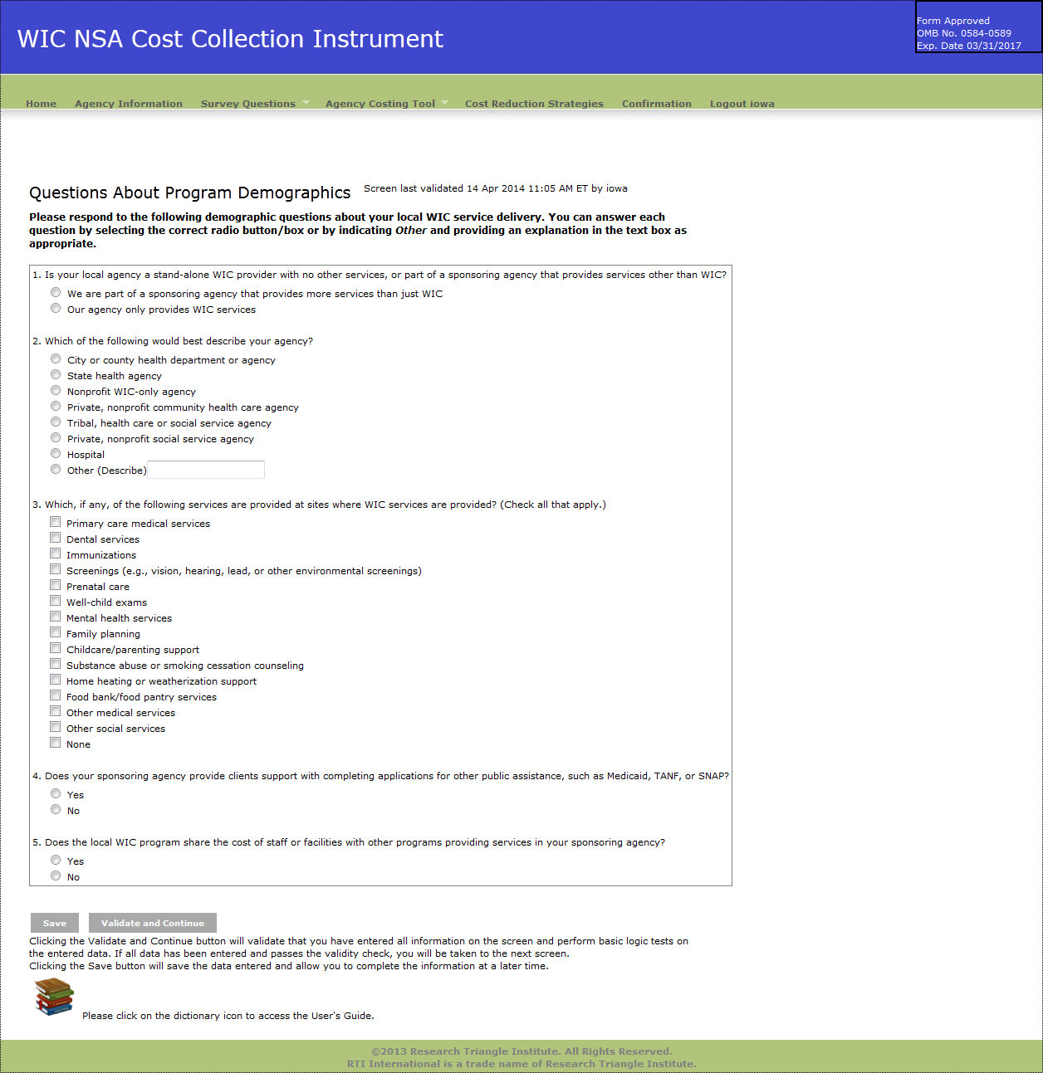

Exhibit 5: Services Provided Questions Screen
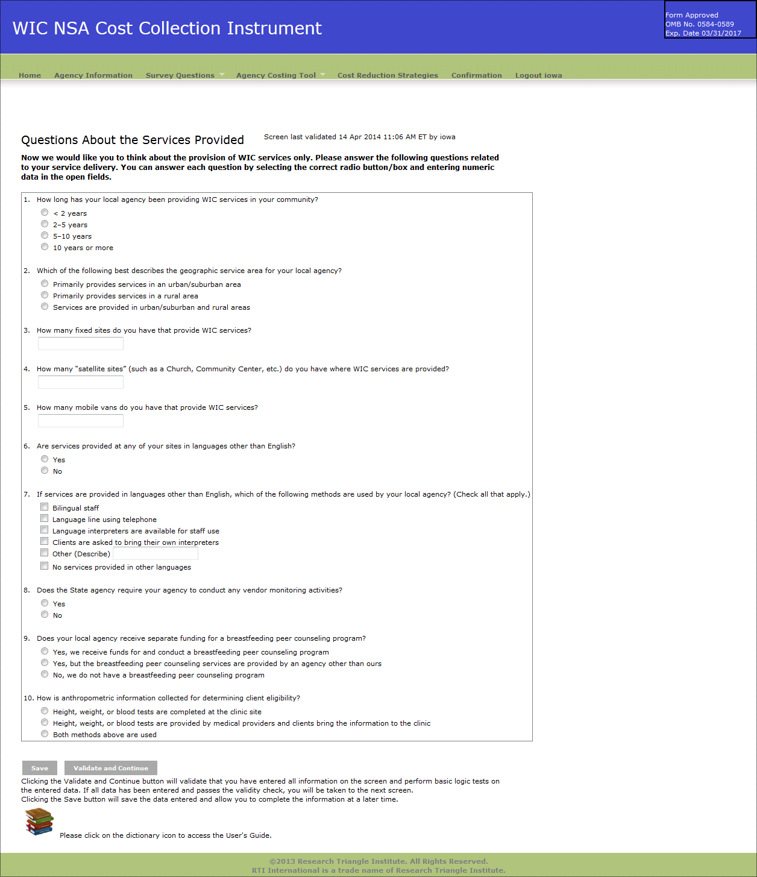

Exhibit 6: Change in Costs Questions Screen
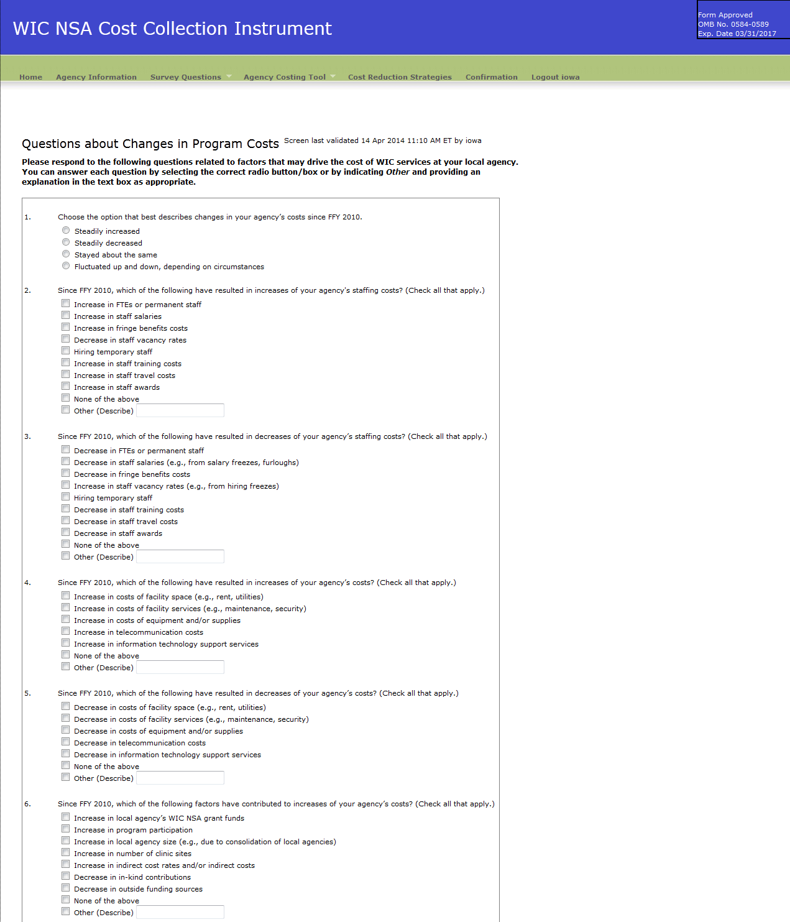

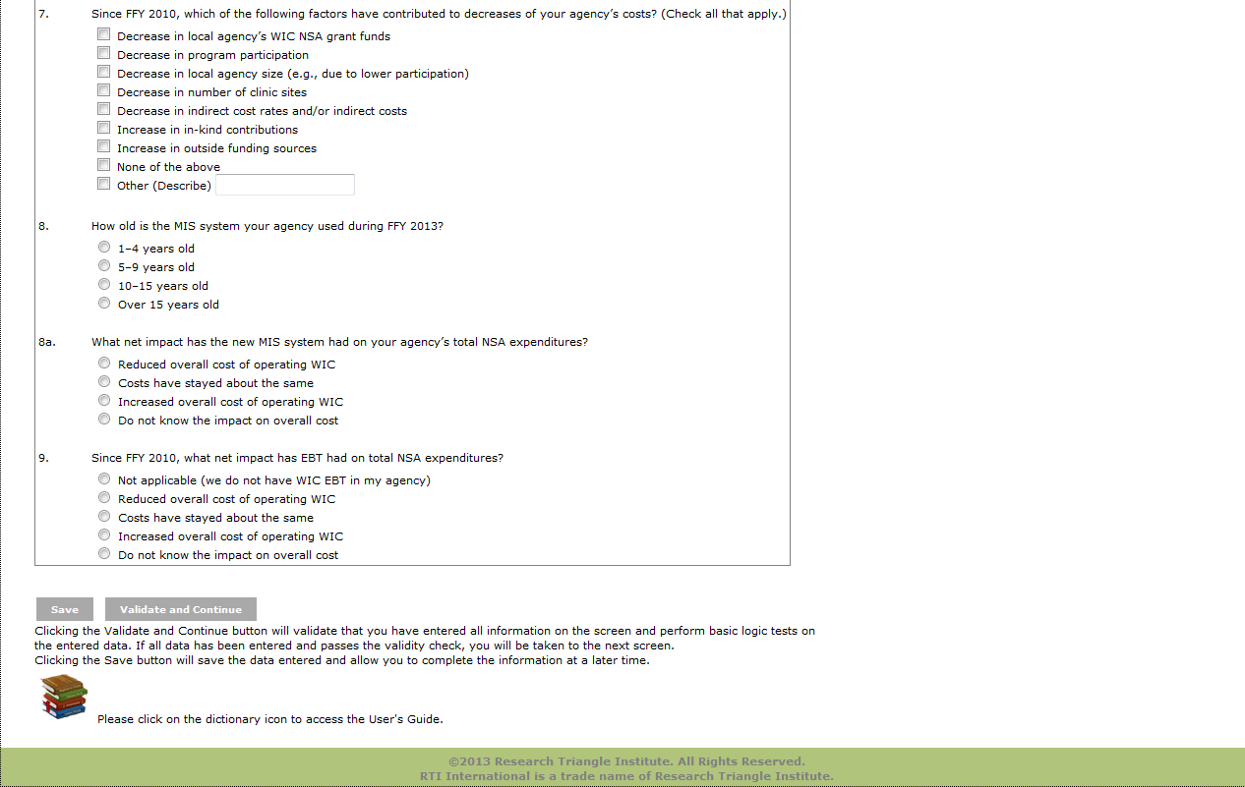

Exhibit 7: Labor/Personnel Expenditure
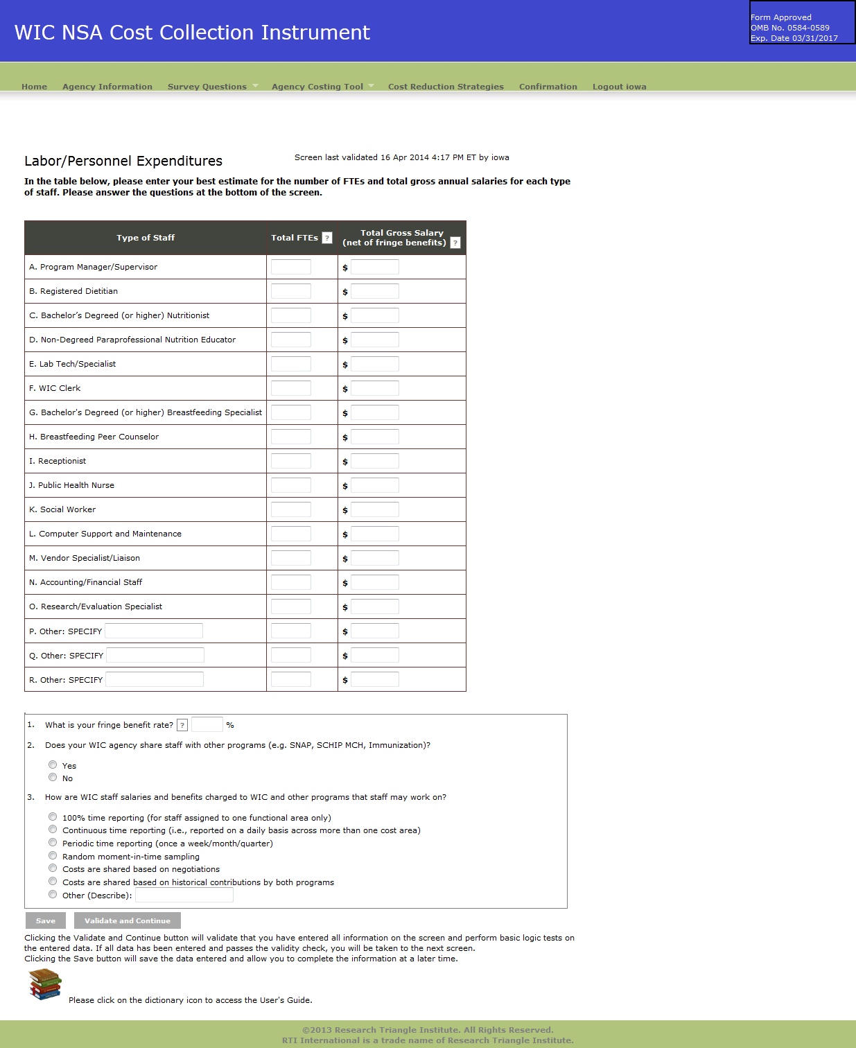

Exhibit 8: Contracted Services Screen
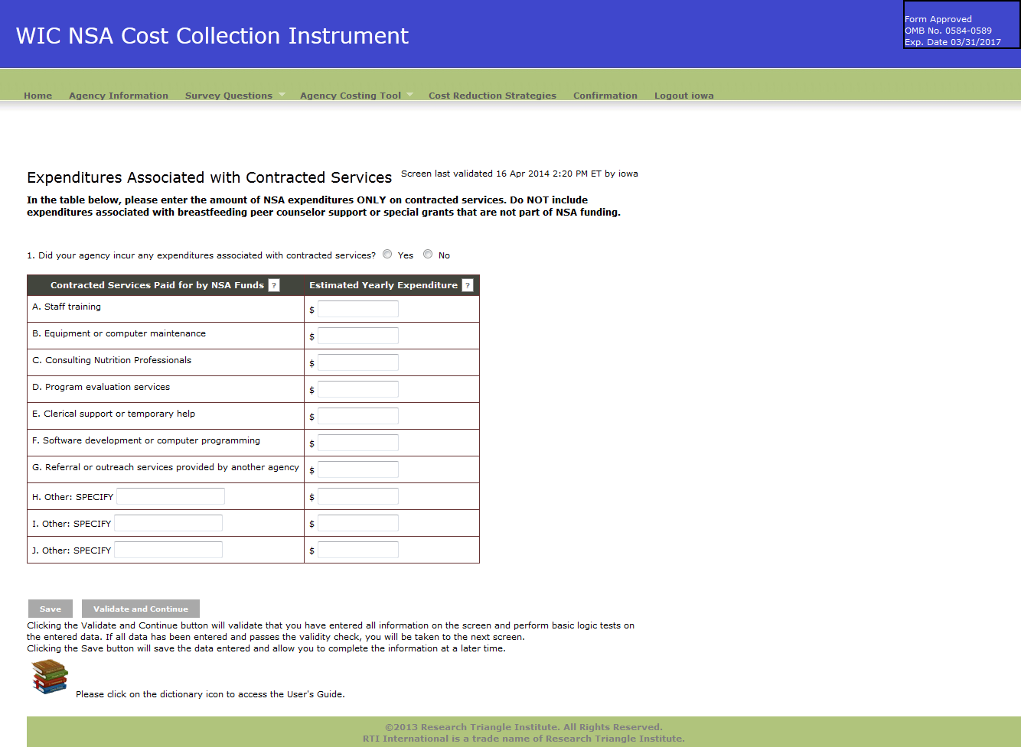

Exhibit 9: Materials, Services, and Travel Screen
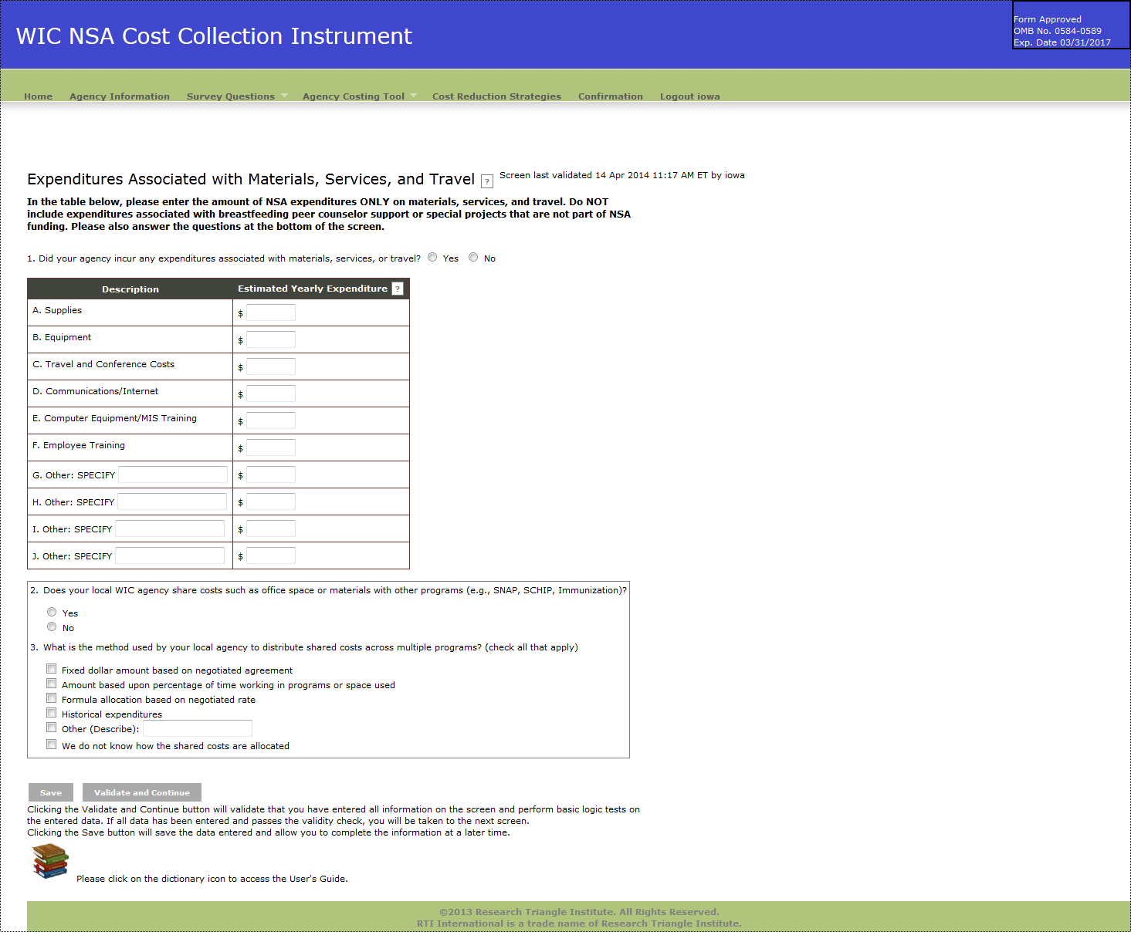

Exhibit 10: Indirect Costs
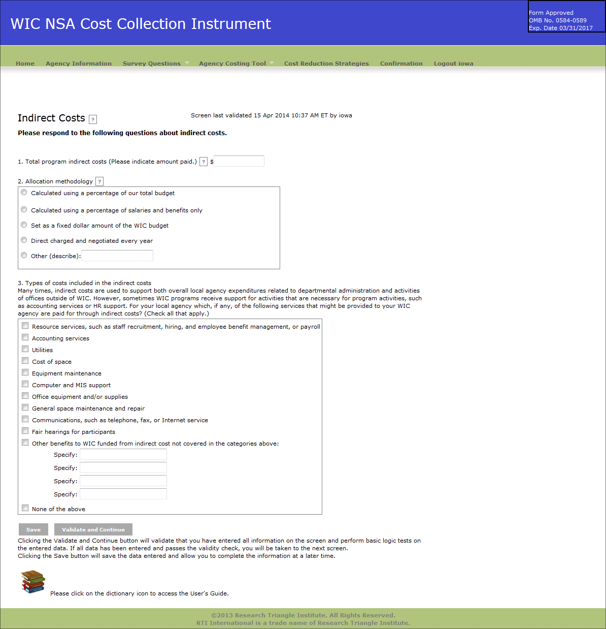

Exhibit 11: Other Sources of Funds
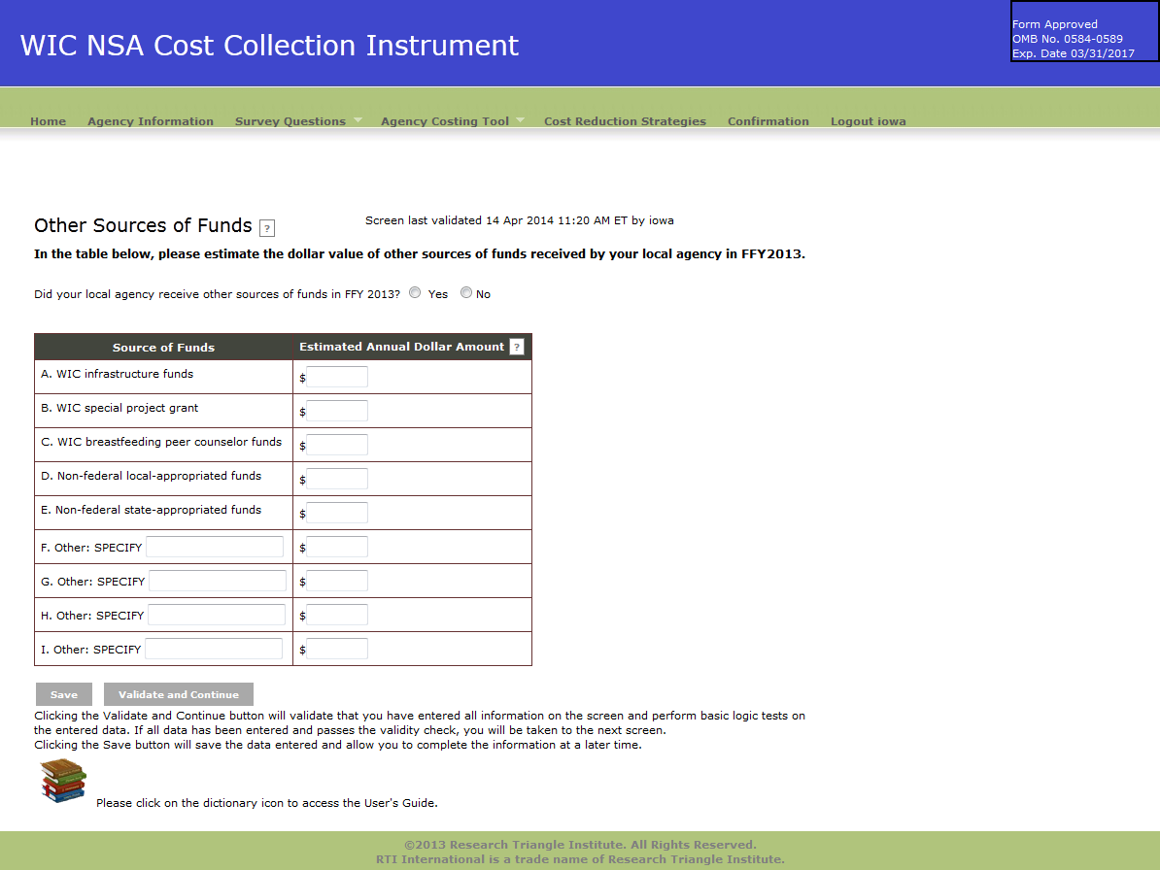
Exhibit 12: In-kind Contributions
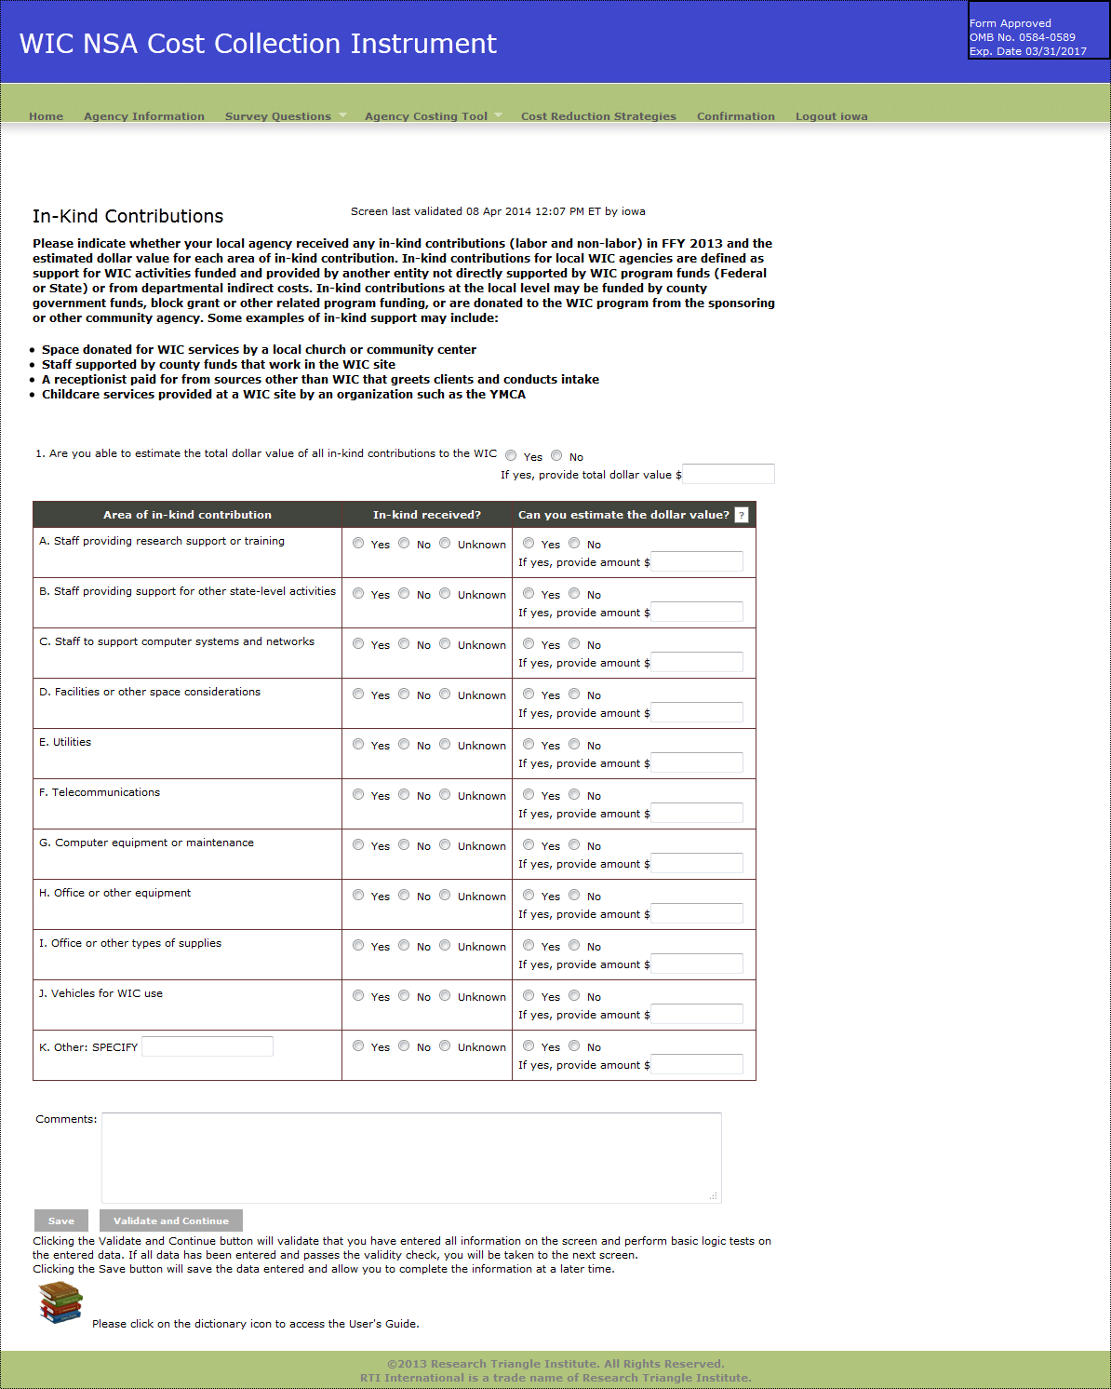

Exhibit 13: Cost Reduction Strategies
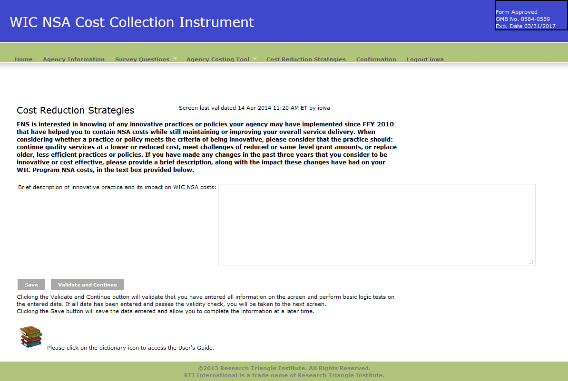
Exhibit 14: Confirmation Screen
