WIC NSA Cost Collection Instrument: Combination State and Local Agency
Exhibit 1: Agency Login
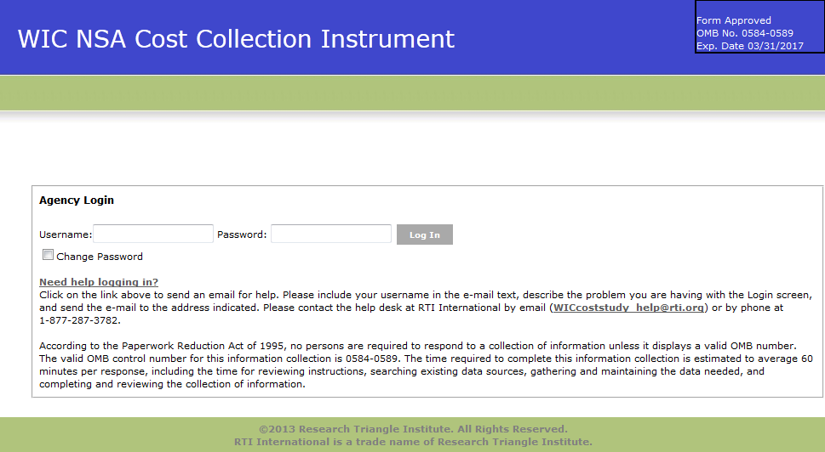

Exhibit 2: Home Screen
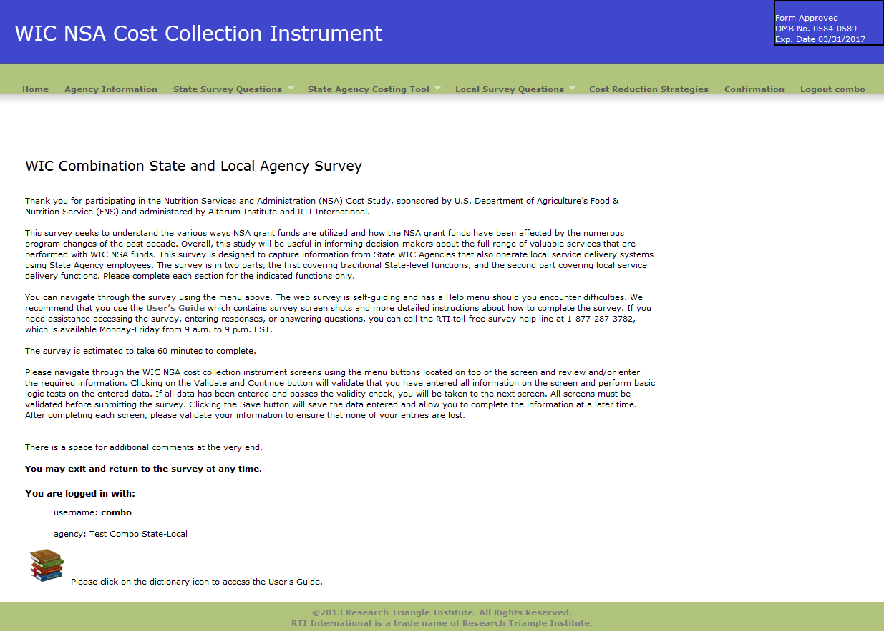
Exhibit 3: Agency Information Screen
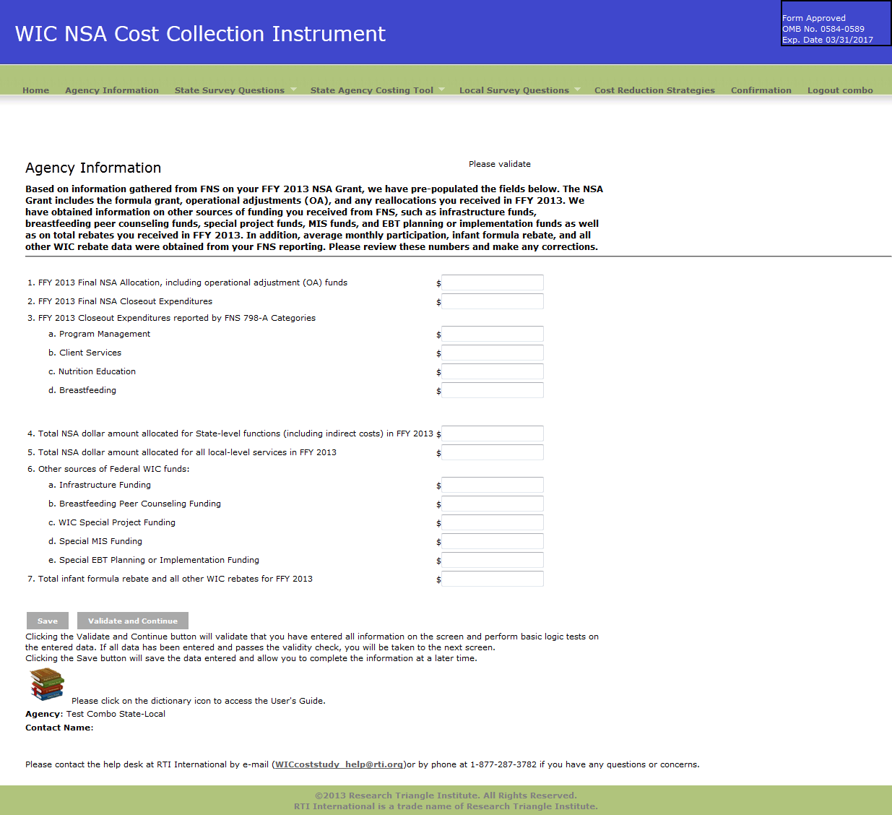

Exhibit 4: State Demographic Questions screen
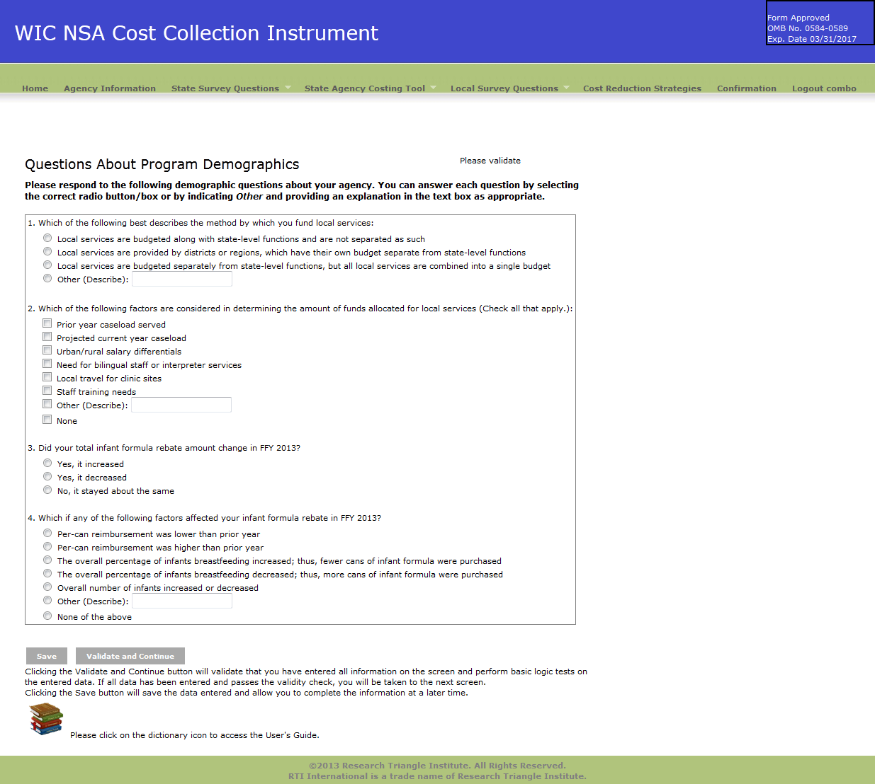

Exhibit 5: State Change in Costs Questions Screen
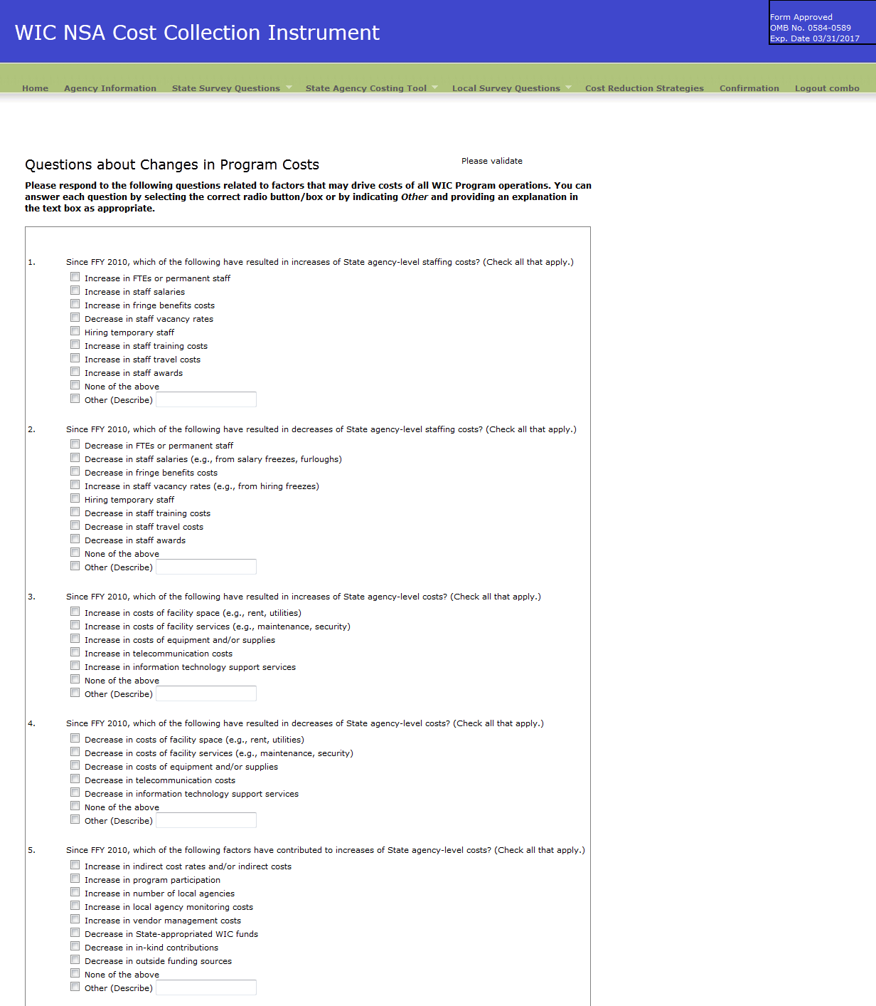

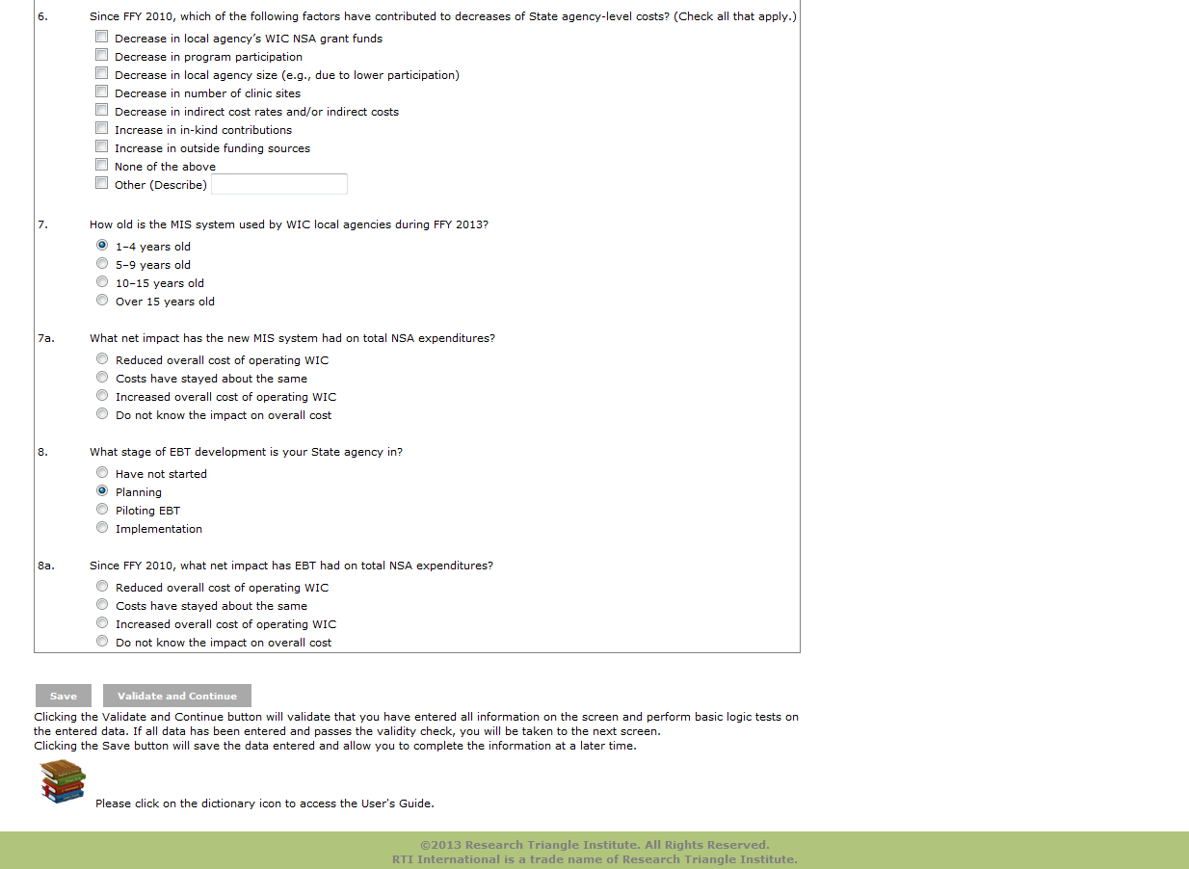

Exhibit 6: Labor/Personnel Expenditure
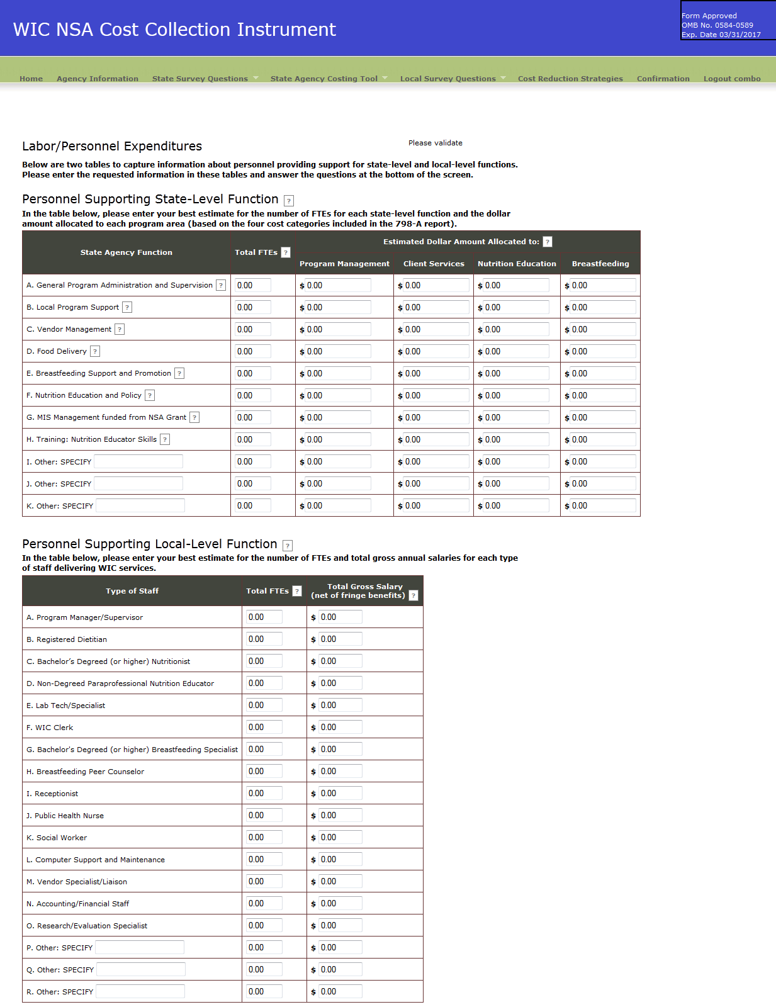
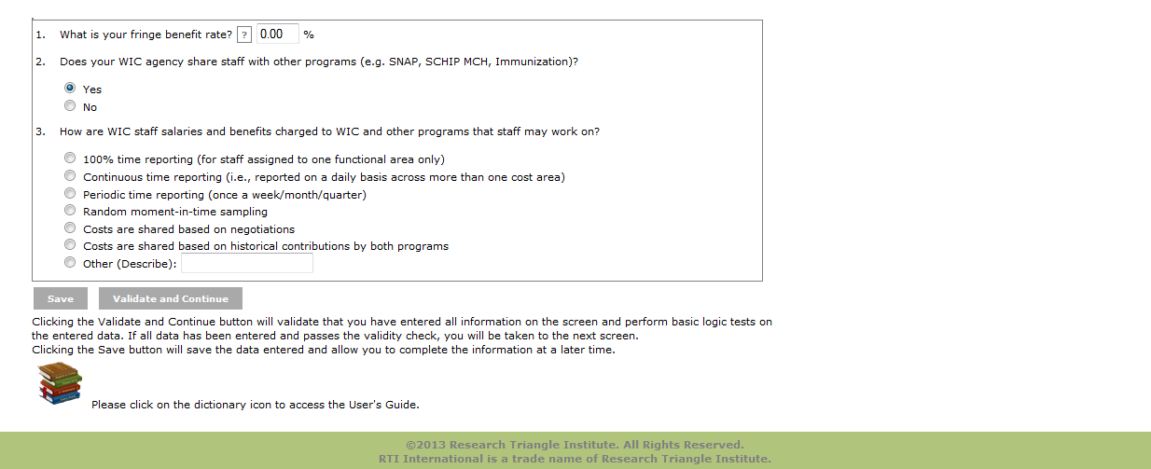
Exhibit 7: Contracted Services Screen
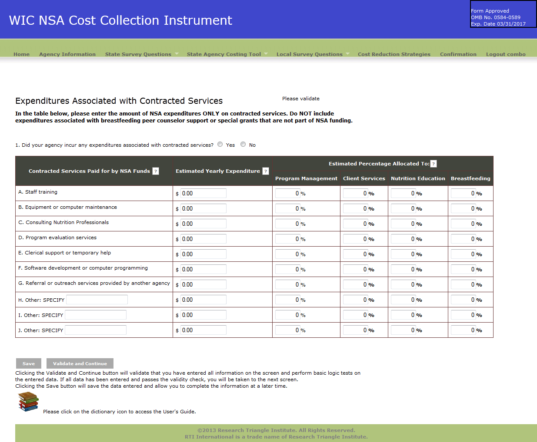

Exhibit 8: Materials, Services, and Travel Screen
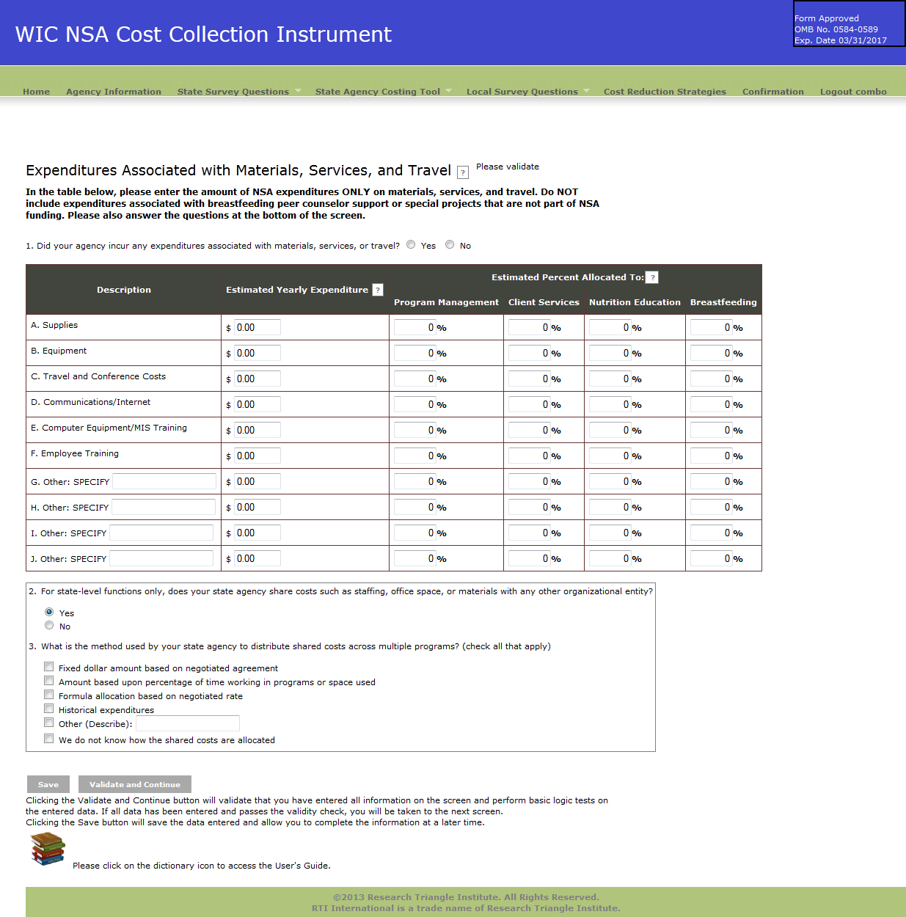

Exhibit 9: Indirect Costs
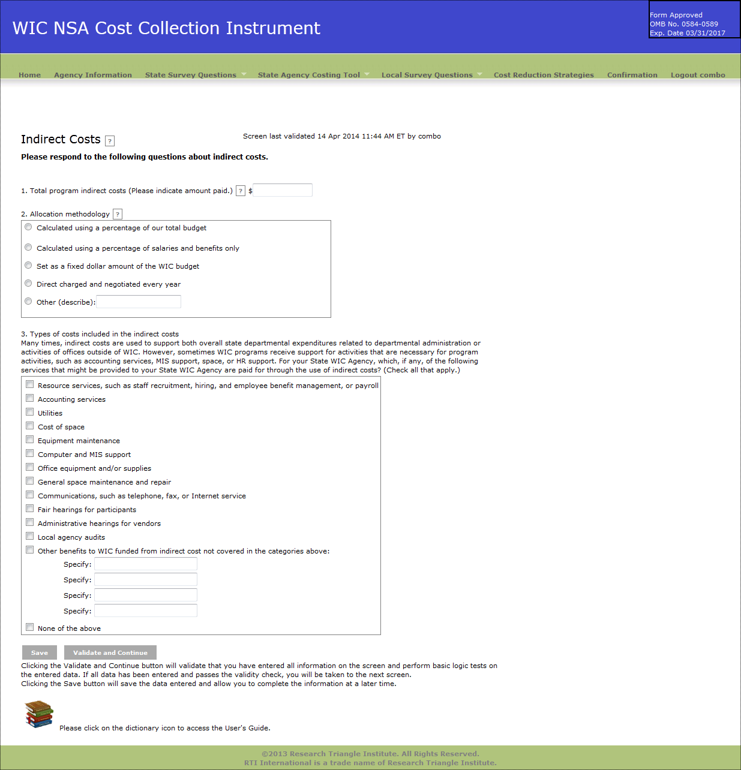

Exhibit 10: Other Sources of Funds
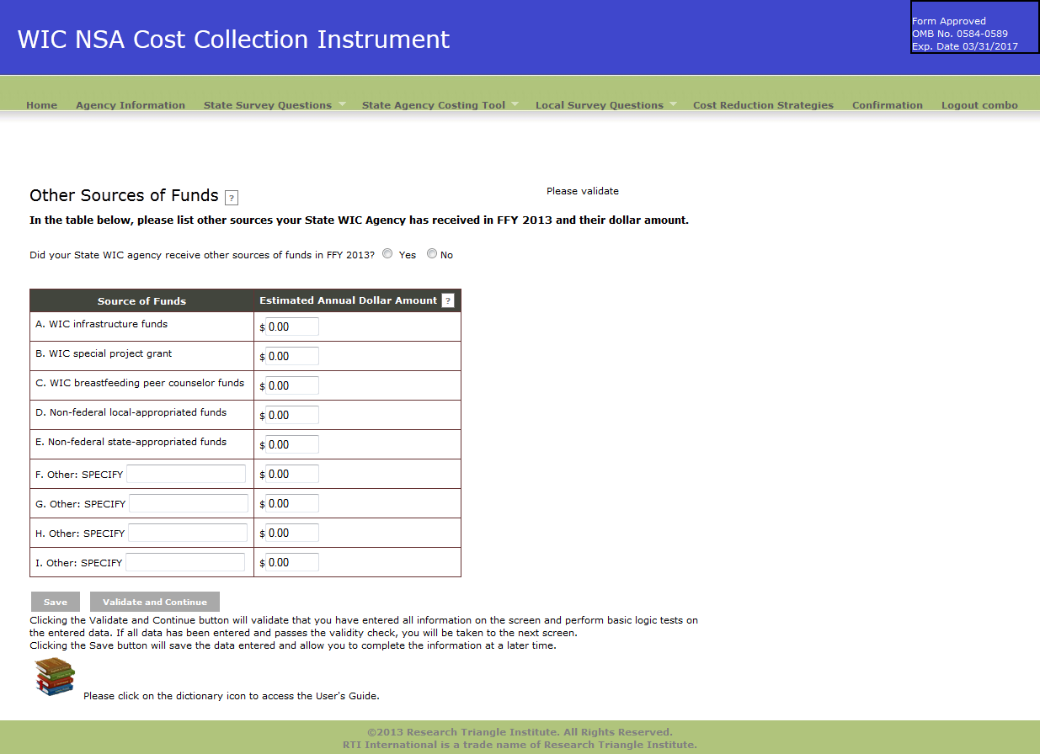

Exhibit 11: In-kind contributions
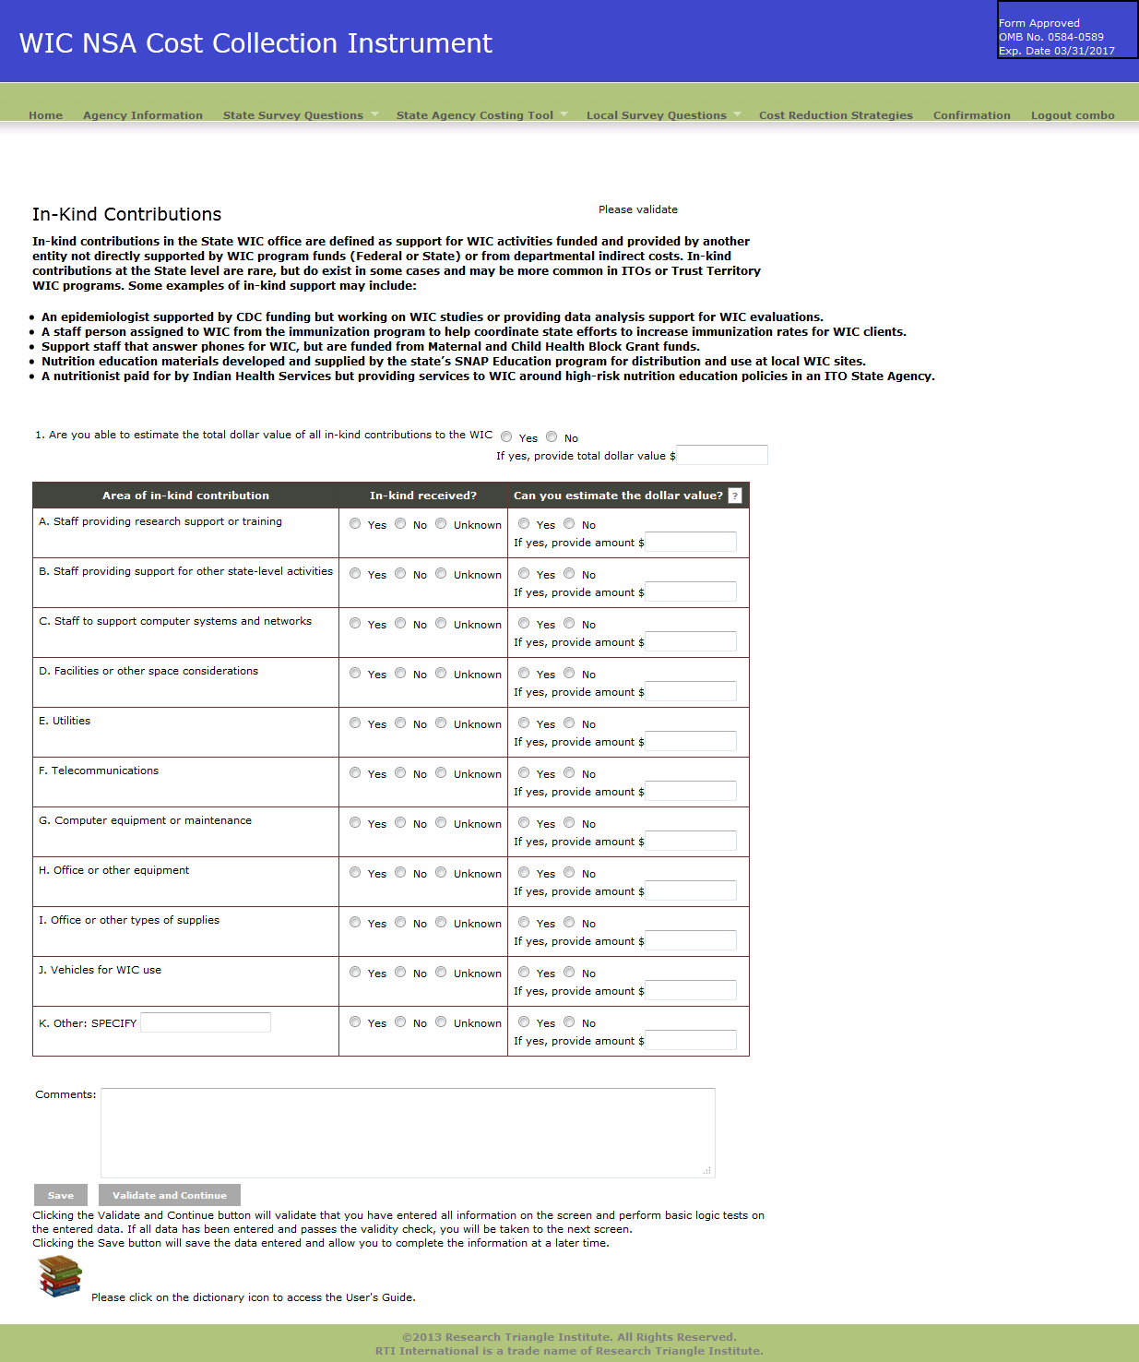

Exhibit 12: Local Demographic Questions Screen
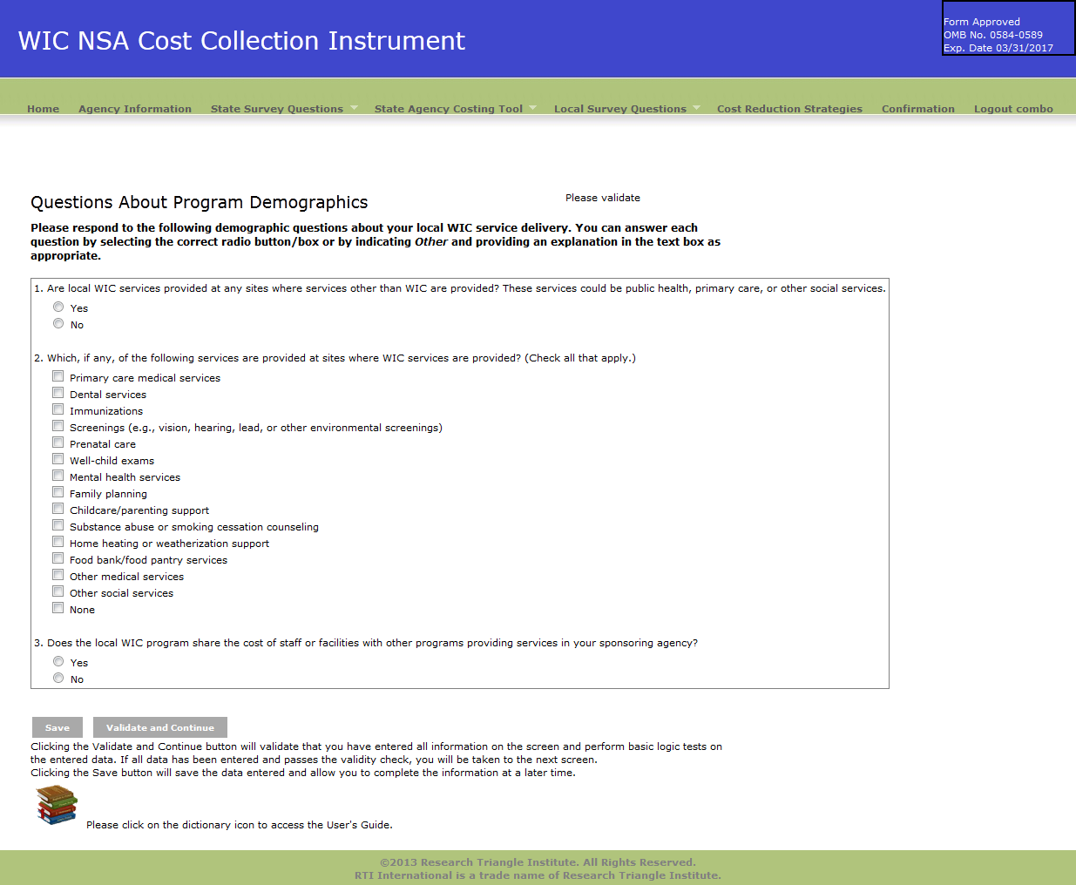

Exhibit 13: Local Services Provided Questions Screen
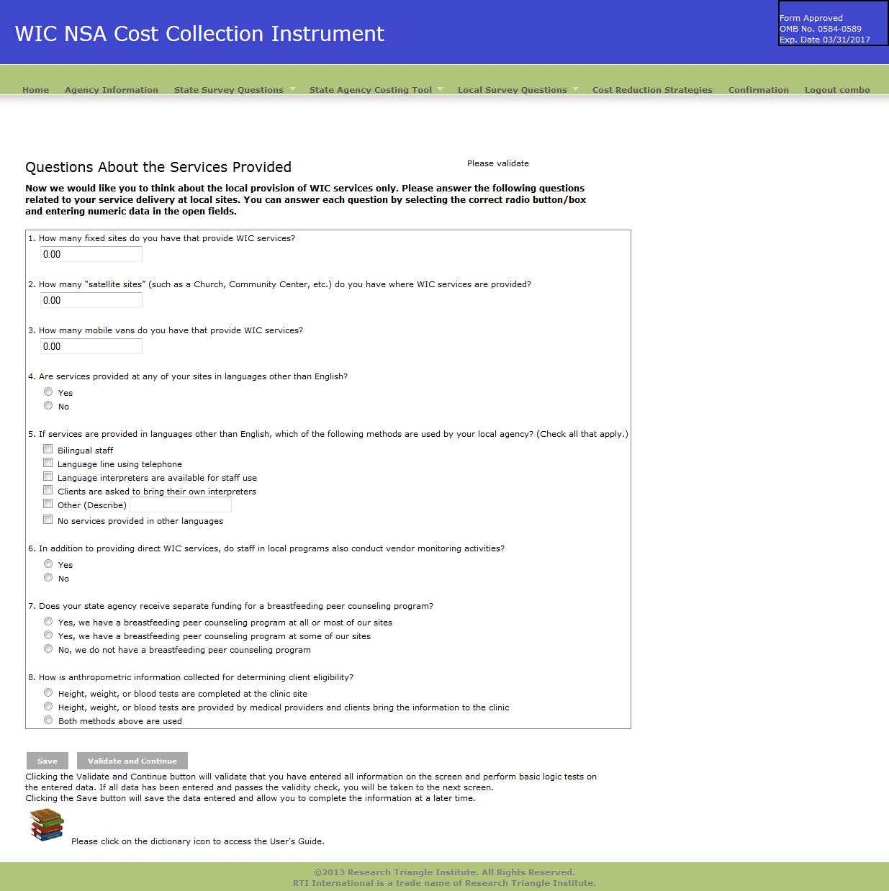

Exhibit 14: Local Change in Costs Questions Screen
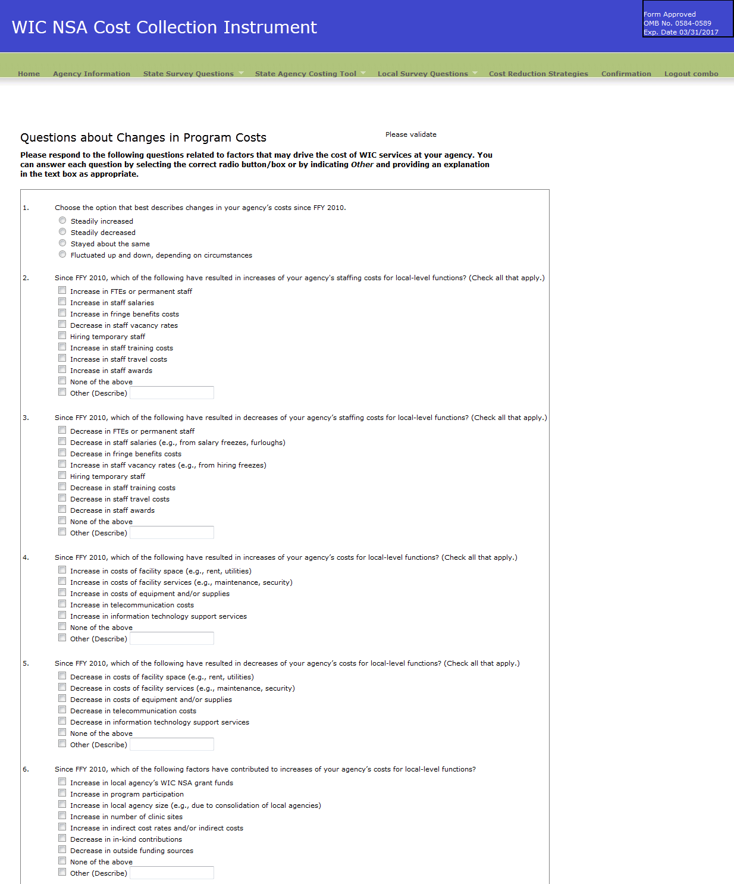

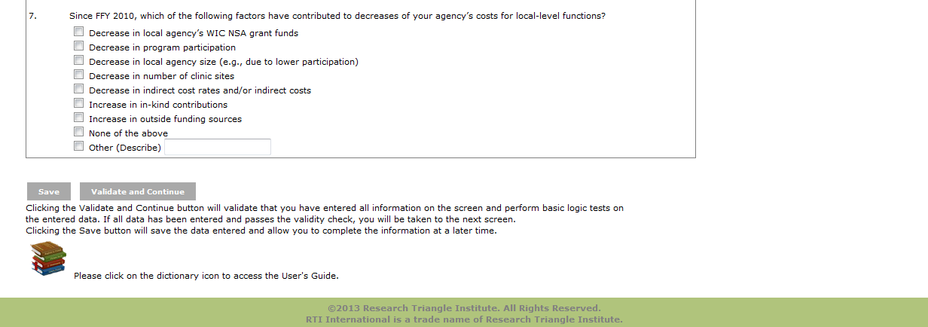

Exhibit 15: Cost Reduction Strategies
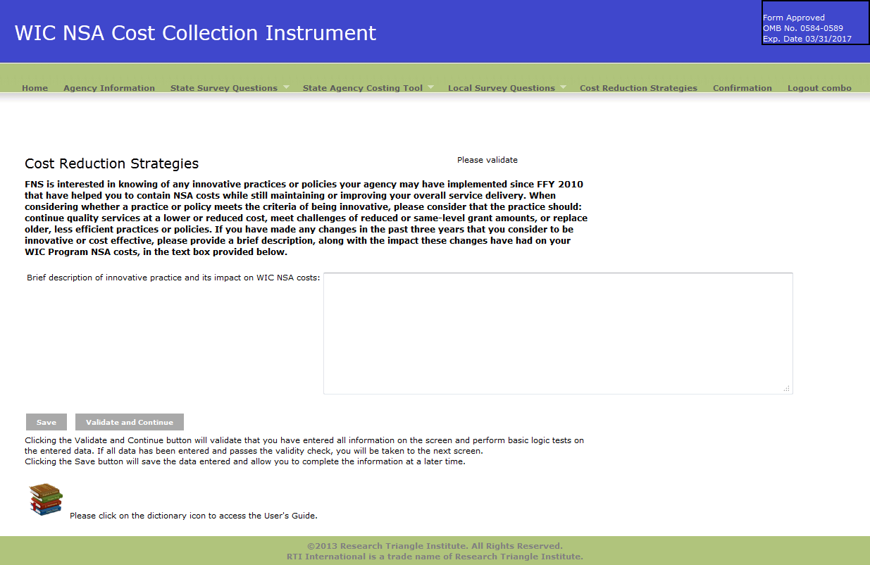

Exhibit 16: Confirmation Screen
