Appendix A – New/Modified Screen shots

Figure 1. New PIN Screen with Security Questions
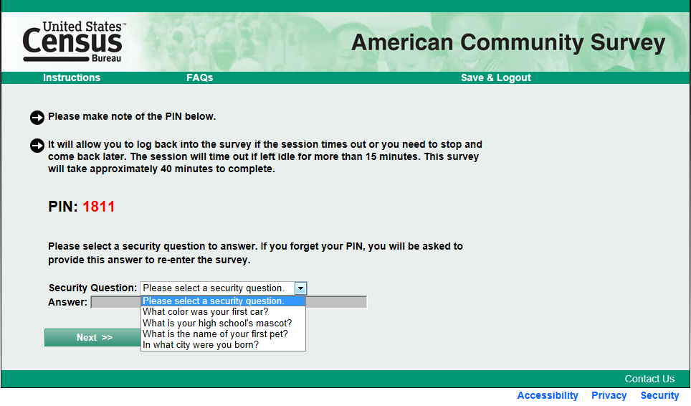

Figure 2. New Return Login Screen with Option to go to Security Question

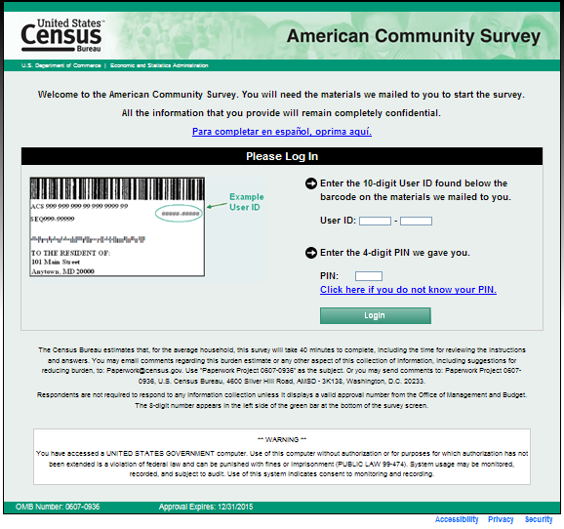
The ***WARNING*** will read “You have accessed a UNITED STATES GOVERNMENT computer. Use of this computer without authorization or for purposes for which authorization has not been extended is a violation of Federal law and can be punished with fines or imprisonment (PUBLIC LAW 99-474). System usage may be monitored, recorded, and subject to audit. Any information you enter into this system may be used by the Census Bureau for statistical purposes, including but not limited to improving the efficiency of our programs. For information regarding the use of this system, and how your privacy is protected, visit our online privacy webpage at http://www.census.gov/privacy/privacy_policy/. Use of this system indicates consent to the collection, monitoring, recording, and use of information provided inside this system.”

Also, the OMB number on this screen will be the production clearance number followed by the Methods Panel clearance number (i.e., “0607-0810/0607-0936”).

Figure 3. New Security Question Verification Screen
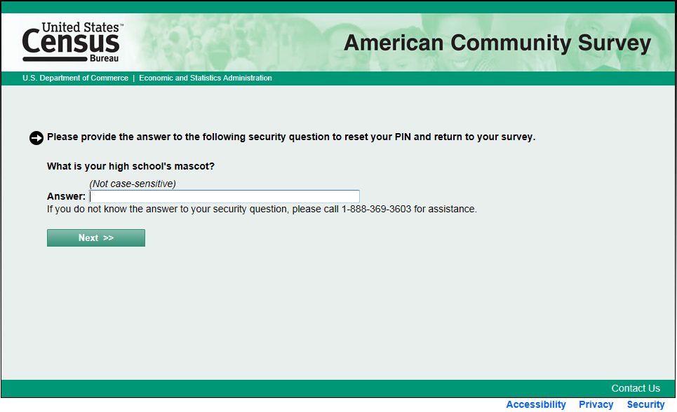
Figure 4. New PIN Screen after Security Question Reset
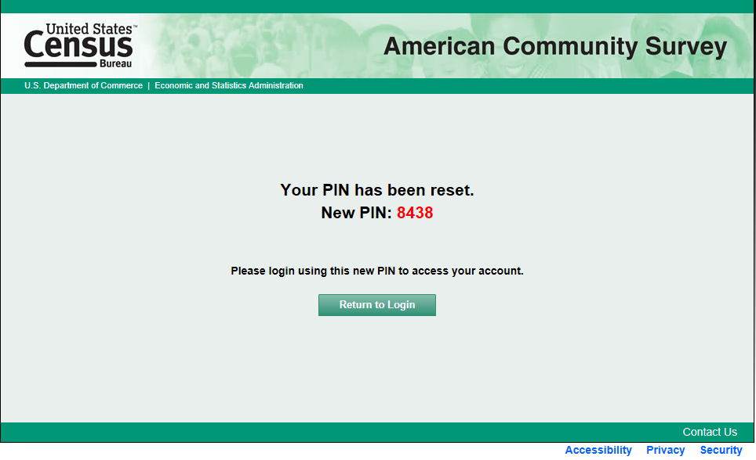

Figure 5. New Screen if no Security Question was Selected

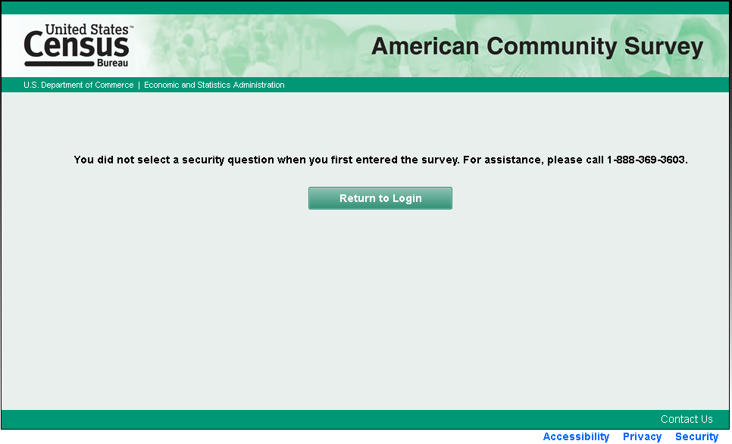

Figure 6. Updated Ancestry Question with Larger Text Box
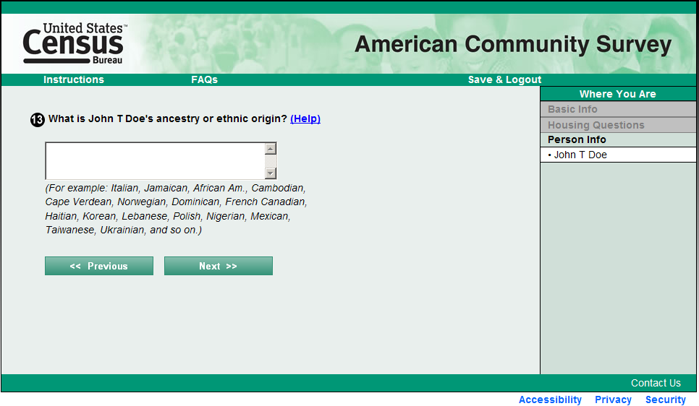

Figure 7. Highlighting of Multiple Task Questions
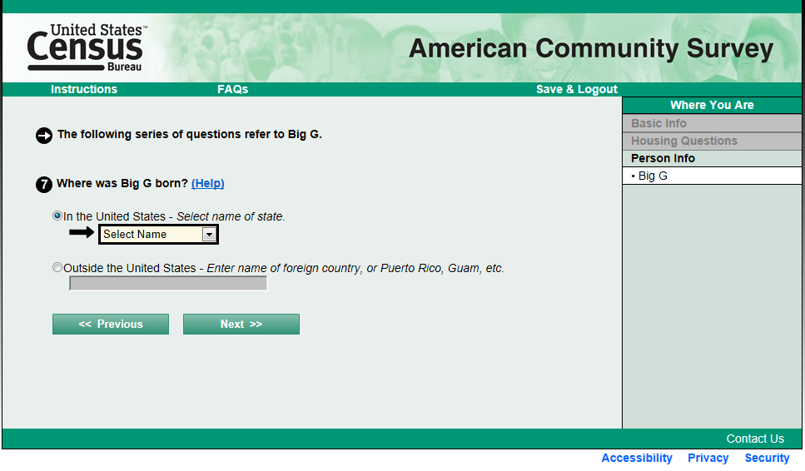

Figure 8. Original Saved Person Screen
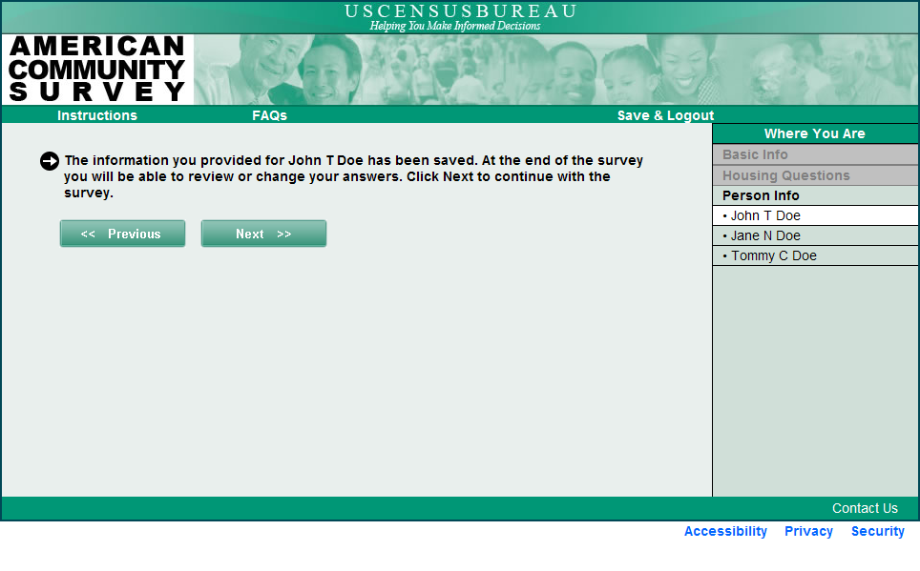

Figure 9. Original Pick Next Person Screen
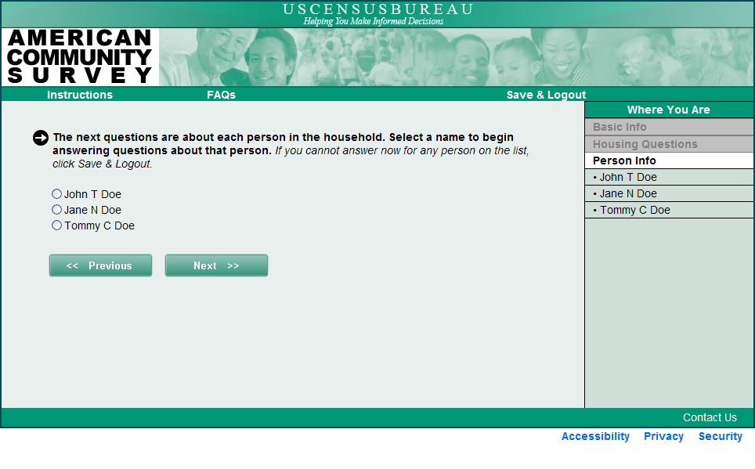
Figure 10. New Pick Next Person Screen (first time viewed)
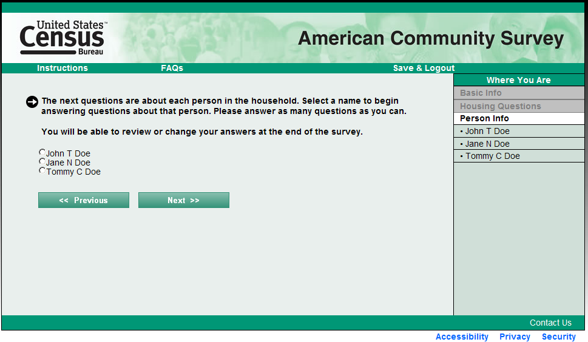

Figure 11. New Pick Next Person Screen (subsequent viewings except last)

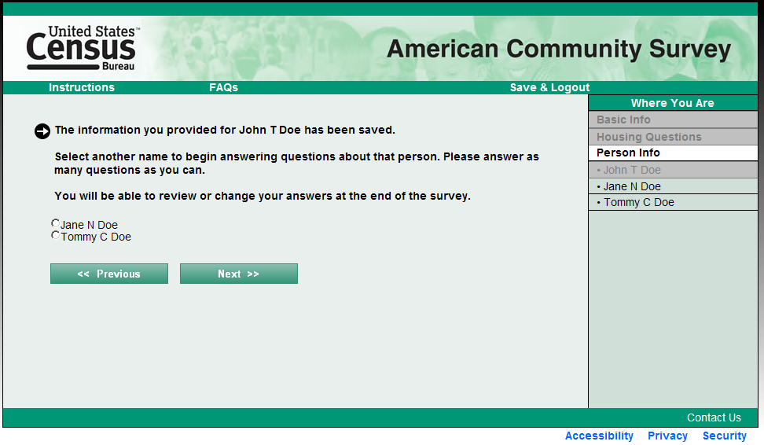

Figure 12. New Pick Next Person Screen (one person left on roster)
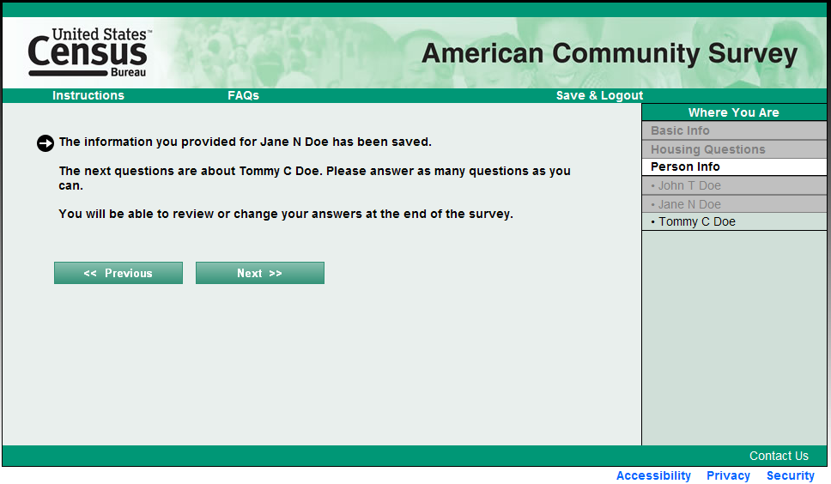

Figure 13. Updated Respondent Name Screen with Email Capture
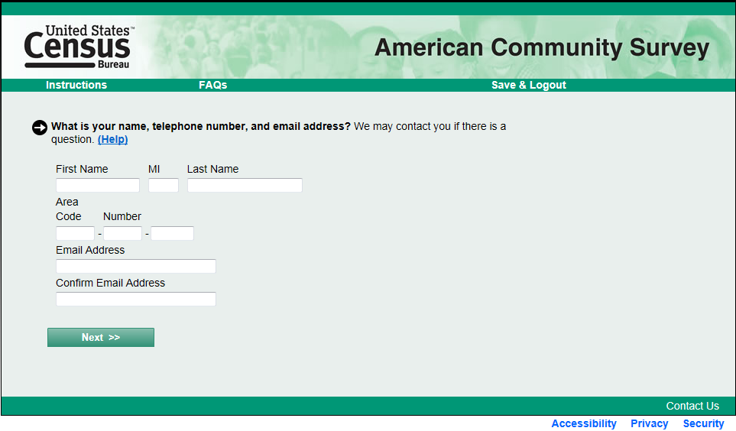

Figure 14. Proposed Language on New Respondent Name Screen

After question: “We will only contact you if needed for official Census Bureau business.”

Help screen:

Why we ask?

We ask for a respondent’s name and contact information in case we need to contact someone to ask about incomplete or missing survey information.

Help:

- Names, phone numbers, and email addresses are kept confidential.
- Providing a name helps eliminate confusion as you proceed through the interview to know about whom questions are being asked.
- The phone number and email address you provide will only be used if needed for official Census Bureau business. You may be asked to participate in other Census Bureau surveys.

