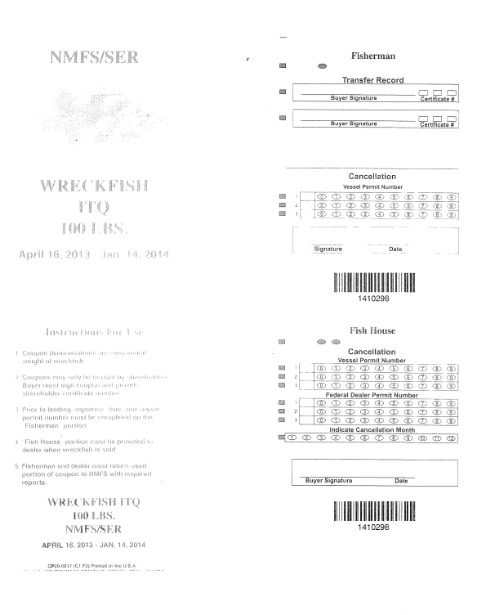

Vessel id number

_______________________________

Add additional row (4) for Federal Dealer Permit Number

April 16, 2014 – Jan. 14, 2015

April 16, 2014 – Jan. 14, 2015

Vessel id number

_____________________________