Exhibit O(2): HRSA 99-1(1) - Determination of Weighted and Unweighted Resident FTE Counts
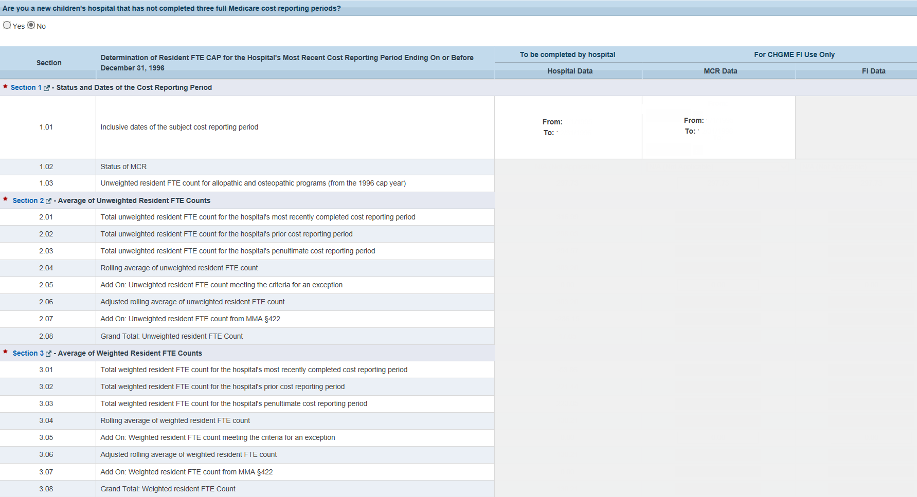

Exhibit O(2): HRSA 99-1(2) - Determination of Weighted and Unweighted Resident FTE Counts
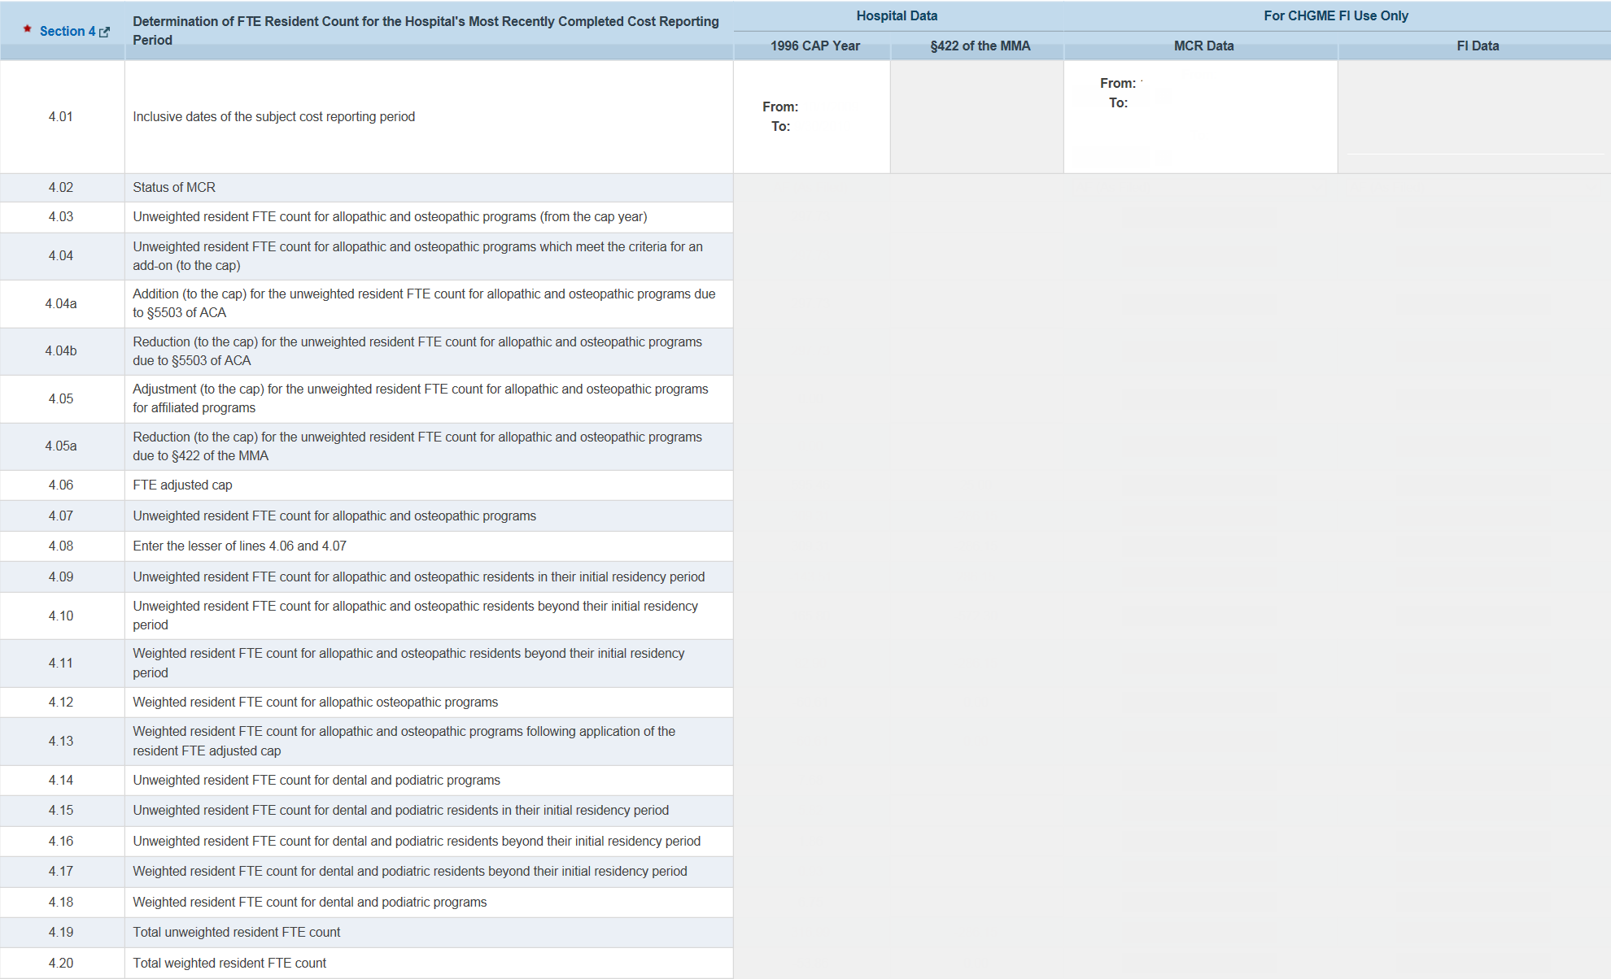

Exhibit O(2): HRSA 99-1(2A) - Determination of Weighted and Unweighted Resident FTE Counts
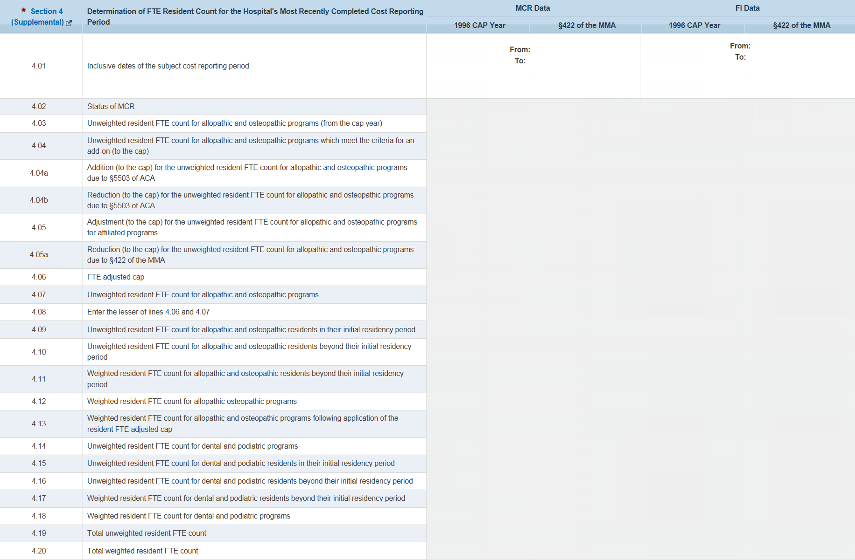

Exhibit O(2): HRSA 99-1(3) - Determination of Weighted and Unweighted Resident FTE Counts
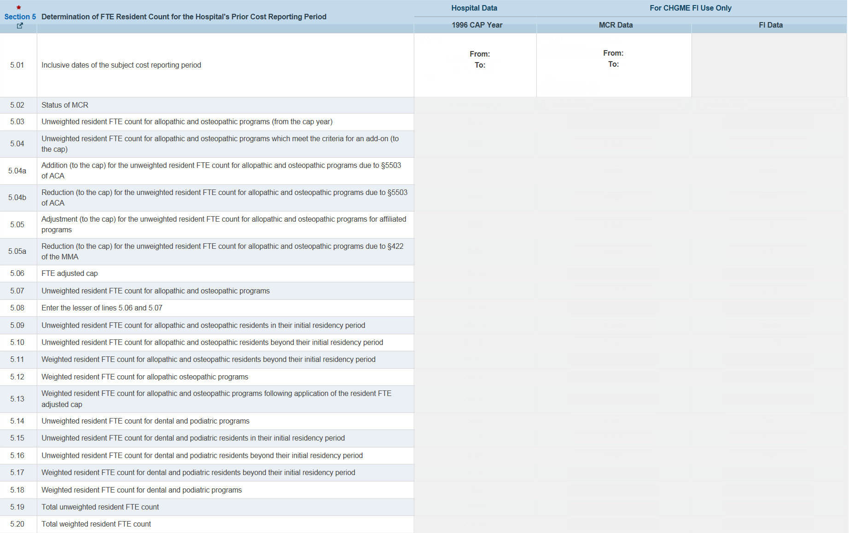

Exhibit O(2): HRSA 99-1(4) - Determination of Weighted and Unweighted Resident FTE Counts
