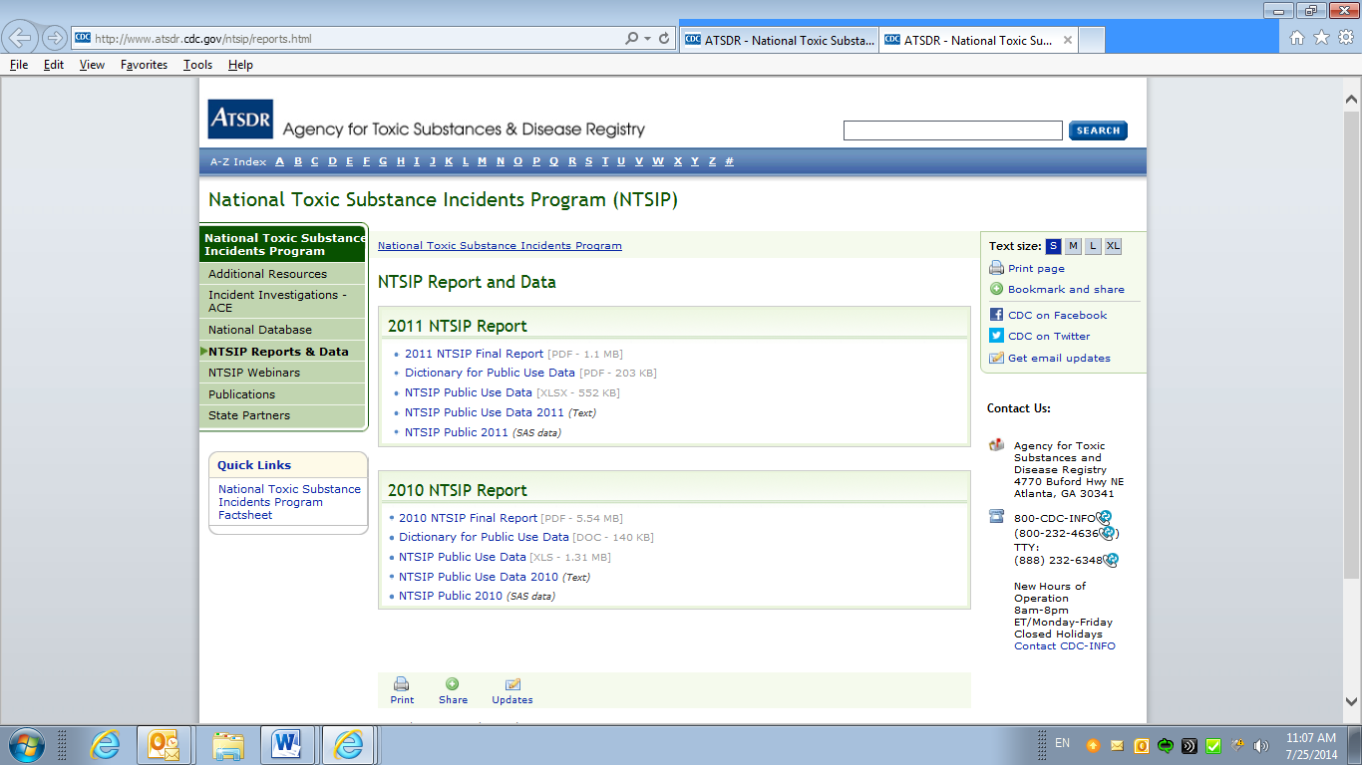

Please note, NTSIP states use a variety of available data sources and reporting procedures to complete the incident form. Aggregating data across states and across incidents should be interpreted with caution.