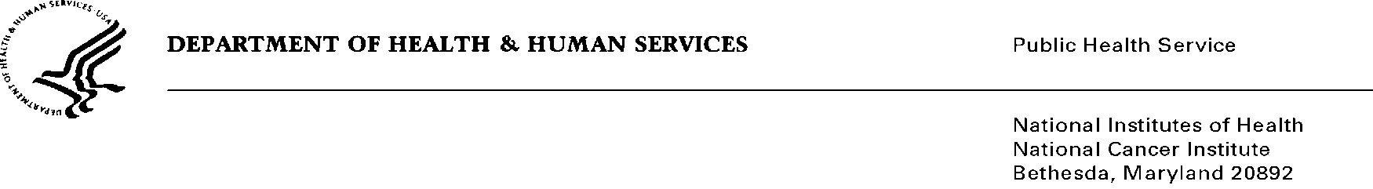
Date: April 3, 2014

To: Office of Management and Budget (OMB)

Through: Keith Tucker, Reports Clearance Officer, HHS
Seleda Perryman, Program Clearance Officer, NIH
Karla Bailey, PRA OMB Project Clearance Liaison, NCI

From: Anne M. Hartman, MS, MA, Project Director, Health Statistician.
Division of Cancer Control and Population Sciences
National Cancer Institute/National Institutes of Health (NIH)

Subject: Reinstatement with Change for Information Collection: “Next Series of Tobacco Use Supplements to the Current Population Survey (TUS-CPS) (NCI)”,
OMB No. 0925-0368, Expiration Date: 3/31/2013

This is a request for OMB to approve the reinstatement with change titled, “Next Series of Tobacco Use Supplements to the Current Population Survey (TUS-CPS) (NCI)” for two years. The supporting statements and various attachments accompany this memorandum.

The 2014-15 Tobacco Use Supplement-Current Population Survey (TUS-CPS) will be conducted by the Census Bureau and is co-sponsored by the National Cancer Institute (NCI) and the Food and Drug Administration (FDA). Fielded since 1992, most recently in 2010-11, this survey is part of a continuing series of surveys (OMB No. 0925-0368) sponsored by NCI that has been administered triennially as part of the Census Bureau's and the Bureau of Labor Statistics’ CPS. For the TUS-CPS, data will be collected from the U.S. civilian non-institutionalized population on smoking, other tobacco use, including switching, flavors, dependence, cessation attempts, and policy and social norms. The TUS-CPS has been a key source of national, state, some local-level, and health disparity data on these topics in U.S. households because it uses a large, nationally representative sample.

The 2014-15 TUS-CPS is designed to meet both NCI’s and FDA’s goals. The NCI and FDA are co-sponsoring the 2014-15 TUS-CPS through parallel, but separate interagency agreements with the Census Bureau. The NCI is particularly focused on policy information such as home and workplace smoking policies, cigarette price, and impact of these on subsequent purchase and use behavior; and changes in smoking norms and attitudes. The FDA aims to support research to aid the development and evaluation of tobacco product regulations. The research findings generated from this program are expected to provide data to inform FDA regulation of the manufacture, distribution, and marketing of tobacco products to protect public health. A unique feature is the ability to link other social and economic Census Bureau and Bureau of Labor Statistics data, other sponsor-supported supplement data, and the National Longitudinal Mortality Study cancer incidence and cause-specific mortality data to the TUS-CPS data. Data will be collected in July 2014, January 2015, and May 2015 from about 255,000 respondents.

