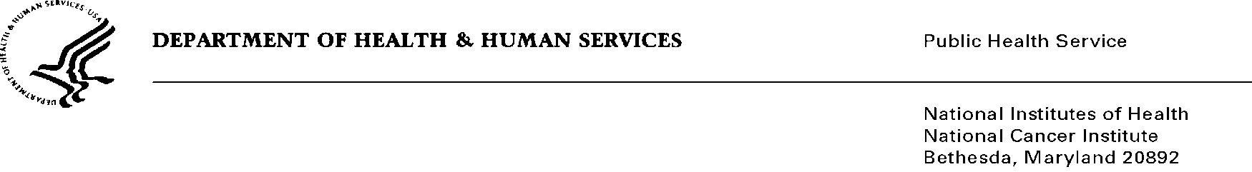
Date: January 6, 2014

To: Office of Management and Budget (OMB)

Through: Keith Tucker, Reports Clearance Officer, HHS
Susan Queen, PhD, Director of the Division of Data Policy, ASPE, HHS
Seleda Perryman, Program Clearance Officer, NIH
Karla Bailey, PRA OMB Project Clearance Liaison, NCI

From: Anne M. Hartman, MS, MA, Project Director, Health Statistician.
Division of Cancer Control and Population Sciences
National Cancer Institute/National Institutes of Health (NIH)

Subject: TIME-SENSITIVE Review of Reinstatement of “Next Series of Tobacco Use Supplements to the Current Population Survey (TUS-CPS),”
OMB No. 0925-0368, Expiration Date: 3/31/2013

This is a request for NIH, HHS and OMB to conduct a timely review of this Reinstatement with Change information collection titled, “Next Series of Tobacco Use Supplements to the Current Population Survey (TUS-CPS) (NCI).”

The 2014-15 TUS-CPS is co-sponsored by the National Cancer Institute (NCI) and the Food and Drug Administration (FDA). The Census Bureau plans to initially field the TUS-CPS instrument in July, 2014 along with their regularly scheduled CPS. There is little to no flexibility in this schedule given CPS’ tightly scheduled Supplements in other months, and the need for TUS-CPS to be spaced in a way that maximizes the number of unique individuals interviewed (i.e., minimizing the number of individuals interviewed twice) given the household panel design of the CPS.

It is particularly important and fortuitous there has been purposeful harmonization, both in the past between the TUS-CPS and NHIS, and in the present for the PATH, TUS-CPS and NHIS. Building upon this attention to harmonization and complementarity of tobacco control related items, and with guidance from OMB and ASPE, NCI and FDA have engaged staff from CDC-NCHS, OSH, and members of the PATH team in finalizing 2014-2015 TUS items. Additionally, TUS-CPS is one of DHHS’s premier national surveys that the PATH study must reference when providing its own tobacco-related estimates (a condition for the PATH approval). Finally, many of the current NIH and OMB staff responsible for the PRA process have reviewed previous cycles of the TUS-CPS survey.

Given the vital importance of timeliness, and the considerable attention we have paid to developing the 2014-15 TUS-CPS according to guiding principles discussed at meetings this summer with both ASPE and OMB, we respectfully request a timely review, such that OMB approval may be obtained by June 1, 2014, enabling the Census Bureau to begin fielding the survey in July 2014.

Should you have additional questions, feel free to contact me at 240-276-6704.

Sincerely,

Anne M. Hartman

