OMB No. 0960-0706 (HAVA)
Sample Collection Screens

Below are HAVA submission screens for several state MVAs. Screen shots vary slightly from State to State, although the information required is standardized when it goes from AAMVA to SSA.

Michigan

Here is a screen shot of the application used by the Michigan voting jurisdictions to enter the data. The 4 digit SSN field is grayed out, but is opened on specific transactions.
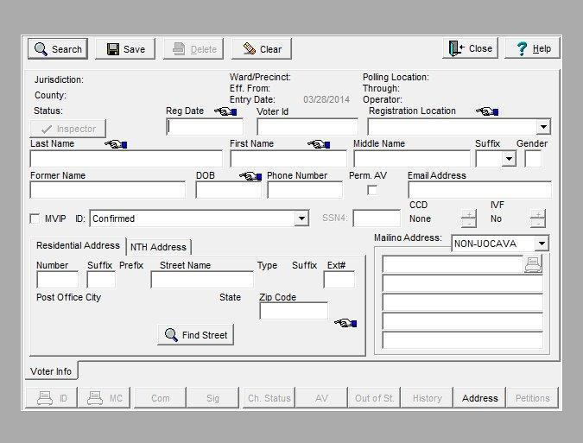

Vermont

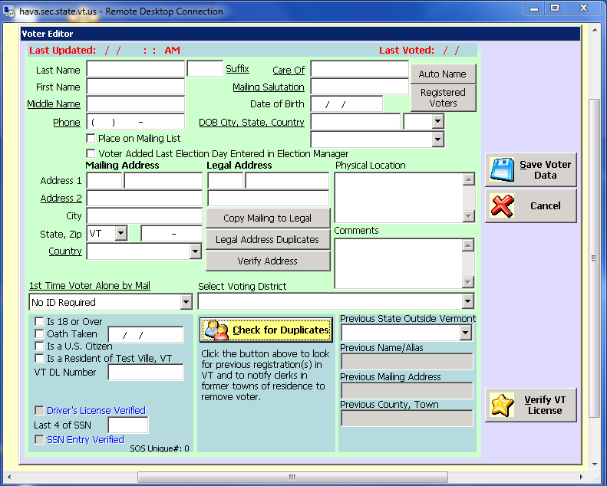

Missouri

HAVA VERIFICATION CHECK

LAST 4 OF SSN
LAST NAME
FIRST NAME
MIDDLE NAME
SUFFIX NAME
DOB

HAVA VERIFICATION RESPONSE

RESPONSE CODE

Arizona

Arizona's Secretary of State office accepts voter registrations from the fifteen Arizona counties and passes any new entries (Full Name, SSN last 4 digits and DOB) through to us here at the Motor Vehicle Division in a daily batch process. We then check to see if the full SSN search has already been verified on our Driver License Data Base and, if so, return the entry with a verified status. If the entry is not found on the MVD data base, or, the SSN verification has not been completed, we initiate the HAVV inquiry. We don't have access to the entry screens used by the Secretary of State but they accept:
Full Name
DOB
SSN (Last 4)
Address
Political Party affiliation
And, assign a unique voter ID to each registrant.

Texas
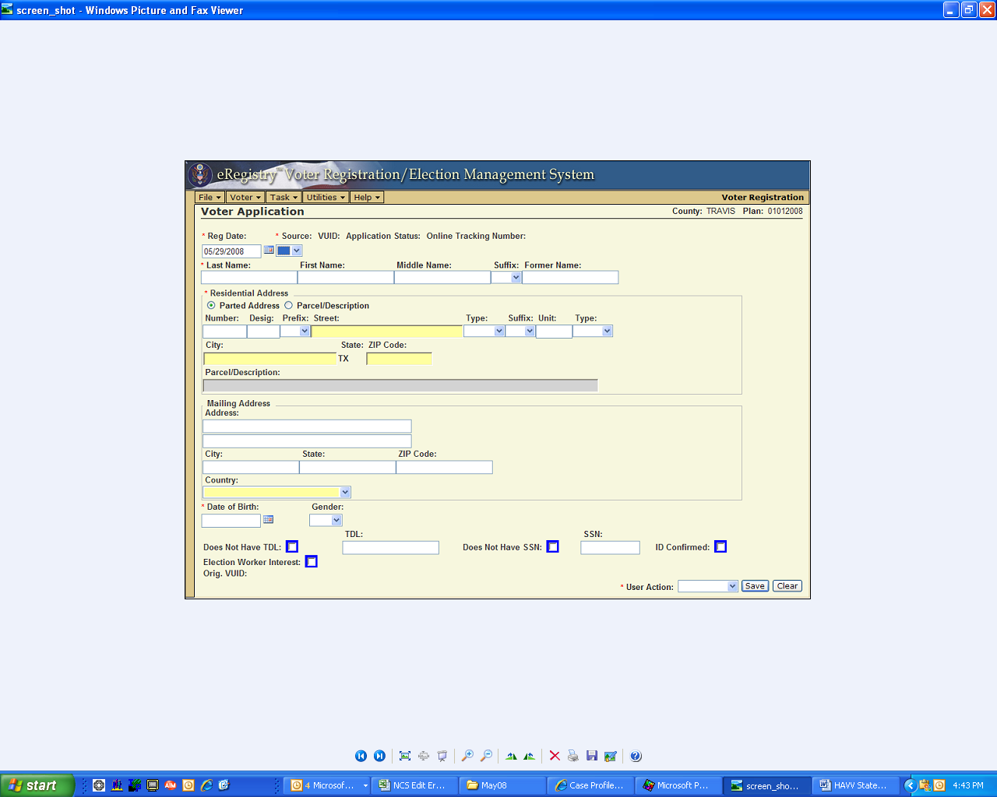

When a new Voter application is entered into the system (via the "eRegistry" GUI or through the import process) it goes through a process called "live check".

The portion of the "live check" that makes the call to the Department of Public Safety (DPS) which in turn makes a call to the Social Security Agency (SSA) requires the following pieces of information:

- Last Name
- First Name
- Last 4 Digits of the SSN
- Date of Birth

We will basically receive a "pass" or "no pass" status back. If it passes the voter application is approved. If it doesn't pass, the County's voter registrar has several options (1. reject the application, 2. send the applicant a notice, 3. approve the application, but blank out the SSN and mark/flag the voter application so that the voter would be required to show proper identification the first time the voter votes).

Note: Not all voter applications are sent to SSA, if they contain a Driver's License, then they've already been checked by DPS as to their identity and are not required to go through the SSA process. Also, if the voter application does not have an SSN then it would not need to go to SSA.

New Hampshire

